The wounds inflicted on millions of soldiers ***accelerated*** the development of new medical techniques and inventions.

MC900078623[1]

**New techniques in the treatment of wounds and infection**

The use of explosive weapons meant that many soldiers suffered deep wounds. These wounds often got infected by clothing or shrapnel. Aseptic (clean) surgery was very difficult because of the conditions in trenches. Carbolic acid proved ineffective for gas gangrene. New techniques were needed:

* **Wound Excision / Debridement:** Surgeons found that the best way to tackle this type of injury was to cut away infected tissue from around the site of the wound, making sure to remove all shrapnel/ fragments. This needed to be done quickly to prevent infection spread. The wound was then kept open for use of antiseptics because immediate sewing of the wound would trap infection into the wound. The wound was then stitched up afterwards. Although this method resulted in larger wounds, it did help to prevent infection.
* **Saline (salt) solution**: Surgeon cleaned the wound with a sterilised salt solution. This was called the ‘**Carrel-Dakin method’** and was used in treating gas gangrene. However, saline solutions had to be made on the go and only stayed usable for 6 hours.
* **Speed:** There was also progress in the speed of treatment. From January 1915 the British military medical machine moved closer to the front line. Casualty clearing stations were now better equipped and, crucially, more surgeons were closer to the battlefield. There were now fewer delays in administering potentially life-saving treatment. Soldiers with wounds that would have been fatal were now more likely to survive.

**Use of mobile X-ray machines**

MC900324410[1]

World War One made the use of Roentgen’s X-rays (discovered in 1895) far more common as surgeons needed to locate bullets and shrapnel lodged deep within flesh. Governments ordered X-ray machines to be built for the hospitals of the Western Front. They were essential to identify shell fragments and bullet wounds that if not removed from the body could cause infection. Two X-Rays were taken from different angles to help the surgeon locate the shrapnel and bullets.

Mobile x-ray units prevented deaths on the front line by letting medics see bullet injuries and sped up process of diagnosis and surgery. There were 6 mobile x-ray units operating in the British sector of the Western Front that could be called upon. Setting up the mobile unit took some time: a tent was attached to the back of the van with a table where stretchers could be placed. The x-ray machine was placed next to the table linked to the engine. Equipment for processing the x-ray films was set up inside the van. The image quality wasn’t as good as the static (still) x-ray from a hospital but was enough to identify the shrapnel and bullets.

Problems with X-Rays on the Western Front:

* X-Rays couldn’t detect all objects in the body e.g. fragments of clothing
* The length of time a wounded man had to remain still was several minutes which could cause problems depending on the wound
* The tubes used in X-Ray machines were fragile and overheated very quickly therefore could only be used for about an hour at a time to then cool down (due to demand for x-rays and overheating problem the solution was to have 3 machines in rotation)

**Broken limbs, amputations and the splint**

If excision or antiseptics failed, amputation was necessary. By 1918, 240,000 men had lost limbs to stop spread of infection. In 1914-15, men with a gunshot or shrapnel wound to the leg only had a 20% chance of survival because**:**

* Compound fractures pierced the skin = infection and broken bone inside the leg
* If the femur (thigh bone) was fractured this would lead to massive muscle damage and bleeding into the thigh.
* The splints they originally used didn't keep the leg rigid so by the time they arrived at the CCS the patient would have lost a lot of blood, would be in shock and maybe already developing gas gangrene. Those who survived had their leg amputated at the CCS.

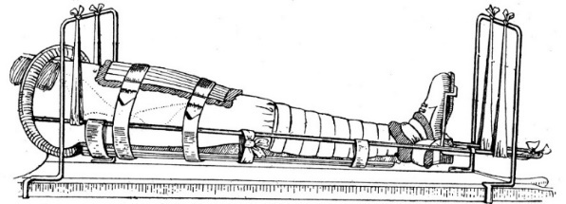Technological innovations developed in the First World War had a massive impact on survival rates, such as the **Thomas splint**, which secured a broken leg. TheThomas Splint was developed in the late 19th Century by Hugh Thomas and was designed to stop joints moving. This had a tremendous positive impact on survival rates; at the beginning of the war 80% of all soldiers with a broken femur died, but by 1916, 80% of soldiers with this injury survived.

**Head injuries and brain surgery**

Before the war many surgeons stayed away from working on the brain as it was too complicated and risky. Injuries to the brain were very likely to prove fatal at the start of the war because:

* The issue of infection applied just as much to the head as other parts of the body
* There were difficulties involved in moving men with head injuries through the chain of evacuation as they were unconscious or confused
* There were very few doctors who had experience of neurosurgery (nervous system, brain & spinal)

MC900055181[1]

However the war caused huge numbers of brain injuries and surgeons became more willing to experiment:

* Patients were operated on at CCS, as quicker operation led to a better survival rate.
* Patients were kept for up to three weeks to make sure they were recovered.
* Even minor head injuries were carefully examined just in case.
* Harvey Cushing developed new techniques in brain surgery using magnets to pull out metal fragments. He used local anaesthetics when operating as general anaesthetics made the brain swell.
* Similarly, surgeons experiments using rubber bands to control bleeding.
* Saline solution was used to wash out pulped brain.

**Blood transfusion and storage (first blood bank at Cambrai)**

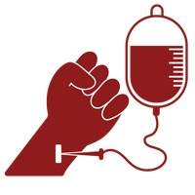

The British Army began the routine use of blood transfusion in treating wounded soldiers. A syringe and tube was used to transfer the donor blood to the patient before surgery and to prevent them going into shock. Those who didn’t reject the blood generally survived so due to this success they started doing transfusions in the CCSs as a matter of routine. Geoffrey Keynes, a British doctor and lieutenant in the RAMC, designed a **portable blood transfusion kit** that was used closer to the front line.

However, the donor had to be present, as the blood was pumped to the recipient. They could not store blood without it clotting. The demand for blood during WWI was high so people needed to find a way to store blood:

* In 1901, Karl Landsteiner identified blood types, which meant that they could prevent recipient bodies rejecting donated blood.
* Then, in 1915, Richard Lewisohn (US doctor) discovered that adding sodium citrate stopped blood clotting. This meant that the need for donor-to-donor transfusion was removed.
* Later in 1915, Richard Weil discovered that blood with sodium citrate could be refrigerated and stored for up to 2 days
* In 1916, Francis Rous and James Turner found that adding a citrate glucose solution allowed the blood to be stored for longer periods without the cells deteriorating as quickly **–** up to 4 weeks. When planning a big attack, they could now ask for donations in the weeks before to prepare for the demand.
* But it was a US Army doctor, Captain Oswald Robertson, who realised the need to stockpile blood before casualties arrived. During the Battle of Cambrai in 1917, he established the first blood bank on the Western Front, using sodium citrate to prevent the blood from coagulating (clotting) and becoming unusable and using Type O blood, which can safely be given to all patients (aka ‘universal’ blood type). Blood was kept on ice for up to 28 days and then transported to casualty clearing stations for use in life-saving surgery where it was needed most.

**Plastic surgery**

For many of those lucky enough to return, the wounds they had suffered in Europe would leave them permanently disfigured. The biggest killer on the battlefield and the cause of many facial injuries was shrapnel. Unlike the straight-line wounds inflicted by bullets, the twisted metal shards produced from a shrapnel blast could rip a face off. Not only that, but the shrapnel's shape would often drag clothing and dirt into the wound. Improved medical care meant that more injured soldiers could be kept alive, but urgently dealing with such devastating injuries was a new challenge. This led Gillies to become interested in **facial reconstruction**.

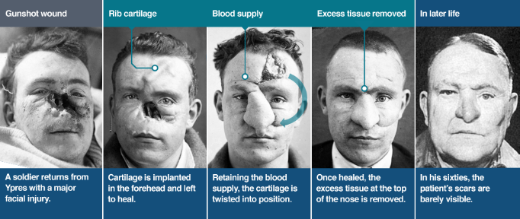Harold Gillies was shocked by the injuries he saw in the field, and requested that the army set up their own plastic surgery unit. Soon after, a specifically-designed hospital was opened in Sidcup. It treated 2,000 patients after the Battle of the Somme in 1916 alone. Here Gillies would do some of his finest work. Previously viewed with suspicion, facial reconstruction became an integral part of the post-war healing process. However, in a world before antibiotics, going under the knife for an experimental form of surgery posed as many risks as the trenches themselves. By November 1915, 7 hospitals in France had specialist areas for dealing with wounds needing plastic surgery. By the end of the war, nearly 12,000 operations had been carried out!