**Paper 1 – Historic Environment Revision**

The British sector of the Western Front:

injuries, treatment and the trenches

** **

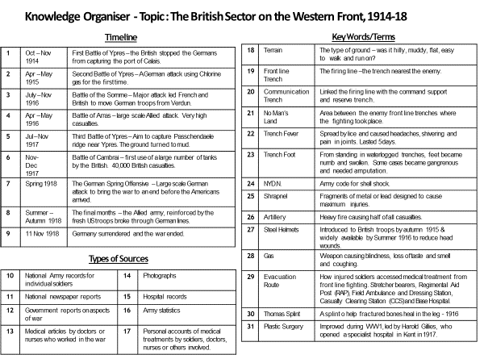

**Student knowledge checklist**

|  |  |  |  |  |
| --- | --- | --- | --- | --- |
| **Key topic** | **Details of topic** | **Have you got notes for this topic?** | **Can you recall at least 3 facts for this topic?** | **Action needed (Catch-up notes? Revision?)** |
| **The British sector of the Western Front, 1914–18: injuries, treatment and the trenches** | | | | |
| 1 The British  sector of the  Western Front,  1914–18:  injuries,  treatment and  the trenches | The context of the British sector of Western Front and the theatre of war in Flanders and northern France: the Ypres salient, the Somme, Arras and Cambrai. |  |  |  |
| The trench system - its construction and organisation, including frontline and support trenches. |  |  |  |
| The use of mines at Hill 60 near Ypres and the expansion of tunnels, caves and quarries at Arras. |  |  |  |
| The significance for medical treatment of the  nature of the terrain and problems of the transport and communications infrastructure. |  |  |  |
| Conditions requiring medical treatment on the Western Front, including the problems of ill health arising from the trench environment. |  |  |  |
| The nature of wounds from rifles and explosives. |  |  |  |
| The problem of shrapnel, wound infection and increased numbers of head injuries. |  |  |  |
| The effects of gas attacks. |  |  |  |
| The work of the RAMC and FANY: The system of transport: stretcher bearers, horse and motor ambulances. |  |  |  |
| The stages of treatment areas: aid post and field ambulance, dressing station, casualty clearing station, base hospital. |  |  |  |
| The role of the underground hospital at Arras. |  |  |  |
| The significance of the Western Front for experiments in new techniques for the treatment of wounds and infection (e.g. saline solution) |  |  |  |
| The significance of the Western Front for the development of the Thomas splint |  |  |  |
| The significance of the Western Front for the use of mobile x-ray units. |  |  |  |
| The significance of the Western Front for the  creation of a blood bank for the Battle of Cambrai |  |  |  |
| The understanding of infection and moves towards aseptic surgery in the early twentieth century (1900s) |  |  |  |
| The development of x-rays from 1895 (Wilhelm Roentgen) |  |  |  |
| The development of blood transfusions and developments in the storage of blood in the early twentieth century (1900s) |  |  |  |
| 2 Knowledge,  selection and  use of sources  for historical  enquiries | Knowledge of national sources relevant to the period and issue, e.g. army records, national newspapers, government reports, medical articles. |  |  |  |
| Knowledge of local sources relevant to the period and issue, e.g. personal accounts, photographs, hospital records, army statistics. |  |  |  |
| Recognition of the strengths and weaknesses of different types of source for specific enquiries. |  |  |  |
| Framing of questions relevant to the pursuit of a specific enquiry. |  |  |  |
| Selection of appropriate sources for specific investigations. |  |  |  |

**Student Question Structure Guide: Paper 1 - Historic Environment**

**The British sector of the Western Front: injuries, treatment and the trenches**

|  |  |  |  |  |  |  |
| --- | --- | --- | --- | --- | --- | --- |
| **Question type** | **Marks / 52** | **AO** | **Time in minutes** | **What is the question asking me to do?** | **How do I get the marks?** | **How do I structure my response?** |
| **Section A: Historic Environment (10%) - The British sector of the Western Front: injuries, treatment and the trenches** | | | | | | |
| Q1 *Describe two features of……* | 4 | AO1 | 5 | -This is simple question; if you have revised you should score full marks.  -There is a writing frame to help you!  - Give **two** pieces of information / aspects about the topic given in the question (*e.g. the effects of poison gas*)  - Then support each point you make with a specific fact / detailed description.  - Include **specific facts and key words:** names, dates statistics and places etc. | Identify (point) and describe (example) **two** features. 1 mark for identifying each feature and 1 for the supporting detail for each. **(1-2 marks x 2)**  **e.g.** *Chlorine gas affected the victim’s breathing* ***(1)****. The victim died quickly from suffocation* ***(1).*** | **2 x Point-Evidence**  **Feature 1**  **Point** - *One feature of….. was*….  **Evidence** – *For example ….. / This was….. / It affected / meant that….*  **Feature 2**  **Point** - *Another feature of….. was*….  **Evidence** – *For example ….. / This was….. / It affected / meant that….* |
| Q2a *How useful are Sources A and B for an enquiry into…* | 8 | AO3 | 15  (spend 5 minutes reading both sources **first**) | -FIRST identify the enquiry: what are you trying to find out about? Underline it in the question.  - Then imagine you are trying to find out about the topic *without* this source; what do you already know about the topic that this source does/doesn’t explore? Are there other problems / details / treatments that are important to the topic?  - Evaluate content (what the source says / shows)  - Evaluate provenance (nature, origin and purpose). Pay close attention to the date and author; is it objective (balanced) and does the date of origin mean the author had all of the facts to give the full picture?  -Use FACTS to show the source fits with your own knowledge: what do you already know about that enquiry topic and how it is accurate / limited for this enquiry?  - You are more likely to gain marks for saying why each source IS useful than ISN’T useful (limitations).  - You DO NOT have to compare the sources or say which is more valuable  -For higher marks, make sure you justify your answers with key words such as ‘**accuracy’**, ‘**limited’**, ‘**incomplete’**, ‘**typicality’** or ‘**provenance’**.  - Give an overall judgement for how useful each source is to show the examiner that you’ve considered all aspects together.  **Key things to remember about NOP**:  - NEVER EVER use the word ‘biased’. This will not gain marks.  - ALL sources are **subjective** in some way because they are written / created by humans. No source is completely **objective**.  - ALL sources are useful in some way  - Subjective sources are VERY useful for giving us an **insight** into certain points of view; don’t ever say ‘it’s useless because it’s biased’.  - If it’s a cartoon / *The Wiper Times* / *Punch*, it is likely to be satirical, critical, **exaggerated**, subjective (one-sided) because they used humour in order to highlight an issue.  - If it’s in a popular magazine / newspaper, then it will also probably reflect public opinion at the time and *may* **sensationalise** for effect.  - Eyewitnesses from the time are not automatically accurate and reliable!  - It doesn’t make sense to say ‘the source lies’!  - If it’s a diary / private letter, it will probably reflect honest opinions.  - Reflections on the past written a while afterwards might be **romanticised** but not necessarily entirely false.  - Remember the author’s circumstances e.g. censorship - a soldier might not include the horrific details of his injury in a letter home. | **Level 3 -** The judgement directly answers the question and assesses utility (usefulness) on the basis of content accuracy and limitations, provenance and typicality. The inferences made from both sources are developed with specific detail and explanation. The inferences are supported and challenged by own knowledge and the student explores provenance in their reasoning. **(6-8 marks)**  **Level 2** -The judgement directly answers the question and the answer begins to assess utility (usefulness) on the basis of content accuracy and limitations, provenance and typicality. A clear inference is made from both sources supported by precisely selected detail from the source or its provenance. The inference is supported/ challenged by own knowledge. **(3-5 marks)**  **Level 1** - A simple judgement supported by general comments about what both sources tells us or who/what/why/when it was made. The answer gives own knowledge but does not link this to how this makes the source useful or not. **(1-2 marks)** | **2 x MAC-NOPE + summary (or SNAPCAT)**  **Paragraph 1: Content accuracy and completeness (MAC)**  **M -** Make a SUPPORTED INFERENCE about the overall **MESSAGE** of the source  One thing you can see/quote from the source and what this shows or suggests (what you can guess at) the overall message of the source is.  *The message of the source is….*  *The content of source A/B makes it useful because it shows… which I can see from ….. / when it states “…….”*  **A** - Use your CONTENT KNOWLEDGE to show how the source **is** **ACCURATE** (true) and TYPICAL  How does it match your own knowledge? How is it **typical** (does it match what most other sources from that time say) of the period / topic? Use PEE to make sure you have supported + explained why this makes it useful.  **Point** - *This is accurate / useful to a historian studying….. / The source’s content is typical of the period ….. / This fits with my contextual knowledge…*  **Evidence** - …. *because indeed I know that… / ….because I further know that.... Indeed…. / For example….*  **Explain -** *So this makes source A/B useful for an enquiry into….because……*  **C** - Use your CONTENT KNOWLEDGE to show how the source is not **COMPLETE** (and therefore limited).  Compare to what you know: what’s missing/omitted and is this deliberate? Is some of it misleading as a result? How does this omission affect the usefulness of the source?  **Point** - *However, source A/B is limited because it does not show / include / leaves out / omits …..*  **Evidence** - *For example…. From my knowledge of the context of the period, I know that…… / For example, it does not include….. / omits the fact that…. / I know that a more typical**experience was….*  **Explain -** *So this makes source A/B one-sided / less useful / limited for telling us ……. because…..*  **Paragraph 2: Provenance (NOPE)**  **NOPE -** State the NATURE, ORIGIN and PURPOSE, then EVALUATE how useful (give strengths and weaknesses)  **Nature –** what type of source is this? (cartoon / photograph etc)  **Origin –** when and how was it created/taken/written?  **Purpose –** Why was it created?  **Evaluate -** How does this affect how useful the source is? Consider how it is and isn’t useful.  ***N*** *- The source is … [WHAT – e.g. propaganda, newspaper, satirical cartoon…]*  ***O*** *- ..written by ….. when…. [WHO, WHEN]*  ***P*** *….with the purpose of….. [WHY]*  ***E*** (strengths and weaknesses) - *This would help a historian understand …… because…… / This is typical of the period because…. / This therefore would reflect …. / However, the provenance also makes it limited because…..*  **REPEAT FOR SECOND SOURCE – MAC NOPE**  **SUMMARY -** *Overall, both sources are useful to a historian studying ….because…. Source A is somewhat useful because, although…. , it would be useful because…. Source B is also useful for….. but limited for…..* |
| Q2b *How could you follow up Source A to find out more about….* | 4 | AO3 | 5 | -Simply follow the sentence starters  -Make sure you are specific in your answers, i.e. go beyond the broadly generic catch-all categories of ‘records’, ‘diaries’, ‘a diary of a soldier’ = 0 marks  -No marks for a question that is notlinked to following up Source A, e.g. ‘*because it would be an interesting question to ask’.*  *-*Possible source ideas:  Army records / statistics of ….. / showing….  National newspapers commenting on…. / reflecting  Government reports that give details about…. /showing….  Medical articles about…  Personal (soldiers, nurses etc) accounts of…. / about….  Photographs of….. / showing….  Hospital records of…. / showing…. | **One mark for each of the following:**  1 = selecting a specific, relevant quote or detail to follow up related to the question.  1 = asking a follow-up question related to the selected detail.  1 = suggesting a relevant and specific type of source (e.g. a diary of a surgeon, newspaper, medical records from the Western Front) which would help to explore the question.  1 = making clear how this suggested source would help explore the question. **(1-4 marks)** | **Follow the sentence starters:**  Detail in Source A that I would follow up:  Select a QUOTE from the source ONLY – do not write anything else.  *I would follow up the comment “……”*  Question I would ask:  Write a question which links to the topic in the question and the quote/detail you have listed in the answer above.  *Why / what / when / where / what / how …..*  What type of source I could use:  Give a **specific** primary source  *XXXX of…. / about….. / reflecting…. / showing…..*  How this might help answer my question:  Explain how your SOURCE could help answer the question you have written  *This would help me to see/understand whether / why ….* |

**THEN AROUND 50 MINUTES TO FINISH THE REST OF THE SECTION B – MEDICINE THROUGH TIME.**

Historical context of medicine in 20th century

Use the information on the next page to complete.

|  |  |  |
| --- | --- | --- |
| **Medical Breakthrough** | **Specific facts** | **Positives/negatives** |
| **Aseptic surgery** |  |  |
| **Development of x-rays** |  |  |
| **Blood transfusion/blood storage** |  |  |

Aseptic Surgery

Lister first used Carbolic Acid to prevent infection in 1865 based on Pasteur’s Germ Theory. By the late 1890’s, Lister’s methods had laid the foundation for aspect surgery. By 1900, most operations were carried out using aseptic surgery

* All medical staff had to wash hands, faces and arms BEFORE entering.
* Rubber gloves and gowns were worn.
* Use of steam sterilisation. A machine called autoclave was invented in 1881 by Chamberland. STERLISED EQUIPMENT USING STEAM.
* Air was sterilised by being pumped over the heating system

Development of x-rays

Development of x-rays was completely accidental by Wilhelm Roentgen in 1895. He was studying the effects of passing an electrical current through a glass tube covered in black paper. He noticed that although everything in the room was dark, a screen about a metre from the equipment began to glow.

1896 radiology departments were opening in a number of hospitals, contributing to advancement of knowledge. First diagnosis based on an x-ray was made by Dr Hall-Edwards at Birmingham General Hospital. However, there were many problems:

* Radiation was 1,500 higher than what is released today. HARMFUL AND LED TO HAIR LOSS OR EXTREME BURNS.
* Taking an x-ray took a long time, 90 minutes for a hand that had to stay still.
* Larger x-ray machines were difficult to move around.

DANGERS DID NOT PREVENT THE USE OF X-RAYS

**Blood transfusions/Blood Storage**

Average human body contained around 5 litres of blood. If people lose too much they could go into shock and die.

* James Blundell did the first experiments in human blood transfusions in 1818 to help women under his medical care who lost blood when they gave birth. Between 1818-29 he carried out 10 transfusions with half surviving.
* Blood had to be used as soon as it became available – The donor would be connected to the recipient of the blood.

|  |  |
| --- | --- |
| **Problem of transfusion** | **Attempted Solution** |
| Blood clots as soon as it leaves the body. This meant that the tubes that transferred blood could become blocked | Attempts to find chemicals that prevented clotting. In 1894, Almoth Wright, concluded that soluble solutions of certain chemicals could prevent clotting. |
| Rejection of the transfused blood | In 1901, Austrian doctor Landsteiner discovered existence of 3 different blood groups, A, B and O. In 1902 AB was also found. This would be used to match a donor and recipients blood type before a transfusion. THIS WAS USED FOR THE FIRST TIME IN 1907 BY OTTENBERG. |
| Infection from unsterilized equipment | Aseptic methods |

**Exam Practice: Describe 2 features of Aseptic Surgery (4 marks)**

**Feature 1: ______________________________________________________________________________________________________________________________________________________________________________________________________________________________________________________________________________________________________________________________________________________________________________________________________________________________________________________________________________________________________________________________________________________________________________________________**

**Feature 2:**

**______________________________________________________________________________________________________________________________________________________________________________________________________________________________________________________________________________________________________________________________________________________________________________________________________________________________________________________________________________________________________________________________________________________________________________________________**

**Context of British Sector of Western Front**

* Britain declared war on Germany on August 4 1914.
* Germany invaded France through Belgium.
* The British government sent the British Expeditionary Force (BEF) to support the French troops in northern France to try to stop the German advance through Belgium.
* The BEF was outnumbered. Although they stopped the German advance briefly, they were ordered to retreat to the River Marne in order to prevent Paris from falling.
* 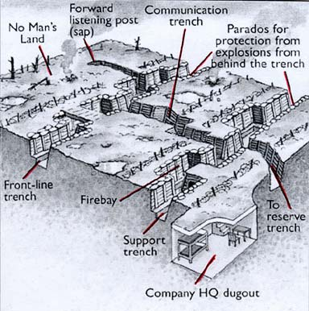After the Battle of the Marne, the German forces pulled back to the River Aisne and it was here that trench warfare began.
* A line of trenches was eventually established all the way from the English Channel in the north, to Switzerland in the south.
* Trenches began to be dug in 1914, however a more complex system was put in place from 1915, generally dug to a depth of about 2.5 metres.

**Task: Note down the purpose of each aspect of the trench (each aspect in the picture)**

|  |  |
| --- | --- |
| **Part of Trench** | **Facts** |
| **Frontline Trench** | Where attacks would be made from |
| **Support Trench** | 80 metres behind front-line. Soldiers would retreat here if frontline came under attack. |
| **Dugouts** | Would be dug into side of trenches where men could take protective cover. |
| **No mans land** | Area between two opposing lines of trenches. |
| **Reserve Trench** | 100 metres behind the support trench. Reserve troops would be mobilised here for a counter-attack if frontline was captured by enemies. |
| **Artillery Emplacements** | Prepared position for certain weapons (guns) |
| **Communication trench** | Ran between other trenches – SO COMMUNICATION COULD HAPPEN. |

**The context of the Western Front**

**2. Identify and write down at least 3 reasons why WW1 accelerated (sped-up) medical advances.**

**3. Can you give three examples of new techniques as a result?**

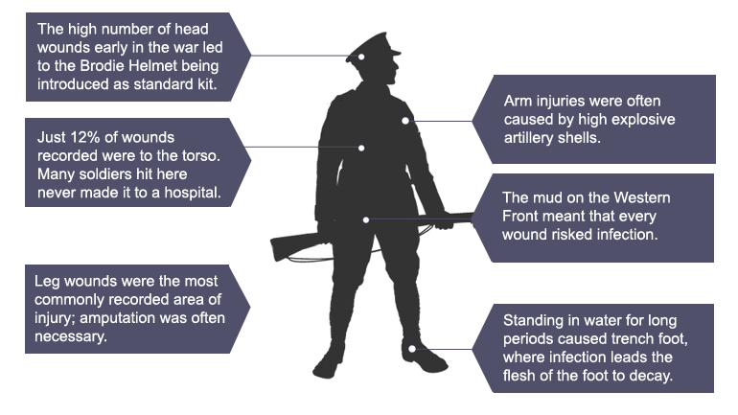

World War One 1914-18 was fought on a scale that had never been experienced before. A million British soldiers died in World War One, and double that amount came home injured. The number and severity of wounds was on a scale that nobody had ever seen before. Even surgeons, being familiar with operations, were not prepared for the terrible wounds that they were expected to treat.

At the Battle of Waterloo in 1815, the main infantry weapon was the muzzle-loading musket, which fired up to four shots a minute. At the Battle of the Somme, just over a century later, machine gunners could fire off 600 rounds a minute. High velocity rounds wreaked havoc in the body, twisting tissue and splintering bone.

Fighting on farmland fertilised by unlearn manure meant that wounds quickly became infected; gangrene was rife. Many surgeons had to unlearn experiences from the South African Conflict (Boer War) (1899-1901) where the climate had been dry and hot. The wet, unsanitary conditions of France presented different problems. Infection was much more likely and disease more evident. Faced with this challenge, new equipment and techniques were invented that, across four years of fighting, would end up saving thousands of lives. British surgeons suffered no shortage of morphine or chloroform during the First World War, so they were able to keep most patients calm and comfortable.

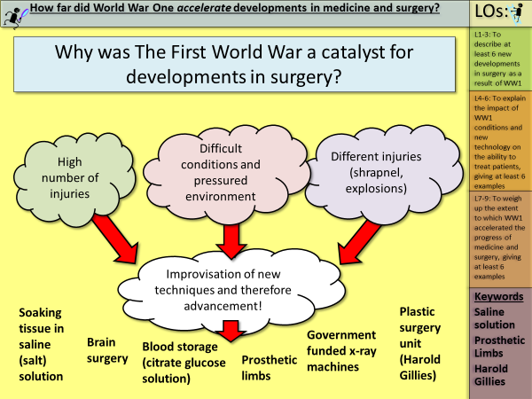

**Key Battles in the British Sector of the Western Front**

|  |  |  |
| --- | --- | --- |
| **Key Event** | **Result** | **Significance** |
| **First Battle of Ypres (1914)**  Autumn of 1914 Germans launched attack on British position to the east and north-east of Ypres. | Britain lost over 50,000 soldiers. BUT THEY HELD ONTO YPRES.  Germans extended some control around the edge of Ypres. | Holding onto Ypres meant that Britain controlled the English Channel ports so their supplies and reinforcements could be provided. |
| **Use of mines at Hill60** Germans captured this man-made hill to south-east of Ypres in Dec 1914, giving them strategic advantage.  British dug tunnels into hills (offensive mining), placed five mines in tunnels and blew top off hill. | By April 1915 Britain took back Hill 60 | Britain took back a strategically important position |
| **Second Battle of Ypres (1915)**  Began straight after the Battle for Hill 60 was finished.  Lasted a month | Britain lost 59,000 men  Germans moved 2 miles closer to the town of Ypres | First time Germans used chlorine gas on Western Front |
| **Battle of Somme (1916)**  Launched 1st July 1916 and aimed to take back land from Germans  Ended November 1916 | Huge casualties. On first day there were 57,000 injuries. 20,000 men died.  Over 400,000 casualties in total. | Use of creeping barrages – artillery launched from the trenches.  Use of tanks in warfare – NOT VERY SUCCESSFUL |
| **Tunnels, caves and quarries at Arras**  In 1916, the British decided to link existing tunnels, caves in quarries in the chalky ground to create an underground network to shelter from German attacks and allow safe movement. | Dug more than 2.5 miles of tunnels in five months. | 25,000 men could be stationed in the tunnels, which contained electric lights, running water, a light railway system and fully functional hospitals. |
| **Battle of Arras (1917)**  April 1917, 24,000 men hiding in tunnels attacks the Germans with aim of breaking through German lines. | Britain advanced 8 miles in first few days but it slowed down by May | Large number of casualties (160,000) |
| **Third Battle of Ypres (1917)**  Throughout June 1917, British prepared for main attack in Battle of Messines (driven Germans off ridge that formed part of Ypres salient).  31st July- launched attack, marching east from Ypres towards Passchendaele. Campaign ended in November. | Advanced 2 miles on first day.  But it began to rain and ground become waterlogged – MANY MEN FELL AND DROWNED.  245,000 BRITISH CASUALTIES | Britain moved edge of salient back by 7 miles. |
| **Battle of Cambrai**  Artillery barrage changed – LESS WARNINGS FOR THE GERMANS  Launched 20th October 1917 | Tanks moved easily across barbed wire and their machine guns were effective. | **FIRST LARGE SCALE USE OF TANKS.** |

**Answer the following questions:**

1. Why do you think treatment in medicine advanced as the war went on?

**______________________________________________________________________________________________________________________________________________________________________________________________________________________________________________________**

1. Why would digging tunnels be important for system of trenches?

**______________________________________________________________________________________________________________________________________________________________________________________________________________________________________________________**

1. What were Britain trying to do in the majority of their attacks during the war?

**______________________________________________________________________________________________________________________________________________________________________________________________________________________________________________________**

1. Which areas were important for Britain to hold onto throughout the war?

**______________________________________________________________________________________________________________________________________________________________________________________________________________________________________________________**

1. What types of injuries do you think occurred based on the openness of battle?

**______________________________________________________________________________________________________________________________________________________________________________________________________________________________________________________**

**Problems with transport and communication – Highlight the problem you think had the biggest impact on transport in communication**

* Constant shelling left landscape full of craters and destroyed many roads.
* Land often waterlogged.
* Had been farmland, so lots of fertiliser in soil. Meant was lots of bacteria that could infect wounds.
* Stretcher bearers exposed to shelling and gunfire. Physically tiring work.
* Beginning war, military leadership decided not to send any motor ambulances but horse-drawn wagons couldn’t cope with numbers casualties.
* Horse-drawn wagons were shaky and often made injuries worse.
* Lack of transport led to soldiers being left to die or taken prisoner.
* Motor vehicles couldn’t operate in muddy terrain.

**Explain WHY it was the biggest problem they faced**

**____________________________________________________________________________________________________________________________________________________________________________________________________________________________________________________________________________________________________________________________________________________________________________________________________________________________________________________________________________________________________________**

**Development of methods to transport the injured**

* Following public appeal for donations, made by *The Times* newspaper, had enough money to buy 512 ambulance wagons within 3 weeks.
* First motor ambulances sent to Western Front in October 1914, as result of work by Red Cross.
* In worst areas, six (rather than the usual two) horses would be used to pull ambulance wagons.
* Wounded men also transported by train or canal in final stage of evacuation to the Base Hospitals on French coast.
* Originally used French good trains but first ambulance train arrived in France in November 1914 (spaces for stretchers). Some later trains even had operating theatres.
* Some of wounded being carried on canals by-passed Base Hospitals to be transferred directly to ships transporting the wounded to Britain.
* Later in the war, some trains sent to France contained operating theatres.
* Canal Barges were used due to the influx of rail travel. They were more comfortable and could bypass Base Hospitals to be transferred back to Britain.

**Explain the best development in the methods of transporting the wounded**

**____________________________________________________________________________________________________________________________________________________________________________________________________________________________________________________________________________________________________________________________________________________________________________________________________________________________________________________________________________________________________________**

**Exam Practice: How useful is Source A for an enquiry into transport and communication on the Western Front?***Use the guidance at the start of this booklet!*

A group of people standing on top of a dirt field

Description generated with very high confidence

Photograph taken by Lieutenant John Brooke, an official photographer for the British army on the Western Front. Taken at the third battle of Ypres in August 1917.

ANNOTTATE THE IMAGE BEFORE YOU START

**Message (Supported Inference)**

**Source A is useful because it shows_____________________________________________________ __________________________________________________________________________________________________________________________________________________________________________________________________________________________________________________________________________________________________________________________________________________________________________________________________________________________________________________________________________________________________________________________________________________________________________________________________________________________________________________________________________________________________________________________________________________________________**

**Accuracy & Typicality (+ Own knowledge to support)**

**________________________________________________________________________________________________________________________________________________________________________________________________________________________________________________________________________________________________________________________________________________________________________________________________________________________________________________________________________________________________________________________________________________________________________________________________________________________________________________________________________________**

**Completeness (+ Own knowledge to support) __________________________________________________________________________________________________________________________________________________________________________________________________________________________________________________________________________________________________________________________________________________________________________________________________________________________**

**NOPE**

**________________________________________________________________________________________________________________________________________________________________________________________________________________________________________________________________________________________________________________________________________________________________________________________________________________________________________________________________________________________________________________________________________________________________________________________________________________________________________________________________________________**

**Main medical problems on the Western Front**

**Shells and Shrapnel**

* Responsible for 58% of wounds on the Western Front.
* When a shell exploded it could kill or injure immediately.
* Shell explosion scattered shrapnel (FRAGMENTS OF METAL) This could cause injury
* 60% of injury was to arms and legs
* Bullets responsible for 39% of wounds – They could fracture bones and pierce organs
* Brodie helmets used to ricochet bullets.

**Trench foot**

* Painful swelling of feet caused by standing in cold mud and water.
* Second stage of TF, gangrene set in. FOOT DECOMPOSES.
* Prevention was key, rubbing whale oil into feet and keeping feet dry and regular change socks.
* Amputation used if second stage occurred.

**Trench fever**

* Flu-like symptoms
* Effected half a million on Western Front.
* Identified that contact with LICE caused it.
* Delousing stations set up to prevent it.

**Shellshock**

* Tiredness, headaches, nightmares, loss of speech, complete mental breakdown in some cases.
* 80,000 soldiers experienced it.
* NOT WELL UNDERSTOOD AT THE TIME.
* Would have possibly led to treatment back in Britain.
* Some soldiers who suffered with Shellshock accused of being cowards.

**Infections**

* Shrapnel and bullets carried fabric from clothes into wound. Soil full of bacteria from fertiliser use.
* Soil contained bacteria for tetanus and gas gangrene (produces gas in gangrenous wounds).
* Use of anti-tetanus injections from end 1914 reduced impact tetanus.
* No cure for gas gangrene- bacteria spread quickly and could kill a person in one day.

**Gas Attacks**

* Gas attacks caused great panic and fear, shown in poetry written after the war.
* NOT A MAJOR CAUSE OF DEATH. Only 6,000 dying as a result of it.
* Gas masks were used from 1915, they developed over time.
* Chlorine used in 1915, led to death by suffocation. Before gas masks were given in 1915, soldiers would soak cotton pads with urine and press them to their faces to stop gas from entering their lungs.
* Britain used chlorine in 1915 however the wind changed and pushed the gas back to the British.
* Phosgene Gas – Using end of 1915 near Ypres. Faster acting than Chlorine and could kill within 2 days.
* Mustard Gas – First used in 1917 – Odourless gas that would work within 12 hours. Caused internal and external blisters.

Task: Create a set of revision cards (cut up paper is fine) with at least one specific fact per condition. *E.g. Gas – Chlorine 1915 – Phosgene 1915 – Mustard 1917 – Only 6000.*

**Exam Practice – How useful are Sources B, C for an enquiry into the impact of gas attacks on the Western Front**

Supported inference

Content accuracy **(+ Own knowledge to support)**

Provenance (NOPE)

Source B – **From Dulce et Decorum Est. A poem written by Wilfred Owen in 1917 whilst he was being treated for Shellshock. He serves on the Western Front in 1916-17 and returned in 1918, where he was killed in action shortly before the end of the war. The text in the title and at the end of the poem is in Latin and means ‘it is sweet and fitting to die for one’s country’**

Gas! Gas! Quick, boys! – An ecstasy of fumbling,   
Fitting the clumsy helmets just in time;   
But someone still was yelling out and stumbling,   
And flound'ring like a man in fire or lime . . .   
Dim, through the misty panes and thick green light,   
As under a green sea, I saw him drowning.   
In all my dreams, before my helpless sight,   
He plunges at me, guttering, choking, drowning.   
If in some smothering dreams you too could pace   
Behind the wagon that we flung him in,   
And watch the white eyes writhing in his face,   
His hanging face, like a devil's sick of sin;   
If you could hear, at every jolt, the blood   
Come gargling from the froth-corrupted lungs,   
Obscene as cancer, bitter as the cud    
Of vile, incurable sores on innocent tongues,   
My friend, you would not tell with such high zest    
To children ardent for some desperate glory,   
The old Lie; Dulce et Decorum est   
Pro patria mori

Supported inference

Content accuracy **(+ Own knowledge to support)**

Provenance (NOPE)

**Source C – From the notebook of Lance Sergeant Elmer Cotton, who serves in the 5th Northumberland Fusiliers in 1915. He is describing the effects of a chlorine gas attack**

It produces a flooding of the lungs. It is the equivalent to drowning, only on fry land. The effects are these – a splitting headache and a terrific thirst (but to drink water is instant death), a knife-edge pain in the lungs and the coughing up of a greenish froth off the stomach and the lungs, finally resulting in death. It is a fiendish death to die.

**Exam Practice – How useful are Sources B, C for an enquiry into the impact of gas attacks on the Western Front**

**_____________________________________________________________________________________________________________________________________________________________________________________________________________________________________________________________________________________________________________________________________________________________________________________________________________________________________________________________________________________________________________________________________________________________________________________________________________________________________________________________________________________________________________________________________________________________________________________________________________________________________________________________________________________________________________________________________________________________________________________________________________________________________________________________________________________________________________________________________________________________________________________________________________________________________________________________________________________________________________________________________________________________________________________________________________________________________________________________________________________________________________________________________________________________________________________________________________________________________________________________________________________________________________________________________________________________________________________________________________________________________________________________________________________________________________________________________________________________________________________________________________________________________________________________________________________________________________________________________________________________________________________________________________________________________________________________________________________________________________________________________________________________________________________________________________________________________________________________________________________________________________________________________________________________________________________________________________________________________________________________________________________________________________________________________________________________________________________________________________________________________________________________________________________________________________________________________________________________________________________________________________________________________________________________________________________________________________________________________________________________________________________________________________________________________________________________________________________________________________________________**

Exam Practice: How could you follow up Source B to find out more about the effects of gas attacks?

1. Which detail would you follow up? __________________________________________________________________________________________________________________________________________________________________________________________________________________________________________________________________________________________________________________________________________________________________________________________________________________________________________________________________
2. What question would you ask? _____________________________________________________________________________________________________________________________________________________________________________________________________________________________________________________________________________________________________________________________________________________________________________________________________________________________________________________________________________________________________________________________________________
3. What type of source would you want to answer your question? _____________________________________________________________________________________________________________________________________________________________________________________________________________________________________________________________________________________________________________________________________________________________________________________________________________________________________________________________________________________________________________________________________________
4. Why might that source help you answer your question?

_________________________________________________________________________________________________________________________________________________________________________________________________________________________________________________________________________________________________________________________________________________________________________________________________________________________________________________________________

|  |  |  |  |  |  |
| --- | --- | --- | --- | --- | --- |
| **Stage** | | **Where were they?** | **Who worked there?** | **What was their role/purpose?** | **How were soldiers transported to them?** |
| **1: Regimental Aid Post (RAP)** |  | |  |  |  |
| **2: Dressing Stations (ADS and MDS)** |  | |  |  |  |
| **3: Casualty Clearing Stations (CCS)** |  | |  |  |  |
| **4: Base Hospitals** |  | |  |  |  |

**Work of RAMC and FANY -** The system of transport and the stages of treatment

**Key Terms:**

**RAMC: Royal Army Medical Corps FANY: First Aid Nursing Yeomanry**

**CCS: Casualty Clearing Stations Base hospitals**

**ADS & MDS: Dressing stations RAP: Regimental Aid Posts**

Because of the large number of casualties, it was essential that there was an efficient system to get the wounded from the frontline to a safe area where they could be treated. This system became known as the chain of evacuation.

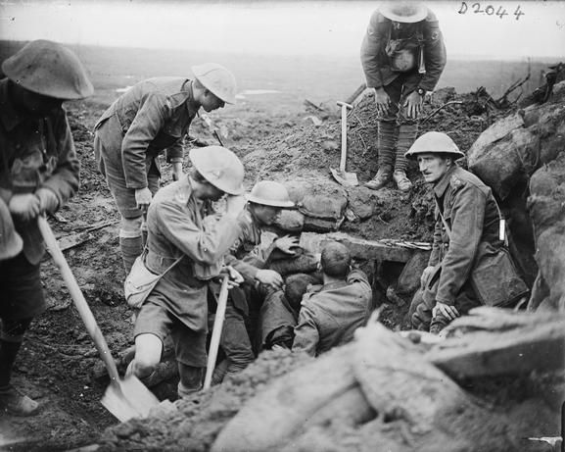**Stage 1: Regimental Aid Post (RAP)**

The RAP was generally located within 200m of the frontline, in communication trenches or deserted buildings. It was staffed by a Regimental Medical Officer, with some help from stretcher bearers with first-aid knowledge. Wounded soldiers would either walk in themselves or be carried in by other soldiers.

The purpose of the RAP was to give immediate first aid and to get as many men back to the fighting as possible. It could not deal with serious injuries. These had to be moved to the next stage in the chain of evacuation.

**Stage 2: Dressing Stations (ADS and MDS)**

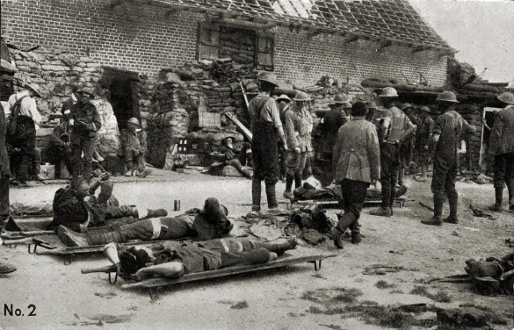In theory, there should have been an Advanced Dressing Station (ADS) about 400m from the RAP and a Main Dressing Station (MDS) a further half a mile back. In practice, this was often not the case and there may only have been one Dressing Station. Where possible, the Dressing Stations were located in abandoned buildings, dug-outs or bunkers, in order to offer protection from enemy shelling. Where these were not available, tents would be used.

Each dressing station would be staffed by ten medical officers, plus medical orderlies and stretcher bearers of the RAMC from a unit known as the Field Ambulance. From 1915, there were also some nurses available for this part of the chain of evacuation.

To get to the Dressing Station, men would either walk, if they were able to do so, or be carried in by stretcher in stages.

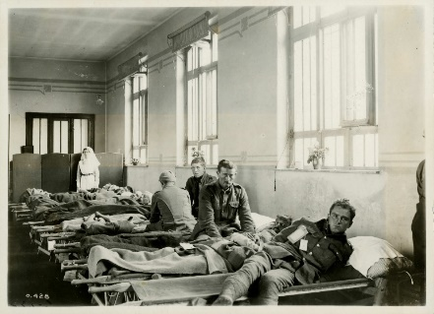The Field Ambulance units did not have the facilities to tend to wounded men for more than a week and in theory could only deal with 150 wounded at a time (there would be considerably more during major battles). Men who had been treated would either be returned to their units if they were fit enough to fight, or they would be moved on to the next phase of the chain of evacuation by horse or motor ambulance.

**Stage 3: Casualty Clearing Stations (CCS)**

Casualty Clearing Stations were located a sufficient distance from the frontline to provide some safety against attack, but close enough to be accessible by ambulance wagons. They were set up in buildings such as factories or schools and were often located near to a railway line to allow the next stage of the chain of evacuation to take place quickly.

When wounded soldiers arrived here, they were divided into three groups. This system was called triage, from the French word for sorting or selecting. Triage helped medical staff make decisions about treatment. The three categories were:

1. The walking wounded. Men who could be patched up and returned to fighting.
2. Those in need of hospital treatment. Once treated for immediate life-threatening injuries, they would be transported to a Base Hospital.
3. Those with no chance of recovery. They would be made comfortable.

[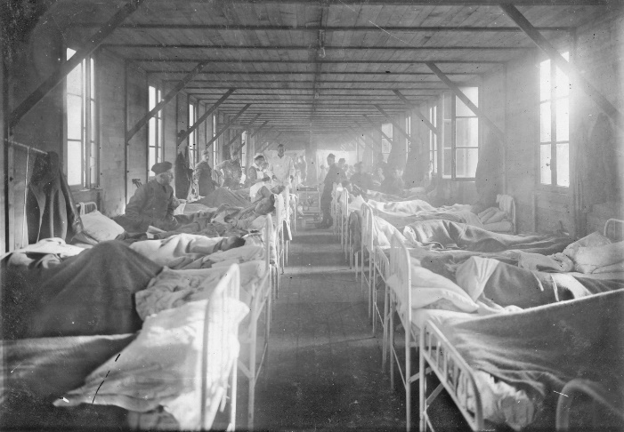](http://www.google.co.uk/url?sa=i&rct=j&q=&esrc=s&source=images&cd=&cad=rja&uact=8&ved=0ahUKEwiI4dOz8L7RAhVF7hoKHexPAkMQjRwIBw&url=http://www.gpembertononline.co.uk/Legion/ww1Wounded.html&bvm=bv.144224172,d.ZGg&psig=AFQjCNE92BdtUCPFozFJ80Djun10APA58Q&ust=1484388541934860)**Stage 4: Base Hospitals**

Base Hospitals on the Western Front were located near the French and Belgian coast, so that the wounded men who were treated there would be close to the ports, from which they could be transported home to Britain. Men were treated in the hospital until they could be returned to Britain for further treatment or were fit enough to return to the fighting.

As the war progressed, Casualty Clearing Stations played an increasingly important role in dealing with wounds instead of Base Hospitals. It had become clear that if contaminated wounds were not dealt with quickly, wounded men were more likely to develop gangrene. In turn, Base Hospitals became increasingly responsible for continuing treatment that was begun in the CCSs, before men were either returned to the frontline or transported back to Britain.

Base Hospitals also experimented with new techniques which, once successful, were used in the CCSs. For example, by dividing patients up into different wards according to their wounds, and by allocating doctors to a specialised ward, it was possible for doctors to become expert in the treatment of particular wounds.

However, when the Germans launched an attack in the spring of 1918, pushing back the frontline, many CCSs had to be pushed back and the Base Hospitals again took over much of the surgery.

**Task: Complete the cloze exercise explaining the work of FANY.**

The first six FANYs arrived in _____________ on 27 October 1914. However, the British would not make use of them so they devoted their energies to helping French and _______________ troops.

Finally, in January 1916, the British army decided to allow FANYs to drive __________________. They became the first women to carry out this role, replacing British Red Cross male ambulance drivers. They were used to transport _________________ troops by ambulance in the Calais region. Although there were never more than 450 FANYs in France, they did open the way for other women who were attached to other organisations, such as the Voluntary Aid Detachments (VADs), to participate in the ________________.

FANY did things other than driving ambulances to support the soldiers on the Western Front. They drove supplies such as food and ____________ to the frontline. They had a mobile bath unit which provided baths to the soldiers in water heated by the power from the van’s ______________. They also set up cinemas to help the ____________ of soldiers.

***morale frontline Belgian clothes wounded ambulances engine France***

**Exam Practice How useful in Source A for an enquiry into the work carried out by FANY.**

Annotate the source (thinking MAC NOPE)

**SOURCE A:** *From Pat Beauchamp’s autobiography, Fanny Goes to War, published in 1919. Beauchamp first worked as a nurse, bringing in the wounded from the trenches, and from 1916 as an ambulance driver. Here she is writing about an account of FANYs from an English newspaper.*

The following is an extract from an account by Mr Beach Thomas in a leading daily:

“Our Yeomanry nurses who, among other work, drive, clean, and manage their own ambulance cars… have done prodigies (wonders) along the Belgian front. One of their latest activities has been to devise and work a peripatetic (travelling) bath… Ten collapsible baths are packed into a motor car which circulates behind the lines. The water is heated by the engine in a cistern in the interior of the car and offers the luxury of a hot bath to several score men.”

______________________________________________________________________________________________________________________________________________________________________________________________________________________________________________________________________________________________________________________________________________________________________________________________________________________________________________________________________________________________________________________________________________________________________________________________________________________________________________________________________________________________________________________________________________________________________________________________________________________________________________________________________________________________________________________________________________________________________________________________________________________________________________________________________________________________________________________________________________________________________________________________________________________________________________________________________________________________________________________________________________________________________________________________________________________________________________________________________________________________________________________________________________________________________________________________________________________________________________________________________________________________________________________________________________________________________________________________________________________________________________________________________________________________________________________________________________________________

**Underground hospital at Arras**

In November 1916, tunnelling began under the town of Arras. In 800m of tunnels, a fully working hospital was created so close to the frontline that it was, in reality, a Dressing Station. From here, wounded soldiers would move through the chain of evacuation. It was sometimes called Thompson’s Cave after the RAMC officer who was responsible for equipping it. The hospital was abandoned during the Battle of Arras in 1917, when it was hit by a shell which destroyed the water supply.

**What facilities were available?**

* Reserve stretchers
* RAMC office headquarters
* Operation theatre
* Mortuary
* Water stand pump
* Waiting wards
* Able to accommodate 700 soldiers at a time.

***Exam Practice:*** *How could you follow up Source A to find out more about Dressing Stations on the Western Front*

**Source A: General Macpherson, published in 1924. He was on the WF from 1914 and in charge of the RAMC from 1916-18. He wrote this history based on official records which he had access to. He is writing about the underground hospital in Arras**

Dressing Stations were established in caves, cellars and basements of buildings, protected as strongly as possible with sandbags on the outskirts of the town. The chief of these was in a large subterranean cave, from which stone had been excavated for building the town in the 16th century. It was close to the 3rd Division trenches and only 800 yards from the frontline. Two entrances for stretchers were tunnelled into it from the communication trenches, and an exit tunnelled out from the back into Rue St Quentin, where an approach was constructed for ambulance cars. This cave was fitted with electric light and a piped water supply and was able to accommodate 700 wounded on stretchers in two tiers.

Detail in Source A that I would follow up: _______________________________________________

__________________________________________________________________________________

Question that I would ask: ___________________________________________________________

__________________________________________________________________________________

What type of source I could use: _______________________________________________________

__________________________________________________________________________________

How this might help answer my question: ________________________________________________

____________________________________________________________________________________________________________________________________________________________________

**New techniques in treatment of wounds and infection**

**Wound excision or debridement** – this was the cutting away of dead, damaged and infected tissue from around the site of the wound. It needed to be done as soon as possible because infection could spread quickly. After excision, the wound needed to be closed by stitching. If any infected tissue had not been removed before the wound was stitched, the infection would spread again.

**What injury or infection could this method help? How successful do you think it could be?**

**_______________________________________________________________________________________________________________________________________________________________________________________________________________________________________________________________________________________________________________________________________________________________________________________**

**Amputation** – if neither wound excision, nor the use of antiseptics succeeded in halting the spread of infection, the only way to deal with it was through the amputation of wounded limbs. By 1918, 240,000 men had lost limbs – many of them because it was the only way to prevent the spread of infection and death.

**What injury or infection could this method help? How successful do you think it could be?**

**_______________________________________________________________________________________________________________________________________________________________________________________________________________________________________________________________________________________________________________________________________________________________________________________**

**The Carrel-Dakin Method** – antiseptics, such as carbolic lotion, were inefficient when treating gas gangrene. By 1917, it was agreed that the Carrel-Dakin method, which involved using a sterilised salt solution in the wound through a tube, was the most effective alternative. The solution only lasted for six hours and so had to be made as it was needed. This could be difficult, especially when large numbers of wounded men needed treatment at the same time.

**What injury or infection could this method help? How successful do you think it could be?**

**_______________________________________________________________________________________________________________________________________________________________________________________________________________________________________________________________________________________________________________________________________________________________________________________**

Using the key underneath source B, highlight information in the sources that says treatment of wounds was effective in one colour. In another colour, highlight treatment for wounds that was ineffective.

🞏 Treatment of wounds was effective

🞏 Treatment of wounds was ineffective

**SOURCE A**

***From the diary of B.C. Jones, 1915-6. Jones served with the Royal Field Artillery in France from the start of the war until he was wounded in 1915.***

7 December. A German shell hit the dugout of our telephone pit. I remembered no more until I woke up in Bethune Casualty Clearing Station Number 33, where I find I have been severely wounded. Left hand blown off, left arm ripped up 12 inches. Scalp wound 6 inches, wound over side of knee (left) 5 inches.

9 December. Operation on upper arm for gangrene (successful).

12 December. I remain here for 8 days then removed to St Omer by hospital barge, very comfortable. I am then removed by train to Etaples. I am then sent to England on the Hospital Ship. Return to Nottingham where I am in bed until the end of February.

3 June 1916. I am eventually transferred to Brighton where I am operated on and re-amputated. Awaiting Roehampton for artificial limb.

**SOURCE B**

*From Ward Muir’s Observations of an Orderly, published in 1917. Muir was a Lance Corporal in the RAMC and worked in a hospital in London that received patients from the Western Front at the end of the chain of evacuation.*

The majority of stretcher-cases… reached us in by no means a desperate state, for, as I say, they seldom come to England without having been treated previously at a base abroad (except during the periods of heavy fighting. And it is remarkable how often the patient refuses help in getting off the stretcher on to the bed.

**Developments in blood transfusions and storage**

**1915** Use of blood transfusions in British sector on Western Front pioneered by Canadian doctor, Lawrence Bruce Robertson, in the Base Hospital at Boulogne. He used the indirect method, where a syringe and tube was used to transfer the donor blood to the patient.

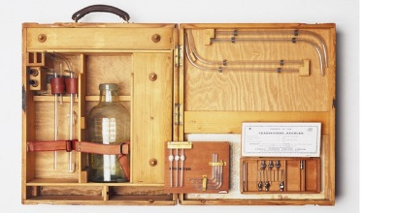Geoffrey Keynes, a British doctor and lieutenant in the RAMC, designed a portable blood transfusion kit that was used to provide transfusions close to the frontline in a Casualty Clearing Station. However, it could not use stored blood as there was no available refrigeration. He added a device to the blood bottle which helped prevent clotting. Keynes claimed that his work saved countless lives.

American doctor, Richard Lewisohn discovered that by adding sodium citrate to blood, the need for donor-to-donor transfusion was removed. Patients no longer needed to be in the same room as the donor.

Richard Weil discovered that blood with sodium citrate could be refrigerated and stored for up to two days.

**1916** Francis Rous and James Turner found that by adding a citrate glucose solution to blood, it could be stored for a much longer period- up to four weeks.

**1917** Blood transfusions were also being administered in the Casualty Clearing Stations as a routine measure in the treatment of shock.

Before the Battle of Cambrai, Oswald Hope Robertson, a British-born American doctor, stored 22 units of universal donor blood in glass bottles. He built a carrying case packed with ice and sawdust and called this a “blood depot”. During the battle, he treated 20 severely wounded Canadian soldiers (none of whom were expected to survive) with 26 day old blood. 11 of the 20 men survived. This was the first time that stored blood had been used to treat soldiers in shock.

**Task:** Find evidence of the following two factors in the above timeline:

**🞏 Developments in blood transfusion process.**

**🞏 Developments in blood storage.**

**Task :** A number of key individuals contributed towards that development of blood transfusions and storage. Who do you think made the greatest contribution and why?

____________________________________________________________________________________________________________________________________________________________________________________________________________________________________________________________________________________________________________

**The Thomas Splint**

* Broken bones were caused by gunshot or shrapnel wounds.
* Major bleeding would be the cause of death if the leg was not kept rigid.
* Many who survived before the Splint would have had their leg amputated.
* Robert Jones worked with his uncle, High Thomas at the end of 19th century, in his medical practice where Thomas had developed a splint to stop joints from moving. When the war started he offered his service. In December 1915, Thomas was sent to Boulogne to instruct medical practitioners how to use the Thomas split. Survival rate went from 20% to 82%

**Use of mobile X-rays**

* X-rays used from start of war to identify shell fragments and bullets in wounds.
* Two x-rays would be taken from different angles and this helped surgeon to identify the location of shrapnel and bullets.
* THERE WERE SOME PROBLEMS

1. X-rays could not detect all objects in the body. E.G Fragments of clothing.
2. Length of time men had to remain still caused problems.
3. Tubes used in x-ray machines were fragile and overheated quite quickly. Could only be used for around one hour at a time. The improvements on this only happened in 1917, when the US became involved in the war.

**Exam practice: How could you follow up Source C to find out more about x-rays on the Western Front? (4)**

**Source C – From Radiography and Radiotherapeutics, by Robert Knox, published in 1917. This was a textbook on the use of x-rays written by a British doctor.**

The need for portable outfits in connections with the war has led to a great development in the provision of motor wagons containing complete x-ray apparatus with all accessories. The mechanism used for driving the wagon i.e. the motor is coupled with a powerful dynamo which delivers a continuous current.

**Detail in Source C that I would follow up**: _______________________________________________

__________________________________________________________________________________

**Question that I would ask**: ___________________________________________________________

__________________________________________________________________________________

**What type of source I could use**: _______________________________________________________

__________________________________________________________________________________

**How this might help answer my question:** _______________________________________________

____________________________________________________________________________________________________________________________________________________________________

**Head Injuries**

**Task:** Use the information provided to summarise the achievements of these two men:

|  |  |
| --- | --- |
| **Key Individual** | **Achievements** |
| **Brain Surgery** | http://www.oocities.org/wrcushing/h/Cushing.jpg**Harvey Cushing (American neurosurgeon)** | Brain injuries were likely to prove fatal at the start of war because:   1. Infection 2. Moving men through the Chain of evacuation was difficult. 3. Very few doctors who had experience in neurosurgery.   Cushing developed new techniques in brain surgery on Western Front. He experimented with magnets to remove shrapnel from the brain. He also used local anaesthetic rather than general. LOCAL MEANT THE BRAIN DID NOT SWELL DURING OPERATION.  Operated on 45 patients in 1917 with survival rate of 71%  CCS became chosen as centres for brain surgery.  Patients remained there for 3 weeks after surgery  All head wounds were focused on and examined in more depth  Summary: _______________________________________________  ________________________________________________________  ________________________________________________________  ________________________________________________________  ________________________________________________________ |
| **Plastic Surgery** | https://static.standard.co.uk/s3fs-public/styles/story_medium/public/thumbnails/image/2014/08/26/09/31littlestitches2608b.jpg**Harold Gillies (New Zealand doctor specialising in ear, nose and throat surgery)** | Developed plastic surgery.  Gillies was sent to Western Front in 1915.  Head injuries that did not kill could cause severe disfigurement. Gillies became interested in facial reconstruction.  Men who needed this were returned to Britain. The key hospital who provided this care was Queen’s Hospital in Kent.  By the end of the war, nearly 12,000 plastic surgery operations were carried out.  Summary: _______________________________________________  ________________________________________________________  ________________________________________________________  ________________________________________________________  ________________________________________________________ |

SUMMARY TASKS

Use the infromationon the next few pages t complete the table

|  |  |  |  |
| --- | --- | --- | --- |
| Area of medicine/ surgery | **What problem did it tackle? (What was the problem before WW1?)** | What developments were brought about by war and why they were necessary? | How effective were these developments? Try to give EVIDENCE (facts and figures) to show the IMPACT of the development on casualty rates. |
| **Blood transfusion and storage (first blood bank at Cambrai)** |  |  |  |
| **Use of mobile X-ray machines** |  |  |  |
| **Plastic surgery** |  |  |  |
| **New techniques in the treatment of wounds and infection** |  |  |  |
| **Broken limbs, amputations and the splints** |  |  |  |
| **Head injuries and brain surgery** |  |  |  |

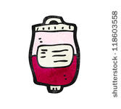The wounds inflicted on millions of soldiers ***accelerated*** the development of new medical techniques and inventions.

**Blood transfusion and storage (first blood bank at Cambrai)**

The British Army began the routine use of blood transfusion in treating wounded soldiers. However, the donor had to be present, as the blood was pumped to the recipient. They could not store blood without it clotting. The demand for blood during WW1 was high therefore people needed to find a way to store blood.

In 1901, Karl Landsteiner identified blood types, which meant that they could prevent recipient bodies rejecting donated blood. Then, in 1915, Richard Lewisohn (US doctor) discovered that adding sodium citrate stopped blood clotting and, in 1916, Francis Rous and James Turner found that adding a citrate glucose solution allowed the blood to be stored for longer periods without the cells deteriorating as quickly.

But it was a US Army doctor, Captain Oswald Robertson, who realised the need to stockpile blood before casualties arrived. During the Battle of Cambrai in 1917, he established the first blood bank on the Western Front, using sodium citrate to prevent the blood from coagulating (clotting) and becoming unusable and using Type O blood, which can safely be given to all patients (aka ‘universal’ blood type). Blood was kept on ice for up to 28 days and then transported to casualty clearing stations for use in life-saving surgery where it was needed most.

**Use of mobile X-ray machines**

MC900324410[1]

World War One made the use of Roentgen’s X-rays (discovered in 1895) far more common as surgeons needed to locate bullets and shrapnel lodged deep within flesh. Governments ordered X-ray machines to be built for the hospitals of the Western Front.

MC900078623[1]**New techniques in the treatment of wounds and infection**

The use of explosive weapons meant that many soldiers suffered deep wounds. These wounds often got infected by clothing or shrapnel. Surgeons found that the best way to tackle this type of injury was to cut away infected tissue and soak with a saline (salt) solution.

There was also progress in the speed of treatment. From January 1915 the British military medical machine moved closer to the front line. Casualty clearing stations were now better equipped and, crucially, more surgeons were closer to the battlefield. There were now fewer delays in administering potentially life-saving treatment. Soldiers with wounds that would have been fatal were now more likely to survive.

**Broken limbs, amputations and the splint**

MC900332990[1]Between 1914 and 1921 over 41,000 men in the British armed forces lost a limb. Advances in prosthetic limbs included the use of light metal alloys and mechanisms. Technological innovations developed in the First World War had a massive impact on survival rates, such as the Thomas splint, named after pioneering Welsh surgeon Hugh Owen Thomas, which secured a broken leg. At the beginning of the war 80% of all soldiers with a broken femur died. By 1916, 80% of soldiers with this injury survived.

**Head injuries and brain surgery**

MC900055181[1]

Before the war many surgeons stayed away from working on the brain as it was too complicated and risky. However the war caused huge numbers of brain injuries and surgeons became more willing to experiment. For example: using rubber bands to control bleeding, saline solution to wash out pulped brain and even magnets were used to pull out metal fragments

**Plastic surgery**

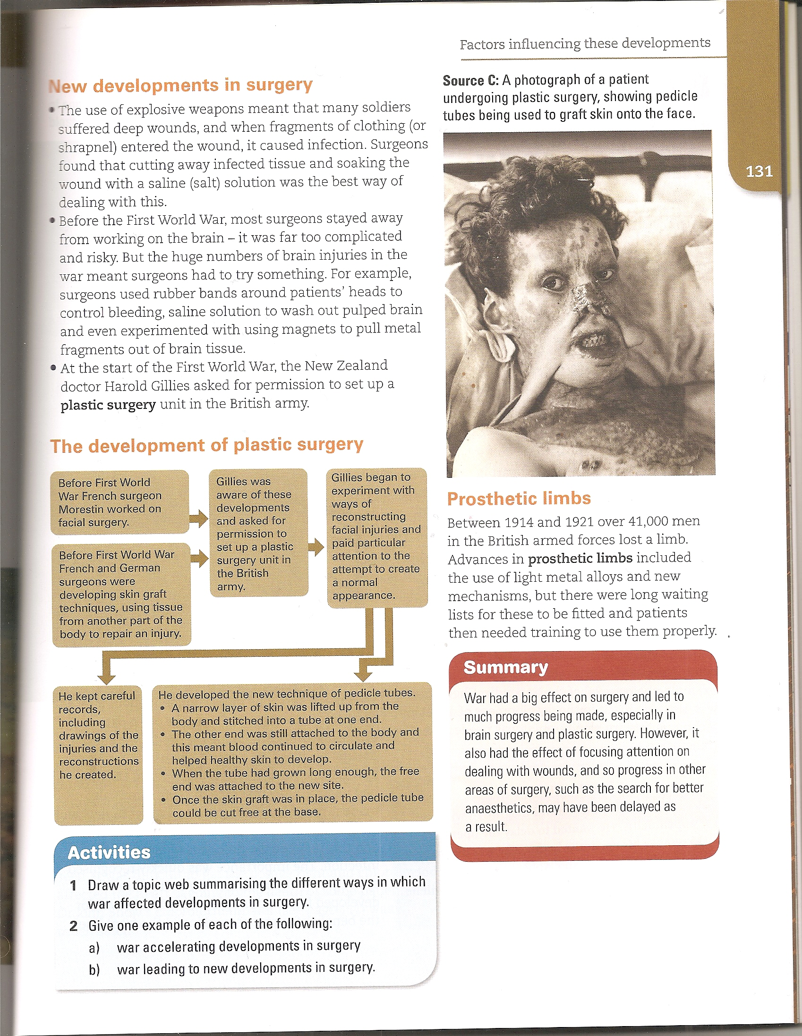

For many of those lucky enough to return, the wounds they had suffered in Europe would leave them permanently disfigured. The biggest killer on the battlefield and the cause of many facial injuries was shrapnel. Unlike the straight-line wounds inflicted by bullets, the twisted metal shards produced from a shrapnel blast could rip a face off. Not only that, but the shrapnel's shape would often drag clothing and dirt into the wound. Improved medical care meant that more injured soldiers could be kept alive, but urgently dealing with such devastating injuries was a new challenge.  
  
Harold Gillies was the man the British Army tasked with fixing these grisly wounds. Gillies was shocked by the injuries he saw in the field, and requested that the army set up their own plastic surgery unit. Soon after, a specifically-designed hospital was opened in Sidcup. It treated 2,000 patients after the Battle of the Somme alone. Here Gillies would do some of his finest work. Previously viewed with suspicion, facial reconstruction became an integral part of the post-war healing process. However, in a world before antibiotics, going under the knife for an experimental form of surgery posed as many risks as the trenches themselves.

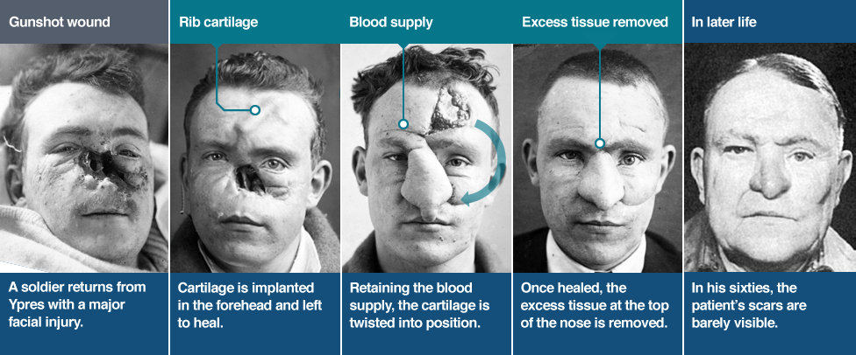

A series of images showing the stages of facial reconstruction. 

**Blood transfusion heads and tails**

The column on the left shows different stages in the development of blood transfusions. Match each statement with a comment from the right-hand column that explains its significance.

|  |  |
| --- | --- |
| The development of blood transfusions | Significance |
| 1  Blood loss was a major problem in surgery because… | A  … he had identified different blood groups. |
| 2  As the problems of pain and infection were overcome… | B  … there was no way to replace the blood lost when the patient bled heavily and transfusions usually failed. |
| 3  Clamps and ligatures were used to restrict the flow of blood, but… | C  … the blood groups of the patient and the donor need to match for a transfusion to be successful. |
| 4  In 1901, Karl Landsteiner announced that… | D  … the donor needed to be present. |
| 5  Scientists and surgeons now understood that… | E  … the first blood depot was set up, using Type O blood, which can safely be given to all patients. |
| 6  Transfusions could now be carried out, but… | F  … a person dies if blood does not circulate around the body, taking oxygen to different parts and organs. |
| 7  In 1915, it was found that adding sodium citrate stopped blood clotting and, in 1916, Francis Rous and James Turner found that… | G  … more complex operations were attempted, but blood loss remained a problem. |
| 8 During the Battle of Cambrai in 1917… | H  … adding a citrate glucose solution allowed the blood to be stored for longer periods without the cells deteriorating as quickly. |

**Recall – complete the practice questions on paper**

1. Describe **2 features** of the following topics (2 paragraphs per topic)

Trench system

Stretcher bearers

Ambulances

Trench foot

Gas attacks

RAMC

FANY

Dressing stations

Casualty Clearing Stations

Base Hospitals

The underground hospital at Arras

The Thomas splint

Blood transfusions

Plastic surgery

1. **List and explain the SIZ key battles in the First World War and the types of medical advances shown during them. Write a paragraph per battle.**
2. **What were the problems with the following transports and communications.** (2 paragraphs per topic)

Horse-drawn and motor ambulances

Train, barge and ship ambulances

1. **What were the main symptoms of Trench Foot?** (2 paragraphs)
2. **What were the attempted solutions to deal with Trench Foot?** (2 paragraphs)
3. **What were the main symptoms of Trench fever?** (2 paragraphs)
4. **What were the attempted solutions to deal with Trench fever?** (2 paragraphs)
5. **What were the main symptoms of Shellshock?** (2 paragraphs)
6. **What were the attempted solutions to deal with Shellshock?** (2 paragraphs)
7. **How did soldiers attempt to prevent injuries from shrapnel, wound infection and head injuries?** (2 paragraphs)
8. **What were the three types of gas used to attack? What were the effects of them?** (2 paragraphs)
9. **What were the main stages of the chain of evacuation?** (3-4 paragraphs)
10. **Write 5 bullet points about the following: RAP, ADS and MDS, CCS**
11. **How did the FANY help with the treatment of soldiers? (2 paragraphs)**
12. **Explain the following treatments used to prevent infections from spreading:**

**Amputation**

**Carrel-Dakin method**

**Wound excision or debridement**

1. **What was the Thomas Splint and how did it treat fractures?** (2 paragraphs)
2. **What were the problems with using x-ray machines in the First World War?** (2 paragraphs)
3. **What were the problems with blood transfusions and how were they solved?** (2 paragraphs)