Paper 1 Section A: Historic Environment:
The British sector of the Western Front, 1914–18: injuries, treatment and the trenches

Overview:
The historic environment study examines the relationship between conditions in a locality – the British sector of the Western Front during the First World War – and their impact on the nature of illness and the provision of medical care, as well as the impact of provision for medical care in the locality in the broader context of developments in medicine in the early twentieth century.

The First World War broke out in 1914 and lasted for four years. The First World War saw a significant technological advancement in the way that countries fought one another: distance weapons such as new types of gun, bombs, gas shells and mines reduced the amount of hand-to-hand combat to almost nothing, while at the same time delivering a set of new, devastating injuries with which doctors were completely unfamiliar. The old problems of surgery – pain, infection and blood loss – had been solved in some respects during the nineteenth century, but the still-new methods had to be further developed for use in field hospitals, and quickly. Necessity is the mother of invention and these technological advances in warfare were matched by some meteoric developments in medical practice. The brutal conditions that this war created, including the trench system and new types of wounds and disease caused by new weapons and battle techniques, triggered rapid progress in techniques for treating and healing patients, including solving the problem of blood loss.

You will need to revise:
- Descriptions of conditions in: the Ypres salient, the Somme, Arras and Cambrai.
- The trench system- its construction and organisation, including frontline and support trenches.
- The use of mines at Hill 60 near Ypres and the expansion of tunnels, caves and quarries at Arras.
- Significance for medical treatment of the nature of the terrain and problems of the transport and communications infrastructure.
- Conditions requiring medical treatment on the Western Front, including the problems of ill health arising from the trench environment e.g. trench foot, trench fever, caused by lice.
- The nature of wounds from rifles and explosives – the problem of shrapnel, wound infection and increased numbers of head injuries. The effects of gas attacks.
- The work of the Royal Army Medical Corps (RAMC) and The First Aid Nursing Yeomanry (FANY) in transporting and treating patients - stretcher bearers, horse and motor ambulances.
- The ‘chain of evacuation’ (the stages of treatment areas): aid post and field ambulance, dressing station, casualty clearing station, base hospital.
- The underground hospital at Arras
- The significance of the Western Front for experiments in surgery and medicine: new techniques in the treatment of wounds and infection - The Thomas splint, Blood transfusion methods, The blood bank at Cambrai, Plastic surgery
- The significance of the Western Front for experiments in surgery and medicine: new techniques in the treatment of wounds and infection, the Thomas splint, the use of mobile x-ray units, the creation of a blood bank for the Battle of Cambrai.

Context: Medicine in the early 20th Century

Medical advancements in WWI were built on the foundations of 19th century breakthroughs.

- Due to the work of Lister with his carbolic spray, building on the work of Pasteur, by 1900, most operations were carried out using aseptic methods.
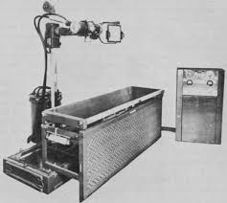
Changes: All medical staff had to wash their hands, faces and arms before operating. Rubber gloves and gowns were worn, the air was sterilised by being pupled over the heating system. A steam machine called an autoclave (invented by French scientist Charles Chamberland in 1881),was used to sterilise surgical equipment.
- X-Rays: The development of the X-Ray was completely accidental. In 1895, Wilhelm Roentgen, a German physicist, was studying the effects of passing an electric current through a glass tube covered in black paper. He noticed that the light rays still penetrated the paper. Early problems with x-rays:
• Health risks were not fully understood. The amount of radiation was x1500 the amount released today. Any form of radiation can lead to problems like losing hair or burns
• X-ray machines had very fragile glass which could break
• Taking an x-ray of a hand took about 90 minutes
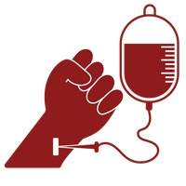
Blood Transfusions: An average adult’s body contains 5 litres of blood, the body will go into shock and die with too much blood loss. This was common in surgery in the 19th century and battle fields. James Blundell in 1818 conducted the first ever human blood transfusion (blood taken from a healthy patient and given to another) in order to help women in childbirth. Half of Blundell’s patients survived and many of his techniques were used in WW1. Blood can only be transfused with someone of the same blood group. As storage was a problem, the blood had to be used straight away!
- Blood Storage: Problems: Blood clots as soon as it leaves the body, meaning it will block up tubes and be too hard to transfuse / the body will reject blood from a donor unless the blood is compatible with their blood group. In 1901 Austrian Scientist Karl Landsteiner discovered existence of blood groups. Later research (Reuben Ottenberg) discovered O blood group as universal donor. Scientists also discovered how to separate and store crucial blood cells which could then be bottled, packed in ice and used when needed, contributing to the growing blood banks
Trench Warfare
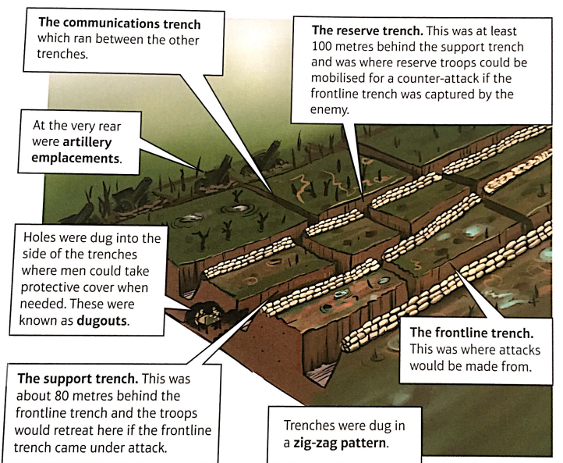
Britain declared war on Germany on August 4th 1914 when Germany invaded France through Belgium.
The British government sent the B.E.F (British Expeditionary Force) to northern France to try and stop the German advance.
The BEF had 70,000 professional soldiers fighting alongside the French army. After the initial fighting, both the British and Germans pulled back their forces.
This is when ‘Trench Warfare’ began. It became a defensive war using trenches with some offensive attempts to capture the enemy trenches / land.
Advantages of Trenches:
• Easy to make
• Easy to defend
• Cheap to build
• Didn't need lots of men to defend them.

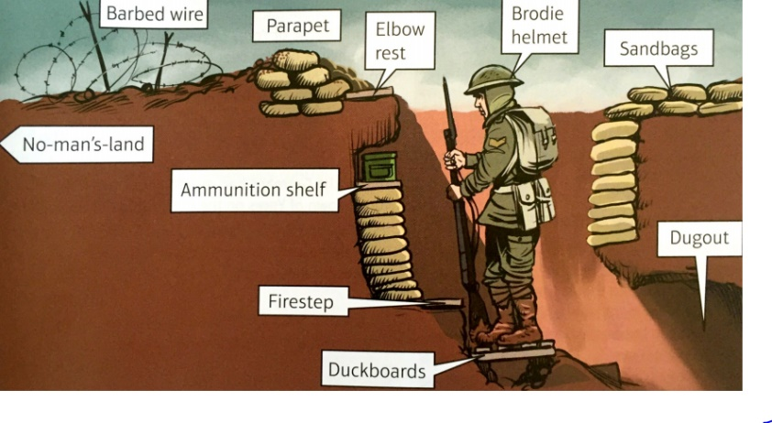
Disadvantages of Trenches:
• Wet and cold
• Hard to get in and out of without being
seen by the enemy.
• Trenches were very dirty and unhygienic as
there was no running water or flushing toilets.

Conditions in the Trenches:
Summer: Sewage, dead bodies & heat led to horrific smell & disease everywhere
Winter: Bad weather led to flooding, frostbite (6000 cases in December 1914)

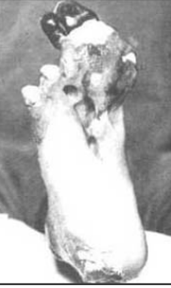
Trench Foot: This was an infection of the feet caused by cold, wet and filthy conditions. In the trenches men stood for hours on end in waterlogged trenches without being able to remove wet socks or boots. The cold would cut off the circulation to the foot. Without blood flow the tissue would die (turn gangrenous). By Jan 1915, 27th British Division had lost 12,000 men to Trench Foot! Remedy: dry their feet and change their socks several times a day, also rubbing whale oil into their feet. Once gangrene set in, amputation was the only solution!

Trench Fever: Flu like symptoms with high temperature, headaches and aching muscles. This was a major problem as it affected half a million men. Solutions: They worked out it was caused by lice. ‘greybacks’ as the soldiers called them. Delousing stations were set up. Men were given louse repellent gel, steam machines used. Between July 1917 and July 1918 15% of British soldiers were out of action due to Trench Fever.

Shell Shock: caused a wide range of symptoms, including tiredness, loss of speech, shaking and total mental breakdown. Not well understood by medics. Not Yet disclosed (NYD) was army code for shell shock. 1916- 16,000 cases in 6 months. Remedy: Some hospitals had anti- shell shock centres. Given rest, food, and talks to calm them. Then returned to duty. But some accused of cowardice. 80,000 recorded cases, probably many more undocumented.

Nature of Wounds:

Rifles & explosives:
- High explosive shells and shrapnel (metal fragments from shells) were responsible for 58% of wounds
- 60% of injuries were to arms and legs
- Bullets were responsible for 39% of wounds
- Machine guns could fie 450 rounds a minute
- Rifles could fire accurately up to 500 m

Shrapnel, wound infection & head injuries:
• When men were injured, either by shrapnel or bullets, the blast impact destroyed tissue and even bone for inches around the site of impact.
• The dirt alone would have caused infection, but remember the soil here had bacteria from the fertiliser used on the land before the war.
• Gas gangrene is an infection caused by the bacteria that produces gas in the gangrenous wound – it could spread and kill within 1 day!

Other problems: rats, dysentery
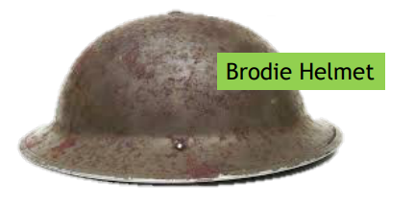
60,000 soldiers suffered head and eye injuries. Autumn of 1915 Brodie Helmets introduced. This was a steel helmet with a strap that prevented it being thrown off in an explosion. It reduced fatal wounds by 80%.

Gas attacks: Gas attack caused great panic and fear. However only 6,000 British soldiers died from gas. Gas masks were provided in 1915. Initially soldiers improvised using urine soaked cloth to prevent inhaling gas.
Types of gas:
- Chlorine: First used by German in Ypres 1915. Led to death by suffocation.
- Phosgene: first used 1915 near Ypres. Similar to Chlorine in terms of effects, but worked quicker. Killed in 2 days.
- Mustard Gas: First used 1917 by Germans. Odourless, caused internal and external blisters and burning of the skin.
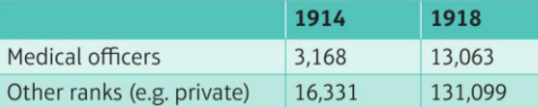
Medical Care

RAMC: Royal Army Medical Corps. This branch of the army was responsible for medical care and was founded in 1898. To deal with the large numbers of casualties in WWI, the number of medical professionals increased dramatically (Approx. 3000 1914 - 13,000 1918!). More than half of Britain’s doctors were serving with the armed forces, most of them on the Western Front.

FANY: First Aid Nursing Yeomanry. FANY was founded in 1907, the first women’s voluntary organisation to send volunteers to the Western Front. It provided front line support for medical services e.g. driving ambulances, driving supplies such as food and clothes to the front line. They had a mobile bath unit (40 men an hour!).They set up cinemas to help morale.

Transport: Problems
- Constant shelling and the type of terrain that the soldiers were fighting on left the landscape full of craters and holes destroying many roads. This led to problems transporting injured men away from the frontline
- Before the war this region had been used as farmland, using fertiliser which meant there was lots of bacteria in the soil leading to infected wounds
- Stretcher Bearers would carry away the large numbers of wounded from the frontline (day and night) exposing themselves to shelling and gunfire.
- The British initially relied on horse drawn ambulances to collect and carry the wounded. This was a mistake! Men were shaken about on the terrain, worsening their injuries. A British newspaper appeal led to 512 motor ambulance being sent to help. Motorised vehicles still ran into difficulty on the muddy terrain, so both horses and motors were used.
- Many injured soldiers were transported to hospitals on the French/ Belgian coast by trains. Some trains even had operating theatres. There were concerns that the number of injured transported on trains was slowing down the war effort. As a result they began using canals to transport patients to hospitals on barges.

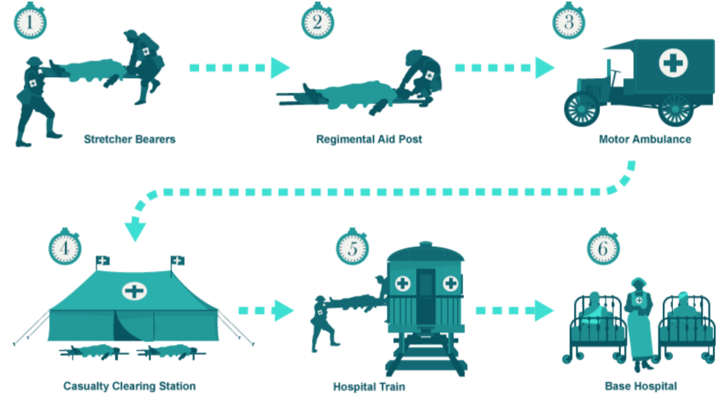
Men who were injured on the Western Front needed to be moved away in stages depending on the severity of their injuries.
Careful!
Motor Ambulance was used to transport but stage of treatment after Regimental Aid Post was Field Ambulance (not a vehicle)/ Dressing Station

Chain of Evacuation:

- Stretcher Bearers- carried dead and wounded. Carried basic medical supplies (bandages/morphine). 16 per battalion of 1000 men. 4 men to carry a stretcher (up to 8 in difficult conditions).
- Regimental Aid Post –close to the front line. Could be in dug out, ruined building or behind a wall, sometimes in firing trench. Staffed by one medical officer/ up to 30 orderlies. Bandaged light wounds, sent more severe cases to Dressing Station.
- Field ambulance- mobile medical unit that set up dressing stations. Could care for soldier for up to a week. Located about a mile from front line in derelict buildings, dugouts or tents. 10 medical officers plus orderlies. Sorted wounded into groups by severity of injury (known as Triage). Capacity for 150 wounded, but sometimes dealt with many more.
- Casualty Clearing Stations were large and better equipped, located in tents, huts, factories or schools. Between 7 and 12 miles from the fighting. About 7 doctors (+nurses/staff). By 1917 performing more operations than base hospitals. Had operating theatres, mobile X-Ray machines, wards, beds. Beds for about 50 men. Could handle approx. 1000 casualties at a time.
- Base Hospitals were situated near ports on the coast. Were civilian hospitals or repurposed buildings. Some could handle 2,500 patients. Injured travelled to them by train, motor ambulance or canal (barge). Had several medical staff (doctors/nurses). Had operating theatres, X-Rays, labs, specialised departments (gas poisoning dept.).

Underground Hospital at Arras: Also known as Thompson’s cave, the hospital was close to the front line in the tunnels under the town. Had 700 beds, an operating theatre and a mortuary. Had electricity and water.

Treatments

Wounds and Infections

Aseptic surgery was very difficult because of the conditions in trenches. Carbolic acid proved ineffective for gas gangrene. New techniques were needed!

Wound Excision / Debridement: Cutting away dead, damaged, infected tissue from around the site of the wound. Making sure to remove all shrapnel/ fragments. Needed to be done quickly to prevent infection spread. Kept wound open for use of antiseptics (immediate sewing trapped infection). Wound stitch up afterwards. Resulted in larger wounds but prevented infection.
Carrel-Dakin method for gas gangrene: cleaning the wound with a sterilised salt solution. Solution only stayed usable for 6 hours. Had to be made on the go.
Amputation: If excision or antiseptics failed, amputation was necessary. By 1918, 240,000 men had lost limbs to stop spread of infection.

The Thomas Splint: In 1914/15, men with a gunshot or shrapnel wound to the leg only had a 20% chance of survival Problems:
- Compound fractures pierced the skin = infection and broken bone inside the leg
- If the femur (thigh bone) was fractured this would lead to massive muscle damage and bleeding into the thigh.
- The splints they originally used didn't keep the leg rigid so by the time they arrived at the CCS the patient would have lost a lot of blood, would be in shock and maybe already developing gas gangrene. Those who survived had their leg amputated at the CCS.
- Solution: The Thomas Splint was developed in the late 19th Century by Hugh Thomas and was designed to stop joints moving.
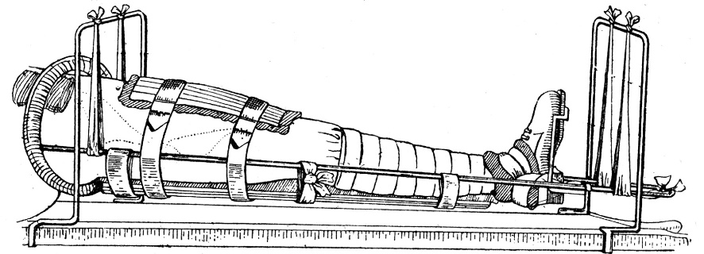

X-Rays were used from the start of the war, essential to identify shell fragments and bullet wounds that if not removed from the body could cause infection. Two X-Rays were taken from different angles to help the surgeon locate the shrapnel and bullets.
Problems with X-Rays on the Western Front:
- X-Rays couldn’t detect all objects in the body e.g. fragments of clothing
- The length of time a wounded man had to remain still was several minutes which could cause problems depending on the wound
- The tubes used in X-Ray machines were fragile and overheated very quickly therefore could only be used for about an hour at a time to then cool down (due to demand for x-rays and overheating problem the solution was to have 3 machines in rotation)
Mobile X-Rays
Prevented deaths on the front line by letting medics see bullet injuries and sped up process. There were 6 mobile x-ray units operating in the British sector of the Western Front that could be called upon. Setting up the mobile unit took some time: A tent was attached to the back of the van with a table where stretchers could be placed. The x-ray machine was placed next to the table linked to the engine. Equipment for processing the x-ray films was set up inside the van. Image Quality wasn’t as good as the static x-ray from a hospital but was sufficient in identifying the shrapnel and bullets.

Blood Transfusions: Syringe & tube was used to transfer the donor blood to the patient before surgery and to prevent them going into shock. Those who didn’t reject the blood generally survived so due to this success they started doing transfusions in the CCSs as a matter of routine. Geoffrey Keynes, a British doctor and lieutenant in the RAMC, designed a portable blood transfusion kit that was used closer to the front line

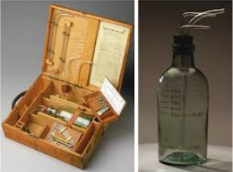
- 1915: American doctor Richard Lewishon discovered that by adding Sodium Citrate to blood stopped it from clotting, the need for donor-to-donor transfusion was removed
- 1915: Richard Weil discovered that blood with sodium citrate could be refrigerated and stored for up to 2 days
- 1916: Francis Rous and James Turner found that by adding citrate glucose solution to blood, it could be stored for much longer – up to 4 weeks. When planning a big attack, they could now ask for donations in the weeks before to prepare for the demand!

Head Injuries and Brain Surgery: Injuries to the brain were very likely to prove fatal at the start of the war because:
• The issue of infection applied just as much to the head as other parts of the body
• There were difficulties involved in moving men with head injuries through the chain of evacuation as they were unconscious or confused
• There were very few doctors who had experience of neurosurgery (nervous system, brain & spinal)

Solutions:
- Patients were operated on at CCS, as quicker operation led to a better survival rate.
- Patients were kept for up to three weeks to make sure they were recovered.
- Even minor head injuries were carefully examined just in case.
- Harvey Cushing developed new techniques in brain surgery using magnets to remove metal fragments. He used local anaesthetics when operating as general anaesthetics made the brain swell.

Plastic Surgery
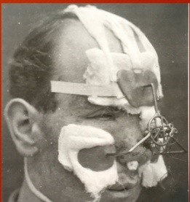
The development of plastic surgery was largely the world of Doctor Harold Gillies. Before the war he was an ENT (ear, nose and throat) surgeon. He was sent to the Western Front in January 1915. Head injuries that didn't kill could cause severe disfigurement. This led Gillies to become interested in facial reconstruction. By November 1915, 7 hospitals in France had specialist areas for dealing with wounds needing plastic surgery. By the end of the war, nearly 12,000 operations had been carried out!

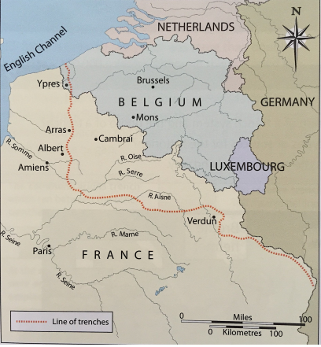
The 4 Key Battles:
- The Ypres Salient
- The Battle of the Somme
- Arras
- Cambrai

The Ypres Salient

Salient: An area of a battlefield that extends into enemy territory, so that it is surrounded on three sides, therefore vulnerable.

First Battle of Ypres: October-November 1914

Autumn 1914, Germany launched an attack to the east and north east of Ypres. Britain lost 50,000 troops but managed to keep hold of Ypres meaning they controlled the English Channel ports. The Germans had extended their control around the edge of the Ypres Salient as far as the village of Messines.

Battle on Hill 60, April 1915

Hill 60 was a man-made hill to the south-east of Ypres that the Germans had captured. The British tunnelled in and exploded 5 mines, taking back the hill.

Second battle of Ypres, April –May 1915

Immediately following the battle for Hill 60, the Second Battle of Ypres began. A sequence of battles over a period of a month. This was the first time the Germans used CHLORINE GAS on the Western Front. British losses were 59,000 men.
Arras, April-May 1917
Arras was easy to tunnel through due to it being very chalky. British decided to link these existing tunnels, caves and quarries to create an underground network around Arras to act as a shelter to the Germans. 24,000 men who had been hiding in the tunnels dug near the German trenches and attacked. Initially it seemed they had been successful with an advance of 8 miles. Following this early success, there was virtually no further advancement or progress.160, 000 casualties (British & Canadian).
Battle of Cambrai, November to December 1917
British army threatened rear of the German line at Calais. Artillery barrage changed so that less warning of the attack was given to the Germans. First LARGE SCALE use of tanks (nearly 500). Could move easily across the barbed wire and their machine guns were very effective, however on the 2nd day less effective.

July- November 1916: Battle of the Somme. British tried to take ground from the Germans. Notable for high casualties. 1 July 1916 -Day 1 casualties: 57,000 / deaths: 20,000. Tactics: Creeping Barrage (Going over the top): Artillery launched from the trenches towards the German lines just ahead of the British infantry as it advanced. First use of tanks: Tanks were not used effectively, they had a lot of technical problems and of course the terrain wasn’t appropriate.

Third Battle of Ypres, July- November 1917
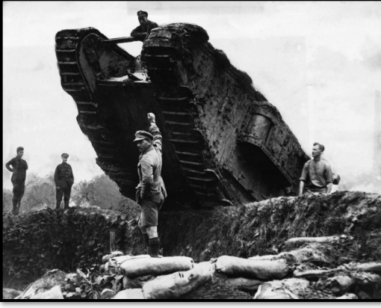
The British used creeping barrage attack to make small gains to break out of the Ypres salient. The awful weather left the ground waterlogged and many drowned.

