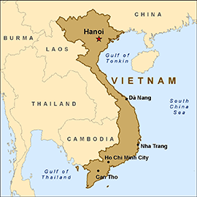

**How did it start?**  
The Vietnam War began as a **civil war** between the **Communist** state of North Vietnam and the non-Communist state of South Vietnam. The United States supported South Vietnam out of fear that Communism would spread throughout Asia if the South fell. North Vietnam wanted to unite with South Vietnam as a single communist country.

**Why did America fight in Vietnam? (Simplified)**

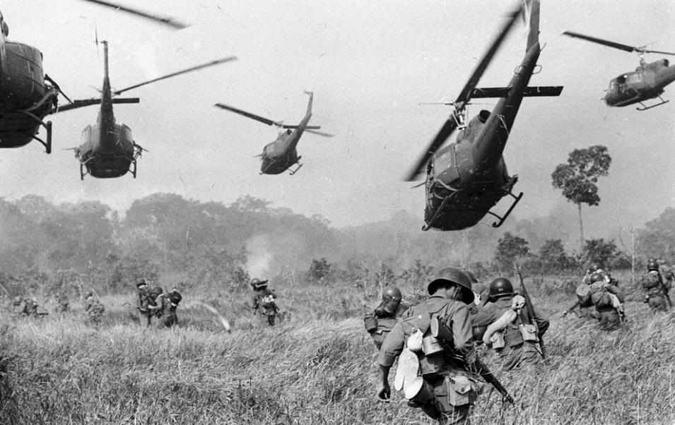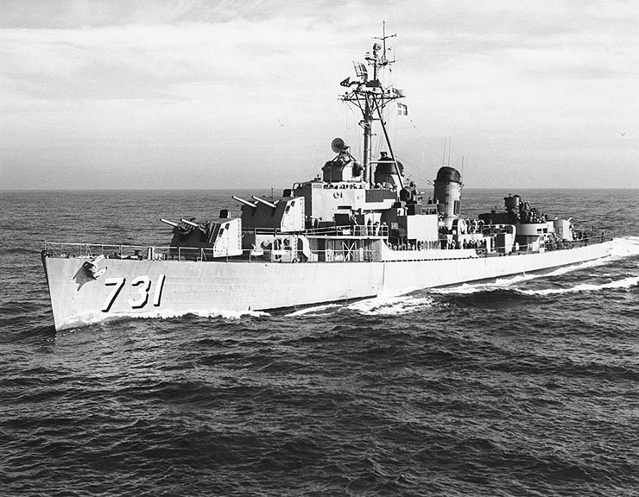

**How did it end?**In spite of the Americans’ superior firepower and technology, they could never totally defeat the highly dedicated forces of North Vietnam. The Vietnamese troops knew the territory and landscape. This meant that they could use **guerrilla** tactics like ambush to catch the Americans out. Many Americans didn’t see the point of the war and were unmotivated. They struggled in the humid conditions and dense jungle. The war ended in 1975, and North Vietnam quickly took over the south. The war resulted in tremendous loss of life; **58,000 American soldiers died, along with close to 3 million Vietnamese.**

**How did the Americans get involved?**   
The USA had given South Vietnam financial and military support during the 1950’s and early 1960’s. But in August 1964, an American warship patrolling the North Vietnamese coast was apparently attacked by Communist soldiers. Although the incident might not actually have happened, President Johnson quickly started to send thousands of soldiers and resources to Vietnam in 1965. This process was known as the **Gulf of Tonkin Resolution.**

**So why did America want to get involved?**   
America was opposed to communism, as it was the opposite of the **capitalist**, democratic system of government used in America. Americans believed Communism would spread to other countries in the region. This was known as the **“domino theory,”** since it imagined democratic governments in the region falling one after another like dominoes. **President Johnson** obviously wanted to stop this spread of Communism as he thought it was dangerous.

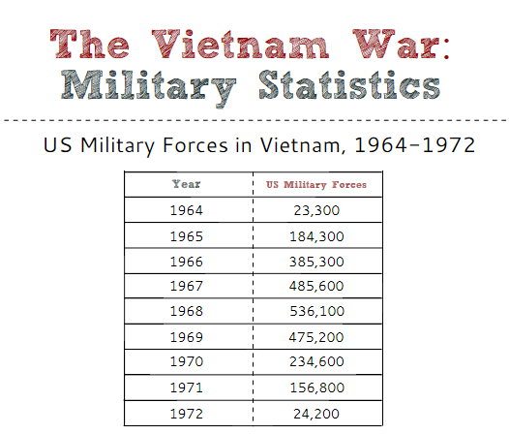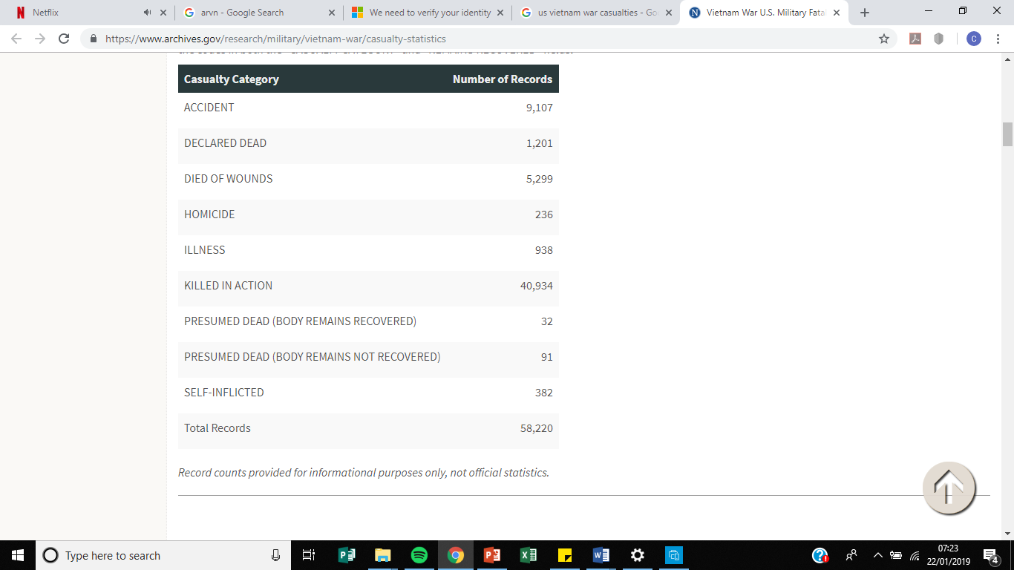

**What was the effect on US society?**

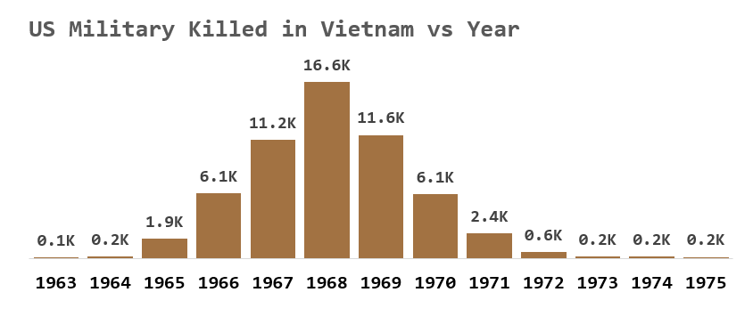

**The Draft:**

* During the Vietnam War, about two-third of American troops were volunteered, the rest were selected for military service through the **drafts**.
* In the beginning of the war, the names of all American men in draft-age were collected by the Selective Service. **When someone’s name was called, he had to report to his local draft broad**, which was made up of various community members, so that they could begin to evaluate and decide who went.
* In other words, local draft broads had an enormous power to decide who had to go and who would stay.
* **Most of U.S. soldiers drafted during the Vietnam War were men from poor and working-class families**. The least political power sections were mistreated.
* American forces in Vietnam included twenty-five percent poor**, fifty-five percent working-class**, twenty percent middle-class men, but very few came from upper-classes families.
* Many soldiers came from rural towns and farming communities.

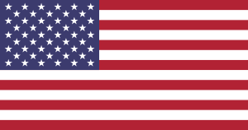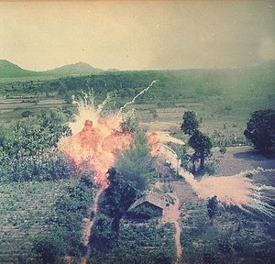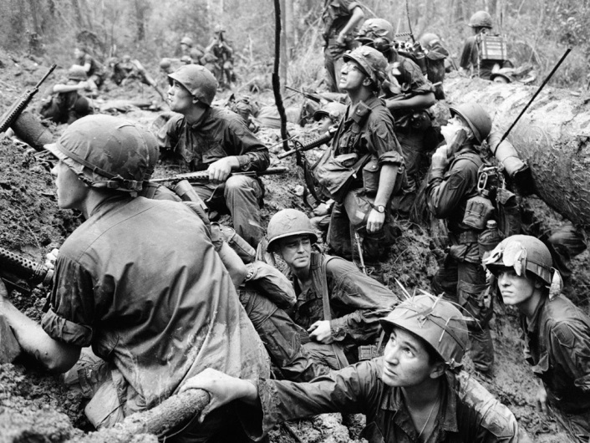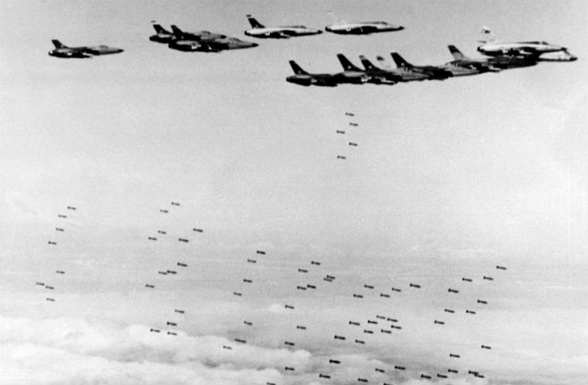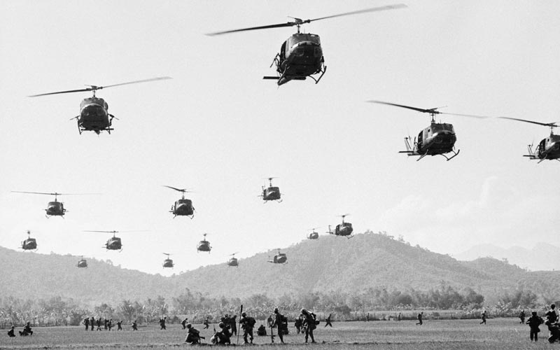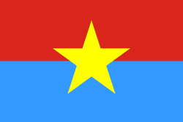[http://www.history.com/topics/vietnam-wa](http://www.history.com/topics/vietnam-war/vietnam-war-history/videos/vietnam-war-tactics)

**Why did America lose the war in Vietnam?**

**The USA flew ground troops in and out of the battle zones and the jungle to take on the Viet Cong and to search out the Viet Cong. The USA did find and kill their enemy but they also lost many of their own men. Violent and bloody battles were fought in the jungle. This tactic also failed because it was hard to decide who were the Viet Cong. American troops were also ambushed in the jungle. It was hard war to fight in an unfamiliar environment.**

**Chemical weapons explosives like napalm & agent orange were used to burn the jungle and forest where the Viet Cong hid. Americans successfully burned villages but innocent Vietnamese like children were also killed. This lost the Americans support of local people. Tactics did not stop the Viet Cong from getting supplies. The tactic of using chemical weapons also failed because the Viet Cong also hid under ground in the jungle.**

**The USA organised massive bombing raids on factories, ports, and army barracks in North Vietnam. The Americans dropped more bombs on North Vietnam than they did the whole of World War 2.**

**The tactic was aimed to stop North Vietnam from sending supplies, weapons and troops to South Vietnam. The USA wanted to bomb North Vietnam into submission so American troops would not be needed.**

**The tactic failed as the Viet Cong brought supplies into south Vietnam through tracks in the jungle. They were also determined to win no matter how many bombs the Americans used.**

**Why did America lose the war in Vietnam?**

**The Viet Cong were clever and skilful in the way they fought the Americans. They knew they could not match the American resources so they used the jungle environment to their advantage. A vast network of underground tunnels, storage bases, workshops, kitchens, hospitals and barracks were built. The Viet Cong could lay in wait and hide from the Americans. The Viet Cong used the Jungle to their advantage and made it hard for the Americans to take on their enemy.**

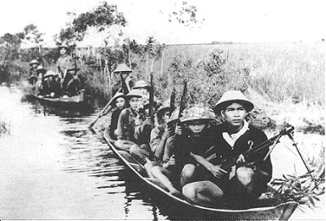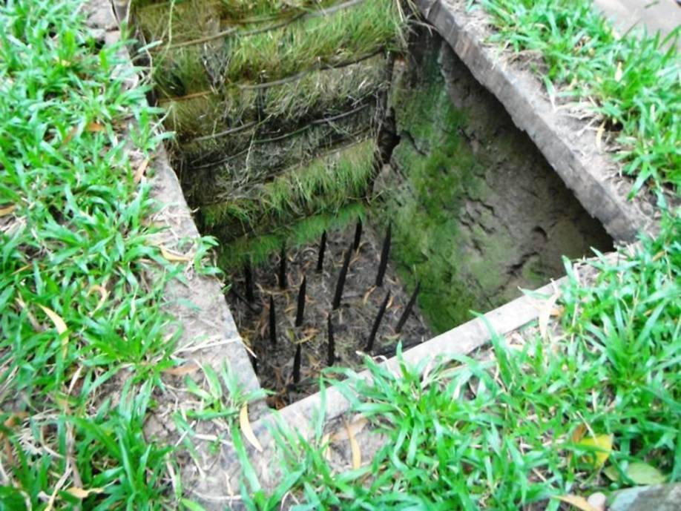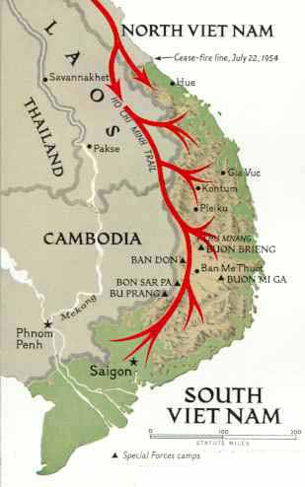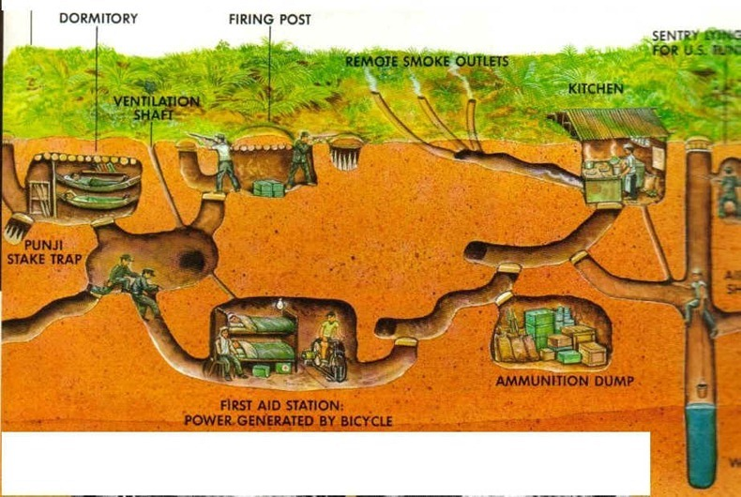

**Weapons from North Vietnam, China and Russia were taken into South Vietnam along tracks through the jungle called the Ho Chi Minh trail. The Trail took supplies on bicycles, lorries & human backs. The Viet Cong had a never ending supply. The trail went through Laos & Cambodia who were not at war.**

**Viet Cong were a guerrilla army . They had the support of the poor peasants in South Vietnam and they were motivated. Vietnam was their country. They believed the Vietnamese should decide their future not America. As they had no uniform and their soldiers included men, women and even children the Viet Cong were hard to identify. The Americans did know who they were fighting against. An innocent civilian could easily be one of the VC’s. In addition, the Viet Cong were willing to die for their beliefs. They were able to replace the dead and injured. The Viet Cong just kept on putting more and more soldiers into battle.**