The First New Deal

Roosevelt persuaded Congress to give him **emergency powers** from 9 March to 16 June 1933 (**the 'Hundred Days'**).   However many of Roosevelt's ideas were not new (some just copied Hoover's).

**1.  Confidence:**

Roosevelt undertook a series of measures to keep the American people on his side.

**a.  Abolished Prohibition**

-   He said: ‘I think this would be a good time for a beer”.   This restored faith in the government because it stopped the humiliation of the government’s laws being openly ignored.

-   (It also increased the government’s revenues.)

**b.  Fireside Chats**

-   FDR described his policies in radio broadcasts called ‘fireside chats’.

-   FDR also made sure that everyone who sent him a letter got a reply (he got up to 8,000 letters a day), and that everyone who telephoned the White House was never cut off.

**c.  Bank holiday**

-   The Emergency Banking Act closed the banks for four days.   The government checked that all were financially sound, and when they reopened, they reopened with the backing of the Federal Reserve.

-   This restored confidence in the banks, and people deposited their money there again.

**d.  Stock Exchange**

-   The Securities and Exchange Commission introduced rules for the Stock Exchange to prevent another Crash like 1929.

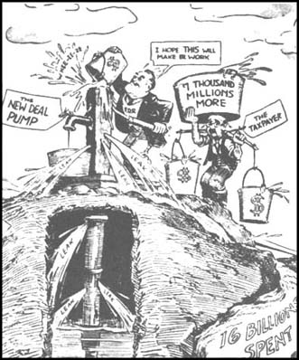

**2.  Finance and Economy:**

Roosevelt then made changes to make the economy more stable.

**a.  Budget**

-   He did not run deficit budgets (i.e. it did not spend more than it gathered in taxes).

-   He CUT the pay of government employees by 15%.

(These measures actually made the depression worse.)

-   The government borrowed huge amounts of money to finance the New Deal, but it spent it on projects that were planned to pay back eventually.

**b.  Bankruptcies**

-   The Farm Loan Act and the Bankruptcy Act prevented banks from closing failing businesses until they had had a chance to borrow from the Federal Reserve.

-   The Home Loan Act and the Home Owners Loan Corporation did the same for ordinary home owners.

**c.  Prices and Wages**

-   The Agricultural Adjustment Act (AAA) paid farmers to take fields out of production; the idea of this was to stop over-production and to drive up prices.

-   The NRA (National Recovery Administration) was set up, where businessmen joined a ‘Roll of Honour’ (and were allowed to show a blue eagle symbol) where they promised to cut production and pay good wages – 2.5 million firms, employing 22 million people, joined the scheme.

-   FDR also abolished Child Labour – this put more adults into work.

**d.  Currency**

-   FDR stopped people owning gold (they had to deposit it in banks)

-   made the banks give all the gold to the government

-   increased the price of gold from $20 to $35 an ounce.

    This stopped people hoarding/saving their money, and increased the amount of government reserves.  Since the dollar was still linked to gold, moreover, many foreign investors bought American dollars for gold, which increased the amount of government reserves.

**.  Alphabet Agencies:**

FDR set up what came to be called the ‘alphabet agencies’ because their names were reduced to acronyms.   The main ones were:

**a.  CCC** (Civilian Conservation Corps):

provided paid conservation work to give unemployed young men jobs – by 1941, 2.5 million had taken part PLUS millions of trees panted/ parks and forest areas developed

**b. FERA** (Federal Emergency Relief Administration): provided matched funding to help states organise payments to the unemployed and homeless.

**c.  WPA** (Works Progress Administration):

ran projects which provided work for the unemployed, e.g. building airports, schools, hospitals or bridges – millions earned a small wage and felt valuable.

**d.  TVA** (Tennessee Valley Authority):

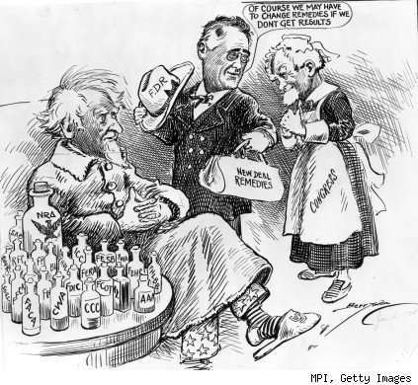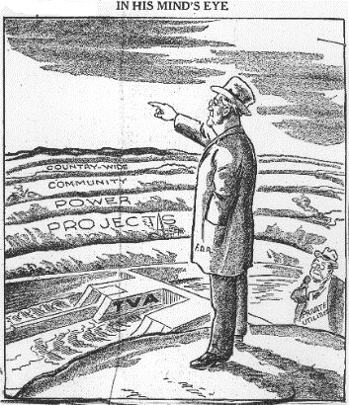built 21 dams in ten years – stopped flooding, provided cheap electricity and provided work.

Second New Deal

In 1935, Roosevelt's New Deal was still hugely popular with the people, but it was running into opposition.

The most important elements of this opposition were:

1. The Supreme Court, which ruled that the NRA and the AAA were illegal, because they took away the right of states to run their own affairs.
2. Some businessmen, who attacked and ignored the NRA saying that it was expensive and wasteful. Republicans also agreed with this point of view because they believed in a laissez faire approach to the economy and said that if poor people suffered it was their own fault for being lazy!

**Therefore, in the run up to the 1936 election and after it, Roosevelt followed a much more radical 'reform' agenda.**

**1.  National Labour Relations Act (1935):**

●   Also known as the Wagner Act.

●   To replace the banned NRA.

●   Protected workers' right to join a trade union.

●   Set up the National Labour Relations Board (NLRB) to prevent employers from victimising workers.

**2.  Soil Conservation Act (1935):**

●   To replace the banned AAA.

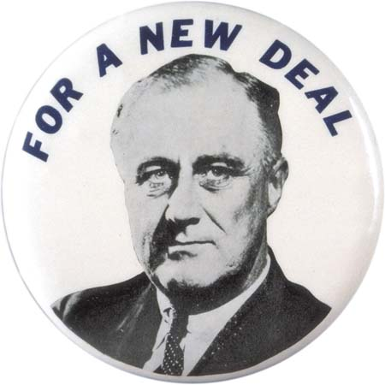●   Allowed the government to continue subsidising farmers.

**3.  Social Security Act (1935):**

●   Provided America's first system of social welfare.

●   set up a national system of old-age pensions

●   gave help to people with physical disabilities

●   gave help to children in need

●   set up a national system of unemployment insurance.

**4.  National Housing Act (1937):**

●   Provided loans to buy houses

●   Reduced excessive rents.

**5.  Fair Labour Standards Act (1938):**

●   Set hours and conditions of work

●   Fixed a minimum wage.

|  |
| --- |
| **How successful was the New Deal?** Successes – 5Rs **1.  Relief**  Millions of people received relief, help with their mortgage, jobs etc. from the alphabet agencies.  **2.  Roads and buildings**  The WPA and the TVA provided valuable economic and social infrastructures, such as roads, airports, schools, theatres, dams etc.  **3.  Reform**  Roosevelt's new laws about social security/ minimum wage/ labour relations and trade unions survived and protected ordinary people’s rights and conditions.  **4.  Roosevelt** became the people's hero - he was elected four times.  **5.  Repercussions**  Democracy survived in America (unlike Italy and Germany).   The New Deal became a model of how a democratic government ought to behave - arguably influenced the British Welfare State of 1948.   And in 1998, when the Labour Government of Britain was trying to introduce new laws to help poor people, it called it: a New Deal. Weaknesses and Failings – 3Ds **1.  Did not end the Depression**  - indeed, Roosevelt's insistence on a balanced budget, healthy interest rates and ‘sound money’ may have helped to continue it.   Roosevelt had no new ideas how to end the depression – just Hoover’s schemes only bigger.   By 1935 he had failed to end unemployment (which was only down to 10.6 million), and – although unemployment fell to 7.7 million in 1937 – when Roosevelt tried to cut back government expenditure in 1938, it rose again to 10.4 million.   It is not really fair to criticise Roosevelt for this - no one at that time knew how to end the Depression - but the Depression did not end until the Second World War got production going again. |
|  |

**2.  Damaged Blacks and immigrants**

– in fact, many were laid off as a direct result of the New Deal’s attempts to give workers rights.

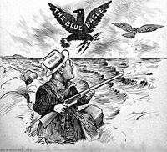**3.  Determined Opposition (BRASS)**

a   **B**usinessmen hated the New Deal because it interfered with their businesses and supported workers’ rights.   Rich people accused Roosevelt of betraying his class.   Henry Ford hired thugs to attack his trade union workers.

b   **R**epublicans hated the expenditure, which they said was wasteful (‘boondoggling’ – jobs for the sake of jobs).  They believed that poor people were responsible for their own problems and that it was not the job of the government to look after them.   After 1938, Republicans took over the Senate, and Roosevelt was unable to get any more New Deal legislation through.

### c   Activists like Huey Long (Senator for Louisiana who started a Share the Wealth’ campaign to confiscate fortunes over $3m) and Francis Townsend (who campaigned for a pension of $200 a month) said it did not go far enough to help people.

### d   State governments opposed the New Deal, saying that the Federal government was taking their powers.

e   The **S**upreme Court ruled that the NRA codes of employers’ conduct, and the AAA programme, were illegal because they took away the States’ powers.   Because of this, in 1937, Roosevelt threatened to force old Supreme Court judges to retire and to create new ones; the crisis was averted when the Supreme Court reversed its decisions.