Some Key Sporting Events in the 1970s
Sports in the 1970s were dominated by a select few, but their names ring on in sports history forever. Athletes like Hank Aaron, Muhammad Ali and Mark Spitz dominated their respective sports in the decade. There were also several sports moments during the decade that still resonate today. These sports moments defined the 1970s.
Marshall University Plane Crash
Date: Nov. 14, 1970
A plane carrying 37 players and eight members of the coaching staff of the Marshall Football team went down. All 75 people on board were killed. Despite the tragedy, the team was rebuilt and managed to win two games the following season, including their home opener against Xavier, 15-13.
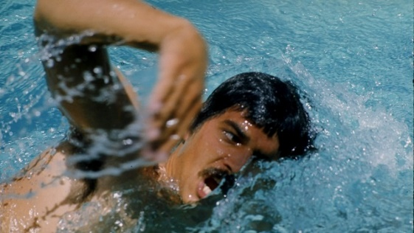
Mark Spitz Wins 7 Gold Medals at the 1972 Summer Olympics
Dates: Aug. 26 to Sept. 10
Before Michael Phelps' record-breaking Olympic performance in 2008, Mark Spitz was the symbol of Olympic dominance in the 1972 Olympic Games. Spitz won seven gold medals in seven different events and also set world records in all of his events.

The 1972 Olympic Men's Basketball Final
Date: Sept. 9, 1972
Trailing 49-48 to the Soviet Union in the closing seconds of the 1972 Olympic Men's Basketball Final, American Doug Collins sank two free throws to put the United States up by one. The United States lost, however, in controversial fashion after the referees gave the Soviets three separate chances to win the game. In protest, most of the Americans have still not officially accepted their silver medals.
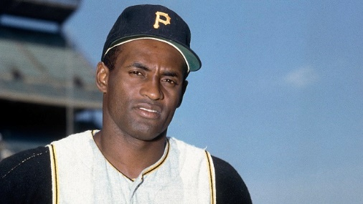
Roberto Clemente Dies in a Plane Crash
Date: Dec. 31, 1972
The first Latino player to win a World Series as a starter (1960), receive a National League MVP Award (1966), and win the World Series MVP Award (1971), Roberto Clemente was one of the greatest players in MLB history. In 1972, Clemente was involved in charity work in Puerto Rico, but the plane he was flying in crashed, killing him and his body was never recovered.
The 1972 Miami Dolphins Complete Their Undefeated Season in Super Bowl VII
Date: Jan. 14, 1973
The 1972 Miami Dolphins completed the NFL's most recent perfect season in an imperfect manner with their 17th victory in Super Bowl VII. Heavily favoured against the Washington Redskins, the Dolphins' defence dominated the Redskins, holding them without an offensive touchdown. The Dolphins won 14-7 and only Garo Yepremian's gaffe cost the team a shutout victory.
Billie Jean King Defeats Bobbie Riggs in the Battle of the Sexes
Date: Sept. 20, 1973
After beating Margaret Court 6-2, 6-1 in an exhibition match, Bobby Riggs faced Billie Jean King in The Battle of the Sexes. This match was also one-sided, but with Riggs coming out on the losing end. Jean King easily defeated Riggs in straight sets 6-4, 6-3, 6-3 and scored a victory for women everywhere.

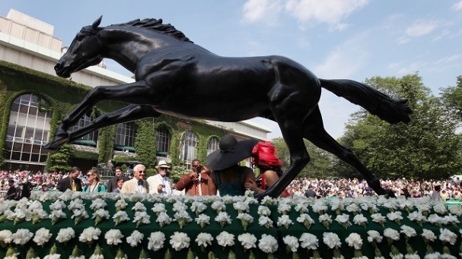
Secretariat Completes Dominant Triple Crown Run
Date: June 9, 1973
In one of the most dominant performances in horse racing history, Secretariat, who had previously won both the Kentucky Derby and Preakness Stakes in 1973, won the Belmont Stakes by a record 31 horse lengths. Secretariat became just the ninth Triple Crown winner and set race records in all three events that year.
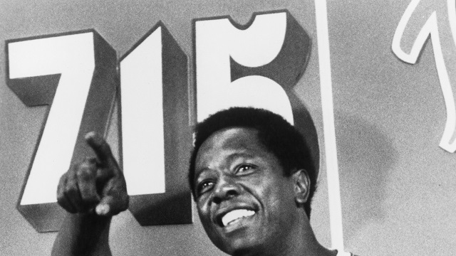
Hank Aaron Breaks All-Time Home Run Record
Date: April 8, 1974
Before a crowd of 53,775 at Atlanta-Fulton County Stadium, Braves outfielder Hank Aaron made history with one swing of the bat. Facing Los Angeles Dodgers pitcher Al Downing, Aaron hit his 715th career home run, surpassing Babe Ruth's all-time mark. Aaron's mark would eventually be surpassed by Barry Bonds 30 years later, but some still view Aaron as the true home run king.

The “Rumble in The Jungle”
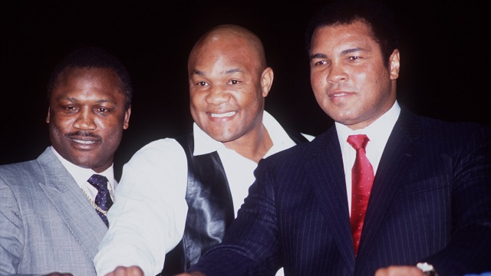
Date: Oct. 30, 1974
In 1974, George Foreman was the king of the ring while Muhammad Ali was still getting back to his old self after being suspended for three and half years as a result of dodging the enlistment into the U.S. Army. In the match, Ali used his now famous rope-a-dope strategy to tire out Foreman and Ali took advantage in the eighth round by scoring a knockout victory.

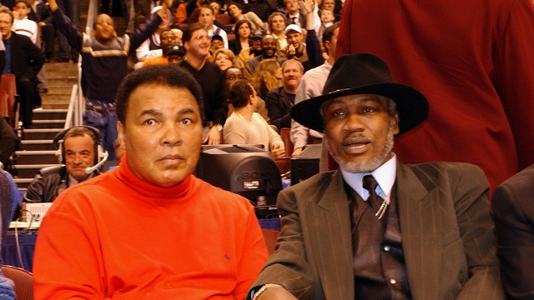
The” Thrilla in Manila”
Date: Oct. 1, 1975
The pinnacle of the Ali vs. Frazier rivalry, the Thrilla in Manila was the third and final bout between two legendary boxers. The two beat the hell out of each other for 14 rounds before Frazier's corner threw in the towel in the 14th round. One of the greatest man-on-man rivalries ended with Ali holding a 2-1 advantage over Frazier.

