3.What do you still NOT know? What does it not tell you? What questions do you still have?

4.Provenence: What type of source is it? Why did someone create this? What was their purpose (to inform / educate / entertain etc)?

1.What can you see? Make sure you refer to specific details.

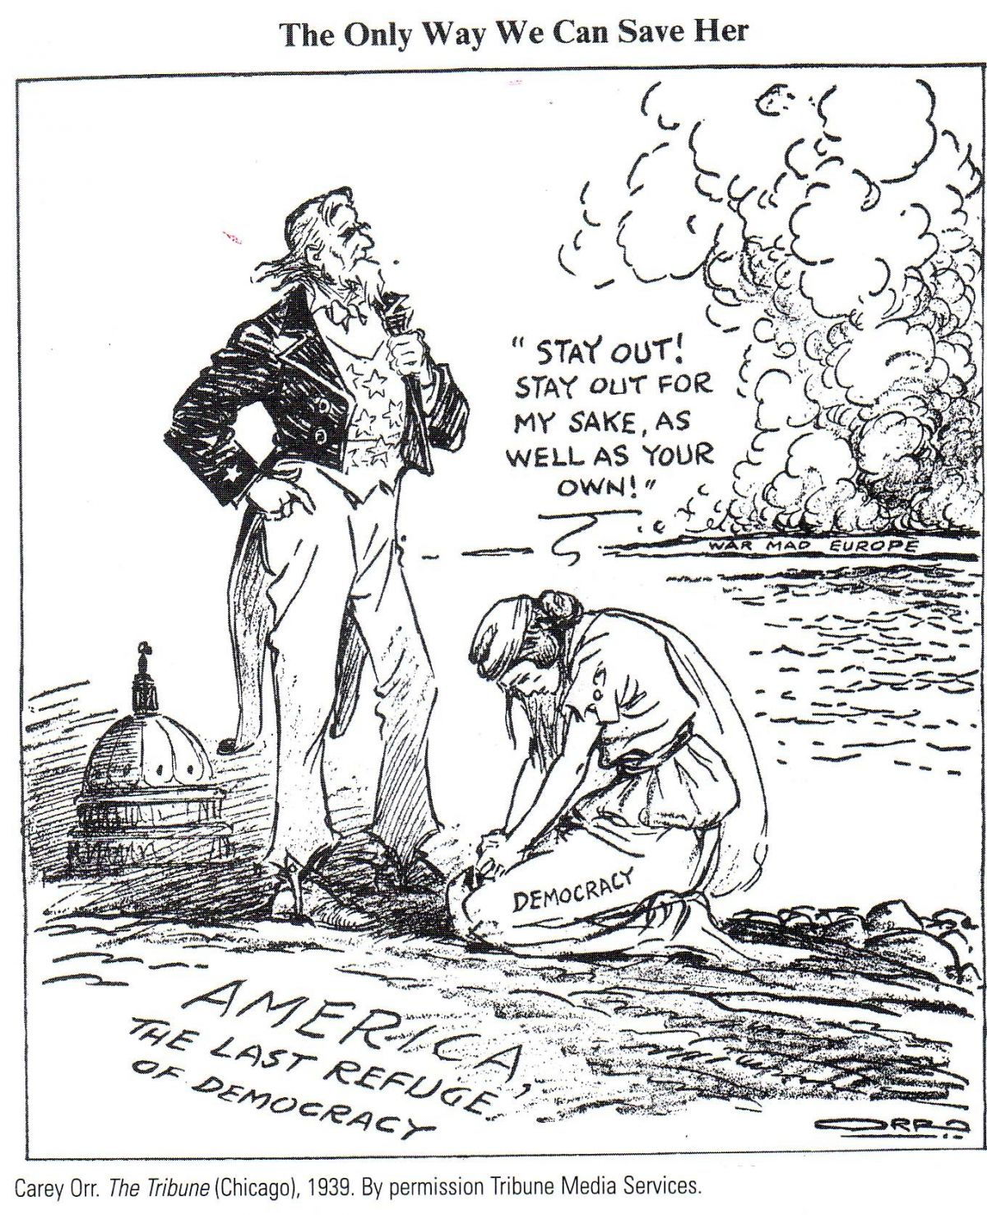

2.What can you infer about popular isolationism in the USA?

January 1917