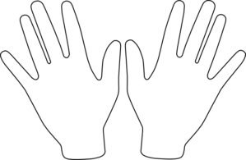

**‘The Second World War did far more to improve the lives of black Americans than Roosevelt’s new Deals’. How far do you agree?**

**The impact of the Second World War on black Americans**

|  |  |
| --- | --- |
| **Impact** | **Supporting example(s)** |
| Raised black racial consciousness and encouraged activism |  |
| Provided greater bargaining power |  |
| Inspired a new generation of civil rights leaders |  |
| Aided future black economic opportunities |  |

**‘New Deal programmes introduced during the presidency of FDR failed Black Americans’. How far do you agree?**

* Identify 5 examples for each view
* **Use page 85-86** in the depth study and page 58 & 61 in the breadth study. **Try to come up with your own too.**

**The impact of New Deal Agencies – more harm than good?**

Although the number of black Americans employed in the federal bureaucracy rose from 50,000 to 150,000 and nearly 50 of these were senior (the ‘black cabinet’, e.g. Mary Mcleod Bethune of the NYA), the racial quotas and segregationist policies of many agencies arguably did more harm than good.

|  |  |  |
| --- | --- | --- |
| Agency / legislation | Examples of the impact on black Americans (summarise; give facts and figures) | Success rating out of 10 |
| AAA |  |  |
| TVA |  |  |
| CCC |  |  |
| NRA |  |  |
| PWA |  |  |
| WPA |  |  |
| NYA |  |  |
| FERA |  |  |
| FHA (Housing) |  |  |
| Social Security Act |  |  |

**The Impact of the Great Depression on black Americans**

**impact of the Great Depression of on black Americans**

**The work of Eleanor Roosevelt**

**A Black Cabinet?**