**How to approach Paper 1: Section C**

**Section C** comprises **one compulsory question** that assesses the ability to **analyse and evaluate interpretations** (AO3) and targets content specified by the ‘historical interpretations’ focus question:

**What impact did the Reagan presidency (1981–89) have on the USA in the years 1981–96?**

* The effect of Reagan’s economic policies.
* The extent to which ‘big government’ was reduced.
* The nature and extent of social change.
* The extent to which the presidency and US politics were revitalised.

Historical interpretations: The Context

This topic focuses on the debate concerning the nature and effect of Ronald Reagan’s presidency from 1980 to 1988, and the consequences of his two terms in office to the presidential election of 1992.

You will need to **know and consider**:

* The main features of Reaganomics and his aims to reduce the role of federal government.
* The extent and impact of cutbacks in federal government and the extent and effectiveness of deregulation policies.
* His conservative social values and the influence of the Religious Right in the 1980s.
* The extent to which Reagan’s social values influenced social change and affected the advancement of women and of African Americans and other minority groups.
* The extent to which Reagan’s economic policies were successfully implemented and the extent to which economic problems were overcome.
* Reagan’s economic legacy in the years to 1996.
* The extent to which Reagan’s policies affected the both the nature of US electoral politics and the public perception of the role of the President up to 1996.
* The nature of the debate on the extent to which Reagan’s presidency changed US politics.
* The impact of the ‘Iran-Contra affair’ on attitudes towards the Reagan presidency.
* The impact of the Reagan legacy on the period 1989–96 with regard to continuity and change in policies and general trends.

**How to approach the question**

Questions will be based on **two extracts** from historical interpretations totalling approximately 350 words.

Questions WILL ALWAYS be worded as:

*In the light of differing interpretations, how convincing do you find the view that……….*

*To explain your answer, analyse and evaluate the material in both extracts, using your own knowledge of the issues.*

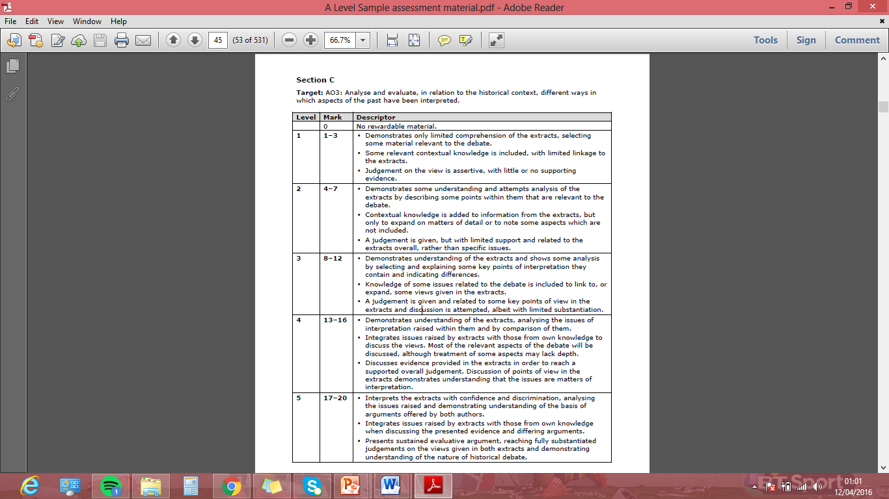**How will I be marked?**

**Section C Mark Scheme (AO1)**

L5 criteria in more detail:

* Analysis and comparison of interpretations:

Interprets the extracts with confidence and discrimination, analysing the issues raised and demonstrating understanding of the basis of arguments offered by both authors.

*Are you treating it as a repository of information analysing the subtleties of the interpretation? Analysis should break extract into parts.*

* Integrates issues raised by extracts with those from own knowledge when discussing the presented evidence and differing arguments.

*This is the knowledge you bring to the exam – do you know the debate and detail? Note the difference between lower and higher levels – at L5 knowledge is ‘integrated’ not just ‘linked’ mechanically and formulaically.*

* Presents sustained evaluative argument, reaching fully substantiated judgements on the views given in both extracts and demonstrating understanding of the nature of historical debate.

*Are you using valid criteria and reaching a judgement? Is the substantiated judgement followed through?*

**Target:** AO3: Analyse and evaluate, in relation to the historical context, different ways in which aspects of the past have been interpreted.

**Each level descriptor has 3 strands:**

* **Analysis and comparison of interpretations**

*Are you treating it as a repository of information analysing the subtleties of the interpretation? Analysis should break extract into parts.*

* **Deployment of knowledge of issues related to the debate**

*This is the knowledge you bring to the exam – do you know the debate and detail? Note the difference between lower and higher levels – at L5 knowledge is ‘integrated’ not just ‘linked’ mechanically and formulaically.*

* **Evaluation of and judgement about the interpretations.**

*Are you using valid criteria and reaching a judgement? Is the substantiated judgement followed through?*

|  |  |  |
| --- | --- | --- |
| **Level** | **Mark** | **Descriptor** |
| **1** | **1-3** | * Demonstrates only limited comprehension of the extracts, selecting some material relevant to the debate. * Some relevant contextual knowledge is included, with limited linkage to the extracts. * Judgement on the view is assertive, with little or no supporting evidence. |
| **2** | **4-7** | * Demonstrates some understanding and attempts analysis of the extracts by describing some points within them that are relevant to the debate. * Contextual knowledge is added to information from the extracts, but only to expand on matters of detail or to note some aspects which are not included. * A judgement is given, but with limited support and related to the extracts overall, rather than specific issues. |
| **3** | **8-12** | * Demonstrates understanding of the extracts and shows some analysis by selecting and explaining some key points of interpretation they contain and indicating differences. * Knowledge of some issues related to the debate is included to link to, or expand, some views given in the extracts. * A judgement is given and related to some key points of view in the extracts and discussion is attempted, albeit with limited substantiation. |
| **4** | **13-16** | * Demonstrates understanding of the extracts, analysing the issues of interpretation raised within them and by comparison of them. * Integrates issues raised by extracts with those from own knowledge to discuss the views. Most of the relevant aspects of the debate will be discussed, although treatment of some aspects may lack depth. * Discusses evidence provided in the extracts in order to reach a supported overall judgement. Discussion of points of view in the extracts demonstrates understanding that the issues are matters of interpretation. |
| **5** | **17-20** | * Interprets the extracts with confidence and discrimination, analysing the issues raised and demonstrating understanding of the basis of arguments offered by both authors. * Integrates issues raised by extracts with those from own knowledge when discussing the presented evidence and differing arguments. * Presents sustained evaluative argument, reaching fully substantiated judgements on the views given in both extracts and demonstrating understanding of the nature of historical debate. |

**How do I approach and structure my answer in Section C?**

1. **What is the question asking**? Identify the two sides of the precise debate in the question. *On the one hand…. On the other hand….*

**2. Annotate and analyse the extracts carefully** - what does each suggest? What evidence have they used? Aim to summarise the arguments of each extract in a sentence each.

3. **Apply your knowledge of the debate to the extracts** - What evidence would you provide to support or challenge certain aspects of each extract? You should aim for two examples for each, as these will form your two points for and against in the essay!

C:\Users\User\AppData\Local\Microsoft\Windows\Temporary Internet Files\Content.IE5\6SN8KSO3\MC900383600[1].wmf

**HOWEVER…. don’t get caught out:**

In the exam, you do not need to link position to a particular historian / schools of thought explicitly.

You need to know the wider debate and that there are different positions that historians can take. You need knowledge of this debate so that you can interrogate the extracts

**Edexcel can be sneaky:** Extracts used by Edexcel *may be* another historian paraphrasing another’s argument; it may be that this historian explains another’s argument more precisely or simply and is therefore of better use for the purposes of this exam! Therefore, it may be counter-productive to explicitly name-drop or link the author of the extract to a particular school of thought, as it may not be their argument.

4. **Plan and write your introduction carefully, to introduce the debate and your judgement.**

* Introduce the debate (wider debate, not simply the extracts alone)

*The two extracts contain ……… points of view / interpretations / perspectives on…..*

* Outline the main arguments in the extracts

*Extract 1 supports this view that….. “quote to support” whilst extract 2 challenges this view “quote to support”.*

* Overall judgement in response to the question

*It is argued that the view expressed in extract ….. has some strengths, but it is not the most convincing interpretation of the controversy. On balance, the most convincing interpretation is……which is supported by extract...*

**5. Write the essay! Suggested structure:**

* The response can consist of two large paragraphs for and against rather than 4.
* Integrate awareness of debate, contextual knowledge and extract analysis continually.

**Para 1 and 2 – FOR the statement in the question.**

**P: Point that relates to the question**

*Some might argue that …….. to some extent because…*

**EE: Is there any evidence from the extracts and your own knowledge to support this?**

*Extract ….. argues that… Extract ….also agrees to an extent because………which is true / and indeed there is truth in this argument……*

*There is validity in the argument that….suggested by extract …..*

*This view can be further supported by…..*

*Those who support this view include….*

*In order to place….. argument that…..into context, it is important to consider….*

*The extract also states that….*

*It is typical of the ….. view that….*

**E: Explain, analyse and evaluate your argument and provide counter-points**

*This is important because…*

*However, this may not be the complete case because…*

*This is partially supported by …….which shows….*

*So and So too says that….*

*However this view is also challenged by extract…. that suggests….*

*…whereas extract …. leans towards….. suggesting that….*

**L: Link back to the question, your line of argument, summarise and state how convincing the argument for/against is.**

*Therefore,……..to a large extent because…*

*Clearly this view plays an important role in understanding the controversy ………*

*Clearly this view is the most convincing in ….., but that is not to dismiss the other contributory interpretations which also make a significant contribution to this controversy….*

**Para 3 and 4 – COUNTER OR MODIFY the argument in the question**

*However this view has some major limitations in terms of the evidence…*

*Despite the fact that both sources show that……., there is some evidence to suggest that ……*

**Repeat the above PEEL structure for both paragraphs.**

**Conclusion** - Display an understanding of the basis of the differing arguments (for example, what criteria are being used on which to base a claim or judgement) and why you find one more convincing than the other. Make sure you justify this fully!

*In conclusion, the most convincing…. / the balance of the argument appears to favour….*

Basic Timeline

|  |  |
| --- | --- |
| 1981 | Ronald Reagan became president  First case of AIDS identified in America |
| 1982 | Unemployment reached 9 million |
| 1983 | Reagan’s ‘evil empire’ speech  US troops invaded Grenada |
| 1984 | Reagan launched SDI  Jessie Jackson sought nomination as the Democratic presidential candidate  Reagan argued for support for Contra ‘freedom fighters’ in Nicaragua  Congress outlawed funding for the Nicaragua Contras |
| 1986 | Reagan-Gorbachev Reykjavik summit  Challenger space shuttle disaster |
| 1987 | Iran-Contra scandal |
| 1988 | Jessie Jackson’s second attempt to win nomination as the Democratic presidential candidate |
| 1989 | George H W Bush became president  Fall of the Berlin Wall |
| 1990 | Bush broke election pledge by introducing new taxes |
| 1991 | US led forces in the Gulf War to drive Iraqi forces out of Kuwait |
| 1994 | Bill Clinton became president |

Wider reading:

This table lists additional (to your main wider reading!) resources that may be useful for the historical interpretations section of this topic.

|  |  |  |
| --- | --- | --- |
| **Resource** | **Type** | **For students and/or teachers?** |
| W Elliot Brownlee and Hugh Davis Graham, *The Reagan Presidency: Pragmatic Conservatism and Its Legacies* (University Press of Kansas, 2003) | Academic | For teachers, but accessible for students. |
| Richard S Conley (editor), *Reassessing the Reagan presidency* (University Press of America, 2003) | Academic | For teachers, but accessible for students. |
| John Ehrman and Michael W Flamm, *Debating the Reagan Presidency* (Rowman & Littlefield 2009) | Academic | For teachers, but accessible for students. |
| John W Sloan, *The Reagan Effect: Economics and Presidential Leadership* (University Press of Kansas, 1999) | Academic | For teachers, but accessible for students. |
| Sean Wilentz, *The Age of Reagan: A History, 1974–2008* (Harper Collins, 2008) | Academic | For teachers, but accessible for students. |
| History Channel (2002)  *Ronald Reagan: Legacy Remembered* | Documentary | For teachers and students. |
| Government resources regarding the Presidency of Ronald Reagan: [www.whitehouse.gov/about/presidents/ronaldreagan](http://www.whitehouse.gov/about/presidents/ronaldreagan) | Website | For teachers and students. |
| Reagan Foundation  [www.reaganfoundation.org](http://www.reaganfoundation.org) | Website | For teachers and students. |

|  |  |  |  |
| --- | --- | --- | --- |
| Historian | Key argument summary | Date / era of publication and how this might influence | Methodology / nature of works |
|  |  |  |  |
|  |  |  |  |
|  |  |  |  |
|  |  |  |  |
|  |  |  |  |
|  |  |  |  |
|  |  |  |  |
|  |  |  |  |
|  |  |  |  |