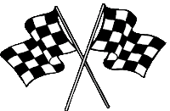
Revision and Exam Technique Pit stop:
The Stresemann Era and the Impact of the Great Depression
To develop good habits for revision and attempting exam questions, we are going to attempt a revision activity and exam question at the end of each short unit of study.
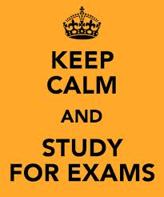
For homework this week, you need to choose and complete two tasks from this homework menu:
1 revision activity
1 exam question

These need to be attempted to the best of your ability and handed in on the due date. They will be marked and will form part of your revision folder, to help you nearer the time of your exams.
Create a set of cue cards about the problems faced by Germany as a result of the Great Depression. | In what ways were the lives of people in Germany affected by the Great Depression?  Explain your answer.  [8 marks] | Create a set of ten quiz questions (with answers) to test your knowledge about the Stresemann era and the Great Depression.
In what ways did German culture change in the 1920s?  Explain your answer.  [8 marks] | How does Interpretation D differ from Interpretation C about what happened at the Munich Putsch?  [4 marks]  Why might the authors of Interpretations C and D have a different interpretation about what happened at the Munich Putsch?  [4 marks] | Create and write down a memory journey to remember the key points about the Stresemann era.
A revision activity of your choice for which you produce evidence of your activity (a signature from home isn’t enough – you need to produce evidence of active revision). | Which of the following was the more important reason why the Weimar Republic was in danger in the years 1919 – 1923:  - Economic problems  - Political unrest?  Explain your answer with reference to both events.  [12 marks] | Create a learning mat to show the key facts about the Stresemann era and the effects of the Great Depression.

