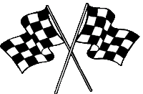
Revision and Exam Technique Pit stop:
Kaiser Wilhelm and the difficulties of ruling Germany
To develop good habits for revision and attempting exam questions, we are going to attempt a revision activity and exam question at the end of each short unit of study.
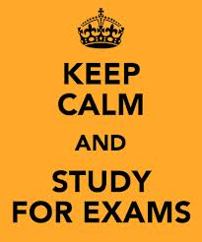
For homework this week, you need to choose and complete two tasks from this homework menu:
2 revision activities
Or:
1 revision activity
1 exam question

These need to be attempted to the best of your ability and handed in on the due date. They will be marked and will form part of your revision folder, to help you nearer the time of your exams.
Create a set of five cue cards about the problems faced by Kaiser Wilhelm. | Describe two problems faced by Kaiser Wilhelm II’s government in ruling Germany up to 1914.  [4 marks] | Explain your understanding of the following key words, using written explanation and pictures: Industrialisation, Second Reich, Kaiser, Chancellor, Reichstag, Bundesrat.
Create an illustrated mindmap using colour and images about the problems faced by Kaiser Wilhelm. | Create a set of revision notes for two of the lessons in this unit. | Design a revision leaflet for this unit. Include key words, key events and pictures or symbols.
A revision activity of your choice for which you produce evidence of your activity (a signature from home isn’t enough – you need to produce evidence of active revision). | A cartoon strip or storyboard to show the problems faced by Kaiser Wilhelm. | A revision game which you have created about this section; you will then be able to use it to help you when you begin revision at the end of the course.

