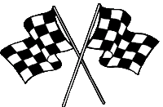
Revision and Exam Technique Pit stop:
The Impact of the First World War
To develop good habits for revision and attempting exam questions, we are going to attempt a revision activity and exam question at the end of each short unit of study.
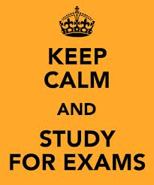
For homework this week, you need to choose and complete two tasks from this homework menu:
1 revision activity
1 exam question

These need to be attempted to the best of your ability and handed in on the due date. They will be marked and will form part of your revision folder, to help you nearer the time of your exams.
Create a set of five cue cards about the problems faced by Germany following the First World War. | In what ways were the lives of people in Germany affected by the First World War?  Explain your answer.  [8 marks] | Using play dough or plasticine, create a set of models to show the causes of hyperinflation in 1923. Take and bring to lesson at least one photograph as evidence.
In what ways did the lives of people in Germany change during the First World War?  Explain your answer.  [8 marks] | Which of the following had the greater impact on the German people:  - The Treaty of Versailles  - The hyperinflation crisis of 1923?  Explain your answer with reference to both events.  [12 marks] | Design a revision leaflet about the Weimar Republic and its problems. Include key words, key events and pictures or symbols.
A revision activity of your choice for which you produce evidence of your activity (a signature from home isn’t enough – you need to produce evidence of active revision). | Which of the following was the more important reason why the Weimar Republic was in danger in the years 1919 – 1923:  - Economic problems  - Political unrest?  Explain your answer with reference to both events.  [12 marks] | Create an A3 chart, diagram or poster to show the differences between left-wing and right-wing ideas, and to compare the threat that the two sides posed for the Weimar Republic.

