AQA GCSE History Outline 2016-2018

Paper 1; Section A:
1B Germany, 1890–1945: Democracy and dictatorship
This period study focuses on the development of Germany during a turbulent half century of change. It was a period of democracy and dictatorship – the development and collapse of democracy and the rise and fall of Nazism.

Students will study the political, economic, social and cultural aspects of these two developments and the role ideas played in influencing change. They will also look at the role of key individuals and groups in shaping change and the impact the developments had on them.

Topics | I am not very confident on this topic | I can explain what it was | I can use evidence to explain why it was important | I could evaluate how important a factor it was
Part one: Germany and the growth of democracy
Kaiser Wilhelm and the difficulties of ruling Germany
The growth of parliamentary government
The influence of Prussian militarism
Industrialisation of Germany
Social reform and the growth of socialism
The domestic importance of the Navy Laws
Impact of the First World War: war weariness, economic problems; defeat; the end of the monarchy
Post-war problems including reparations, the occupation of the Ruhr and hyperinflation.
Weimar democracy and the Constitution
Political change and unrest, 1919–1923, including Spartacists, Kapp Putsch and the Munich Putsch
the extent of recovery during the Stresemann era (1924–1929): economic developments including the new currency, Dawes Plan and the Young Plan;
The impact of international agreements on recovery;
Weimar culture and the Golden Age
Part two: Germany and the Depression
The impact of the Depression
The growth in support for the Nazis including the role of the SA; Hitler’s appeal (1928–1932)
The failure of Weimar democracy: election results; the role of Papen and Hindenburg and Hitler’s appointment as Chancellor
The establishment of Hitler’s dictatorship: the Reichstag Fire; the Enabling Act; elimination of political opposition; trade unions; Rohm and the Night of the Long Knives; Hitler becomes Führer.
Part three: The experiences of Germans under the Nazis
Control: Goebbels, the use of propaganda and censorship; Nazi culture
Control: repression and the police state and the roles of Himmler, the SS and Gestapo;
Opposition and resistance to the Nazis, including White Rose group, Swing Youth, Edelweiss Pirates and July 1944 bomb plot.
Economic changes: benefits and drawbacks; employment; public works programmes; self-sufficiency
The impact of war on the economy and the German people: rearmament; bombing, rationing, labour shortages, refugees.
Social policy and practice and their impact on women, young people and youth groups; education
Control of churches and religion
Aryan ideas, racial policy and persecution; the Final Solution

Revision Guides

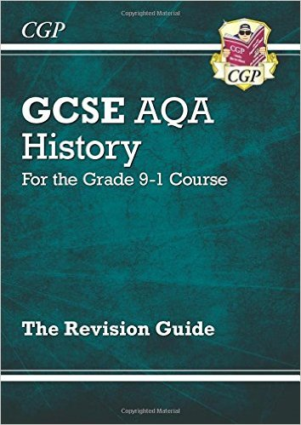
New GCSE History AQA Revision Guide - for the Grade 9-1 Course
by CGP Books £6.53 approx

https://www.amazon.co.uk/New-GCSE-History-Revision-Guide/dp/1782946047/ref=sr_1_fkmr0_1?ie=UTF8&qid=1482242919&sr=8-1-fkmr0&keywords=AQA+GCSE+History+revision+1890-1945+Germany

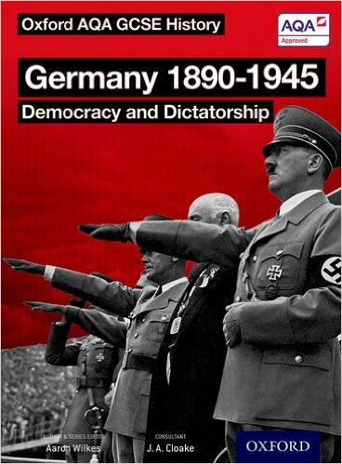
Oxford AQA History for GCSE: Germany 1890-1945: Democracy and
by Aaron Wilkes £11.99

https://www.amazon.co.uk/Oxford-AQA-History-GCSE-Dictatorship/dp/0198370105/ref=sr_1_fkmr1_3?ie=UTF8&qid=1482243088&sr=8-3-fkmr1&keywords=AQA+GCSE+History+revision+1890-1945+Germany

Revision Websites
http://www.bbc.co.uk/schools/gcsebitesize/history/mwh/germany/
http://www.johndclare.net/Weimar1.htm

Ideas for Revision Tasks
Create a poster showing the reasons why Hitler became Dictator of Germany | Create an acrostic for Propaganda in Nazi Germany | Create a puppet show showing the story of Hitler’s rise to power | Write a diary entry for a Jew in Nazi Germany | Make a timeline for the persecution for the Jews in Germany
Create a poster supporting the idea that Hitler came to power through luck | Create a quiz about everything we have learned so far on Germany | Write a script for a play about life in Hitler’s Germany | Write a poem about the Reichstag Fire | Draw up a table showing how both skill and luck led to the rise of the Nazis
Create a poster opposing the Nazis | Write a textbook page with activities about Terror in Nazi Germany | Write a Newspaper report about how Stresemann solved many of the problems in Nazi Germany | Write a story about a rebel in Nazi Germany | Create a diamond 9 showing the main reasons why Hitler came to power
Create a mind map explaining why terror was so effective in Nazi Germany | Create a Haiku about opposition to the Nazis | Write a newspaper report about Kristallnacht | Design a monument to Gustav Stresemann | Design a questionnaire about the impact of the Great Depression
Create a mind map showing the different types of propaganda used in Nazi Germany | Design and make a board game about control in Nazi Germany | Write a newspaper report complaining about the Nazi government | Write a song about Gustav Stresemann | Write an essay about the reasons why Hitler came to power

