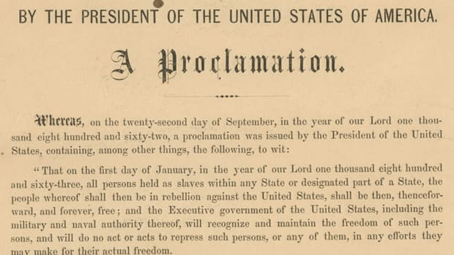
The ‘Long Civil Rights Movement’ up to 1917:
1861-1865: The US Civil War

The Emancipation Proclamation of 1863 aimed to bring man-power to the Union (North) to win a decisive victory. It also undermined the Southern economy, attacking their means of labour.

180,000 Black Americans served in the American Civil War, including 10,000 in the navy; 37,000 black Americas lost their lives. On the whole, black Americans were limited to menial jobs or non-combatant roles, which explains why so many died from preventable diseases rather than in combat. The rationale for Lincoln was that their non-combatant role freed up white American soldiers to fight at the front. However, racist stereotyping meant that black American units were often commanded by the most talented officers, and were therefore most successful in battle.

1865-1877: Reconstruction
- 1865 – 13th Amendment abolished slavery
- 1868 – 14th Amendment declared equal citizenship
- 1870 – 15th Amendment declared equal voting rights.
- 1870s – cotton depression in the South
- 1875 – Civil Rights Act (access to public facilities)
- 1877 – ‘Reconstruction’ ends as government military support is pulled out of the South by Hayes (Democrat).
1861  Start of American Civil War. Northern States are fighting against the Southern states. The Northern States want to end slavery. | 1865  American Civil War ends with a Northern victory under Abraham Lincoln. A law is passed (called The Thirteenth Amendment) to end slavery. All slaves are set free. | 1865  The Ku Klux Klan is setup. They use violence and intimidation to keep black and white Americans segregated (separate). | January 1865  William T. Sherman's Special Field Order No. 15, issued on Jan. 16, 1865 declared that freed slaves were entitled to ‘forty acres and a mule’ to support themselves. This came to nothing and, instead, sharecropping was introduced. Free men worked the land for a share of the crop they grew. Some sharecroppers ended up working for their old slave masters, but as free men. Sharecroppers had to buy tools and supplies from planters’ shops. The money to pay for this came out of their ‘share’. Many often spent more than their share could cover each year, so they fell into debt
1866  The Fourteenth Amendment was passed, making black people full US citizens, not three-fifths of a person. | 1867  A Freedmen’s Bureau is setup to help black people find work and to build black schools. It set up over 4000 schools, which took in over 250,000 black students. These included colleges and primary schools. This was part of the period called ‘Reconstruction’, establishing freedom in the South. | 1870  The Fifteenth amendment is passed, giving black people the right to vote in America. This also meant that black men could stand for election, sit on juries, become judges. Black men could now represent southern states in Congress.
1870  Black men found that there was a difference between their legal rights and what they were allowed to do. They had the right to vote, but were threatened or physically stopped from voting. In some places riots broke out over black voting, and many black people were killed. It was not goo having rights which were not enforced. | 1870  The Freedmen’s Bureau is shut down. By this time, 21% of freed slaves could read and write. | 1872  The Ku Klux Klan was banned. Some judges and policemen were members of the Klan so the ban was hard to enforce. | 1876  Northern soldiers leave the Southern states. They had been protecting the rights given to black people.
March 1877  Many schools for black children were forced to close in Southern states because white people would not sell them supplies. Some were also burned down and students beaten up. A 17 year old black teacher was murdered for starting a school in Tennessee. | May 1877  Southern states passed laws called the JIM CROW laws. This forced black and white people to use separate facilities. These included restaurants, theatres, buses, water fountains and schools. These would be labelled for ‘whites’ and ‘coloureds’. Many shops and restaurants wouldn’t serve black people at all. | March 1877  The new US president, Rutherford B. Hayes (Republican) took the army out of the South. This made life harder for black people there. | 1877 onwards.  Some black churches and schools suggested that people might be better-off moving north or west (out of the South). Many went.

Why did Reconstruction fail?
- SOCIAL reasons - This is the easy argument, that whilst federal legislation was passed to allow for equality, it was never enforced by states because it was constantly undermined by inherent racist attitudes. By 1877, freedom legislation had been eroded and abandoned.
- POLITICAL reasons - As David Blight argues, politically Reconstruction failed because reconciliation with the South was prioritised by the federal government at the expense of black civil rights. They were keen to appease resentment of northern military occupation. This was why Johnson was so lenient towards the south, leaving discrimination unchecked. Steven Hahn argues that Reconstruction ultimately failed when Southern black Americans lost the military support of the North (Hayes’s compromise of 1877).
- ECONOMIC reasons - Robert Cooke argues that Reconstruction was undermined by the failure to redistribute wealth and land and the non-autonomous sharecropping system that forced black Americans to rent land and locked them into a system of indebtedness. Without the means for a free labour economy and adequate land reform, black Americans had no economic power or capital to buy land. At this time, citizenship was tied to property. This rendered their vote useless, as they had no means to exercise their freedom. This was worsened by the cotton depression of the 1870s.

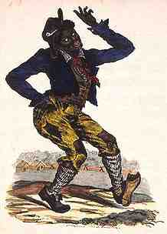
1883 – 1954: Jim Crow

“Jim Crow” was a song by a minstrel – someone who blackened their face and performed to crowds. The ‘Jim Crow’ character was very popular with white audiences. It later became an offensive name for black people. By their stereotypical depictions of blacks, they helped to popularize the belief that blacks were lazy, stupid, inherently less human, and unworthy of integration.

Segregation laws were known as ‘Jim Crow laws’. During the 1890s, de jure segregation increased.
De facto segregation = segregation as fact, whether by right/law or not
De jure segregation = segregation by right; supported by law

Key dates:
- 1883 Civil rights cases in US Supreme Court; they declared that individual cases of discrimination in private businesses did not contradict the amendments because these only applied to federal cases.
- 1883 Civil Rights Act 1875 declared unconstitutional by the SC (SC had been given increasing power since 1801 (Judge John Marshall Harlan) to test legislation against the constitution….even though the SC itself was never specified in the constitution!)
- 1887 Florida introduces legal segregation in railway carriages between black and white citizens.
- 1888 Mississippi follows Florida's lead and introduces legal segregation on the railways
- 1890 Mississippi changes state constitution in a plan to exclude black Americans from voting.
- 1892 New voting regulations involving poll tax and literacy test in Mississippi
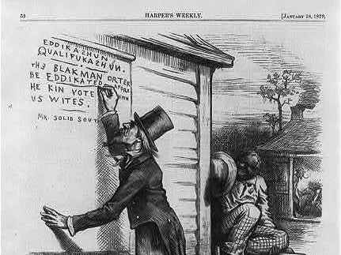
- 1896 Plessy v Ferguson Supreme Court case accepts ‘separate but equal’ interpretation of the fourteenth amendment
- 1898 Louisiana introduces the Grandfather Clause to its voting regulations, which excludes vast majority of black voters.
- 1898 Williams V Mississippi Supreme Court case endorses changes in voting rules in Mississippi.
- 1899 Cumming v Richmond County Board of Education endorses legal segregation in public schools.
- 1900 Ida Wells Barnett pamphlet is published on violence against black Americans.

Examples of Jim Crow Laws:
- Marriage - "All marriages between a white person and a negro, or between a white person and a person of negro descent to the fourth generation inclusive, are hereby forever prohibited." (Florida)
- Barbering - "No colored person shall serve as a barber [to] white women or girls." (Georgia law)
- Toilets - "Every employer of white or negro males shall provide for such white or negro males reasonably accessible and separate toilet facilities." (Alabama)
- Buses - "All passenger stations in this state operated by any motor transportation company shall have separate waiting rooms or space and separate ticket windows for the white and colored races." (Alabama)
- Restaurants - "It shall be unlawful to conduct a restaurant or other place for the serving of food in the city, at which white and colored people are served in the same room, unless such while and colored persons are effectually separated by a solid partition extending from the floor upward to a distance of seven feet or higher, and unless a separate entrance from the street is provided for each compartment." (Alabama)
- Burial - "The officer in charge shall not bury, or allow to be buried, any colored persons upon ground set apart or used for the burial of white persons." (Georgia)
- Schools - "[The County Board of Education] shall provide schools of two kinds; those for white children and those for colored children." (Texas)

