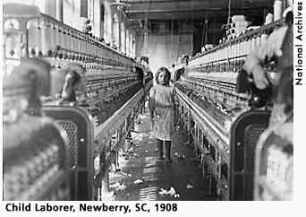
The Progressive Era in the USA (1890 - 1920)
Historians refer to the first two decades of the twentieth century as the ‘progressive era’. Historians do not agree about the causes, meaning or success of the progressive era, arguing that it is more useful to look at several strands of progressivism rather than a unified movement.
Progressivism is the term applied to a variety of responses to the economic and social problems rapid industrialization introduced to America.
Progressivism began as a social movement and grew into a political movement. The early progressives rejected Social Darwinism. In other words, they were people who believed that the problems society faced (poverty, violence, greed, racism, class warfare) could best be addressed by providing good education, a safe environment, and an efficient workplace.
Whether the aim was to combat big business, protect consumers, civilise the marketplace or guarantee industrial freedom in the workplace, Progressives assumed that the modern era required a fundamental rethinking of the functions of political authority.
Progressivism was an international movement. Facing similar social problems, reformers Europe and the US crisscrossed the Atlantic, exchanging ideas and studying social policy. As governments in Britain, France and Germany instituted old age pensions (Britain 1908) minimum wage laws, unemployment insurance (Britain 1911) and the regulation of workplace safety, American reformers came to believe they had much to learn.
The term ‘social legislation’, meaning government intervention to address urban problems and the insecurities of working-class life, originated in Germany but soon entered America’s political vocabulary.
Americans began to modify their view of government as a threat to individual liberty and instead see it as a means for solving social ills. This was in part because the American understanding of liberty itself was in flux. Instead of a highly limited and negative concept of freedom from outside restraint, it was seen as a positive and dependent of the effective distribution of power.
Progressives lived mainly in the cities, were college educated, and believed that government could be a tool for change. Social reformers, like Jane Addams, and journalists, like Jacob Riis and Ida Tarbel, were powerful voices for progressivism. They concentrated on exposing the evils of corporate greed, combating fear of immigrants, and urging Americans to think hard about what democracy meant. Other local leaders encouraged Americans to register to vote, fight political corruption, and let the voting public decide how issues should best be addressed.
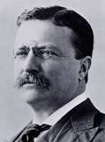
On a national level, progressivism gained a strong voice in the White House when Theodore Roosevelt became president in 1901. Theodore Roosevelt believed that strong corporations were good for America, but he also believed that corporate behaviour must be watched to ensure that corporate greed did not get out of hand (trust-busting and federal regulation of business).
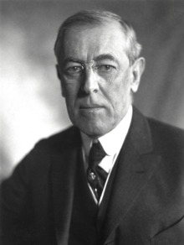
Neither Republicans nor Democrats had a monopoly on progressivism. McKinley, Taft and Roosevelt were progressive Republicans whilst Wilson was a progressive Democrat. In 1912, there was even a short-lived Progressive Party.
Woodrow Wilson (Democrat, won 1912 election on 42% of the vote because of the Republican split between Taft and Roosevelt) represented a competing strand of Progressivism. He admired the British system and saw himself as more a Prime Minister, leading the nation, formulate legislation and manage Congress. Although both believed government action necessary to preserve individual freedom, they differed on the dangers of increasing government power. Wilson insisted that democracy must be reinvigorated by restoring market competition and freeing government from domination by big business.
The New Freedom, envisaged the Federal government strengthening antitrust laws, protecting the right of workers to unionise and actively encouraging small businesses, in order to create the conditions for the renewal of economic competition without increasing government regulation of the economy. Wilson warned that big business was just as likely to corrupt government as to be managed by it. To Roosevelt’s supporters, Wilson’s program supported small businesses at the expense of labour, consumers and professionals.
In office from 1913, Wilson’s presidency marked a turning point, where his measures sought to investigate and regulate big business. He introduced reductions on import duties (the Underwood Tariff) and imposed a graduated tax on the richest 5%of Americans. Other measures supported farmers, trade union rights to strike and railroad workers, including an eight-hour working day for the latter. Some Americans argued that he didn’t go far enough.
Progressivism arguably ended with World War I. It was ironic that he won the 1916election by keeping the USA out of the war, then entered WWI in April 1917. Wilson's applied progressivism to foreign policy, with progressive language ("the war to make the world safe for democracy"), and involved federal government in private enterprise, taking over the running of railways and telephone lines, for example. Female suffrage and prohibition (18th Amendment) were also key progressive aims achieved as a result of WWI. However, the longing for stability and order amongst the public largely ended the progressive era.
Many left-wing historians see the progressive era as illusory, as a triumph of conservatism. They claim marginal reforms were made to keep the masses happy, whilst big business and corruption survived and even prospered. Right-wing historians tend to argue that the real achievements of the era, wage increases, pensions and profit-sharing schemes, were the result of the voluntary actions of big businesses rather than government intervention.

