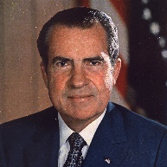
Richard Milhous Nixon (1969-74)
Personality (p.162-164) – Nixon was ruthlessly ambitious and pragmatic, but personally un-liked.

Impact of the Watergate Scandal (p.164 & 298-299 & cartoons on 264) – Nixon lost credibility and came under huge media scrutiny for his ruthless ambition – it was now clear that the press aimed to challenge government authority, as well as merely report on it.
International politics: (p.261 & 162-164) – Nixon was pragmatic in his cold war leadership, but blundered over Vietnam & acted without Congress..
Domestic politics: (p.262) – Nixon was traditionally republican and tried to regain economic stability, albeit unsuccessfully.
Key dates

