* of Suburbia*

Women’s economic position

Disadvantages of suburban living

The failure of women’s activism

*Living the American Dream*

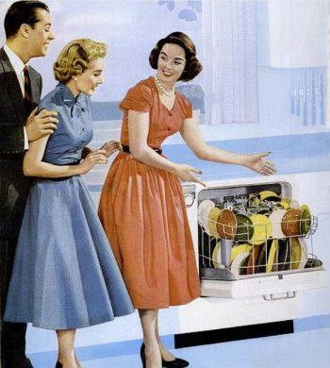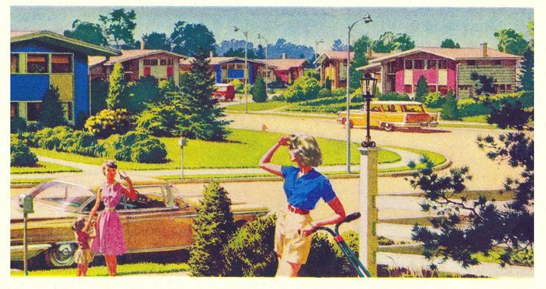

New conveniences and labour-saving devices

Media portrayals of the ‘happy housewife’ living the American Dream

The dramatic growth in suburbia