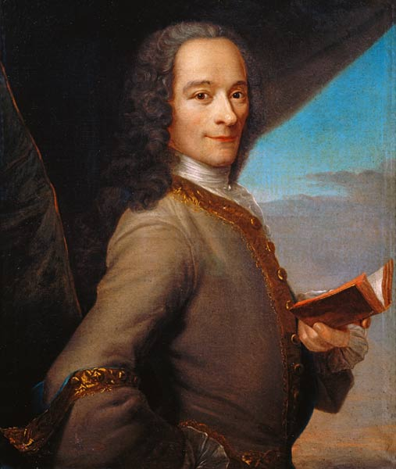

**Francois-Marie Voltaire**  
  
Voltaire complained about the many wrongs he saw in his home country of France. He complained about injustice and inequality within the law. He also believed that the French church held far too much power.  
  
Voltaire was a keen supporter of the idea that Catholics and non-Catholics should be able to co-exist (live together) peacefully.   
  
He was most passionate about attempting to change or remove the cruel laws and punishments that were still being used in France. He thought that these punishments were uncivilised and represented a more medieval society. The picture below shows a traditional punishment whereby people were “broken on a wheel”.   
   
Voltaire stated that all people should have the right to speak their mind and he wanted to see new freedoms in France. He disliked the idea of censorship (where information is controlled or hidden from the public).

**Voltaire**  
“Should you be able to say anything you want to say?”

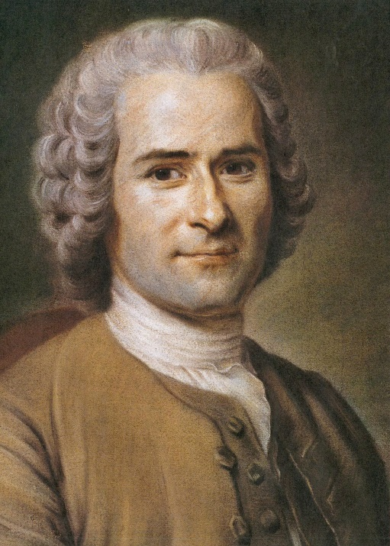

**Rousseau**  
“Are we born to act the way we do or does society make us what we are?

**Jean-Jacques Rousseau**  
  
Rousseau developed some very important ideas during the Enlightenment. One of these was the ‘social contract’. He believed that more people should take part in government, and that people should serve each other any way they could.   
  
He also started using words from the ancient classical world, like “citizen”. He believed that it was the citizens of a country who made up a nation. These citizens had both duties (things they should do) and rights (things they could expect).   
  
He wanted people to have meetings where the government could learn ordinary people’s wishes. His main idea was the belief that all people are born equal, he therefore argued against the idea of royalty and nobility.

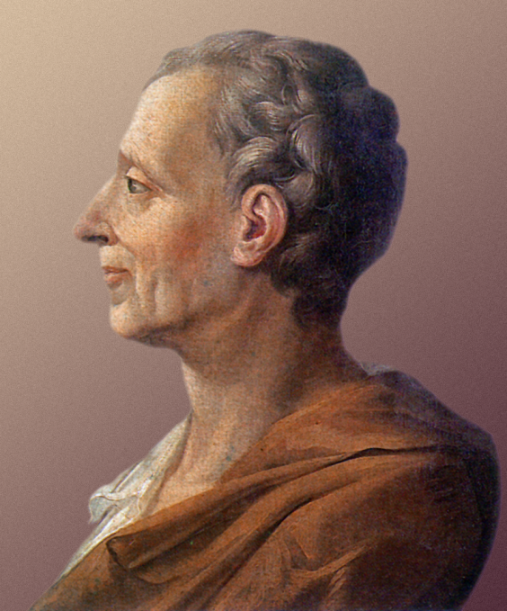

**Montesquieu**“How can we prevent our leaders from being corrupt and going bad?”

**Charles-Louis Montesquieu**  
  
Montesquieu believed that all things were made up of rules or laws that never changed. He believed that a government elected by the people was the best form of government. This is called democracy, where everyone can vote for their government.   
  
In order for a country to succeed, Montesquieu stated that the right balance of power needed to be achieved. This was an idea that he called “the separation of powers”. He thought that England was a good example of this, as the power was divided between the king, parliament and the law courts.   
  
Montesquieu believed that there would be no freedom if one person held too much power and that power should be able to be limited if necessary.  
  
Despite his ideas about democracy he did not feel that all people were equal. Montesquieu approved of slavery and thought that women were weaker than men. However he did claim that he thought women ought to play a part in government as he thought that their apparent calmness and gentleness would help the decision making process.

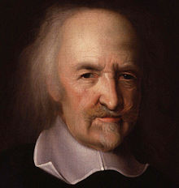

**Thomas Hobbes**  
  
Hobbes was an English philosopher whose political philosophy dominated the 17th century and continues to have a major influence today. Many of Hobbes’s ideas centred around theories of how to prevent fear and conflict (fighting or arguments) within society.   
  
Hobbes believed that humans in their “natural” state were fearful and violent. As a consequence he suggested that all people should look to accept a central authority, be it a king or an elected group of people.  
  
He firmly believed that all people should be governed (ruled) by someone else. His beliefs on human nature suggested that without government each person would compete for resources, which would lead to violence.   
   
Personally, Hobbes encouraged a system whereby a king or a queen was in control.

**Thomas Hobbes**“Is it ever right to overthrow your ruler?”

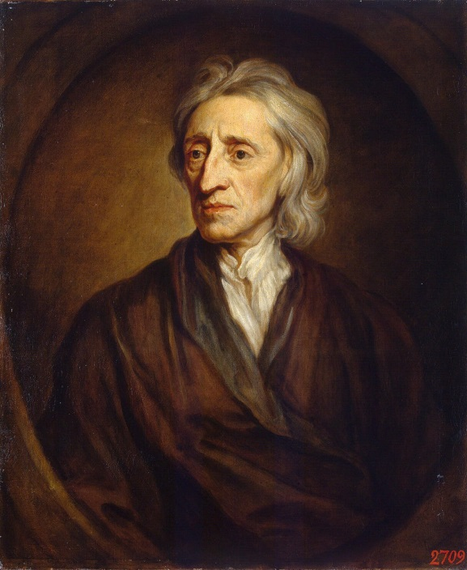

**John Locke**  
  
In his most important work named *Concerning Human Understanding,* John Locke described how humans gain understanding from the environment that they live in. He further described how he believed that all people had basic “natural rights” and that those in control are required to protect and uphold these.  
  
As part of their “natural rights”, Locke stated that citizens had the right to overthrow their rulers under certain circumstances. Locke further described how he thought that people should come together as a community to create and enforce laws.   
  
The most powerful idea presented by Locke was the idea that each person should use reason to judge what is right and wrong rather than simply accept or trust the opinion of those in power. It is through this process that natural laws are created.

**John Locke**“Is it ever right to overthrow your ruler?”