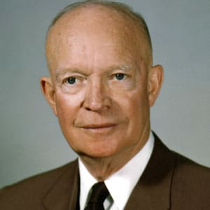
Dwight Eisenhower (1953-61)
Personality (p.83 and box on p.84) – Eisenhower was decisive, optimistic and friendly.
Relations with the media and the public (p.85-6) – Eisenhower aimed to restore what he saw as the dignity of presidential leadership lost under Truman. He had a good public manner and explained complex concepts using images (e.g. Domino theory). However, he could sometimes obscure / minimise / hide realities and was often seen as a ‘do-nothing’ President.
Domestic politics: Ability to manage Congress and other bodies (p.84-85) – Eisenhower argued that his ‘dynamic conservatism’ meant ‘conservative when it comes to money, liberal when it comes to people’.
Key dates

