A short history of The American Revolutionary War, 1775 to 1783.

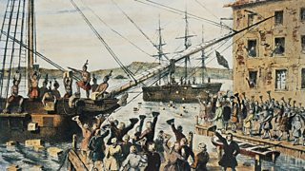
13 Colonies
Before the American Revolution, there were several British Colonies in the Americas. Not all of them participated in the revolution. The 13 colonies who did were Delaware, Virginia, Pennsylvania, New Jersey, Georgia, Connecticut, Massachusetts, Maryland, North Carolina, South Carolina, New Hampshire, New York, and Rhode Island.
Representation
One of the main reasons that the colonists rebelled against Great Britain is that they felt they were not represented in the British government. The British government was making new laws and taxes on the colonies, but the colonies had no say. For example, the British government decided that the American colonists should contribute financially to the protection of this new expanded empire. It imposed certain new taxes on the colonists to pay for the British armed forces in America.
- In 1765 Britain passed the Stamp Act, which put a stamp duty (tax) on various documents and items. This included all legal documents, which upset lawyers, and playing cards, which upset sailors. There were major riots in the colonies against the tax, and in 1766 the British cancelled it.
- In 1767 the British introduced more new taxes known as the Townshend Acts. In 1770 there was a riot against these duties in Boston and several American protesters were killed by British soldiers – this became known as the ‘Boston Massacre’.
- In 1773 Britain introduced a new tea duty, and a disturbance broke out, again in Boston, when a group of colonists dressed up as Native Americans and tipped a cargo of taxed tea into the sea in protest. The British reacted very fiercely to this ‘Boston Tea Party’. They passed the Coercive Acts in 1774 to punish Boston by closing the port to any trade until the cost of the tea was repaid. The Acts also took away some of the democratic rights of Boston's citizens.

The War
By 1775 relations between Britain and the colonies had deteriorated badly, and a war broke out between them. This eventually became known as the War of the American Revolution or the American War of Independence. The initial aim of the colonists was to have more control over their own affairs, especially taxes, but they did not want to be independent. By 4 July 1776 they had changed their minds, and severed their ties with Britain by signing the Declaration of Independence.
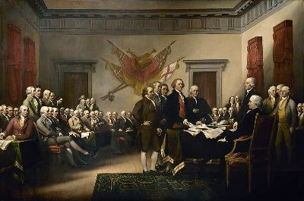
One of the key things that helped change their minds on independence was the book Commonsense written by the English radical thinker Tom Paine in 1776. Paine persuaded many American colonists that they owed nothing to their British masters. The war ended after Lord Cornwallis’ surrendered at Yorktown in 1781. The Peace Treaty was then signed in September 1783 at Versailles. The 13 American colonies became the independent United States of America.
Who wrote the Declaration of Independence?
The Declaration of Independence is one of the most important documents in the history of the United States. It was an official act taken by all 13 American colonies in declaring independence from British rule.
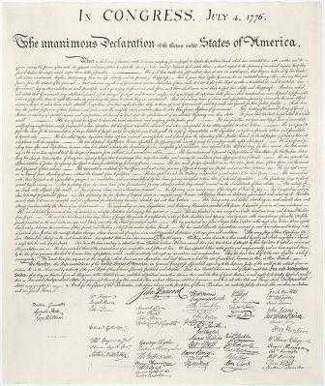
On June 11, 1776 the Continental Congress appointed five leaders, called the Committee of Five, to write a document explaining why they were declaring their independence.

The five members were Benjamin Franklin, John Adams, Robert Livingston, Roger Sherman, and Thomas Jefferson. The members decided that Thomas Jefferson should write the first draft. Benjamin Franklin, John Adams, and Jefferson then worked together to make changes to the document.
Did everyone agree?
Not everyone agreed at first on declaring independence. Some wanted to wait until the colonies had secured stronger alliances with foreign countries. In the first round of voting South Carolina and Pennsylvania voted "no" while New York and Delaware chose not to vote. The Congress wanted the vote to be unanimous, so they continued to discuss the issues. The next day, July 2nd, South Carolina and Pennsylvania reversed their votes. Delaware decided to vote "yes" as well. This meant that the agreement to declare independence passed with 12 yes votes and 1 abstention (meaning New York chose not to vote).

July 4, 1776
On July 4, 1776 the Congress officially adopted the final draft of the Declaration of Independence. This day is still celebrated in the United States as Independence Day. The actual signing of the final document was on August 2, 1776.
After the signing, the document was sent to a printer to make copies. Copies were sent to all the colonies where the declaration was read aloud in public and published in newspapers. A copy was also sent to the British government.
Famous Words
The Declaration of Independence did more than just say the colonies wanted their freedom. It explained why they wanted their freedom. It listed all the bad things that the king had done to the colonies and that the colonies had rights which they felt they should fight for.
Perhaps one of the most famous statements in the history of the United States is in the Declaration of Independence:
"We hold these truths to be self-evident, that all men are created equal, that they are endowed by their Creator with certain unalienable Rights, that among these are Life, Liberty and the pursuit of Happiness."

Were ‘all men’ equal?
At the heart of these famous words lies a famous contradiction; conflict arises when, in seeking to extend the freedoms and rights of one individual, the freedoms of others are violated. Can freedom and equality ever co-exist in a society?

Whilst Jefferson’s words helped to create an image of the USA as a land of freedom, opportunity and promise, in reality this was not the case. At the time of writing, there were 500,000 men, women and children who were slaves. Jefferson’s claims also did not include the vast numbers of immigrants who had travelled to the USA hoping to find the dream he had promised. In reality, Jefferson had reserved his ‘American Dream’ for the colonists, the descendants of the first British settlers, rather than the ‘melting pot’ of differing cultures and origins that came to become American society.

