Weimar and Nazi Germany, 1918-1939

Key Topic One  The Weimar Republic 1918-29 | Key Topic Two  Hitler’s Rise to Power, 1919-33 | Key Topic Three  Nazi control and dictatorship, 1933-39 | Key Topic Four  Life in Nazi Germany, 1933-39
- The origins of the Republic, 1918-19  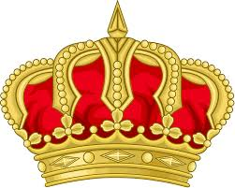  - WW1 had a terrible impact on Germany- blockade, feelings of defeat, lack of food etc  - German revolution- abdication of the Kaiser and creation of a republic.  - The Weimar constitution had a number of strengths such as both men and women could vote.  - There were also weakness such as many small parties would win seats which led to no majority in the Reichstag. | 2.1 Early development of the Nazi Party, 1920-22  - As part of his work for the army after WW1 Adolf Hitler attended meetings of the German Workers’ Party.  - Hitler joined the party and within 2 years had taken control. He created a 25-point programme.  - Hitler was a popular leader and worked hard to reorganise the party.  - The SA played an important role in the early party, they looked strong and organised. | 3.1 The creation of a dictatorship, 1933-34  - Hitler’s power as chancellor was limited by Von Papen his vice chancellor who was not a Nazi and the Reichstag.  - On the 27th of February there was a fire at the Reichstag. Hitler used this as an excuse to ban the Communist party and pass emergency powers.  - The Enabling Act was passed by the Reichstag on the 24th March 1933, it changed the constitution and gave Hitler more power.  - Trade unions and other political parties were banned. | 4.1 Nazi policies towards women  - Nazis believed women should be housewives and mothers. They should dress traditionally  - The Law for the Encouragement of marriage gave financial incentives for people to get married.  - The mother cross medals encouraged large families.  - The Lebensborn programme encouraged single women to have babies with SS men.  - Propaganda and polices discouraged women from working. e.g. women banned from professional jobs.
- Early challenges to the Republic, 1919-23  - The Weimar government was unpopular, it was linked to defeat and the peace treaty, the Treaty of Versailles.  - The treaty meant Germany lost colonies, had to pay reparations and had limits on the armed forces.  - In January 1919, the Spartacist uprising (left wing) tried to seize Germany, it was crushed by the Freicorps.  - In 1920 the Kapp Putsch (right wing) tried to seize power, the rebellion failed.  - Political violence was almost constant- 1919-23.  - 1923 saw the French occupation of the Ruhr due to missed reparations payments and hyperinflation. | - The Munich Putsch and lean years, 1923-29  - In 1923 Hitler tried to seize power in Germany.  - Long term causes- WW1 and consequences, Weimar  - Medium term- influenced by Italian fascists  - Short term- hyperinflation  - The putsch was a failure and Hitler was imprisoned. The Nazi party was banned. The party lost support.  - In prison Hitler wrote Mein Kampf, clarifying his ideas.  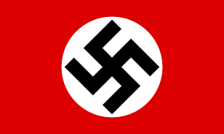  - The party was again reorganised- headquarters were set up, the SS were strengthened and a national system of organisation was created.  - Bamberg Conference (1926)- confirmed Hitler as leader. | 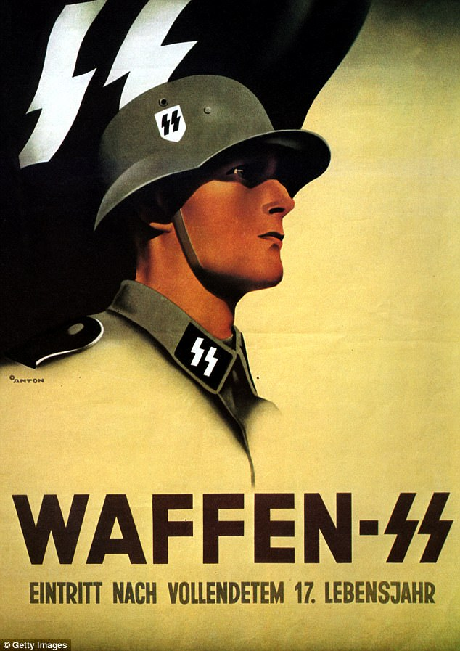  3.2 The Police state  - A police state is a country where the police are used to help keep control.  - Nazi police and security services had a lot of power in Germany- SS (private police force), SD (monitored opponents), Gestapo (secret police). SA (Nazi army) also supported.  - Concentration camps were set up to house opponents of the state.  - Judges and courts were controlled.  - The Nazis also controlled religious views. Hitler tried to work with the churches at first but later he Nazified them. | 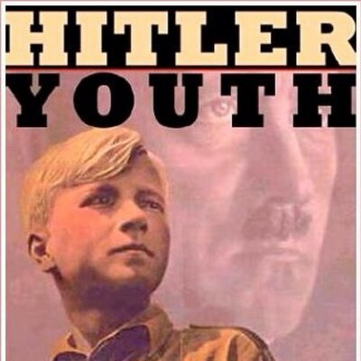  4.2 Nazi policies towards the young  - Hitler wanted to create a ‘Thousand Year Reich’, to do this he needed young people.  - In March 1939, it became compulsory to join the Hitler Youth- girls and boys youth groups organised by age.  - Boys- Political, military, character and physical training.  - Girls- Political, character and physical training. Focus on role as wives and mothers.  - Teachers had to join the Nazi Teacher’s league and promoted Nazi ideas and practices in the classroom.  - The Nazis controlled the curriculum and ensured students learnt about race, did lots of exercise and that all subjects indoctrinated students.
- The recovery of the Republic, 1924-29  - In August 1923 Stresemann was appointed chancellor.  - A period of economic recovery began  - The Rentenmark was a new currency which people trusted and so it stabilised the economy.  - The Dawes Plan (1924) temporarily reduced payments and provided US loans to support the economy.  - The Young Plan (1929) reduced the amount of reparations and extended the amount of time to pay. There were drawbacks but 85% supported it.  - The Locarno Pact, joining The League of Nations and the Kellogg-Briand Pact were foreign policy successes. | 2.3 Growth in Nazi support, 1929-32  - Stresemann died in October 1929  - In October 1929, the American stock market collapsed (Wall Street Crash) causing a worldwide depression.  - The effects on Germany were devastated- businesses closed and unemployment soared. The Weimar government seemed unable to act.  - This economic crisis made people turn to extremist groups like the Nazis to solve the problem.  - The Nazis appealed to many groups in society such as farmers and industrialists by having policies that had mass appeal. | 3.3 Controlling and influencing attitudes  - Joseph Goebbels was in charge of propaganda- films, posters, newspaper and radio that persuaded people to believe Nazi ideas.  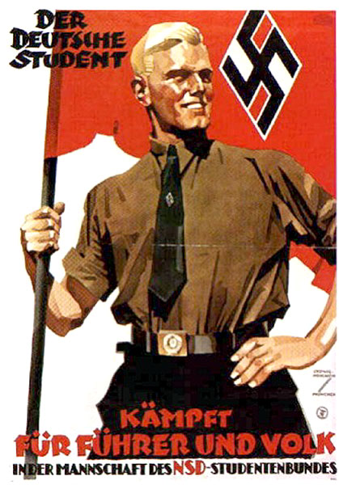  - The Nazis also used rallies, big gatherings to spread Nazi ideas and impress people.  - Some ideas were censored or prevented from being published.  - The Berlin Olympic Games of 1936 was a big propaganda opportunity.  - The Nazis controlled the art, architecture, music and literature that was created. | 4.3 Employment and living standards  - Hitler’s key aim was to reduce unemployment.  - Labour Service (RAD)- provided paid work for unemployed people and Autobahns (motorways) were built, creating many jobs.  - Rearmament also reduced unemployment.  - Unemployment figures looked better than they were because many people such as Jews and those in concentration camps didn’t count.  - Living standards also rose due to schemes such as Strength Through Joy, the VW and Beauty of Labour.  - German workers had to work more hours a week.
- Changes in Society, 1924-29  - Living standards suffered as a result of the economic problems  - There were some gradual improvements after 1924 including lower unemployment, less working hours, better houses and education.  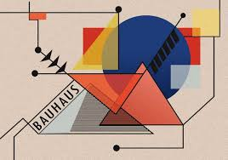  - Women’s lives changed- they had the vote, new rights and more access to professional jobs.  - There were cultural changes; Bauhaus movement in art, cinema, architecture.  - Some were opposed to these cultural changes and thought Germany should remain traditional. | 2.4 How Hitler became Chancellor, 1932-33  - In the early 1930s there were a number of elections for both president and chancellor.  - 30 May 1932: Von Papen became chancellor. He and Von Schleicher thought they could control Hitler and the Nazis.  - In July 1932, there were further elections and campaigning caused violence on the streets. The Nazis won the largest share of the votes.  - President Hindenburg refused to make Hitler Chancellor and elections were called for November. He hoped the Nazis would lose support.  - In the elections the Nazis were still the largest party and with civil unrest looming, Hitler was made chancellor in January 1933. | 3.4 Opposition, resistance and conformity  - Most Germans supported or conformed to the Nazis due to fear, propaganda and Hitler’s successes.  - There were some areas of opposition-  - The church- The Pastor’s emergency league and Pastor Niemoller led the opposition. The Confessing Church was created. Some Catholic priests also spoke out. This had limited success.  - Young people- Opposition groups were the Edelweiss Pirates and Swing Youth. The wrote anti-Nazi graffiti and did not join the Hitler Youth. Success limited.  - The army- Several plots attempted to kill Hitler- all failed.  - Political parties- The SPD campaigned against the Nazis with limited success. | 4.4 The persecution of minorities  - The Nazis had 2 key beliefs about race- Eugenics and racial hygiene- all Germans should be white and healthy (Master race/Ayran).  - Those not seen as fit to be ‘German’ were classified as ‘Untermenschen’ or sub-human). Groups included in this were Slavs, Roma people, homosexuals and people with disabilities, mental or physical.  - The Nazis were Anti-Semitic, they hated Jewish people and passed laws to make their lives unbearable. Many Jews had died in concentration camps by 1939.  - Jews were targeted in Kristallnacht in November 1938.  - Many German people did not speak out against the treatment of these minority groups.

