GCSE – 9-1
Paper 2: Period study and British depth study (1HI0/20–29) - B4: Early Elizabethan England, 1558–88.
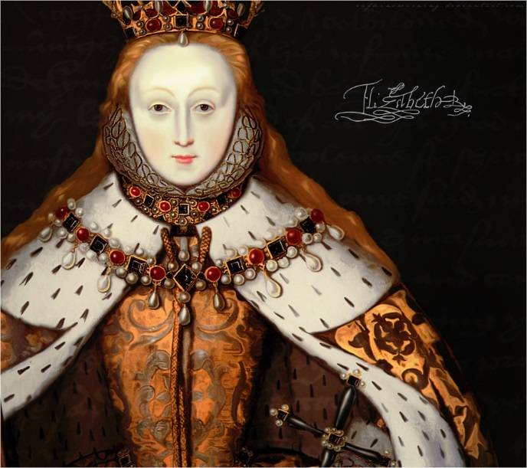
Key topic 1: Queen, government and religion, 1558–69

The situation on Elizabeth’s accession | ● Elizabethan England in 1558: society and government.  ● The Virgin Queen: the problem of her legitimacy, gender, marriage. Her character and strengths.  ● Challenges at home and from abroad: the French threat, financial weaknesses.
The ‘settlement’ of religion | ● Religious divisions in England in 1558.  ● Elizabeth’s religious settlement (1559): its features and impact.  ● The Church of England: its role in society.
Challenge to the religious settlement | ●The nature and extent of the Puritan challenge.  ● The nature and extent of the Catholic challenge, including the role of the nobility, Papacy and foreign powers.
The problem of Mary, Queen of Scots | ●Mary, Queen of Scots: her claim to the English throne, her arrival in England in 1568.  ● Relations between Elizabeth and Mary, 1568–69.

Key Questions

- Elizabeth I: who do you think you are?
- What was England like when Elizabeth became Queen?
- Why did Elizabeth decide to marry her country?
- How successfully did Elizabeth deal with her challengers abroad?

- How fair was Elizabeth’s religious settlement?

- How serious were the challenges to the religious settlement?
- Why did the Elizabeth’s cousin Mary Queen of Scots pose a threat to her rule?
- Review: How successful was Elizabeth’s first decade as queen of England?

Past Qs on this Key Topic (where the bullet points are ? they are questions from the textbooks so plan these by coming up with what you would have a paragraph on)

Describe two features of (4) 5 mins | Explain why …  You may use the following in your answer:  • …  • …  You must also use information of your own. (12) 15 mins | ‘Statement.’  How far do you agree? Explain your answer  You may use the following in your answer:  • …  • …  You must also use information of your own (16 - SPaG) 20 mins
Describe two features of Elizabeth’s experiences before she became Queen  Describe two features of Elizabeth’s education  Describe two features of the Privy council  Describe two features of the Elizabethan religious settlement  Describe two features of the challenge from the Puritans between 1558-1569  Describe two features of Mary Queen of Scots’ threat to Elizabeth | Explain why religion was so important in sixteenth century England  You may use the following in your answer  - ?  - ?  You must also use information of your own  Explain why Mary Queen of Scots created a problem for Elizabeth when she came to England in 1568  You may use the following in your answer  - ?  - ?  You must also use information of your own | ‘Elizabeth I dealt with the problems of 1558 successfully.’  How far do you agree? Explain your answer.  You may use the following in your answer:  • ?  - ?  You must also use information of your own  ‘The threat of invasion was Elizabeth’s main problem when she became queen in 1558.’  How far do you agree? Explain your answer. You may use the following in your answer:  • France  • Elizabeth’s legitimacy  You must also use information of your own.  ‘Elizabeth I dealt with the problems of 1558 successfully.’  How far do you agree? Explain your answer.  You may use the following in your answer:  • ?  - ?  You must also use information of your own  ‘‘Elizabeth’s religious settlement was a successful compromise.’  How far do you agree? Explain your answer.  You may use the following in your answer:  • ?  - ?  You must also use information of your own  ‘Religion was Elizabeth’s main problem in the year 1558-69.’  How far do you agree? Explain your answer.  You may use the following in your answer:  • the settlement of religion  Mary Queen of Scots; arrival in England in 1568  You must also use information of your own.  ‘Elizabeth I dealt with the problems of 1558 successfully.’  How far do you agree? Explain your answer.  You may use the following in your answer:  • ?  - ?  You must also use information of your own  ‘The religious Settlement of 1559 did not solve the problem of religion in Elizabethan England.’  How far do you agree? Explain your answer.  You may use the following in your answer:  • the new Church of England  - The Catholics and Puritans  You must also use information of your own  ‘The Babington plot was the main cause of the execution of Mary Queen of Scots.’  How far do you agree? Explain your answer.  You may use the following in your answer:  • ?  - ?  You must also use information of your own

Key Topic 1 Key Word Bank
- Spell
- Understand
- Use

- Life expectancy
- Religious martyrs
- Traitors
- Treason
- Mary I
- Anne Boleyn
- Henry VIII
- Catherine of Aragon
- Plots
- Spies
- Elizabethan
- Nobility
- Gentry
- Yeoman
- Tenant farmers
- Merchants
- Professionals
- Craftsmen
- Unskilled labourers
- Vagrant
- Court
- Privy Council
- Parliament
- Lord Lieutenant
- Justice of the Peace
- Courtiers
- Extraordinary taxations
- Militia
- Monarchy
- Secretary of State
- Divine Right
- Patron
- The Crown
- Royal Prerogative
- Patronage
- Succession
- Legitimacy
- Illegitimate
- Divorce
- Church of England
- Heir
- Roman Catholic
- Pope
- Protestant
- Annulment
- Arthur
- Allied
- Suitors
- Queen regnant
- Charismatic
- Financial
- Custom duties
- subsidies
- Profits of justice
- Loans
- Debt
- Crown income
- French alliance
- Auld alliance
- Mary Queen of Scots
- Mary of Guise
- Calais
- Treaty of Cateau-Cambersis
- English Reformation
- Christian
- Protestant
- Catholic
- Church of England
- Henry VIII
- Mass
- The Clergy
- Intermediary
- Last Supper
- Sacraments
- Holy Communion
- Diocese
- German States
- Puritan
- Altars
- Act of Supremacy
- Act of uniformity
- Royal injunctions
- Ecclesiastical high commission
- Book of common prayer
- Transubstantiation
- Royal supremacy
- Pilgrimage
- Saints
- Bishops
- Oath
- Parishes
- Recusants
- Church courts
- Visitations
- Puritan challenge
- Crucifixes
- Clothing
- Royal chapel
- Vestment
- Papacy
- Counter-reformation
- Heretics
- Martyr
- Nobility
- Northumberland
- Westmoreland
- Durham Cathedral
- Rebellion
- Holy Roman Empire
- Hapsburg
- French Protestants
- Treaty of Troyes
- Protestant rebels
- Netherlands
- Excommunicated
- Trade
- Embargo
- Rome
- Spanish inquisition
- Dutch Revolt
- Council of Troubles
- Council of Blood
- Duke of Alba
- Sea beggars
- Genoese loan
- Claim to the throne
- Mary Queen of Scots
- Treaty of Edinburgh 1560
- King Francis II
- Scottish Protestant Lords
- Anointed
- Henry Stuart – Lord Darnley
- James Stuart
- Earl of Bothwell
- Langside
- Name an heir
- Earl of Leicester

