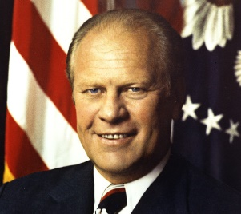
Gerald Ford (1974-1976)
Personality – the ‘regular guy’? How did he attempt to differentiate himself from Nixon’s style and how successful was this attempt? (p. 3,7)

Relations with the media and the public (p.7-8, 17) A legitimate President in the eyes of Americans?
Domestic politics: The economy and relations with Congress (p.3-4, 7-8, 27)

Key dates
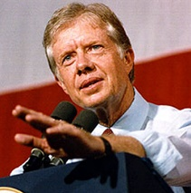
Jimmy Carter (1976-1980)
Personality – the ‘common touch’. How did he attempt to differentiate himself from Nixon’s style and how successful was this attempt? (p. 4, 8-9)

Key dates
Relations with the media and the public (p.9, 17, 30) A decline in confidence?

Foreign policies: A success or failure? (p.30)

Domestic politics: The economy and relations with Congress (p.4, 29, 30)

