Edexcel A-Level History
Papers 1 and 3 – establishing and using criteria
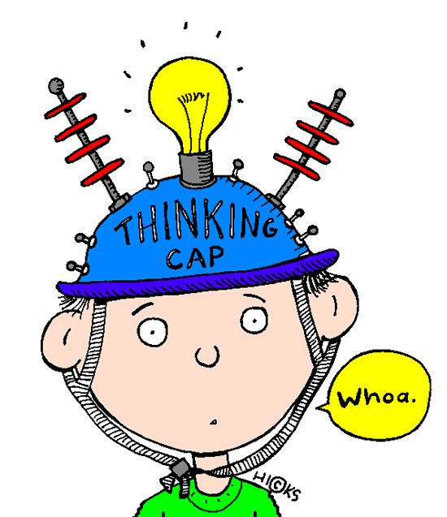
On the mark schemes for all the new Edexcel A-Level papers, there is a requirement to establish and use criteria in your judgements. This just means showing the examiner how you can measure the extent of something.

But this is not hard to do - it simply means being clear about the reasons for the judgements you make!

Here are some thoughts for how you can do this on Papers 1 and 3…….

Change/Continuity, Significance, and Similarity/Difference criteria (to judge the extent)
* Amount of people affected – consider social class, geographical spread, age and gender
* Length of change or impact – short or long term?
* Deep difference or lots of progress compared to previous situation – eg: in attitudes or policies
* Speed or pace – happened quickly or slowly over time?
* Effectiveness – accepted or resisted?
* Level of threat to the status quo
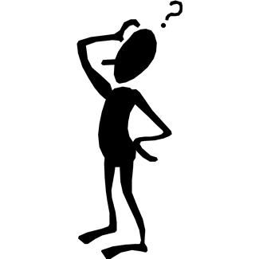
Consequence criteria (to judge the most significant consequence)
* Speed or pace – effects happened quickly or slowly over time?
* Effectiveness – accepted or resisted? Achieved aims?
* Coherence/consistency – stayed the same or adapted?
* Lead to or connected to other effects

Causation criteria (to judge the most significant cause)
* Connections to other causes
* Presence in a range of factors
* Level of threat to the status quo
* Trigger – present for a short time, but without it the event or change may not have happened when it did
* Underlying – present for a long time and created the conditions for an event or change to happen

The criteria you use will depend on the conceptual focus of the questions and the topic focus

Don’t overdo it – keep to around 3 criteria for any one question

For some questions, you could structure your answer around the criteria

In reaching a judgement, you should also evaluate the relative significance of criteria – for example in judging the extent of change you might conclude that something which affects all social classes is more significant than something that lasts a long time (or vice versa!)

