To what extent were the presidency and US politics revitalised, 1981 - 1996?
Homework to be collected today: Mock paper improvements and the second essay attempted.

Work to be checked in lesson tomorrow: This cover work.

Homework set today to be completed for your first lesson back in September (i.e. get it out of the way before the holidays):

- Read at least one on of the following texts, scanned and uploaded to Show My Homework, and complete the suggested tasks. You must be prepared to feedback to the class.
- Overview reading: Gil Troy, The Reagan Revolution: A Very Short Introduction (2009) - Find evidence for and against the view the Reagan revolutionised politics and society from 1980.

Economic focus: Sean Wilentz, The Age of Reagan: A History, 1974-2008 (2008) – What is Wilentz’s interpretation of Reagan’s initial economic measures and what examples does he use to support this?

Subjective contemporary account (from Republican Representative who resigned under Reagan): David A. Stockman, The Triumph of Politics: Why the Reagan Revolution Failed (1986) – Why does Stockman think that Reagan’s economic policies failed? Who does he blame?

- Read and ensure you are familiar with our Paper 3 course guide (available from the beginning of next week, so I have time to write it once we’ve agreed on the unit today!). You should be able to give basic information about the paper – key themes, number of sections, style of essays required, key texts suggested by the exam board. You may also wish to do some wider reading for Paper 3 during the summer. Use the reading list in the guide; some are free weblinks and many used copies of academic texts will be available on Amazon for less than £5.
- Ensure that your USA folder is organised – these always get messy during mocks!

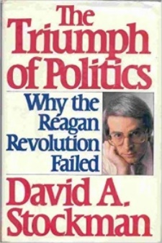
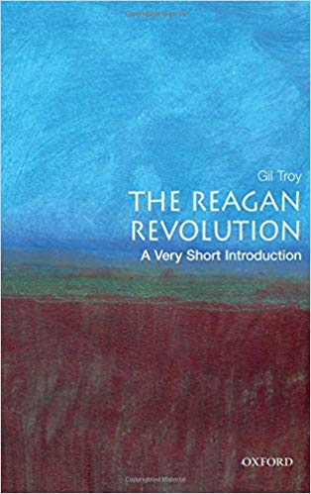
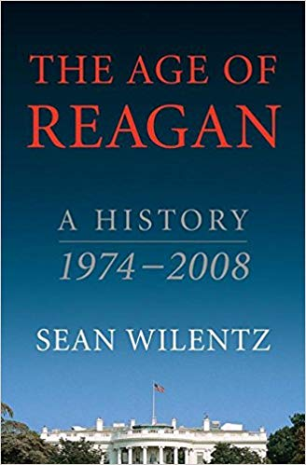

Do Now: Match the descriptions to Reagan’s social policies
Welfare for the poor |  | He supported efforts to undo affirmative actions and opposed bussing.
Welfare for veterans and the elderly |  | He saw such programmes as a disincentive to work. There was a sharp reduction in spending on food stamps, school meals and childcare as a result.
Civil Rights |  | An outspoken opponent and tried to overturn the 1973 Supreme Court ruling on this.
Abortion |  | Launched Nancy’s ‘Just Say No’ campaign and spent an estimated $15b annually on this. Some 750,000 Americans faced these charges each year during the 1980s.
AIDs |  | Opposed this despite having nearly been assassinated in 1981.
The War on Drugs |  | Provisions grew during Reagan’s presidency, for example Medicare, faming subsidy costs and social security.
Gun control |  | Although more women entered the work force during the 1980s than ever before, his stance was clear in opposing the Equal Rights Amendment.
Women’s rights |  | Slow to act; his conservative values meant that refused to advocate the use of condoms and associated the disease with immorality.

Task One: Revitalising the presidency and US politics
Use the p. 218 – p. 222 of the Sanders handout to answer the following:
- Why had presidential leadership become so problematic and ineffective by 1980?
- Why might some argue that Reagan had the potential to revitalise the presidency?
- Why have some argued that Reagan demonstrated that the presidency was not weak?
- What was the Iran-Contra affair and why did it shock many Americans?
- What were the consequences of the Iran-Contra affair for Reagan and the presidency?
- What have some historians blamed Reagan’s poor decisions on? (list three)
- Using the section ‘amiable dunce’ complete the table:
Evidence / anecdotes to suggest Reagan was an ‘amiable dunce’ | Evidence to suggest he was in more control than commonly assumed | What might account for the belief that Reagan was an ‘amicable dunce’

- What were his popularity ratings like at the end of his presidency and why might this be?
- How do historians disagree on the importance of Reagan’s role in ending the Cold War?
- To what extent did Reagan revitalise confidence in the Republican Party?
- Use the diagram at the bottom of page 222 to summarise arguments for and against the interpretation that Reagan revitalised the presidency and US politics. You can make a list / table / spider diagram but don’t spend more than 5 minutes on it – keep it succinct.

Task two: Reagan’s legacy
Use the p. 223 – 232 of the Sanders handout to complete the table and remaining questions:
After Reagan: | Bush | Clinton | As a whole, were their policies a departure from or a continuity of Reagan’s, and how successful were they?
The economy
Big Government |  | (focus on Welfare Reform Act)
A revitalised presidency
Social change: abortion
Social change: Homosexuality
Social change: Permissiveness | Clinton:
Social change: Race | Political status:  Legal status:  Economic status:  Social status:
Social change: Women

- Why were Reagan and the Religious Right unable to ‘turn the clocks back’ to the 1950s?
- Use the diagram at the bottom of page 232 to summarise arguments for and against the interpretation that Reagan was influential beyond 1989. You can make a list / table / spider diagram but don’t spend more than 5 minutes on it – keep it succinct.
Challenges:
- Use the additional handout from the Pearson (orange) textbook to note down key arguments and evidence for and against the interpretation that Reagan revitalised the presidency and US politics.
- Attempt the following exam question using all of the structure guidance you have been given for Section C. Ideally give it to Miss Hardingham / Howley / Ashraf (to pass onto us) before the Summer so that we can mark it!

In light of differing interpretations, how far do you agree with the view that Reagan’s administration “altered the landscape of political debate and public policy” in the years 1981-1996?

Extract 1: From More equal than others: America from Nixon to the New Century, written by Godfrey Hodgson in 2004. Hodgson had worked in Britain and the USA as a journalist, radio and television presenter, university lecturer and author who writes mainly about American history
The proportion of Americans who called themselves “liberal” had been declining even before 1980. By 1990 it was 16 percent. Since the 1970s, substantial majorities disapproved of affirmative action for minorities. There was a broad and growing assumption that government was often not the right agent to provide solutions for social problems. Instead, there was a new consensus that the “free market”- a term loosely used to describe extremely complex phenomena, and even more loosely invoked to propose solutions that were often unproved- was the place to find answers.
From the 1970s’ on there was a huge shift in voters attitudes to government, on one hand, and to corporate business on the other. Since 1932 the great majority of Americans had accepted the idea of a welfare state. That implied, at least in principle, willingness to pay taxes that would enable government to provide the services people could not provide for themselves. By the middle 1970’s, that fundamental assumption was already under attack.

Extract 2 From ideological images for a television age written by Charles W Dunn and J .David Woodward published in 1989. Dunn is an academic, Woodward has written a biography of Reagan.
Such (tax) reforms had effects that were more symbolic than real but in the world of media impressions such illusions are often important. Reagan was seen as a helmsman who was turning the ship of the state in a new direction. Even when his changes were seen to be illusory Reagan was seen as an effective leader. Going for tax cuts in the first year of the administration gave the appearance of change.
A popular conservative messenger with a popular conservative message had altered the landscape of political debate and public policy. The word conservative, no longer anathema in American political discourse has replaced the word “liberal” as the most popular of the two words, forcing the political opposition to search for other ways to express their ideas, sometimes using the word conservative itself. Liberal Democrats are now reacting to the successes of the conservative Reagan agenda rather than conservative Republicans reacting to the successes of successful New deal policies that had dominated America’s political landscape for three decades.

