Edexcel POLITICS
Component 1: UK POLITICS

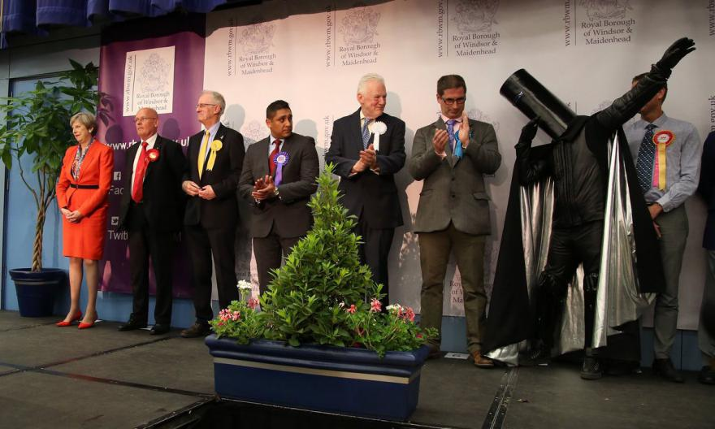
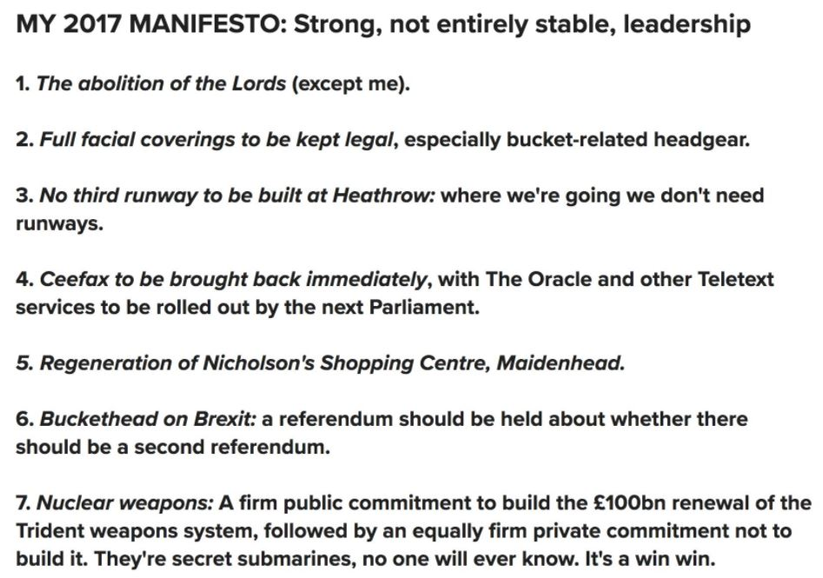
Contents
Key Questions checklist 3
Course Overview 8
Component 1 Overview 9
1. Democracy and Participation 22
1.1 Current systems of representative democracy and direct democracy 22
1.2 A wider franchise and debates over suffrage 30
1.3 Pressure groups and other influences 35
1.4 Rights in context 42
2 Political parties 47
2.1 Political Parties 47
2.2 Established political parties 51
The Labour Party 53
The Conservative Party 56
2.3 Emerging and minor UK political parties 62
2.4 UK political parties in context 65
3 Electoral systems 67
3.1 Different electoral syatems 67
3.2 Referendums and how they are used 73
Criticisms of referendums 75
3.3 Electoral system analysis 78
4 Voting behaviour and the media 85
4.1 Case studies of three key general elections 85
1997 Election 86
2017 election 87
4.2 The influence of the media 89
Key terminology glossary 91
Specimen Exam Paper 100
MARK SCHEMES 106

Key Questions checklist
 | 1. Democracy and participation
 | Current systems of representative and direct democracy
1 | 1. What are the pros and cons of direct versus representative democracy?
2 | 2. What is the case for reforming the UK democratic system?
3 | 3. Is the UK experiencing a ‘participation crisis?
4 | 4. What are the reasons for lower participation rates?
5 | 5. How should the system be reformed? Should voting be made compulsory?
 | A wider franchise and debates over suffrage
6 | 1. What are the key milestones for the widening of the suffrage?
7 | 2. How did the suffragists and suffragettes help to extend the franchise?
8 | 3. Should 16- and 17-year-olds be given the vote?
 | Pressure groups and other influences
9 | 1. What are the different ways of categorising pressure groups?
10 | 2. What methods are available for pressure groups to exert influence?
11 | 3. Why do some pressure groups have more influence than others?
12 | 4. Case studies of two pressure groups: Occupy London; Vote Leave
13 | 5. How do think tanks, lobbyists and corporations influence politics?
 | Rights in context
14 | 1. How did civil rights and responsibilities develop in the UK?
15 | 2. What are the debates over the extent, limits and tensions within rights in the UK?
16 | 3. Case studies of the extent, limits and tensions within the UK’s rights-based culture: Qatada and Hamza
 | 2. Political parties
 | Functions and Funding of Political Parties
17 | - What are the functions of political parties?
18 | - How are the UK’s political parties funded?
19 | - Is party political funding ‘fit for purpose’?
 | Established political parties
20 | - What is the difference between left-wing and right wing political ideas?
21 | - Is Labour still committed to socialist principles?
22 | - Are the conservatives still committed to Thatcherite principles?
23 | - What do the Liberal Democrats stand for?
24 | - How do the major political parties compare?
 | Emerging and minor UK political parties
25 | - How important are minor political parties in the UK?
26 | - Case studies: UKIP and The Green Party
27 | - How similar are the minor parties?
 | UK political parties in context
28 | - How has a multi-party system developed?
29 | - Why do some parties succeed and some parties fail?
30 | - How important is the media to political party success?
 | 3. Electoral systems
 | Different Electoral Systems
31 | - What are the advantages and disadvantages of FPTP?
32 | - What are the advantages and disadvantages of AMS; STV and SV?
33 | - How does FPTP compare to the Single Transferable Vote?
 | Referendums and how they are used
34 | - What is a referendum?
35 | - How have referendums been used in the UK?
36 | - What are the cases for and against referendums in a representative democracy?
 | Electoral System analysis
37 | - Why are different electoral systems used in the UK?
38 | - What has been the impact of the different electoral systems in the UK on the type of government appointed?
39 | - What has been the impact of different systems on party representation?
40 | - What has been the impact of different systems on voter choice?
 | 4. Voting behavior and the media?
 | Case studies of 3 general elections: 1983; 1997 and 2017
41 | - Explain the factors that influenced the outcome of each election
42 | - What is the influence of class on voting patterns?
43 | - What is the influence of gender; age; ethnicity and region as factors in influencing voting behavior?
 | The influence of the media
44 | - What is the role of the media in politics?
45 | - What is the impact of the media in politics?
46 | - Should we have opinion polls?

Course Overview
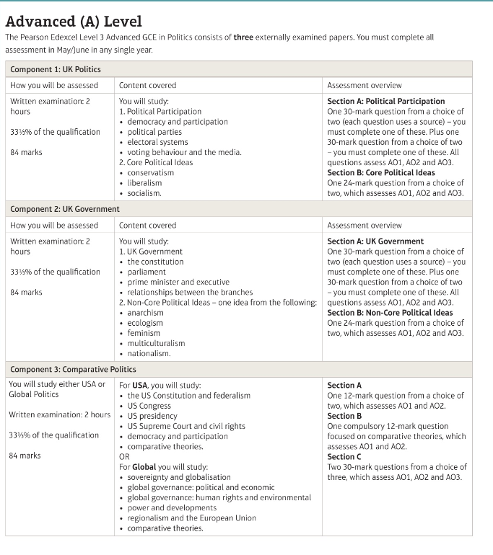

Component 1 Overview
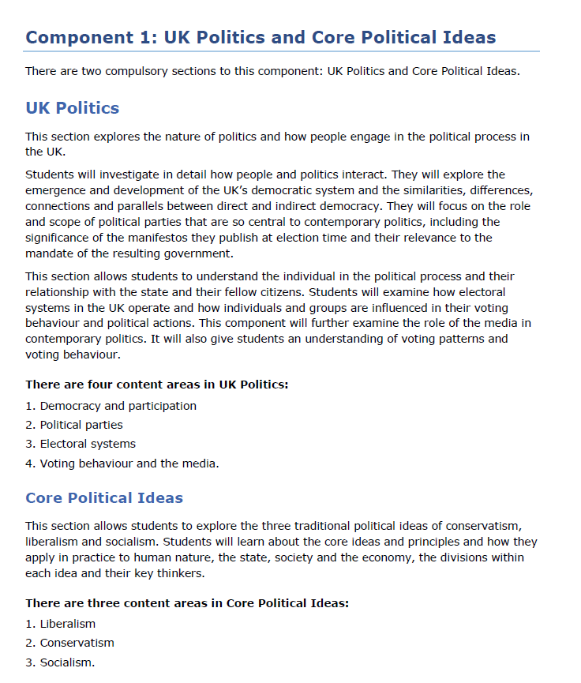

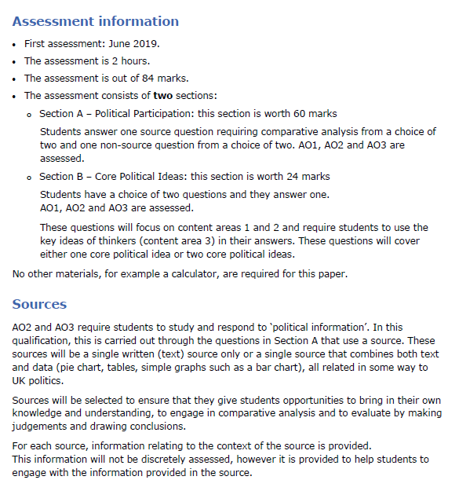

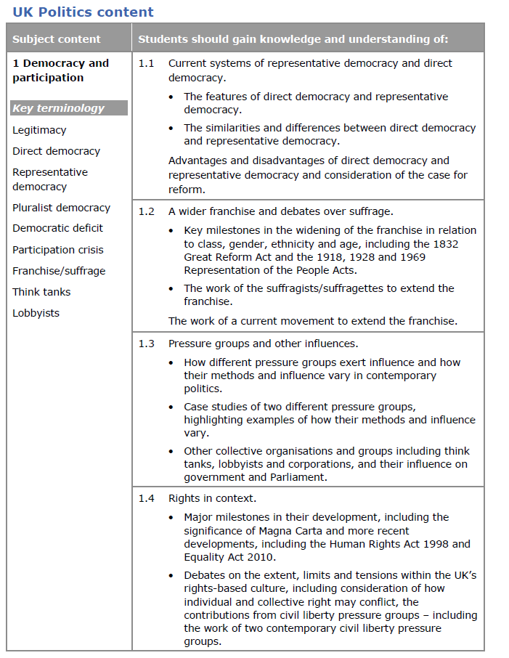
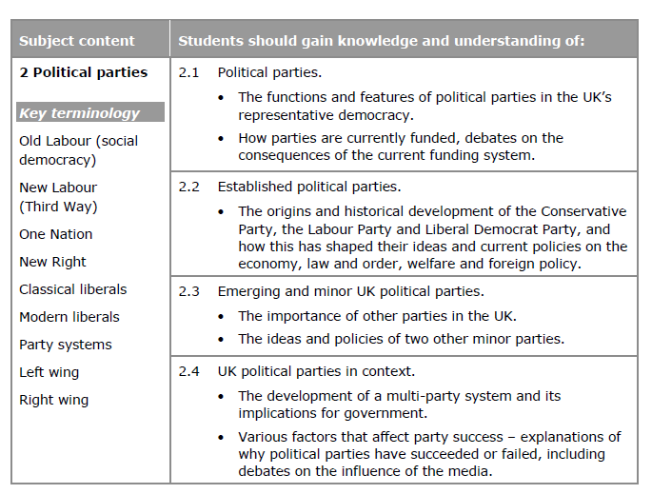
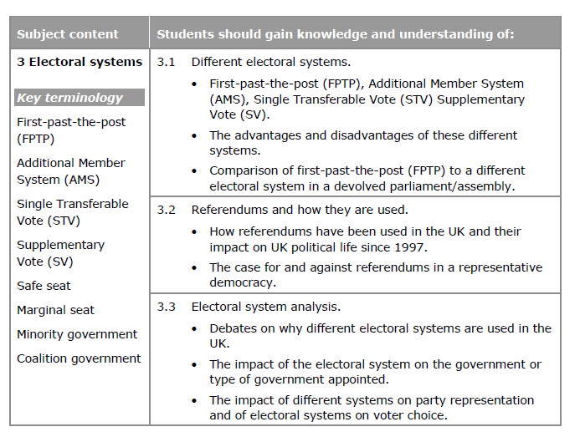
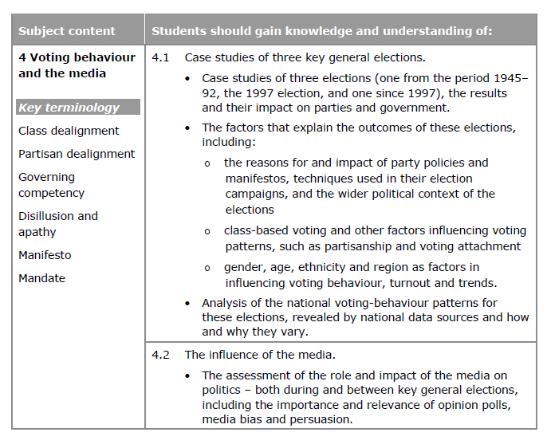
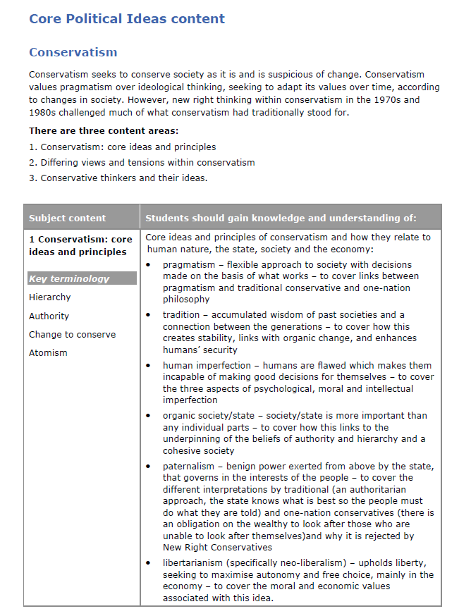
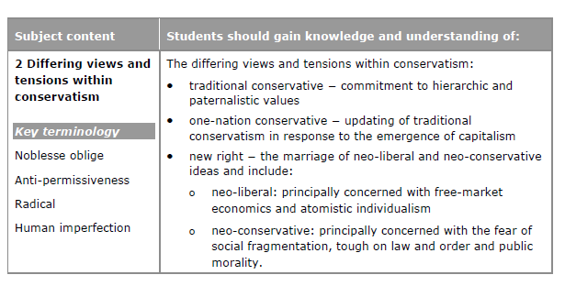
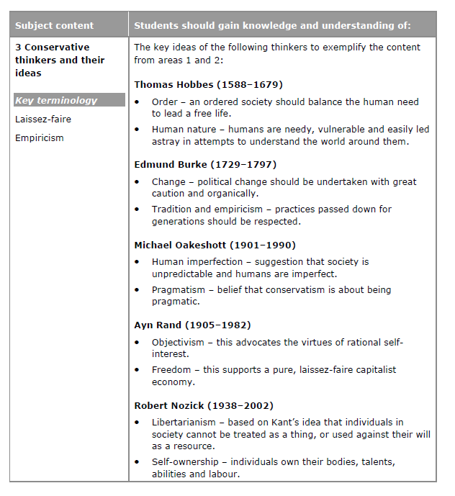
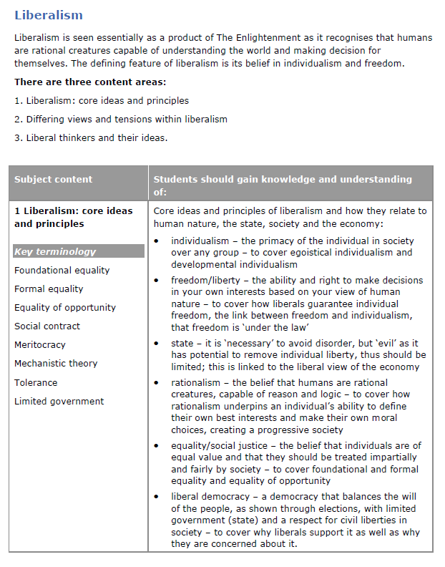
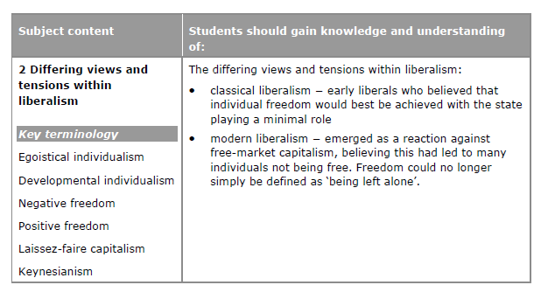
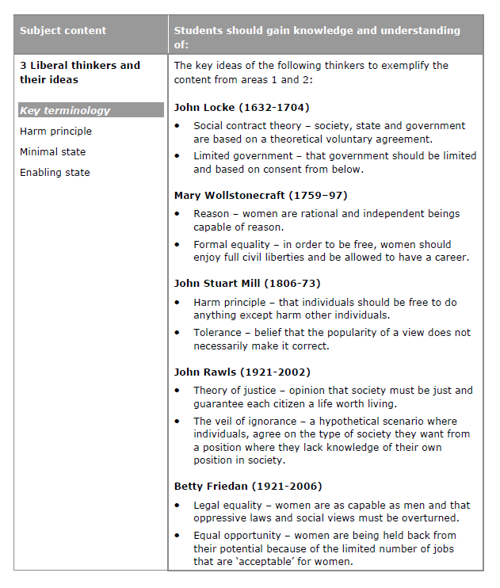
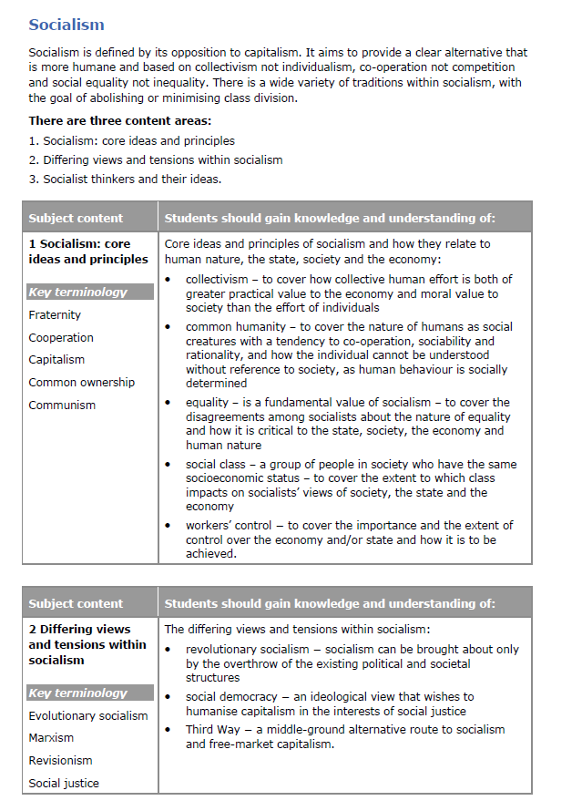
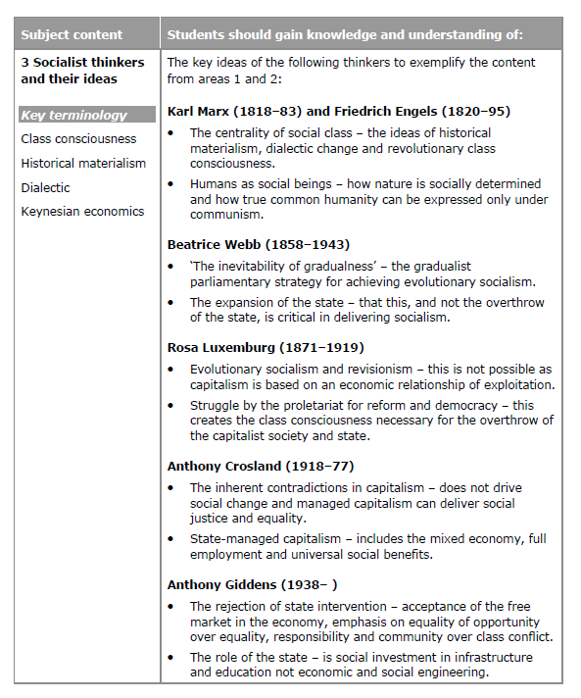

- Democracy and Participation

  - Current systems of representative democracy and direct democracy
What is Democracy?
https://www.youtube.com/watch?v=4MH89RzS39g
Direct Democracy
https://www.youtube.com/watch?v=y5W45Va0cPE
What is direct democracy?
- Direct democracy can be defined as: “the direct, constant and unhampered involvement of the people in political life.” It is a system in which the people make all of the key decisions themselves.
- It can be described as a system of self-government, because it is the people rather than professional politicians who govern – there are no professional politicians to govern.
- Politics is ‘happening’ all the time, because decisions on new issues constantly need to be made.
- Decisions can be made unanimously or by a vote. A majority is needed for legislation to be passed.

Athenian direct democracy
- Democracy first emerged in Athens, which was a city-state in Ancient Greece, approximately 2,500 years ago.
- The Athenian system allowed all free adult men who had been born in Athens to attend an Assembly, in which decisions were made about laws and how the city would be governed.
- It was a system of direct democracy because the Athenian people made all of the key decisions themselves.
- It wouldn’t be seen as fully democratic now because women, slaves and foreigners (those who had been born elsewhere) were not allowed to attend the Assembly.
- It would be impractical to have this kind of democracy in the modern world because there are too many people for everyone to attend an assembly.

What is a referendum?
- It is a modern version of direct democracy, because the people are asked to make a political decision themselves.

- It can be defined as “a popular vote on an issue of public policy”. This means that the people vote on a single issue, usually framed as a yes/no question.

- It may be either binding, which means that the government is forced to carry out the people’s decision, or advisory, which means the government will take the public’s wishes into account in their decision-making, but they reserve the right to make a different decision.

- In the UK referendums are affected by Parliamentary Sovereignty. This means that Parliament has the final say on all political matters, so technically a UK referendum can never be binding.

- There are two great examples of referendums you should remember:
  - The referendum on Scottish independence in 2014, which voted in favour of Scotland remaining part of the UK.
  - The referendum on UK membership of the European Union (EU), which took place in June 2016 and resulted in Brexit – a victory for the Leave campaign.

Are there any other forms of direct democracy?
Initiatives
- These are a form of referendum brought about by citizens.
- If a certain number of signatures are obtained, calling for a referendum on a particular issue, then a vote must be held.
- They are used regularly in Switzerland.
Propositions
- These are used by some US states, notably California.
- They are referendums held at the same time as state elections.
- Citizens are able to place an issue on the ballot paper by collecting a set number of signatures (the number required is relative to the number of votes cast for the governor at the last election).
- The group sponsoring the proposition must also pay for its inclusion on the ballot.
- Recent propositions include:
  - A proposal to legalise medical marijuana (1996)
  - A proposal to ban gay marriage (2008) passed, but later defeated on appeal.

Representative Democracy

What is representative democracy?
- Representative democracy is political system in which most decisions are made by elected representatives rather than the people themselves. It has several features:

- Features of representative democracy
Feature | Further detail and examples
Free, fair and regular elections at a range of levels. | For example, in the UK we elect MPs to the national government, members of devolved regional parliaments/assemblies and local councillors.
Universal suffrage/ wide franchise. | ‘Suffrage’ or ‘the franchise’ refer to the right to vote. In the UK we have universal suffrage, which means that all adults have the right to vote. We have a wide franchise, because many different types of people are included.
Assemblies or legislatures which pass laws. | The Parliament at Westminster is the most important legislature in the UK, because it makes laws that affect everyone. Other legislatures are the Scottish Parliament (Holyrood), the Welsh Assembly and the Northern Irish Assembly (Stormont), but these have limited law-making powers and cannot override Westminster.
The people do not make decisions directly, rather their representatives do this on their behalf. | MPs make decisions on behalf of their constituents. It is important to remember that the MP does not just represent those who voted for him/her, rather s/he represents everyone living within his/her constituency.
Representatives are accountable to the people. | If the people are not happy with the job their representative or government is doing, then they can vote for a different representative in the next election. In this way representatives are held responsible for their actions and decisions.
Decisions reached on the basis of a majority. | MPs need a majority of votes to be elected. Proposed laws need a majority of votes in both Houses of Parliament to pass.
A range of political parties which represent differing policies and ideas. | There is no need for parties to exist at all in a representative democracy, because the electorate vote for the individual candidate, not a party (in most electoral systems). However, parties naturally develop in democracies, as people with similar ideas work together to maximise their chances of influencing and making law. Most democracies have 2-3 major parties and several minor parties.

Advantages of representative democracy
- Representative democracy is the only practical form of democracy in a large modern society. Direct democracy is unpractical for many reasons.
  - For example, the country would have to be divided into thousands of very small self-governing areas just to enable everyone to have their say in the assembly.

- Representative democracy allows citizens to carry on with their ordinary lives without having to research complex political issues, attend political meetings and participate in debate, which would be extremely time-consuming.
  - For example, MPs participate in debates and committee work 5 days a week. In a direct ‘Athenian’ democratic system everyone would be a full-time politician!

- Representative government is government by experts or specialists. MPs are usually highly educated in relevant subjects and have the time to research issues in depth to inform their decisions.
  - For example, many MPs have degrees in PPE (Philosophy, Politics & Economics) and Law, which helps them to understand the issues on which they are legislating.

- Representative democracy provides accountability. Through elections and free speech the public can hold office holders to account, throwing out bad governments and poorly performing ministers.
  - For example, in 2010 the public were dissatisfied with the Labour government and voted them out of office.

- Representative democracy provides stability. The general public can be prone to extreme reactions to certain circumstances, which could result in extreme changes to laws if the public were making laws directly.
  - For example, in the early years of the century there was a moral panic concerning paedophilia, which led to mobs persecuting and beating up paedophiles, and various demands by the public for changes in the law. This was in response to three separate high profile murder cases involving young girls, despite the fact that overall rates of such crimes were unchanged. While laws were tightened up, the fact that full-time experts were able to consider the facts dispassionately limited excessive changes being made, which would have prevented children from engaging in positive activities with adults under certain circumstances.

- Representative democracy is pragmatic and evolves in a range of areas, in the UK it has adapted to the use of referendums. It could adapt to the use of initiatives and the power of recall over representatives.
  - For example, the UK didn’t really use referendums before 1975, but since then it has gradually become established practice to hold a referendum to justify any constitutional change.
  - The use of e-petitions, especially by the government itself, takes us some way towards formal initiatives.
  - The Liberal Democrats explicitly support giving citizens the power of recall.
Disadvantages of representative democracy
- Political scientists often point out that the social background of MPs is very narrow. They are overwhelmingly white, male, heterosexual, middle-aged (in their 50s) and upper-middle class. Many younger MPs have Politics or PPE degrees and worked as special advisors (SPADs) to ministers before they became MPs, so they have no experience of the ‘real world’. This means that they are not a true reflection of the people they represent and therefore they may not understand what is in the best interests of the people.
  - For example, only 29% of MPs are female and only 6.6% are from ethnic minorities.
  - The average age of MPs is 51.
  - 4.9% of MPs are homosexual, although this is close to the proportion in the general population.
  - 20% of MPs were privately educated (compared to 7% of the general population) and 20% went to Oxbridge.

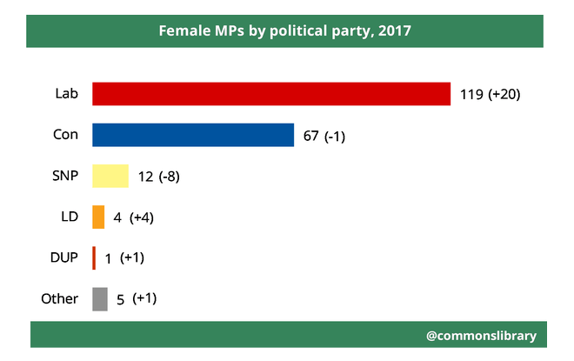
- Some minorities may feel excluded and marginalised under a system of representative democracy
  - For example, approximately 14% of the general population is from an ethnic minority, but only 6.6% of MPs are from ethnic minorities, so ethnic minority citizens may feel that their views are not often heard by politicians.
  - Additionally, while women are not a minority group in society, politics, especially at Cabinet level, is dominated by men, which means women are likely to feel their concerns are regarded as peripheral rather than central issues.

- It can be argued that the nature of political parties also restricts voter choice because the main political parties are trying to appeal to the same group of ‘middle of the spectrum’ voters, so their policies are very similar. This is partly because people of very similar backgrounds and opinions are making policy in the first place.
  - For example, in the 2015 election, all of the main parties agreed that austerity policies were necessary, they just disagreed on the details.

- Participation levels are often low and this calls into question the legitimacy of the system, because there is no way of knowing whether non-participants would disagree with the political system or haven’t voted simply because they don’t care (apathy).
  - For example, less than two thirds of the electorate voted in each of the last four general elections pre 2017 (2015, 2010, 2005, 2001).
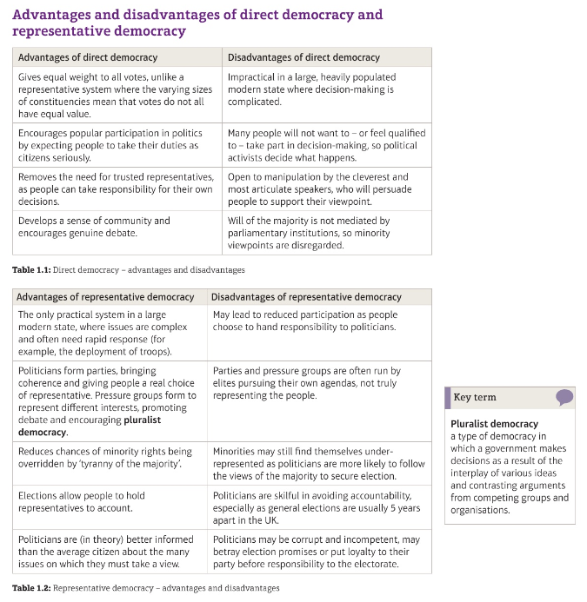

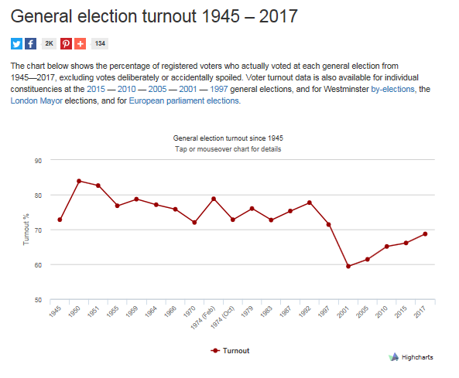
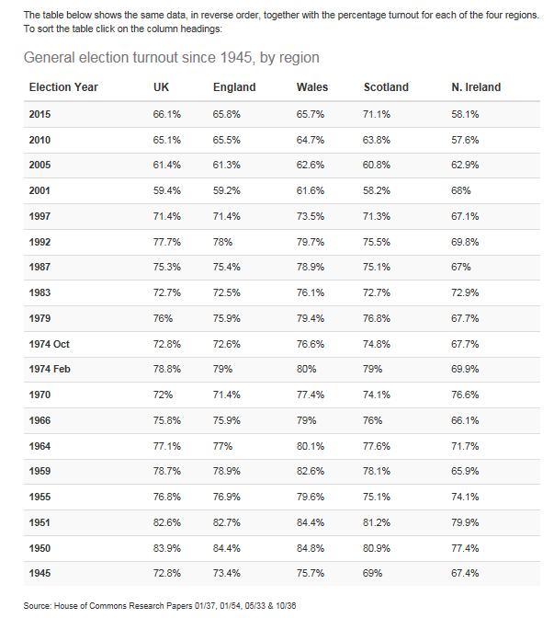
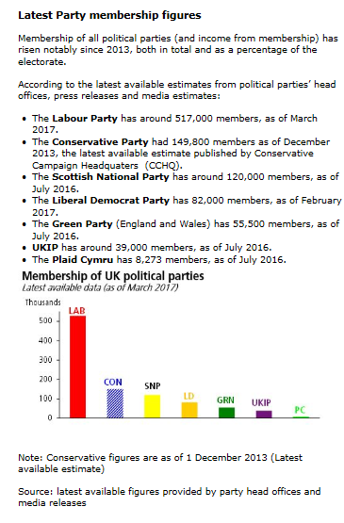
Current systems of representative and direct democracy
1. What are the pros and cons of direct versus representative democracy?
2. What is the case for reforming the UK democratic system?
3. Is the UK experiencing a ‘participation crisis’?
4. What are the reasons for lower participation rates?
5. How should the system be reformed? Should voting be made compulsory?

1.2 A wider franchise and debates over suffrage
Out of a population of 10.5 million, only c.400, 000 could vote by 1801
The 1832 Reform Act
Partly in response to the riots Parliament passed the 1832 Reform Act.
The act stated that:
- One in five men - those who owned property and earned more than £10 per year - got the vote.
- Seats must be created for MPs in new industrial towns such as Birmingham.
- Seats for MPs from rotten boroughs had to be removed.
There was a mixed reaction to the new political changes. The middle class was happy about the changes, but the working class still could not vote. Elections remained corrupt and the country was still run by the rich. MPs in the countryside continued to have more power than those in industrial towns.
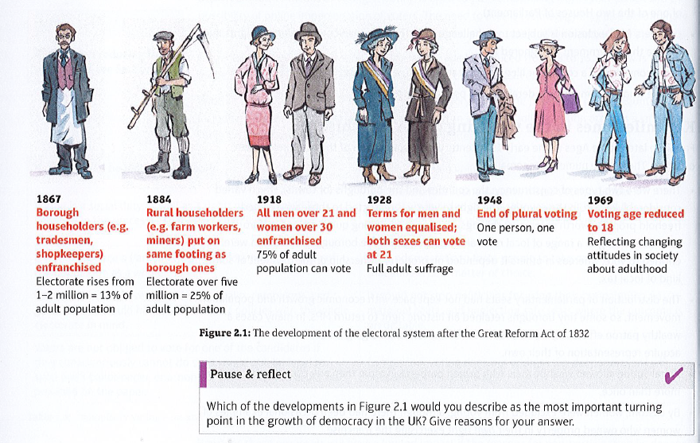
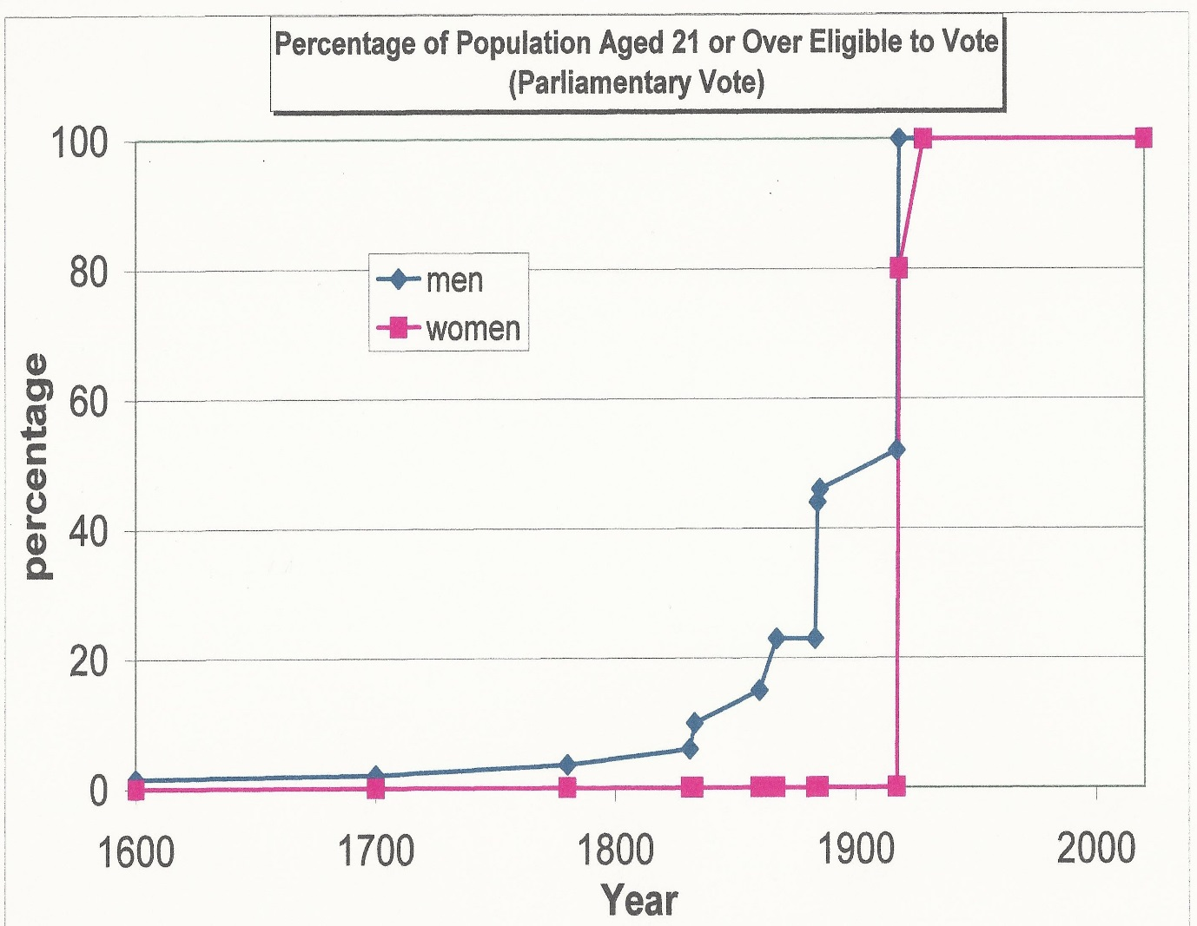
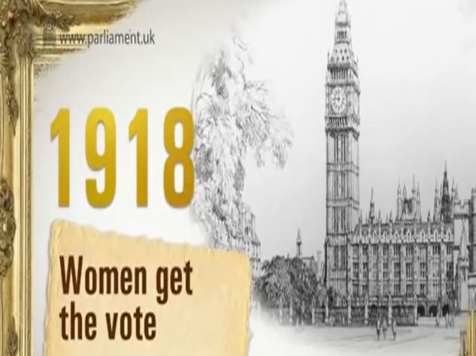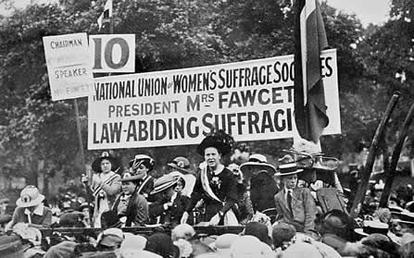

https://www.tutor2u.net/politics/reference/development-of-suffrage-franchise-in-britain-matching-exercise
Enhancing Democracy

Votes for 16 year olds
Arguments in favour of lowering the voting age.
- Allowing voting at 16 places this right in line with other aspects of citizenship available at this age, which include the age of consent, the right to marry, entering the field of employment and income tax payment.
- Earlier involvement in politics will capture the younger generation and instil the political responsibilities of citizenship, fostering a sense of civic pride and duty. It can build on the citizenship curriculum in pre-16 schooling.
- Long term participation rates may rise if 16 year-olds develop the habit of voting, because they will carry on voting as they get older.
- Knowledge and competence are not significantly lower at 16 than 18. It can be argued that decisions about whether to continue in education (and what to study) or to go into employment are far more personally important decisions, to be taken at a younger age than voting.
- Involving under-18s will make youth issues a more relevant topic in elections. For instance career options and education are vital for this age group and political parties will have to make this a key topic in elections, as the Lib Dems have done with university tuition fees.

ANALYSIS: how could participation and democracy be strengthened in the UK?
 | Effective | Ineffective
Compulsory voting for all citizens | This automatically increases participation levels and forces elected representatives to take account of the views of all social groups, thus advancing democratic legitimacy. | However to force someone to make a choice and vote may be unreal, as there may be no genuine choice on offer. Many former authoritarian regimes, such as the USSR, cited turnout in the high 90%, but the choice on offer was false, because genuine opposition parties were banned.
Reducing the voting age to 16. | Matching the voting age to other ‘maturation’ levels is just and fair. It will develop political engagement and prevent frustration. | At 16 young adults are still not experienced enough to make that choice.
The greater use of referendums. | As a means of direct democracy, this instantly gives greater legitimacy to decisions. | However, the public can soon tire of referendums and their creation may reflect government drives as opposed to democratic advancement.
The use of initiatives and the process of recall. | It is argued that this would invigorate political life and give democratic power to the public. They will allow the public to draw up the political agenda and address popular issues which profession politicians may avoid. They will also engage and educate the wider public. | This may simply create political instability, where a sensitive and scheming media may really create puppets out of the electorate. They may further trivialise decision making and could unfavourably slant the political agenda with populist items.
The introduction of more electronic technology to aid participation. | This makes both the process of voting easier and makes participation more precise, swift and inclusive. | This may alienate the public further, making politics akin to a frivolous TV show, as opposed to voting being a major life-changing decision. Digital systems may also be subject to hacking and fraud and may appear less open and transparent.
A change to the voting system for Westminster elections. | On the one hand this could revitalise politics, especially at Westminster. If PR were to be introduced, it would make citizens feel that their vote was equal and counted. | However, there is no agreed electoral system that commands universal approval. In addition where PR has been introduced it has not especially delivered increased level of participation.
Increased provision of political education. | It is argued if the public in school and beyond were allowed greater levels of political education then levels of participation would increase as people would both value and understand the political process. | Constitutional reform by governmental structure may improve both participation and democracy – the House of Lords reform may be cited.

A wider franchise and debates over suffrage
1. What are the key milestones for the widening of the suffrage?
2. How did the suffragists and suffragettes help to extend the franchise?
3. Should 16- and 17-year-olds be given the vote?

  - Pressure groups and other influences

Sectional and promotional pressure groups
Sectional (Interest) | Promotional (Cause) | Social Movements
Tend to be exclusive and have restricted rather than open membership. Membership is restricted to people in particular occupations, professions or positions. | Have an open membership – anyone can join. | Similar to cause groups, but more loosely structured
Concerned with the well-being of their own members. | Concerned with the well-being of others, society in general and/or the whole planet. | Some members may also belong to traditional pressure groups
Seek to advance the interests of their members – driven by self-interest. | Seek to advance ideas, ideals or political causes – driven by altruism. | Some members just take part in a specific protest
Usually based on economic (people working in a particular industry/profession) or social (related to age, religion, ethnicity etc) groups. | Based on ‘causes’, such as the environment, animal rights etc. | Social movements are usually radical and seek to achieve a single objective
Examples include professional bodies and trade unions, such as the National Union of Teachers (NUT), the Law Society and the Confederation of British Industry (CBI). | Examples include Greenpeace, Shelter, Oxfam, the RSPCA and RSPB. | Examples include the ‘Camps for Climate Action’ created 2007-10 to oppose the expansion of Heathrow airport and the Occupy Movement from 2011

Insider and outsider pressure groups
Insider | Outsider
An insider pressure group has a close and productive relationship with the government. This relationship may mean that insiders will be consulted before and during policy implementation. | An outsider has little or no government contact and are not consulted before/during policy formation/implementation, no matter what level of expertise they possess.
Insider groups will be highly unlikely to use direct action or break the law, as this would damage their relationship with the government. | Outsider groups may under certain circumstances be attracted to law breaking. For example, animal rights groups have broken into animal testing labs and freed the animals.
Examples of insider groups include the NFU and the BMA. | Examples of outsider groups include Earth First and the Animal Liberation Front.

Functions of pressure groups
- An educative function: here pressure groups can provide information and education to the general public, making them aware of political events and facts. For instance pressure groups who campaign against pollution and aim to protect the environment may inform the public of pollution levels.

- A representative function: PGs can speak up for sections of society who are not adequately represented through the existing electoral system. For example, the Gurkha Justice Campaign, publicised by Joanna Lumley in 2009 is an example of a social group that was represented by a pressure group as opposed to a political party.

- A participative function: we have seen falling membership of political parties over the last 25 years but have witnessed the growing membership of pressure groups. It is through pressure groups that the public can participate in a variety of political issues and events. For example, citizens may go on marches organised by pressure groups such as those held by the Countryside Alliance, or they may sign petitions created by pressure groups.

- Policy formulation: here pressure groups can be credited with developing and creating policy which governments and political parties may take up. For instance economic groups such as the CBI and Trade Unions have influenced both Labour and Conservative governments and parties.

- Policy implementation: occasionally pressure groups implement policy. A good example of this is the National Farmers Union (NFU) who works alongside the government in policy implementation. Another example is the RSPCA who will carry out prosecutions where it considers animal welfare has been severely violated.

- Scrutiny: where pressure groups hold those in power accountable. For example, Greenpeace emails its members regarding Government progress/achievements on climate change targets.

Pressure group power

Methods used by pressure groups to influence government.
- They may protest and demonstrate in high profile venues such as governmental offices and parliament (outsiders).

- Insider groups are able to contact ministers and civil servants directly.

- Sectional groups may strike to disrupt economic activity, to pressure the government to give in to their demands.

- They may hand in petitions to the Prime Minister and ministers, or have their members write directly to the relevant ministers.

- They may use e-petitions and the internet, eg a YouTube video, to voice their concerns.

- Some pressure groups contribute to political party funds, such as political levy paid by trade union members who choose to support the Labour party. They are said to gain privileged access via this method if that party goes on to form a government.

- Some pressure groups may provide expert advice, including academic studies, for government when new legislation or policy changes are being considered, such as the Howard League for Penal Reform. This provides pressure groups with access to influence governments.

- Some pressure groups may use direct action.

- Pressure groups may also use the courts, seeking redress through judicial review.

What is direct action?
- The public actively become involved in politics as opposed to dealing through a representative or just voting in elections.

- Direct action takes many forms, both legal and illegal.

- Some pressure groups will organise marches and demonstrations, such as the Stop the War marches against the Iraq war from 2003 and the marches from 2010 against the rise in student tuition fees.

- Some trade unions may go on strike (official & unofficial) or break their contract of employment.

- Civil disobedience is where groups deliberately and publicly break the law in order to send a message to the government that they believe the law to be wrong and in need of change.

- Some pressure groups carry out ‘sit ins’ where they occupy public buildings. This was often used in the 1960s and has been used much more recently by students occupying their university buildings in protest against the rise in student tuition fees.
- Occasionally pressure groups may cause an illegal obstruction by blocking the highway. For example, Fathers4justice often brought traffic to a halt illegally in 2008-9, while Plane Stupid occupied a runway at Heathrow to protest against building a third runway.

- Some pressure groups aligned with campaigns against animal testing, such as the Animal Liberation Front (ALF), have carried out a number of illegal acts from grave violation to harassing animal laboratories.

Why do pressure groups use direct action?
- Pressure groups turn to direct action to advance their cause as other non-direct methods have either failed or are not available.

- At times pressure groups need the media spotlight and direct action is a method of achieving this.

- Often outsider groups turn to direct action as they do not have the privileged access to government enjoyed by insider groups.

- The failure or exhaustion of conventional or legal routes may cause illegal direct action as a last resort. For example, protestors against the hunting ban broke the law in frustration after their attempts to prevent it passing had failed.

Why do different pressure groups use different methods to achieve their aims?
Pressure groups resort to a vast range of methods to achieve their aims, quite often changing and amending these methods dependent on the results which they obtain.
- To reach a wide audience, wealthy pressure groups will pay for adverts to advance their cause. For example, The National Trust regularly uses the press to promote its causes. Other groups may use celebrities, often as patrons, to gain media attention. For example, the Duchess of Cambridge (Kate Middleton) is patron of a number of charities, including Action on Addiction.

- To make best use of their resources, many pressure groups will collect and arrange for petitions by holding events in town centres to attract members of the public. This is an affordable option for some pressure groups that have less finance. It may be especially relevant to serve local causes for some pressure groups.

- To make use of their insider status, insider pressure groups may simply make contact with the relevant government minister or senior civil servant to advance their cause. For example, the National Farmers Union (NFU) has close contact with the relevant Government department.
- To reflect their outsider status, outsider pressure groups who know that the government will not take notice carry out high profile stunts (at times illegal) to capture the public attention. Fathers4justice often used this as a device.

- To fit in with and reflect the pressure groups membership and their level of radicalism. Groups such as the RSPCA will not resort to direct action whereas groups such as the ALF will naturally resort to direct action.

Factors that can limit the success of pressure groups
Finance/wealth | A lack of finance may prevent a group buying adverts, paying higher salaries for good staff and carrying out public campaigns.
Size | Fewer members, especially low density of membership, may indicate a lack of public support.
Hostile public opinion | Government is unlikely to be sympathetic to a group whose aims run counter to public opinion. For example, Muslim groups who sought to protest at the Afghan War at Wootton Basset met with widespread public hostility.
Adverse publicity | If the aims of the pressure groups receive a poor press, then this can spell disaster, even if government was initially supportive.
A hostile government | For example, the current government’s austerity programme automatically makes them unsympathetic to any group proposing government should increase spending in any area.
Countervailing groups | A pressure group may have an opposing group(s) set directly against its aims. These are known as. For example, pro-choice (Abortion Rights) and anti-abortion (ProLife Alliance) groups.
Leadership and management | Poor leadership is unlikely to lead to successful campaigns.
Lack of expertise | A group that campaigns on a technical issue, such as climate change, is unlikely to be successful if it cannot support its arguments with hard evidence.
Insider or outsider status | Insider status can prevent groups from being critical of government in public campaigns. Conversely, outsider status can condemn a group to being permanently ignored by government.

CASE STUDIES
- Occupy Movement
http://occupylondon.org.uk/about/about-2/
What did they achieve?
http://www.bbc.co.uk/news/uk-17188327
- Vote Leave
https://www.youtube.com/watch?v=hC8qO1nyYoM
What did they achieve?
https://www.ft.com/content/90c054fe-3953-11e6-9a05-82a9b15a8ee7
Misleading promises?
https://www.indy100.com/article/8-of-the-most-misleading-promises-of-the-vote-leave-campaign-ranked-in-order-of-preposterousness--WyxD59VO3Nb
Pressure groups and other influences
1. What are the different ways of categorising pressure groups?
2. What methods are available for pressure groups to exert influence?
3. Why do some pressure groups have more influence than others?
4. Case studies of two pressure groups: Vote Leave, Occupy London
5. How do think tanks, lobbyists and corporations influence politics?

  - Rights in context
The development of the UK’s Constitution

Magna Carta (1215)
The Magna Carta is an English legal charter
The Magna Carter required King John of England to proclaim certain rights, respect certain legal procedures, and accept that his will could be bound by the law. It explicitly protected certain rights of the King's subjects, most notably the writ of habeas corpus, allowing appeal against unlawful imprisonment. Magna Carter was arguably the most significant early influence on the extensive historical process that led to the rule of constitutional law today in the English speaking world.

The Human Rights Act 1998
The Human Rights Act gives effect to the human rights set out in the European Convention on Human Rights. These rights are called Convention rights.
Examples of Convention or human rights include:
•the right to life
•the right to respect for private and family life
•the right to freedom of religion and belief.
The Human Rights Act means you can take action in the UK courts if your human rights have been breached.

The Equality Act 2010
The Equality Act brings together over 116 separate pieces of legislation into one single Act. Combined, they make up a new Act that provides a legal framework to protect the rights of individuals and advance equality of opportunity for all.
The nine main pieces of legislation that have merged are:
- the Equal Pay Act 1970
- the Sex Discrimination Act 1975
- the Race Relations Act 1976
- the Disability Discrimination Act 1995
- the Employment Equality (Religion or Belief) Regulations 2003
- the Employment Equality (Sexual Orientation) Regulations 2003

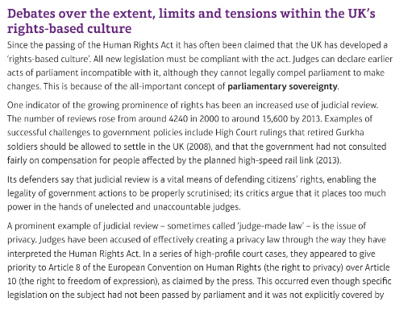
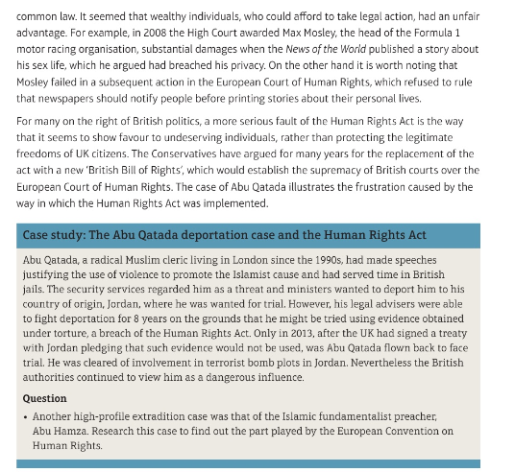

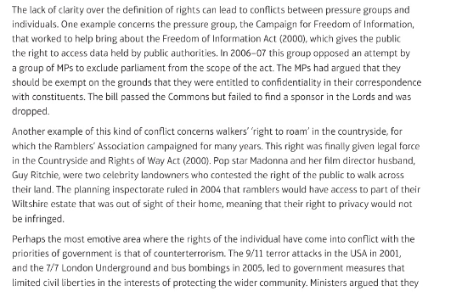
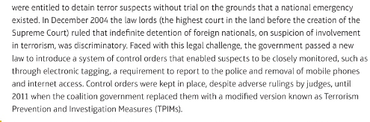
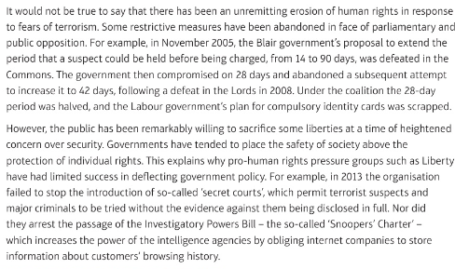

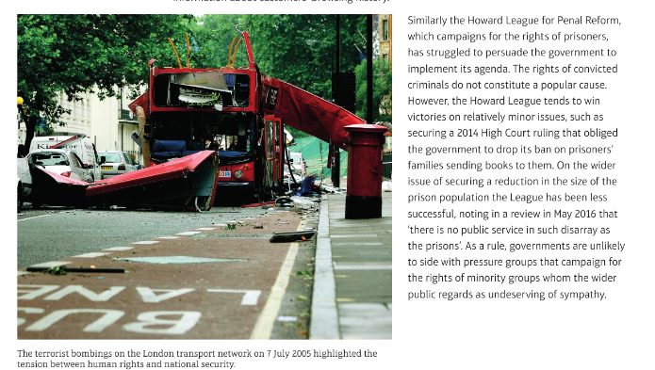
Abu Hamza
http://www.telegraph.co.uk/news/uknews/terrorism-in-the-uk/9590016/Key-events-in-battle-to-extradite-Abu-Hamza.html
Aby Qatada
https://www.youtube.com/watch?v=v-3dJSVvhMU

Rights in context
1. How did civil rights and responsibilities develop in the UK?
2. What are the debates over the extent, limits and tensions within rights in the UK?
3. Case studies of the extent, limits and tensions within the UK’s rights-based culture: Qatada and Hamza

- Political parties

  - Political Parties
Functions of a political party
- Political parties contest elections essential in a representative democracy. Parties have a function to contest elections by putting up candidates and creating a manifesto of new policies.
- A role to engage and assist participation in society, including any elections. Citizens can join political parties and contribute to their structure and ultimately policy formulation.
- They provide a channel whereby the public can participate in politics via voting or standing for office.
- Parties function to represent their members and support and promote their interests
- A role to represent the views and beliefs of large sections of society and to act in their interests. Today the major political parties can be said to be ‘catch all’ parties in that they do not exclusively appeal to one class or group and attempt to create a broad class attraction.
- They promote political education by explaining their beliefs and ideas. Parties also function to provide education on contemporary topics such as defence and the environment. A role to educate and inform the general public. Political parties’ role is to stimulate open debate and to raise political awareness of issues and events
- They bring together a coherent set of ideas and policies. Parties also act to formulate polices on a wide range of topics such as the economy, education and foreign affairs. A role to create policy and ideas. Political parties are the creators of new policy innovations to ensure a progressive society in many areas such as economic and social policy. A party manifesto is a reflection of this function.
- They provide the personnel of government. Parties recruit members to provide not only candidates for elections but also officers in government and leaders in a national and local context. Recruiting, developing, and selecting the next generation of political leaders.
- A role to hold government office and wield power by managing the country.
- The process of government in the UK is made possible by organised political parties.
- In a modern context a major function of political parties is to ensure legislation is passed and service Parliament

Ways in which political parties differ from pressure groups.
Parties | PGs
The aim of political parties is to achieve power and govern affairs of state. | Pressure groups seek to influence and persuade those who are in power.
Political parties will field candidates across all elections | Although pressure groups have stood for election this is not the norm
Political parties will have policies and ideas on a vast range of subjects | Pressure groups tend to be more specialised with a narrow policy and ideas focus
Political parties have clear lines of accountability and operate in a constitutional framework | Many pressure groups have less transparent frameworks for accountability.

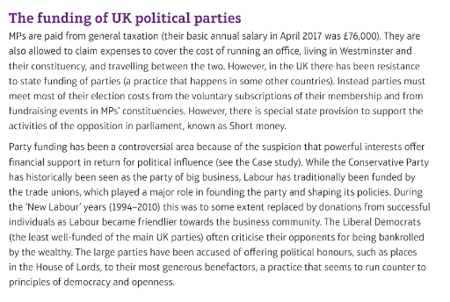
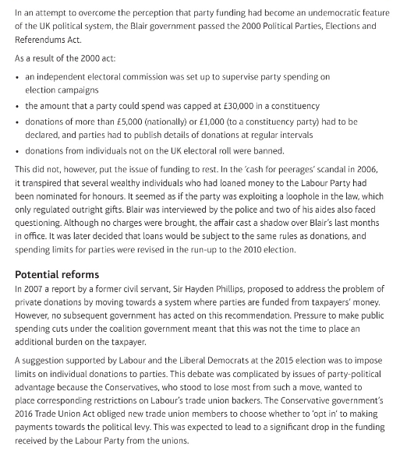
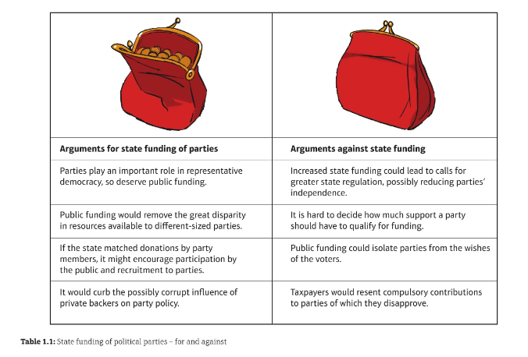
Functions and Funding of Political Parties
What are the functions of political parties?
How are the UK’s political parties funded?
Is party political funding ‘fit for purpose’?

  - Established political parties
What is the difference between left wing and right wing political ideas?
The terms left-wing and right-wing are extensively used today to distinguish two main types of political values and principles. However, they are historically associated with the French Revolution – whether people sat to the right of the king and supported him, or whether they sat on his left and advocated change.
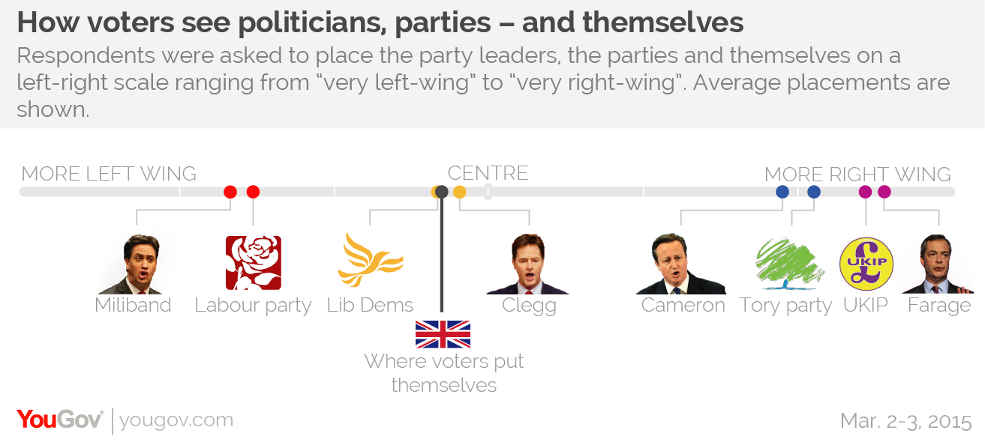
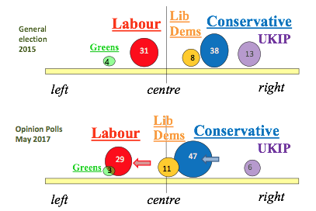
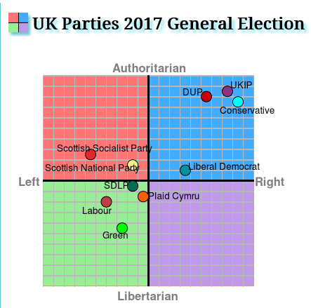

https://www.politicalcompass.org/

The Labour Party
Ideas and policies that link the current Labour Party to socialism
The Labour Party in the UK has shown a commitment to socialism in the UK. This type of socialism can be seen as revisionist in that it seeks to reform capitalism, not overthrow it. The commitment to socialism has always been a feature but levels of this have varied. Current indicators of socialism could include:
- A firm belief in welfare to improve the conditions of the most vulnerable in society.
  - The above may be expressed in targeting benefits for those in greatest need such as those on low incomes or who may have disabilities.
  - Labour currently oppose the ‘bedroom tax’ and cuts to tax credit for low-income working families.

- A clear commitment to equality and to make society work more harmoniously with the reduction of class differences.

- Commitment to the NHS free at point of delivery.

- A commitment to improving education for all so that social mobility can more readily take place.

- A belief in state action in the economy to regulate and protect, as seen by the bank bailout in 2008. This links socialism to the reform of capitalism.

- A belief that to an extent crime arises out of social deprivation and therefore if this is addressed then crime levels will fall.

Factions within the Labour Party
- On one level these can largely be portrayed as the difference between New Labour and Old Labour. Each element harbours differing policy aims and ideas. This revolves around the degree of acceptance of the free market and a commitment to welfare; the debate between the ‘hand up’ versus the ‘handout’.
  - Current ‘New Labour’ moderates: Andy Burnham, Yvette Cooper, Sadiq Khan, Chuka Umunna, Liz Kendall, Tristram Hunt.
  - Current ‘Old Labour’ Corbynistas: John McDonnell, Diane Abbott, Angela Rayner.

- Momentum: a mixture of traditional ‘Old Labour’ and more radical left-wing corbynistas. Has been criticised for giving Trotskyist radicals access to too much power over decision-making and selection of candidates within the party.

- Progress: a group formed to maintain the core ideals of New Labour and push back against the rise of the far left, as represented by Corbyn, despite the fact that Corbyn’s policies are not far from the centre ground (in ideological terms at least).

- Blue Labour: stands for less state intervention and more power in the hands of the people. It has links to conservatism in its emphasis on personal responsibility and the importance of traditional values, but remains socialist through a critique of capitalism and a commitment to workers having greater power in relation to executives and shareholders.

- Purple Labour: the Blairite wing of the party. Wants greater economic credibility and more power for lower levels of government, which would lead to devolution for English regions along the same lines as Scottish and Welsh devolution. Much of the pre-Corbyn Labour shadow Cabinet fit into this faction, such as Harriet Harman and Ed Miliband.

- Red Labour: Jeremy Corbyn’s faction. Wants to return to Labour’s roots. Emphasises redistributive taxation and re-industrialisation.
ANALYSIS: Is Labour still committed to its traditional socialist principles?
At the start of the 20th Century, Labour declared itself to be a socialist party committed to a peaceful or parliamentary route to achieving socialism.
Committed | Not committed
A commitment to a major role for the state in delivering public services. This will ensure that the less fortunate in society have some minimal form of protection. | A process of continual revisions to that original socialist goal have included a re-wording of Clause IV which no longer commits the party to wide scale public ownership.
Interfering in the operation of a free market to curb the excesses of capitalism, hence the nationalisation of the banks. | An acceptance of many of the Thatcherite reforms from the 1980s and 90s, which made the operation of a free market a paramount goal.
Taxation at higher levels for the wealthy and thus redistributing wealth, for example the introduction of the 50p income tax rate by Brown’s government. | Blair and then Brown took the party in a post-socialist direction, which can be seen as the rejection of Old Labour and the creation of New Labour. The party no longer sees itself as the party exclusively of the working class, but rather appeals to as wide an audience as possible. In the 2010 elections, the votes the party received from the middle classes outnumbered the votes from the working class.
The setting of a minimum wage. | A refusal to set the level of the minimum wage at the ‘living wage’ level.
The Labour Party is committed to the needs of the working classes and sees them as the most deserving section of society. As such it has tailored policies to alleviating this section’s material poverty. This can be seen in welfare programmes, from welfare benefits to the minimum wage. | It is alleged that in order to be more electorally successful the Labour Party had to widen its appeal to all classes and sections of society. In so doing it has reached out to other classes in society and also to the business and city groups.
The Labour Party traditionally was not very active in terms of constitutional change. It may have favoured reform, but this was never at its core. | Since 1997 the Labour Party has delivered one of the most radical constitutional reform programmes in over 100 years and has changed the political framework of the UK.
The Labour Party is committed to be pro-state and favours intervention in the economy to secure fairness in society. The Labour Party has intervened in the economy where possible. It has nationalised Northern Rock and encouraged banks to merge in order to survive in a global market. However, the wide scale nationalisation programme, long a commitment of Labour before and after the Second World War, has gone. The emphasis of the new Clause IV is to control rather than to own. | The Labour Party was committed to the provision of universal benefits. Now, either by financial restraint or policy direction, benefits are targeted to achieve economic well-being. Labour was in favour of a managed economy where the Government was a key actor in securing outcomes on its own terms. There has been a move now in the Party to work with a market economy and be bound by the rules which a market system dictates, thus rewarding individual merit and hard work as a prime motivator.
In overview, the Labour Party may be seen as less ideological and focused and more pragmatic. More practical in achieving realistic outcomes than unobtainable ones.
There is the accusation that Labour has adopted fully the reforms of Mrs Thatcher and the Conservative Party. The belief is the so called Third Way is a re-programming of the traditional principles of the Labour Party. This can be viewed as part of the change from Old Labour to New Labour.

The Conservative Party
One Nation conservatism
- One Nation conservatism is a form of conservatism that has influenced the Conservative Party in the 19th and 20th centuries.

- It is based around several core features, including paternalism, pragmatism and consensus.

- A key element of One Nation conservatism is the introduction of social reform to diminish but not to eliminate social inequalities, with the rich fulfilling an obligation (noblesse oblige) to meet the needs of the poor.

- Evidence that the Conservative Party is influenced by these principles includes the following:
  - A commitment to avoid social deprivation by supporting limited welfare.
  - A commitment to the NHS.
  - A willingness to intervene in the economy to a limited degree to prevent social breakdown. This may be seen as social liberalism.
  - A willingness to accept that ‘there is such a thing as society’ (contra Thatcher)
  - A drive to accommodate social inclusion, for example legislation by the coalition government, but driven by David Cameron and Michael Gove, to legalise gay marriage.
  - An emphasis on duty and obligations on those who have reaped rewards in a society to those less fortunate (the drive to close tax loopholes).
  - Large acceptance of the constitutional changes of the Labour Party in office (pragmatism).

Thatcherism
- Mrs Thatcher became leader of the Conservative Party in 1975 when she replaced Edward Heath as leader. In 1979 she became Prime Minister and fulfilled both roles until she was removed from office by her own party in November 1990.

- After a long period in office her political ideas have been termed as Thatcherism and can be said to have some of the following features:
  - A preference for the individual as opposed to the state. The above can be seen as ‘rolling back’ the state and the state doing less in social terms (providing fewer public services).
  - A preference for the free market and open competition. This can be seen in the process of privatisation where the state sold off its assets.
  - A strong commitment to lowering taxation to boost growth
  - A preference for strong law & order tactics, favouring prison and punishment. The above can be seen in a number of Criminal Justice Acts which increased sentences for offences.
  - Thatcherism was seen to be anti-trade union. This was seen in the numerous statues which restricted trade union power.
  - In its latter stages Thatcherism was seen as being opposed to the integration of the EU and having a strong nationalistic character. The above was seen in the Bruges speech where Mrs Thatcher warned against the ‘United States of Europe’

How has the Conservative Party distanced itself from Thatcherism?
- In 2005 David Cameron became leader of the Conservative Party and promised to move the party into a new direction, one in which its past ideas and polices would be reviewed. To this end certain Thatcherite views were abandoned.
  - A move away from aggressive individualism, which advocated that ‘there is no such thing as society’ to an acceptance of the need for a social conscience. The Big Society policy embodied a revival of the conservative belief in community instead of a focus on the individual.
  - A more forgiving and tolerant view of crime, not solely rooted in punishment but one also versed in tolerance and forgiveness, the so called ‘hug a hoodie’ approach mooted by Cameron. This is evident in current policy emphasising rehabilitation rather than retribution.
  - A growing emphasis on the environment above economic priorities, and a radical commitment to environmental schemes. However, this has largely been abandoned in practice, sacrificed on the altar of Austerity.
  - A clearer commitment to state provision in certain areas but especially health.
  - An acceptance of the constitutional change ushered in by Labour, opposed in the 1980s. A willingness to reform the constitution further, for example English votes for English laws (EVEL).
  - A move to the previous mantra of One Nation conservatism, which stresses the duty of the haves in society to feel the need to help the have-nots. Again, this has been abandoned in practice, especially since the Conservative majority government of 2015.
  - A more focused belief in the value and worth of civil rights than in the Thatcher period.
  - In education, a move away from endorsing selective methods to ensuring good educational provision for all.
  - A more understanding and tolerant view of alternative lifestyles and personal choices, accepting same sex unions and support for minorities

- However to an extent certain Thatcherite policies have remained in place
  - A firm belief in the free market solutions to solve economic problems. Supply side oriented not Keynesian demand stimulation.
  - Anti trade union positions and favouring the business community, thus listening more to the needs of business rather than labour.
  - A clear Eurosceptic approach to the EU as seen by the use of the veto in 2011 concerning the Euro and the commitment to renegotiating Britain’s relationship with Europe, culminating in a referendum on EU membership by 2017.
  - A lack of moral concern or compassion as the government cuts back on public services and certain benefits.
  - A willingness to tax the better off as lightly as possible, seeing this section as the wealth creators for the rest of society.

What divisions exist within the current Conservative Party over ideas and policies?
- A division over the party’s attitude to its Thatcherite past. These divisions embody different attitudes to the role of the state, whether it should be active or passive in citizens’ lives.
  - The traditionalists, who stress family values and law and order.
  - The libertarian section, which advocates low taxation and minimal state interference.
  - The ‘modernisers’, who stress ideas of social inclusion, efficient public services and concern about poverty.

- There may be disunity in preference for private provision in public services as opposed to enhancing state provision (NHS vs private medicine for example).

- There is disunity between those in the party who prefer unregulated capitalism in preference to some limited state intervention in the economy. This lack of unity may be seen with those in the party who wish to cut taxes and those who will not do so initially upon taking office.

- There is disunity over attitude to crime which has expressed itself on the one hand as authoritarian on one side (Chris Grayling – refused prisoners access to books from outside) and compassionate and reformative on the other (Ken Clarke’s evidence-based approach and Michael Gove’s newfound commitment to rehabilitation).

- There may be a tension between those who prize economic freedoms above the party’s commitment to its ‘green’ credentials. This may be one reason why Zac Goldsmith (a committed environmentalist) has decided to run for London Mayor rather than continue as an MP, as this mayoral role offers him greater freedom to pursue his ideals.

- There may be disunity between those who place social justice before the concept of ‘self-help’.

- Within the party there is a lack of unity over the issue of the EU and the Euro. Few in the Conservative party support withdrawal, but there are groups who are termed Eurosceptic who fear any further integration and the Europhiles who are less apprehensive towards the EU.

- Many of these divisions may be depicted as a lack of unity between the ‘new right’ and the ‘one nation’ sections of the party.

The Liberal Democrats
Liberalism
- Liberalism is a broad political ideology, with a long tradition. It is based on the idea of individual freedom.

- Liberalism is associated with:
  - Attempts to codify or limit powers of the state, as such it welcomes a separation of powers and devolved/local government.
  - Social welfare and the responsibility of the state to support the most vulnerable in society.
  - Economic intervention to support business and advocated Keynesian methods
  - The promotion of individual rights and freedoms.
  - The concept of tolerance.

https://www.tutor2u.net/politics/reference/key-people-in-the-development-of-the-liberal-democrats-matching-activity
https://www.tutor2u.net/politics/reference/timeline-development-of-the-liberal-democrat-party-matching-activity
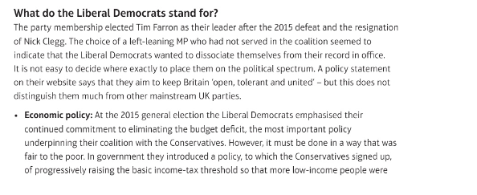
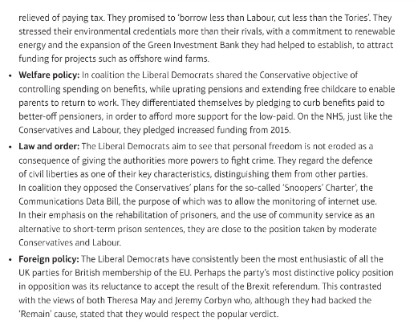
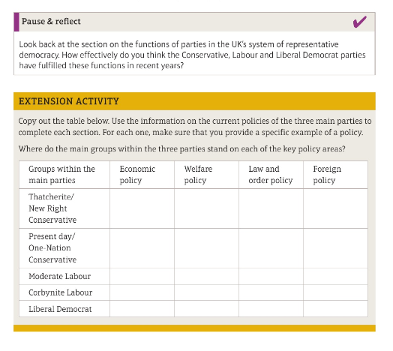
Established political parties
What is the difference between left-wing and right wing political ideas?
Is Labour still committed to socialist principles?
Are the conservatives still committed to Thatcherite principles?
What do the Liberal Democrats stand for?
How do the major political parties compare?

  - Emerging and minor UK political parties
The Scottish National Party (SNP)
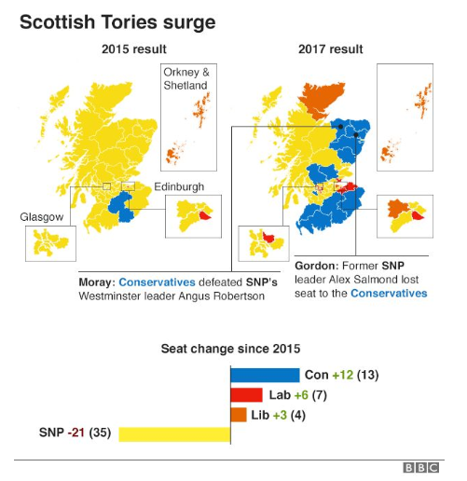
Guardian video ‘How long can the SNP own Scottish Politics?’: https://www.youtube.com/watch?v=8cQym29siz0

The UK Independence Party (UKIP)
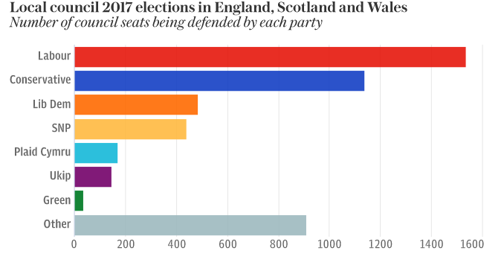
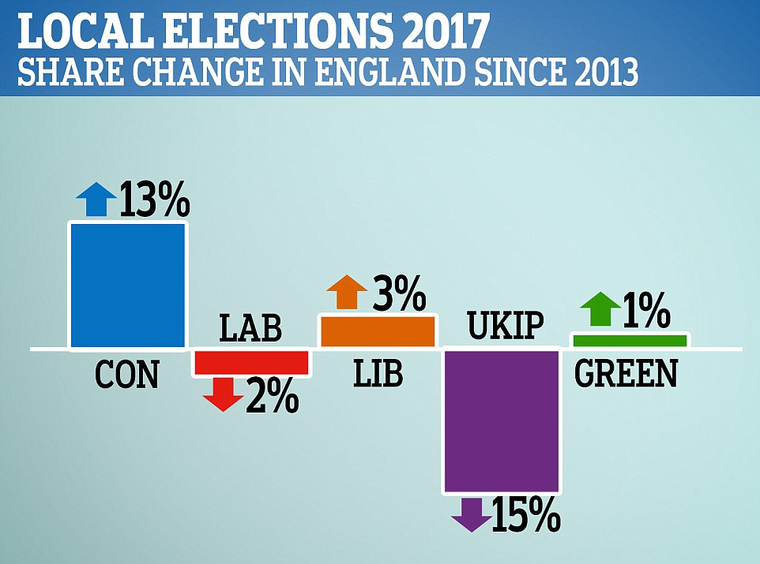
The Green Party
http://www.bbc.co.uk/news/election-2017-39993007

Emerging and minor UK political parties
How important are minor political parties in the UK?
Case studies: UKIP and The Green Party
How similar are the minor parties?

  - UK political parties in context

The development of a multi-party system
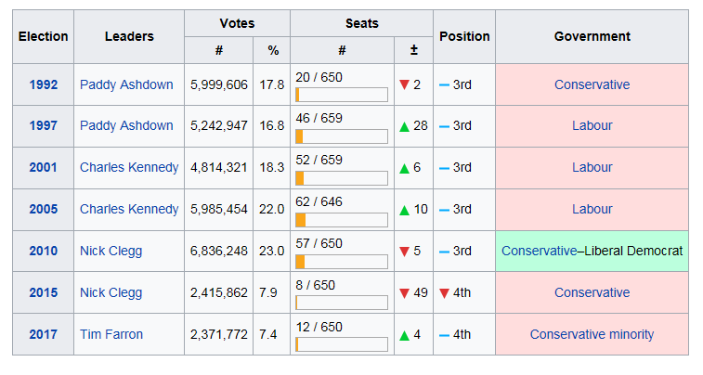
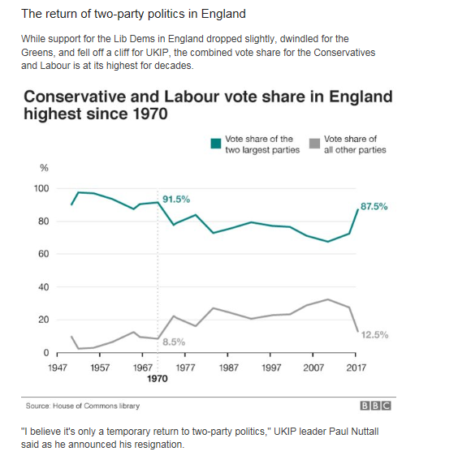
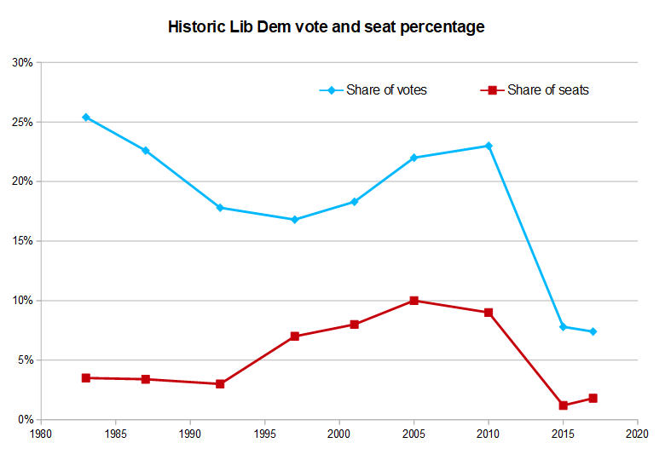
UK political parties in context
How has a multi-party system developed?
Why do some parties succeed and some parties fail?
How important is the media to political party success?

- Electoral systems

  - Different electoral syatems
Functions of an election
- They are a means by which citizens can participate in society. In a representative democracy voting is a crucial link in the participative process. Elections serve to be the means in a large society by which citizens can actively participate and feel involved in political life.

- They are a means of providing choice for the electorate; elections are contested by parties who offer different programmes if they are placed in power. Elections identify and secure that choice.

- Elections serve to ‘showcase’ the political spectrum in society: they allow for the display of mainstream politics and how elections are conducted serves to engage and educate the general public

- Elections have a representative function. Constituents are represented by their geographically based MP and in a national sense the parties represent the nature of political opinion in the country. Elections enable different shades of political opinion to be represented and act as a channel of communication for the public. For example, Caroline Lucas in securing the seat at Brighton speaks for the Green Party in the Commons.

- They provide a government. Following a general election a government will be formed. For example, in May 2015, the election produced a Conservative government.

- They are a method of conferring legitimacy on government and politicians. A new administration will claim a mandate to act based on victory in the preceding election.

- Elections are devices which allow governments to be fairly removed and new ones to form. If a party wins an election, it secures the right to govern. If a party loses an election, it bows to the loss and leaves the offices of state.

- They are a means of holding an incumbent government to account. For example, in 1997, and to an extent in May 2010, the incumbent governments were rejected by a majority of the electorate.

Elections in the UK
Types of elections held in the UK
- General Elections: provide members of Parliament (MPs) for all geographical locations in the UK. They also serve to determine the government and are seen as the most important elections in the UK.

- By-elections: provide representatives when a vacancy arises in a parliamentary constituency.

- Local elections: provide representation at a lower level by electing councillors who administer certain services in the locality.

- Elections to the devolved assemblies: provide representatives for regional government in Scotland, Wales and Northern Ireland.

- Mayoral elections: take place for regionally elected mayors, including in London.

- EU elections: take place to elect MEPs – representatives to the EU.

What is First Past The Post (FPTP)?
- FPTP is used for general and local elections in the UK.

- To win under FPTP, the victorious candidate must have at least one more vote than his or her nearest rival – a simple majority. This is a plurality system, as the winner does not need an overall majority (over 50% of votes cast).

- Each constituency returns just one MP to Parliament.

- Each voter only has one vote and cannot express preferences for more than one candidate.

- It is not a proportional system, as the percentage of votes cast for a particular party will not usually match the percentage of seats gained.

What is the Alternative Vote (AV)?
- AV is used extensively by major UK political parties for selecting their leaders.

- It is a majoritarian system, which produces a winner supported by the majority of the electorate.

- It is a preferential system, where a voter ranks their preferences in order and can vote for as many or as few candidates as they like.

- To win, the victorious candidate needs an overall majority of votes cast, but several ‘rounds’ of counting may need to take place in order for one candidate to achieve 50%⁽⁺⁾ of the vote.
  - In the first round, votes are counted on the basis of first preferences. If no candidate achieves an overall majority, then the candidate with the lowest number of first preference votes is eliminated.
  - Second round: the votes from the eliminated candidate are redistributed to other candidates on the basis of second preferences. If no candidate achieves an overall majority, then the candidate with the lowest number of votes is eliminated.
  - The process of eliminating the candidate with the lowest number of votes and redistributing their votes to other candidates on the basis of lower preferences continues until one candidate achieves an overall majority.

What is the Supplementary Vote (SV)?
- SV is used for London Mayoral elections.

- It works in the same way as AV, except that voters are only able to express a first and second preference.

- If an overall majority is achieved by one candidate on first preference votes, then the process ends; if not, second preferences are then taken into account.

What is the Party List system?
- The Party List system is a form of proportional representation.

- It requires voters to choose a political party and usually not an individual candidate.

- Parties can put up as many candidates as there are seats available and the parties themselves determine who is on the list and the order in which they are ranked.

- Seats are allocated to reflect the percentage of the vote a party receives, using the D’Hondt method.

- Lists can be open (where voters are able to vote for individual candidates, rather than just a party) or closed, and regional or national.

- The Closed Party list is used in all regions of the UK, except Northern Ireland, for elections to the European Parliament.

- This method is acclaimed as being the most proportionate of all systems.
What is Single Transferable Vote (STV)?
- STV is a form of proportional representation, in which voters express preferences for as many candidates as they like.

- Multi-member constituencies are used, usually electing 5-9 representatives.

- Parties can put up as many candidates are there are seats available and voters can choose multiple candidates from the same party.

- To become elected a representative has to reach a quota. This quota is calculated using a formula calculated once all the votes are cast.
  - First, any excess votes (above the quota) gained by candidates who have already achieved the quota are redistributed to other candidates on the basis of second preferences.
  - Then, if there are still seats available, the candidate with the lowest number of votes is eliminated and their votes are redistributed to other candidates on the basis of second (or lower) preferences.
  - The process of redistribution of votes ends when sufficient candidates have reached the quota to fill all available seats.

- STV aims to avoid wasted votes as well as to achieve a proportional outcome.

- STV is used for the Northern Ireland Assembly at Stormont, elections for the European parliament in the province of Northern Ireland and more recently it has been introduced for local elections in Scotland.

- A process of redistributing votes take place, where those with excess first preferences are elected and those with fewest votes are redistributed.

What is the Additional Member System (AMS)?
- AMS is a ‘hybrid’ voting system.

- It is a combination of FPTP and the regional (closed) party list system. A plurality and a proportional combination.

- Voters have two votes, one for the candidate in their constituency and the other from the party list.

- This produces two types of representative, one local (through single-member FPTP constituencies) and one regional (through Party List multi-member constituencies).

- The party-list element is used to ‘top up’ the constituency vote. It is used correctively to achieve a more proportional outcome using the D’Hondt method.

- AMS is used for the devolved regions in Wales, Scotland and for the London Assembly. In Scotland and London (in the Greater London Assembly) 56% of seats are filled by FPTP; in Wales this is 67%.

How has the use of AMS affected party representation in the UK?
- A wider and more diverse range of political parties have been elected than under FPTP, which has meant that more political parties have enjoyed administrative power, such as the Liberal Democrats who formerly shared power in the Scottish parliament with Labour.

- Single party majorities are highly unlikely with AMS.

- It has reduced the dominance of the Labour Party in both Wales and Scotland. It has not become the automatic or ‘natural’ party of government.

- It has revived and enhanced the fortunes of the nationalist parties, Plaid Cymru and the SNP, and had a similar effect on the Liberal Democrats and the Green Party. Representation of the Conservative Party has also increased in Wales and Scotland.

- It has allowed for minor party representation, such as the Scottish Socialist parties in Scotland.

Why have proportional electoral systems have been more widely used in the UK since 1997?
- There was a growing dissatisfaction with the unrepresentative nature of FPTP.

- There was a desire to achieve wide support for the newly established devolved assemblies, as well as the newly created Greater London Assembly, from as wide a section of the electorate as possible.

- It has been used for European elections because it was seen to be more in line with the PR systems which were used in the other member countries.

- STV has been used in Northern Ireland for the devolved government because it was intended to bring about a government in which power was shared by the major parties.

- PR was part of Labour’s commitment to constitutional reform and for democratic renewal.

- Some suggest that PR was ‘on trial’ for a possible introduction for Westminster which never materialised.
Different Electoral Systems
What are the advantages and disadvantages of FPTP?
What are the advantages and disadvantages of AMS; STV and SV?
How does FPTP compare to the Single Transferable Vote?

  - Referendums and how they are used
Why do governments hold referendums in the UK?
Referendum | Circumstances
Membership of the EU – Brexit (2016) | The Conservative Party has been split over Europe since the 1980s. The ‘Eurosceptics’ are a powerful group and have pressured David Cameron into holding a referendum on the UK’s membership of the EU. From 2013 onwards, when Cameron promised to hold the referendum, this ensured the Eurosceptics would vote with the government on key issues, so that the government could pass legislation. This referendum was therefore held to prevent a damaging split in the Conservative party.
Scottish independence (2014) | This asked if Scotland should remain part of the UK (and concluded it should). It was held because the Scottish National Party (SNP) won the 2011 Scottish parliamentary election and they had made a manifesto commitment to hold such a referendum. This was allowed by the UK government as they did not believe the SNP could win independence for Scotland.  Referendums are also generally now seen as necessary to establish popular support for constitutional change.
Elected mayors (2012) | The Labour governments 1997-2010 established a precedent of holding referendums on proposals for cities to have elected mayors. When the coalition government decided to introduce elected mayors, they then had to follow precedent and hold referendums.  Of the 10 cities holding referendums, only Bristol voted in favour of introducing an elected mayor.
AV (2011) | This referendum was held to satisfy the terms of the Coalition Agreement between the Conservative and Liberal Democratic parties. The Liberal Democrats had made a manifesto commitment to changing the electoral system, but the Conservative Party were against electoral reform. Holding a referendum was a compromise for both parties because it gave the decision to the people rather than one party getting its own way.  The proposal to adopt AV as the UK’s electoral system was rejected.
Welsh devolution (2011) | This referendum was held to satisfy increasing calls for the Welsh Assembly to be given wider law-making powers in view of its popularity and success in Wales. The proposal was accepted by a large margin.
Congestion charging in Manchester (2008) | The local authorities of Greater Manchester wanted to tax cars crossing the M60 to come into Manchester. The proceeds would be used to fund investment in public transport. The referendum was held to gain support for this policy, as it was very controversial, because car drivers were being asked to pay for benefits to others (those using public transport).  Not surprisingly, the proposal was rejected.
North-East English devolution (2004) | This referendum was held to test the popularity of the government’s policy of devolution to the English regions and to demonstrate public support for another constitutional change. The result was a resounding ‘no’, which led the government to drop its policy of English devolution.
Good Friday Agreement (1998) | This referendum was also held to show popular support for a controversial policy. The policy concerned ending violent conflict in Northern Ireland and setting up a devolved Assembly to govern the region. It was necessary because without clear support from both Protestant and Catholic communities, the Agreement could have been seen as biased towards one community, which would have perpetuated rather than ended the violence. It was also important to demonstrate support for the constitutional element of the proposal.  The Good Friday Agreement was accepted by the people, with a ‘yes’ vote of over 70%.
London Mayor (1998) | This referendum was held to fulfil a pledge made in the Labour party manifesto. Labour in 1997 promised in their manifesto to hold a referendum on an elected Mayor for London and an elected Greater London Assembly. The people of London accepted the proposal.
Scottish and Welsh devolution (1997) | These referendums were held to provide legitimacy to major constitutional changes and to fulfil pledges made in Labour’s manifesto. Devolution had been an important policy for Labour since the 1970s and they took the earliest opportunity to hold referendums and put the policy into practice.
EU membership (1975) | This referendum was held for essentially the same reason as that of 2016 - to settle an internal party dispute. The governing Labour party had a very small majority and was split over membership of the European Economic Community (EEC), so the referendum was held in order that Cabinet members could campaign on opposing sides and the people could resolve their dispute.  The referendum endorsed UK membership of the EEC.
Strengths of referendums
- They are the most direct form of modern democracy. The people’s views are clearly indicated and there is no confusion over the extent to which politicians are accurately representing public opinion. In this way referendums help to legitimise governmental decisions and confirm the principle of government by consent.
  - For example, the referendum on Scottish independence confirmed that the people of Scotland wanted to remain part of the UK, contrary to the claims of the SNP.

- If the people have given express consent, they are more likely to accept the decision that is made.
  - For example, the Good Friday Agreement could only succeed if it received widespread and clear support from most of the community, which could only be demonstrated by a referendum.

- Referendums can prevent governments from making unpopular decisions.
  - For example, there was no public appetite for adopting AV as the new electoral system for the UK in 2011, although there are increasing calls for a switch to some form of proportional representation in the wake of the 2015 general election result.

- Sometimes parties and governments are split over issues and are unable to resolve their differences. Referendums are used in these circumstances to provide a clear decision that everyone can abide by.
  - For example, the 2011 referendum on AV was held to resolve differences between the Coalition partners over electoral reform and the 1975 referendum on Europe was held to resolve differences within the Labour Party over European membership.

- A referendum entrenches constitutional changes. Since governments can be replaced every 5 years, changes can be reversed after a very short period of time by an incoming government. A referendum protects a constitutional change from being quickly reversed, as this would be seen as a new government going against the will of the people.
  - For example, it would have been very difficult for the Coalition government in 2010 to reverse Scottish and Welsh devolution established by the previous government.

Criticisms of referendums
- Issues may be very complex. This raises several problems. Firstly, most people are unlikely to make the effort to research the issues properly, so they will vote on the basis of an incomplete understanding. Secondly, they may get most of their information from biased sources such as newspapers, which follow the agenda of their owners. Thirdly, the public debate may focus on emotive issues rather than practicalities.
  - For example, the issues surrounding EU membership are extremely complex, but are often misrepresented as simple by politicians looking to gain public support. Additionally, many people (although by no means all) who are against EU membership are xenophobic rather than properly informed.

- Another reason why the public may vote on the grounds of reasons other than those relevant to the referendum concerns the involvement of the government. The electorate, especially in the middle of the incumbent government’s term of office, are often unhappy with what the government is doing. They may therefore use a referendum to vote against the government’s preferred option, as a way of expressing their dissatisfaction.
  - For example, in the 2011 AV referendum, the ‘Yes’ campaign was led by the Liberal Democrats, as they had campaigned for electoral reform before the 2010 general election. The victory for the ‘No’ campaign was therefore considered to be at least partly a vote against the Liberal Democrats by left-wing voters angry at the fact that the Party had formed a coalition with the right-wing Conservatives.

- A different type of problem can also be raised by complex issues, namely that it is impossible for them to be reduced to a yes/no format as a referendum requires. So, even if a referendum is held, there are residual problems that remain controversial. The referendum therefore is unable to provide a definitive resolution.
- For example, one reason why the UK mostly holds referendums on constitutional issues is because they tend to be relatively straightforward. A social issue, such as the potential re-introduction of the death penalty or the legalisation of marijuana, could be more complex in the sense that there are many different arguments, all suggesting different actions and potential consequences.

- Referendums can also prevent the government from acting to protect minorities. This is because a referendum result reflects the will of the majority, but takes no account of minority needs and preferences. If a government must abide by the result of a referendum, then it may not be possible for the corresponding legislation to make appropriate concessions to minority needs.
  - For example, the vote for Brexit has led to a rise in hate crime against migrants currently living in the UK as well as those wishing to emigrate to other European countries. In the weeks surrounding the referendum, hate crime was up by 42% in comparison to the previous years.

- Referendums can be manipulated by those in power to suit their own needs. This may occur when a party is split over an issue, but the general public is largely apathetic or in agreement. Under these circumstances, the referendum has the advantage for the party in question of resolving the internal rifts, but does not meet a clear democratic need.
  - For example, the referendum on EU membership of 1975 was held to reunite the Labour party so the Labour government could pass legislation more easily.
  - Similarly, the referendum on EU membership in 2016 was held to reunite the Conservative Party, so the Eurosceptics stop rebelling and embarrassing the government.

- A referendum rarely has a neutral or unbiased platform. Often one side has more money, more favourable media coverage and finance determines the outcome.
  - For example, the ‘No’ campaign in the 2011 AV referendum was very well-funded and well organised. It received a lot of media coverage in comparison to the ‘Yes’ campaign and the result was never really in doubt.

- When referendums are held frequently, the public can become more apathetic and therefore less likely to vote.
  - For example, in the 2012 mayoral referendums, turnout varied between 24% - 32%. This shows that the majority of the people didn’t really care about whether they had an elected mayor or not.

- Low turnouts can undermine the legitimacy provided by the referendum. It can be argued that even when a vote is very close, a high turnout legitimises the decision made, because by participating, people implicitly consent to abide by the result on the basis that it has been made legitimately. When turnout dips below 50%, then a majority of people have not endorsed the decision made in any sense (whether by voting for it, or participating in the process).
  - For example, the 2011 referendum on extending devolved law-making powers to the Welsh Assembly only had a turnout of 35.6%, so devolution was extended, but on the basis of a dubious mandate.
Referendums and how they are used
What is a referendum?
How have referendums been used in the UK?
What are the cases for and against referendums in a representative democracy?

  - Electoral system analysis
ANALYSIS: UK electoral systems
 | Criticisms | Counter-arguments
FPTP | FPTP does not provide an accurate or fair reflection of how people voted because it does not give all political parties a justified (proportionate) share of the seats.  Not all votes count or are of equal value, because some are not used to elect a candidate.  FPTP sacrifices accuracy in favour of strong government. No governments in recent times have gained 50% of the votes cast, but there has only been one minority and one coalition government since 1945. | FPTP does provide electoral choice in a straightforward manner. The winning party can claim a mandate and there are established clear lines of accountability because one party can be held responsible for the government’s successes and failures.  FPTP provides strong government and that is to be prized above some of its drawbacks.
Closed List | The Closed Party List is used to elect MEPs.  It can be criticised for giving representation to too many parties too small to govern or provide leadership. The system is also said to break the close link between voters and their representatives.  The order in which individual candidates appear on the closed party list also gives too much power to party managers. | It is the most proportional system that we use in the UK and is fair to all political parties; as such votes are not wasted as citizens vote for their first choice rather than tactically. Furthermore it aids not only smaller parties but also helps minorities and women.
AMS | AMS has been criticised for creating confusion by providing two types of MP: one elected on a constituency basis, the other from the party list. Furthermore this party list is numbered by the party not the electorate. It has meant that some members who failed to secure a constituency seat are still able to gain election through this route. As such these two types can be said to enjoy differing levels of legitimacy given their election routes. | However, many argue that the combination of FPTP with the list system is the best compromise possible for the UK, keeping a constituency base with some proportionality. It widens choice and attempts to reduce wasted votes.
STV | STV is criticised for the uneven proportionality which may result in certain of the multi-member constituencies. It also attracts criticism in that it can lead to problematic in-fighting amongst party members as they search for popularity and votes in the larger constituencies. STV has been attached for the complexity of the calculation system and the difficulty in many electors has in understanding the system.  Many votes were spoilt in Scotland when it was introduced for local government. | However the survival of a difficult peace process under STV is testament to its suitability. The uneven proportionality is still much fairer than FPTP. Teething issues with new systems can be overcome.
SV | The Supplementary Vote (SV) has been criticised in that the victor always appears to be a compromise candidate with not achieving an outright victory of first preferences. Victory emerges from the second preferences of the more extremist votes which are redistributed | However it can be argued that it is a farer system than FPTP and that a compromise candidate is far better than one who achieves victory on a more marginal base.

ANALYSIS: FPTP
Strength | Critique
It is simple and easy to operate. All that is required is an ‘X’ in the box next to the chosen candidate’s name. This allows all citizens clarity and confidence in use. Other electoral systems by contrast may appear cumbersome and complex. | However, it may be argued that this benefit is overrated. It may be the case that today’s electorate can cope with listing numerical choice and preferences. This happens in other developed nations there is no evidence that the UK is less educated than our European counterparts, who use various other electoral methods.
It is quick to produce a result, there is no delay and elected members and governments are soon in place. It is alleged that PR systems can take some time for the final outcome to be calculated and delivered. | However, some allege that this ‘speed’ attribute is overrated. If electronic voting was introduced than other systems would be equally as swift. Furthermore it is suggested that although speed is valued, accuracy and fairness are more desired virtues to be prized.
The system produces strong governments at Westminster with working majorities; other electoral systems can often produce coalitions. | Two points to consider here however. Firstly it may be seen that strong government comes at the expense of unrepresentative government. Secondly it may be wrong to assume that a coalition government is a weak or a bad government: the opposing case for coalitions can be advanced.
The system maintains the MP/Constituency link and preserves and nurtures an important geographical link. | However, it may be seen that other electoral systems, such as AMS can equally maintain and possibly build on this link. It is not exclusive.
The system produces a good choice for the electorate and the two party format mirrors the natural divide in society. | It may be seen however that the choice on offer is illusory. It is hard for third or other parties to break a two party dominance, which is thrown up by FPTP. In addition the two party monopoly is not reflective of the political culture of the UK.
The system keeps extremism at bay. Minority parties with extreme and politically unsavoury or destabilising views are denied representation. | This may be true, but other electoral systems with in-built thresholds can equally achieve this outcome.
ANALYSIS: Benefits/costs of changing from FPTP to PR for general elections
Benefits | Costs
It will make the House of Commons more reflective of how the country voted. Fair representation is well worth pursuing by introducing PR for Westminster. It is laudable to sacrifice strong government for accurate representation as a principle in its own right. Some coalition governments under PR can claim the support of at least 50% of the electorate. | It will produce unstable governments which fail to secure a working majority, because there will be a strong likelihood of coalition government and coalitions are inherently unstable.
It will eradicate many of the anomalies or the alleged unfairness of the current system. These include issues such as tactical voting, safe seats, marginal seats etc. | The current system is easy to use and operate.
It will increase voter turnout at the general election. It can be said to increase participation as more people will vote knowing that their vote counts and will make a difference. On this basis elected representative and governments can increase their democratic legitimacy. It is alleged that participation rates may not rise but legitimacy credentials certainly will. | There is no major demand amongst the public for change.
It will revive the fortunes of the Liberal democrats and other smaller parties. PR will improve the representation of parties thwarted under FPTP currently at Westminster. A broader and more accurate range of parties increases democracy by allowing all shades of opinion some level of representation. Thresholds could be introduced to make the system effective and eliminate racist or other extremist parties. | It will serve to allow extremist parties to gain credence and respectability.
It will move to make votes nationally to be of equal value. | This will be at the expense of eradicating the link of MPs to a constituency base.
It will introduce a clear possibility of coalition governments. If a coalition government arises and this is a clear possibility of PR for Westminster then this is to be favoured. Coalitions introduce compromise and promote consensus, evidence of this is now apparent. | No one votes for a coalition, so the complete legislative programmes of coalition governments cannot be regarded as having been endorsed by the electorate. Thus, coalitions lack legitimacy in comparison to single party governments.
PR for Westminster will make the governments more accountable to the legislature, thus avoiding accusations of elective dictatorship.
Differing systems of PR all have certain alleged benefits and some may be more easily adopted for Westminster than others | There are many types of PR and no one system emerges as being appropriate for the House of Commons.

ANALYSIS: Proportional Representation
 | Advantage | Criticism
Turnout | It is claimed that proportional systems increase turnout as voters feel that their vote will count and be effective, it will not be wasted and used to make a difference. | However evidence is not conclusive as to this claim, for example turnout for devolved elections is not higher than those for Westminster elections.
Legitimacy | It is claimed that proportional systems increase legitimacy as the outcome is more accurate it means that both Governments and individual representatives can rightly claim victory with a ‘fair’ system of turning votes in to seats. | However following elections in the UK under non-proportional systems such as FPTP, there is no heavily contested argument over the victor, for even following the outcome of the May 2010 General Election the formation of the coalition was seen as legitimate and just.
Representation for smaller parties | Proportional electoral systems will produce a more reflective and accurate outcome for small parties who under simple plurality systems will suffer, in reality this may mean growth and fair representation for the Green Party for example. | However, it may mean that some extreme parties gain a foothold in Parliamentary politics which have racist and undemocratic views, and this could destabilise society.
Coalition government | Proportional electoral systems are more likely to produce a coalition government which has at its core compromise and conciliation between different views in society. | However, coalitions can also be unstable and may fragment society as such proportional systems may harm democratic government.
Wasted votes | Under proportional electoral systems there are less likely to be ‘safe seats’ as under plurality systems. Seats which do not change hands and where some voters feel that their vote will simply be wasted and does not count, under systems of PR this is less prone to occur. | However, it is inevitable that some votes will have to be wasted, we cannot all vote for the winner and elections have to be combative and produce an outcome and a winner, PR is prone not to deliver a clear end result.

How would the 2017 General Election look under PR?
https://www.channel4.com/news/factcheck/how-would-parliament-look-under-proportional-representation
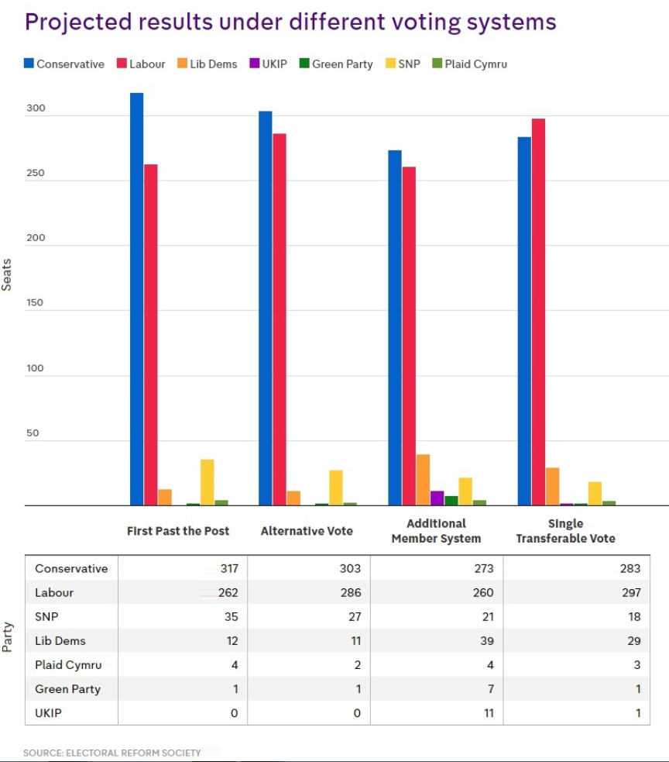

Electoral System analysis
Why are different electoral systems used in the UK?
What has been the impact of the different electoral systems in the UK on the type of government appointed?
What has been the impact of different systems on party representation?
What has been the impact of different systems on voter choice?

- Voting behaviour and the media

  - Case studies of three key general elections
Overview of elections since 1945
https://www.tutor2u.net/politics/reference/general-election-results-matching-activity
1983 Election

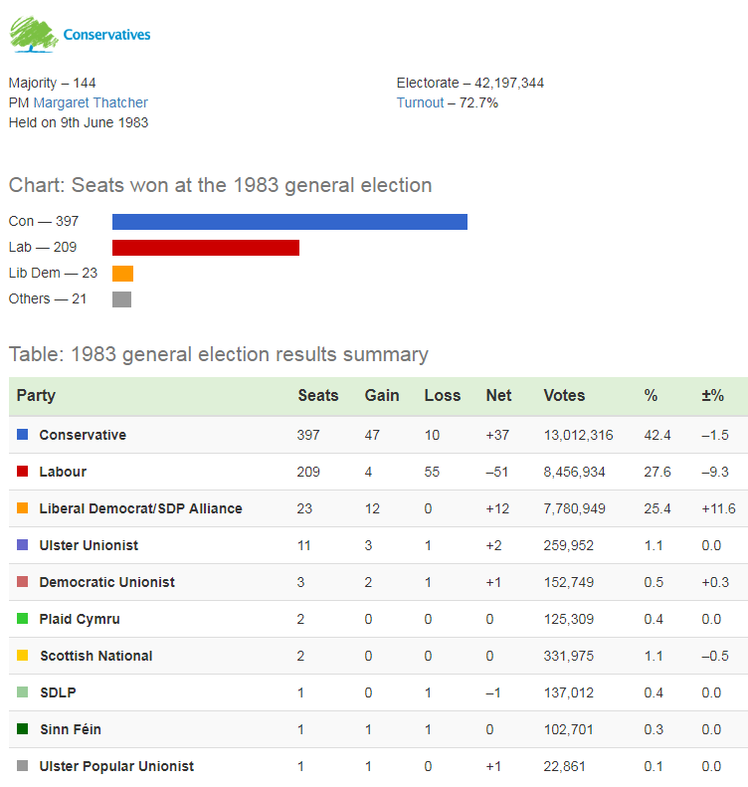
https://www.youtube.com/watch?time_continue=115&v=sf3NxCCSz3Y

1997 Election
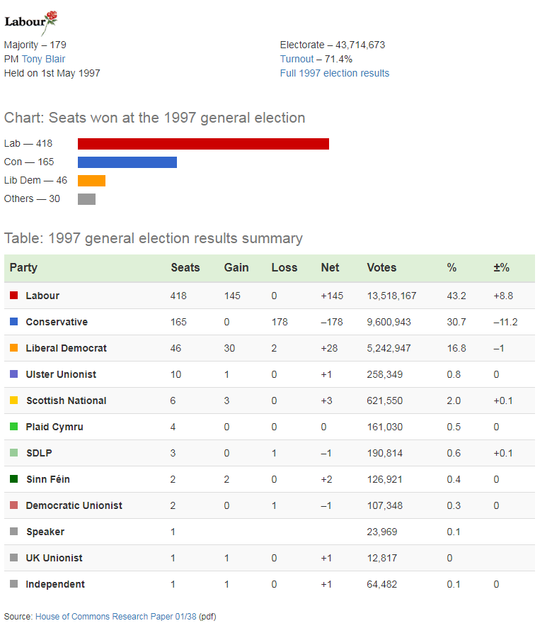
Labour 1997 original party political broadcast: https://www.youtube.com/watch?v=gi5j7jjhm4M
1997 election night aftermath: https://www.youtube.com/watch?v=RHXA5GykEbw

2017 election

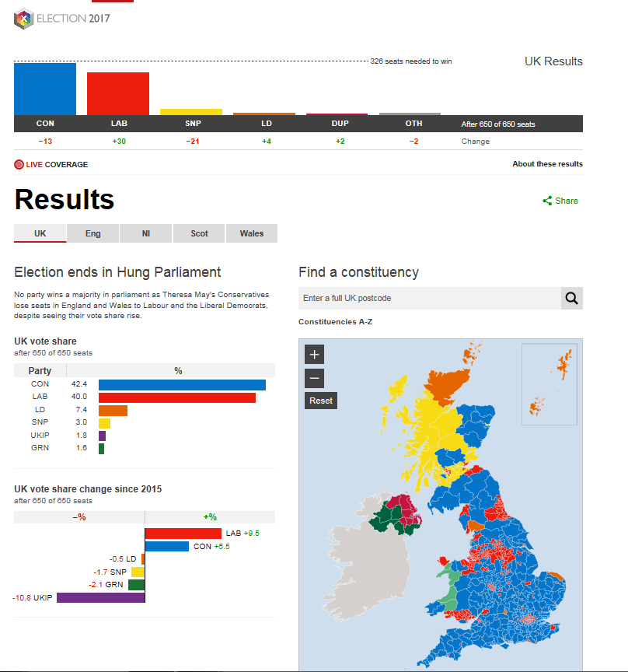

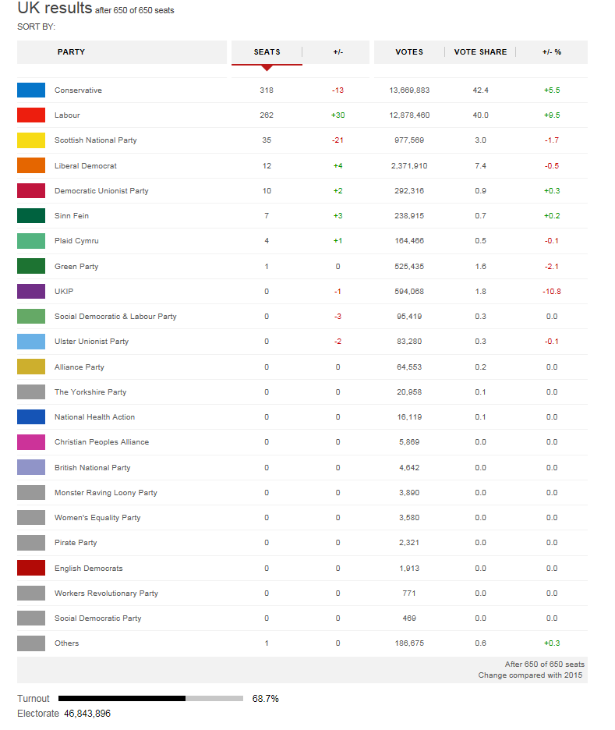
https://www.tutor2u.net/politics/blog/seven-ways-to-look-at-election-data

Case studies of 3 general elections: 1983; 1997 and 2017
Explain the factors that influenced the outcome of each election
What is the influence of class on voting patterns?
What is the influence of gender; age; ethnicity and region as factors in influencing voting behavior?

  - The influence of the media
Has the press lost its power?
https://www.tutor2u.net/politics/blog/has-the-press-lost-its-power
http://www.independent.co.uk/news/uk/politics/conservative-social-media-strategy-attack-jeremy-corbyn-labouir-twitter-facebook-video-stormzy-akala-a7784406.html
The influence of the media
What is the role of the media in politics?
What is the impact of the media in politics?
Should we have opinion polls?

Key terminology glossary
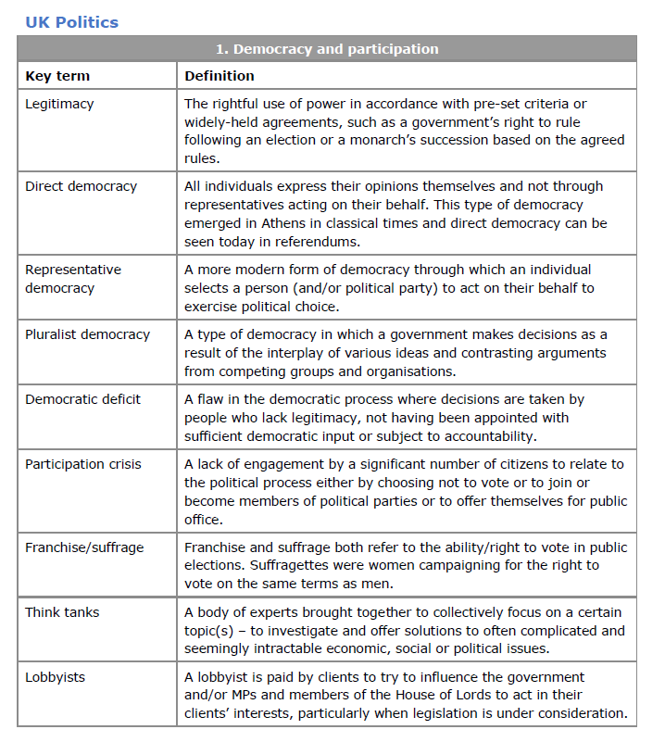
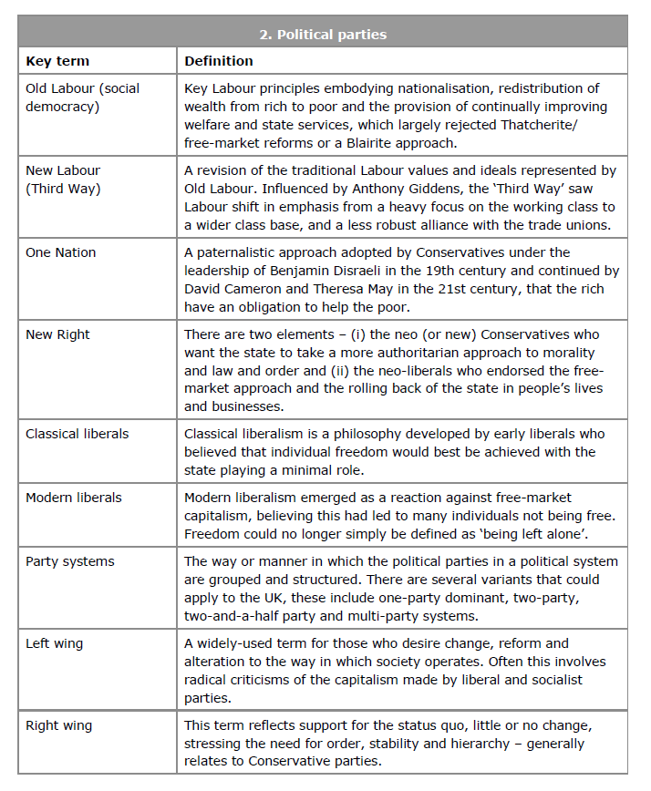
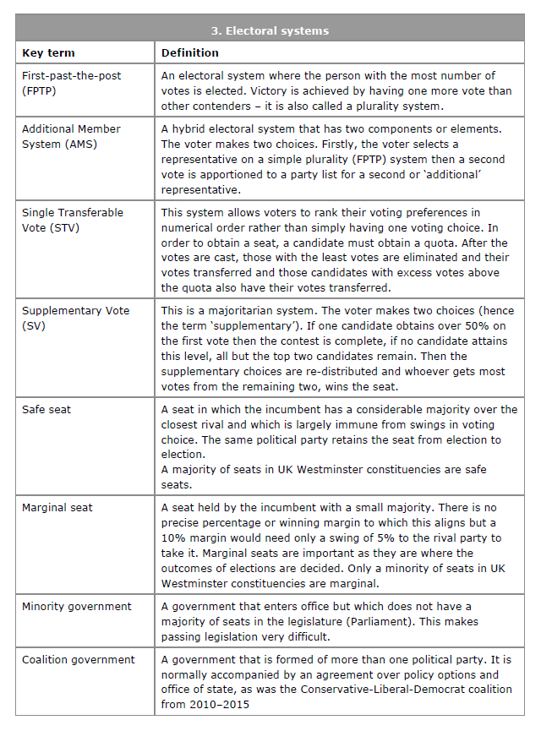
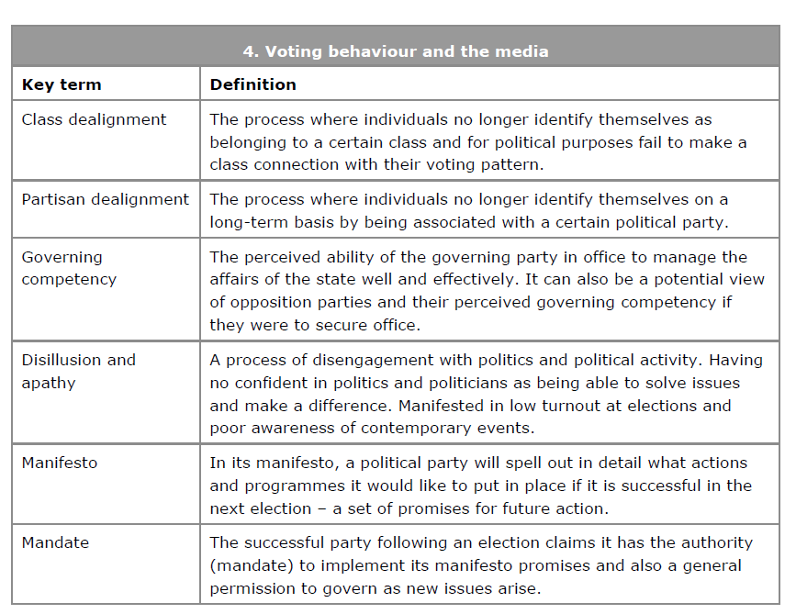

Extra key words
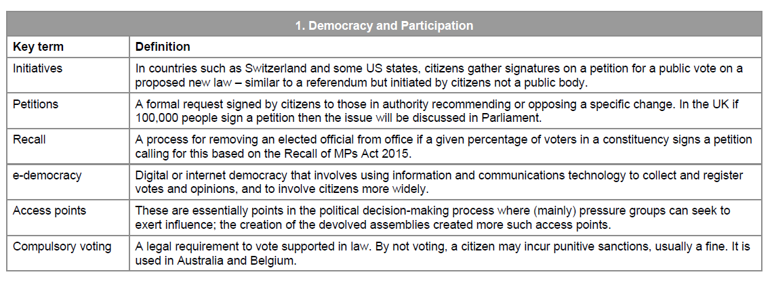
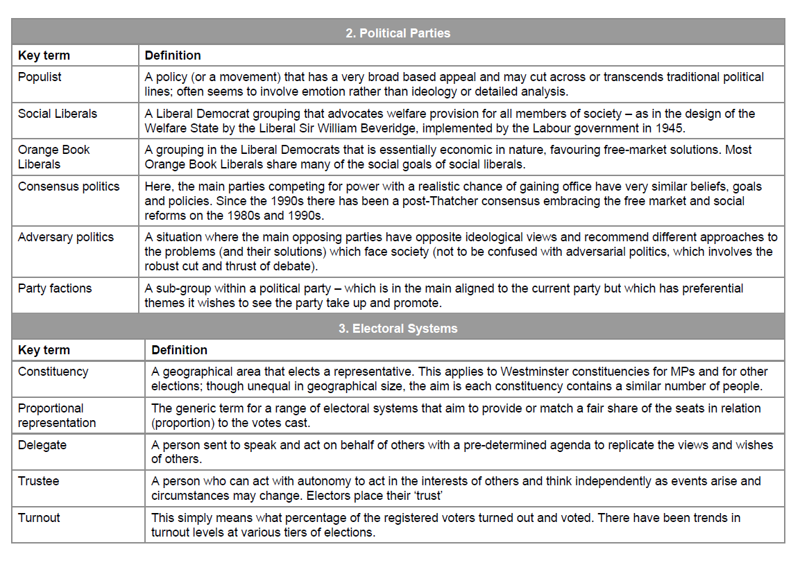
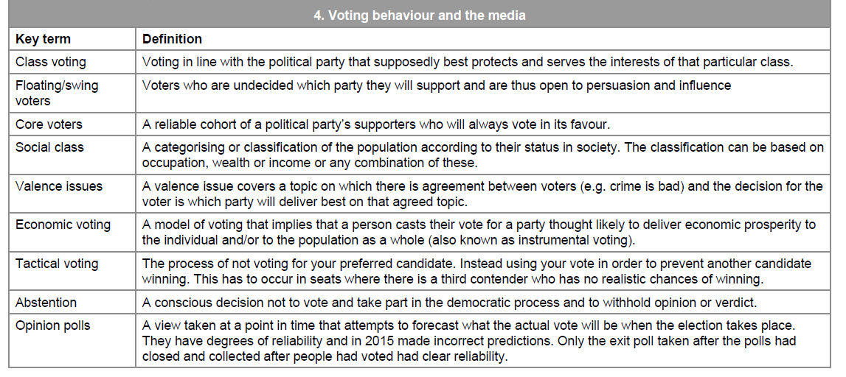
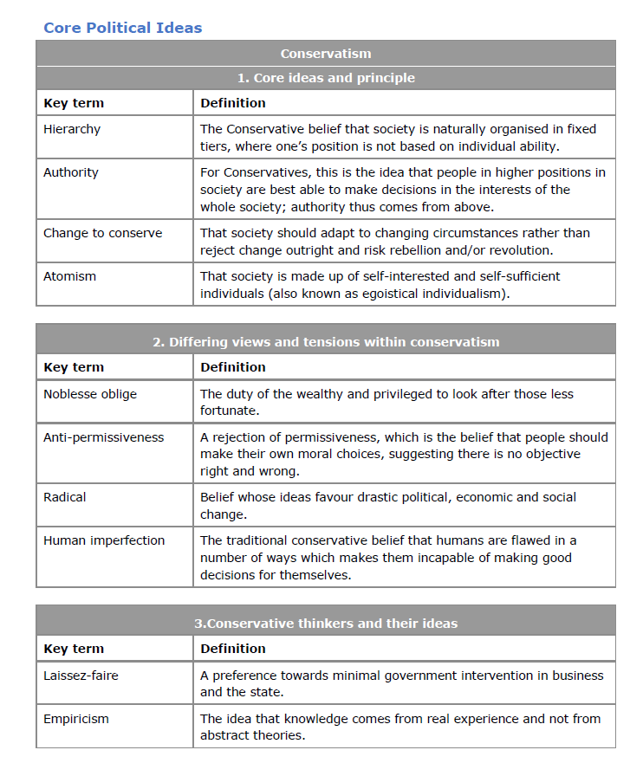
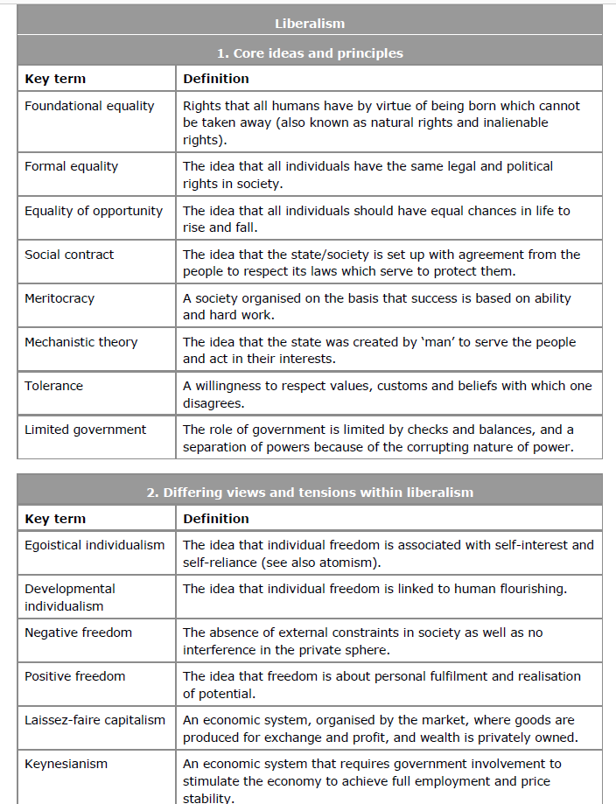
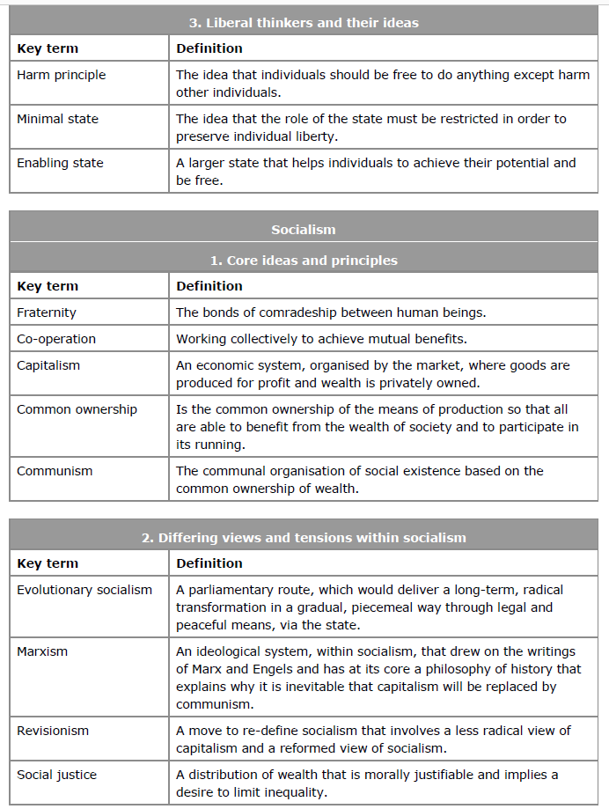
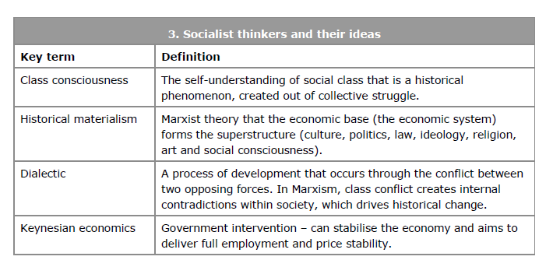

Specimen Exam Paper
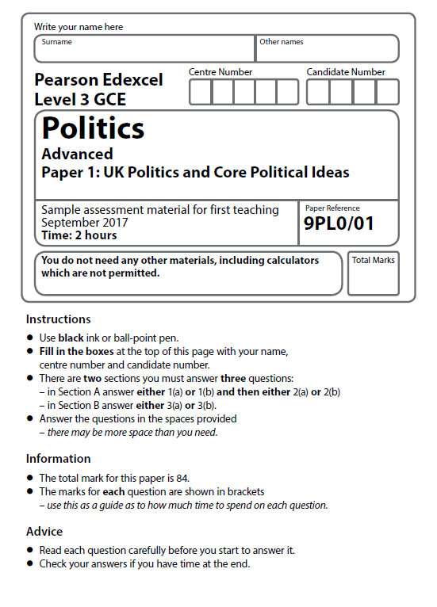
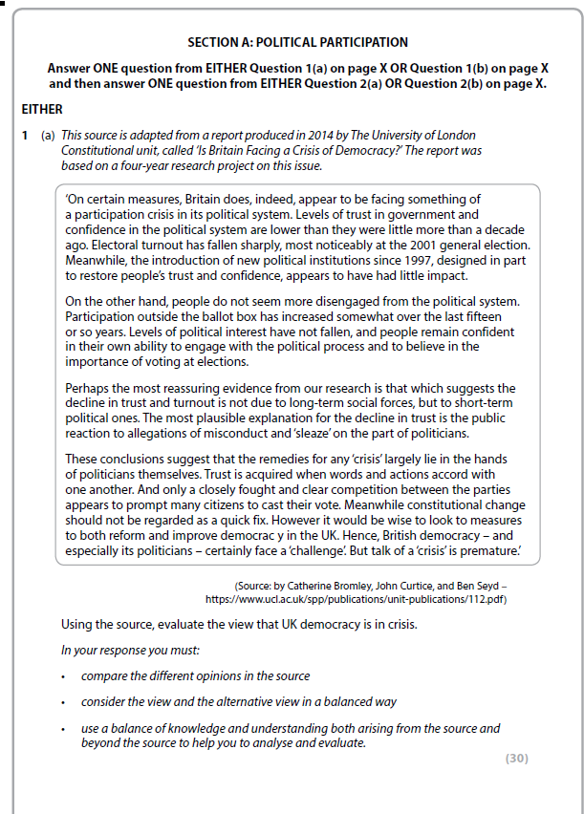

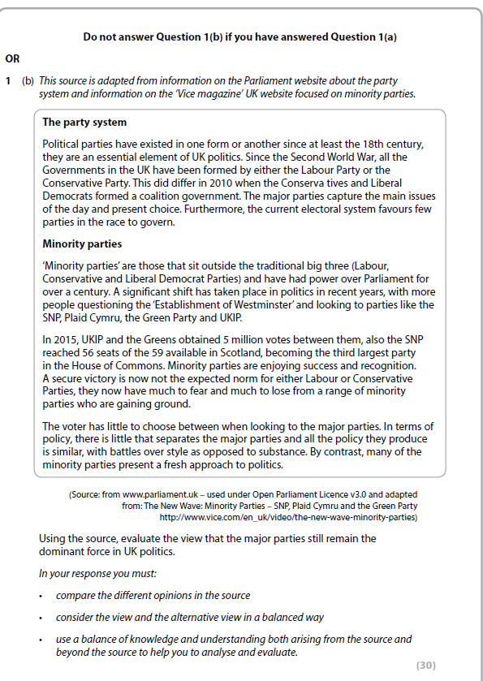

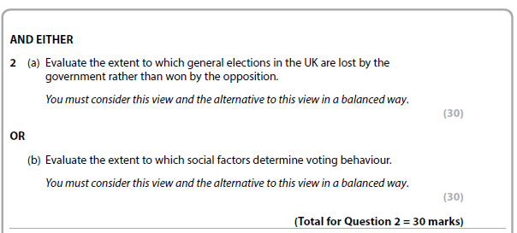
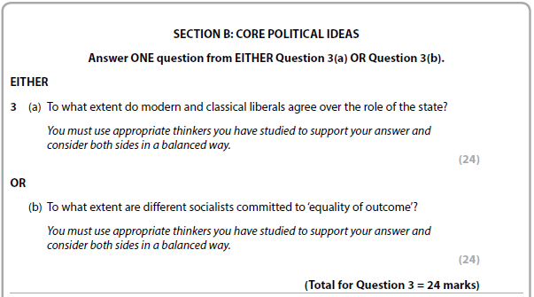

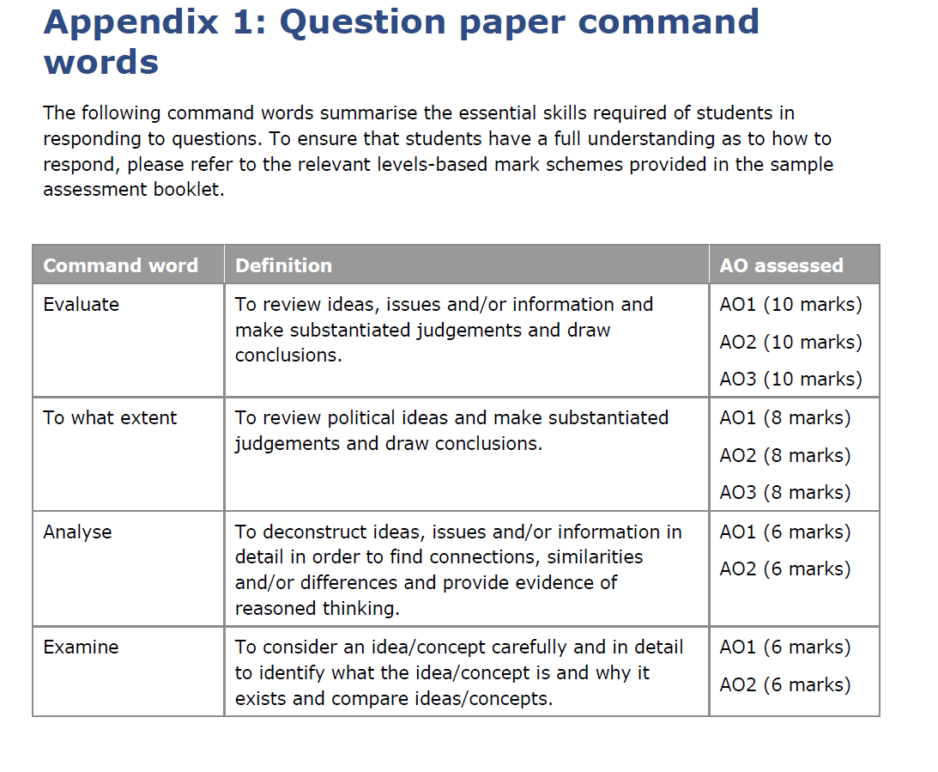
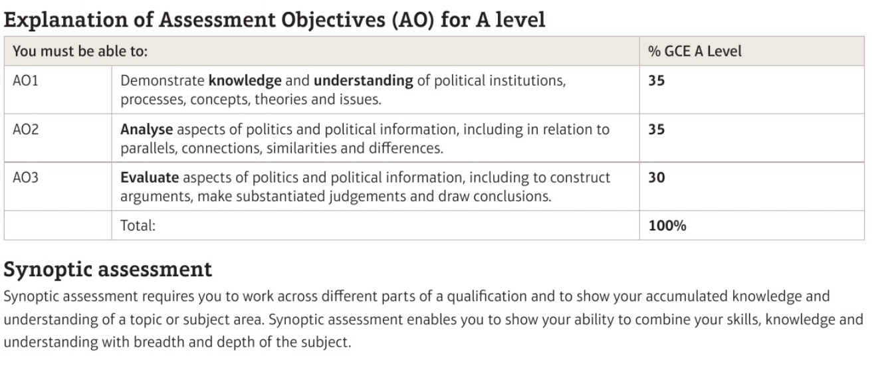
Understanding Objective Assessments
Assessment objective 1 (AO1)
· Knowledge (suggests breadth)
· Understanding (suggests depth)
Demonstrated, for example, by:
· Naming something
· Setting out features/characteristics
· Describing functions
· Surveying information
· Defining terms
· Describing differences
· Supplying examples
Marks for AO1 are gained for accuracy (is it true or false?) and thoroughness (is it comprehensive or limited/superficial?)
Assessment objective 2 (AO2)
Analyse: Break something into its component parts and show how they relate to one another
Demonstrated, for example, by:
· Examining something closely
· Providing explanations (setting out purposes or reasons, or highlighting causal relationships)
· Demonstrating interconnections, similarities and differences
· Showing how two or more things resemble one another, or are connected
· Judging the balance between similarities and differences
Assessment objective 3 (AO3)
Evaluate: Make judgments on significance or value based on evidence
Demonstrated, for example, by:
· Assessing extent (judging how far something happens)
· Measuring effectiveness (judging how far something fulfils its purpose)
· Weighing up importance (judging the impact of something)
· Criticising a viewpoint or statement (judging the strength of an argument)
· Arguing to a conclusion (judging the respective strengths of competing viewpoints)

MARK SCHEMES

Politics Unit 1A/2A – UK Politics and Government - Source 30 Mark question

Level | Mark | AO1: Knowledge and Understanding | AO2 :Explaining Comparisons and Concepts | AO3:Weighing up to make Judgements
Level 1 | 1–6 | - Points don’t relate to the question/source/s  - Supports points with very few examples /vague knowledge from the source/own knowledge  - Lacks understanding of political processes, concepts, theories and context | - Doesn’t really explain or compare the views in the source/s  - Little explanation and argument about the similarities and/or differences in the source/s  - Answer does not use ideas/concepts to explain points | - Little evaluation of the different views in the source/s  - Simple argument and judgements are made in paragraphs but are not supported or explained  - In a conclusion the overall judgement is simple and described or does not follow the rest of the answer
Level 2 | 7–12 | - Points relate to the question/ source/s  - Supports points with some examples selected from the source/own knowledge  - Shows some accurate knowledge and understanding of political institutions, processes, concepts, theories and context | - Begins to explain and compare the views in the source/s  - Max L2 for answers which do not compare the source/s  - Some explanation and argument about the similarities and/or differences in the source/s  - Begins to use ideas/concepts to explain points | - Some relevant evaluation of some of the different views in the debate from the source/s  - Simple arguments and judgements are made in paragraphs but are not always supported or explained  - In a conclusion the overall judgement is clear and party supported and follows rest of answer  - Max 2 if conclusion does not weigh up different views before making own judgement
Level 3 | 13–18 | - Points mostly answer the demands of the question/ focus of the source/s  - Supports points with well selected examples from the source and own knowledge  - Explains points with mostly accurate knowledge and understanding of political institutions, processes, concepts, theories and context | - Explain and compare the views in the source/s which relate to the debate  - Mostly focused explanation and argument of the similarities and/or differences in the source/s  - Mostly connects relevant ideas/concepts to explain points | - Mostly relevant evaluation of the different views in the debate from the source/s  - Some clear/persuasive arguments and judgements are made in paragraphs which are mostly supported or explained  - In a conclusion the overall judgement is focused, mostly supported and explained
Level 4 | 19–24 | - Points made answer the demands of the question /relate directly to the focus of the source/s  - Supports points with precisely selected examples from the source and own knowledge  - Explains points with accurate knowledge and understanding of political institutions, processes, concepts, theories and context | - Explain and compare the views in the source/s which relate to the debate throughout  - Clearly focused explanation and argument of the similarities and/or differences in the source/s  - Clearly connects relevant ideas/concepts to explain points | - Relevant evaluation of the most of the different views in the debate from the source/s  - Many clear/persuasive arguments and judgements are made in paragraphs which are mostly supported or explained  - In a conclusion the overall judgement is focused, supported and explained
Level 5 | 25–30 | - Points fully answer the demands of the question/relate to several focuses in the source/s  - Supports points with a range of precisely selected evidence from the source and own knowledge  - Explains thorough and in-depth knowledge and understanding of political institutions, processes, concepts, theories and context | - Explain and compare all contrasting views in the source/s which relate to the debate  - Clearly focused explanation and argument of the similarities and/or differences in the source/s throughout  - Clearly connects relevant ideas/concepts to explain points throughout to fully answer the question | - Fully relevant evaluation of all the different views in the debate from the source/s  - Clear/persuasive arguments and judgements are made in paragraphs which are fully supported or explained  - In a conclusion the overall judgement is fully focused, supported and explained

Politics Unit 1B and 2B – Core and Non-Core Ideologies 24 Mark question

Level | Mark | AO1: Knowledge and Understanding | AO2 :Explaining Comparisons and Concepts | AO3:Weighing up to make Judgements
Level 1 | 1-4 | - Points don’t relate to the question  - Supports points with very few examples /vague knowledge  - Lacks understanding of political processes, concepts, theories and context  - Makes limited reference to political thinkers’ ideas | - Doesn’t really explain or compare different views in the debate  - Little explanation and argument  - Answer does not use ideas/concepts to explain points | - Little evaluation of different views in the debate  - Simple argument and judgements are made in paragraphs but are not supported or explained  - In a conclusion the overall judgement is simple and described or does not follow the rest of the answer
Level 2 | 5-9 | - Points relate to the question  - Supports points with some examples  - Shows some accurate knowledge and understanding of political institutions, processes, concepts, theories and context  - Make some reference to political thinkers’ ideas  - Max L2 if doesn’t mention different political thinkers’ ideas | - Begins to explain and compare different views in the debate  - Max L2 if doesn’t balance different views  - Some explanation and argument  - Begins to use ideas/concepts to explain points | - Some relevant evaluation of some different views in the debate  - Simple arguments and judgements are made in paragraphs but are not always supported or explained  - In a conclusion the overall judgement is clear and party supported and follows rest of answer
Level 3 | 10-14 | - Points mostly answer the demands of the question  - Supports points with well selected examples  - Explains points with mostly accurate knowledge and understanding of political institutions, processes, concepts, theories and context  - Refers to different political thinkers’ ideas | - Explain and compare different views in the debate  - Mostly focused explanation and argument  - Mostly connects relevant ideas/concepts to explain points | - Mostly relevant evaluation of the different views in the debate  - Some clear/persuasive arguments and judgements are made in paragraphs which are mostly supported or explained  - In a conclusion the overall judgement is focused, mostly supported and explained
Level 4 | 15-19 | - Points made answer the demands of the question  - Supports points with precisely selected examples  - Explains points with accurate knowledge and understanding of political institutions, processes, concepts, theories and context  - Refers to a range of political thinkers’ ideas | - Explain and compare different views in the debate throughout  - Clearly focused explanation and argument  - Clearly connects relevant ideas/concepts to explain points | - Relevant evaluation of the most of the different views in the debate  - Many clear/persuasive arguments and judgements are made in paragraphs which are mostly supported or explained  - In a conclusion the overall judgement is focused, supported and explained
Level 5 | 20-24 | - Points fully answer the demands of the question/  - Supports points with a range of precisely selected evidence  - Explains thorough and in-depth knowledge and understanding of political institutions, processes, concepts, theories and context  - Refers to a full range of political thinkers’ ideas | - Explain and compare all contrasting views in the debate  - Clearly focused explanation and argument throughout  - Clearly connects relevant ideas/concepts to explain points throughout to fully answer the question | - Fully relevant evaluation of all the different views in the debate  - Clear/persuasive arguments and judgements are made in paragraphs which are fully supported or explained  - In a conclusion the overall judgement is fully focused, supported and explained

Politics Unit 2A – Essay 30 Mark question – UK Government
Level | Mark | AO1: Knowledge and Understanding | AO2 :Explaining Comparisons and Concepts | AO3:Weighing up to make Judgements
Level 1 | 1–6 | - Points don’t relate to the question  - Supports points with very few examples /vague knowledge  - Lacks understanding of political processes, concepts, theories and context  - Makes 1-2 synoptic links or references to own knowledge from UK Politics/Political Ideas Units | - Doesn’t really explain or compare different views in the debate  - Little explanation and argument  - Answer does not use ideas/concepts to explain points | - Little evaluation of different views in the debate  - Simple argument and judgements are made in paragraphs but are not supported or explained  - In a conclusion the overall judgement is simple and described or does not follow the rest of the answer
Level 2 | 7–12 | - Points relate to the question  - Supports points with some examples  - Shows some accurate knowledge and understanding of political institutions, processes, concepts, theories and context  - Makes some synoptic links or references to own knowledge from UK Politics/Political Ideas Units | - Begins to explain and compare different views in the debate  - Max L2 if doesn’t balance different views  - Some explanation and argument  - Begins to use ideas/concepts to explain points | - Some relevant evaluation of some different views in the debate  - Simple arguments and judgements are made in paragraphs but are not always supported or explained  - In a conclusion the overall judgement is clear and party supported and follows rest of answer
Level 3 | 13–18 | - Points mostly answer the demands of the question  - Supports points with well selected examples  - Explains points with mostly accurate knowledge and understanding of political institutions, processes, concepts, theories and context  - Makes some relevant synoptic links or references to own knowledge from UK Politics/Political Ideas Units | - Explain and compare different views in the debate  - Mostly focused explanation and argument  - Mostly connects relevant ideas/concepts to explain points | - Mostly relevant evaluation of the different views in the debate  - Some clear/persuasive arguments and judgements are made in paragraphs which are mostly supported or explained  - In a conclusion the overall judgement is focused, mostly supported and explained
Level 4 | 19–24 | - Points made answer the demands of the question  - Supports points with precisely selected examples  - Explains points with accurate knowledge and understanding of political institutions, processes, concepts, theories and context  - Makes several relevant synoptic links or references to own knowledge from UK Politics/Political Ideas Units | - Explain and compare different views in the debate throughout  - Clearly focused explanation and argument  - Clearly connects relevant ideas/concepts to explain points | - Relevant evaluation of the most of the different views in the debate  - Many clear/persuasive arguments and judgements are made in paragraphs which are mostly supported or explained  - In a conclusion the overall judgement is focused, supported and explained
Level 5 | 25–30 | - Points fully answer the demands of the question/  - Supports points with a range of precisely selected evidence  - Explains thorough and in-depth knowledge and understanding of political institutions, processes, concepts, theories and context  - Makes well selected synoptic links or references to own knowledge from UK Politics/Political Ideas Units  - Cannot reach L5 without synoptic links/references | - Explain and compare all contrasting views in the debate  - Clearly focused explanation and argument throughout  - Clearly connects relevant ideas/concepts to explain points throughout to fully answer the question | - Fully relevant evaluation of all the different views in the debate  - Clear/persuasive arguments and judgements are made in paragraphs which are fully supported or explained  - In a conclusion the overall judgement is fully focused, supported and explained

Politics Unit 3A – Comparative Politics 12 Mark Examine Question

Level | Mark | AO1: Knowledge and Understanding | AO2 :Explaining Comparisons and Concepts
Level 1 | 1–3 | - Points don’t relate to the question  - Supports points with very few examples /vague knowledge  - Lacks understanding of political processes, concepts, theories and context | - Doesn’t really explain or compare politics in the USA/UK  - Max L1 if you only mention the UK OR the USA  - Little explanation and argument about the similarities and/or differences between the UK/USA  - Answer does not use ideas/concepts to explain points
Level 2 | 4-6 | - Points relate to the question  - Supports points with some examples  - Shows some accurate knowledge and understanding of political institutions, processes, concepts, theories and context | - Begins to explain and compare politics in the USA/UK  - Some explanation and argument about the similarities and/or differences between the UK/USA  - Begins to use ideas/concepts to explain points
Level 3 | 7-9 | - Points mostly answer the demands of the question  - Supports points with well selected examples  - Explains points with mostly accurate knowledge and understanding of political institutions, processes, concepts, theories and context | - Explains and compares politics in the USA/UK  - Mostly focused explanation and argument of the similarities and/or differences between the UK/USA  - Mostly connects relevant ideas/concepts to explain points
Level 4 | 10-12 | - Points made answer the demands of the question  - Supports points with precisely selected examples  - Explains points with accurate knowledge and understanding of political institutions, processes, concepts, theories and context | - Explain and compares politics in the USA/UK throughout  - Clearly focused explanation and argument of the similarities and/or differences between the UK/USA  - Clearly connects relevant ideas/concepts to explain points

Politics Unit 3B – Comparative Politics 12 Mark Analyse Question

Level | Mark | AO1: Knowledge and Understanding | AO2 :Explaining Comparisons and Concepts
Level 1 | 1–3 | - Points don’t relate to the question  - Supports points with very few examples /vague knowledge  - Lacks understanding of political processes, concepts, theories and context  - Limited comparative theory used | - Doesn’t really explain or compare politics in the USA/UK  - Max L1 if you only mention the UK OR the USA  - Little explanation and argument about the similarities and/or differences between the UK/USA  - Answer does not use ideas/concepts to explain points
Level 2 | 4-6 | - Points relate to the question  - Supports points with some examples  - Shows some accurate knowledge and understanding of political institutions, processes, concepts, theories and context  - Some relevant comparative theory used | - Begins to explain and compare politics in the USA/UK  - Some explanation and argument about the similarities and/or differences between the UK/USA  - Begins to use ideas/concepts to explain points
Level 3 | 7-9 | - Points mostly answer the demands of the question  - Supports points with well selected examples  - Explains points with mostly accurate knowledge and understanding of political institutions, processes, concepts, theories and context  - Relevant comparative theory used  - Max L3 with no comparative theory used | - Explains and compares politics in the USA/UK  - Mostly focused explanation and argument of the similarities and/or differences between the UK/USA  - Mostly connects relevant ideas/concepts to explain points
Level 4 | 10-12 | - Points made answer the demands of the question  - Supports points with precisely selected examples  - Explains points with accurate knowledge and understanding of political institutions, processes, concepts, theories and context  - Comparative theory is used effectively to answer the Q - | - Explain and compares politics in the USA/UK throughout  - Clearly focused explanation and argument of the similarities and/or differences between the UK/USA  - Clearly connects relevant ideas/concepts to explain points

Politics Unit 3C – Essay 30 Mark question – UK/US Politics

Level | Mark | AO1: Knowledge and Understanding | AO2 :Explaining Comparisons and Concepts | AO3:Weighing up to make Judgements
Level 1 | 1–6 | - Points don’t relate to the question  - Supports points with very few examples /vague knowledge  - Lacks understanding of political processes, concepts, theories and context | - Doesn’t really explain or compare different views in the debate  - Little explanation and argument  - Answer does not use ideas/concepts to explain points | - Little evaluation of different views in the debate  - Simple argument and judgements are made in paragraphs but are not supported or explained  - In a conclusion the overall judgement is simple and described or does not follow the rest of the answer
Level 2 | 7–12 | - Points relate to the question  - Supports points with some examples  - Shows some accurate knowledge and understanding of political institutions, processes, concepts, theories and context | - Begins to explain and compare different views in the debate  - Max L2 if doesn’t balance different views  - Some explanation and argument  - Begins to use ideas/concepts to explain points | - Some relevant evaluation of some different views in the debate  - Simple arguments and judgements are made in paragraphs but are not always supported or explained  - In a conclusion the overall judgement is clear and party supported and follows rest of answer
Level 3 | 13–18 | - Points mostly answer the demands of the question  - Supports points with well selected examples  - Explains points with mostly accurate knowledge and understanding of political institutions, processes, concepts, theories and context | - Explain and compare different views in the debate  - Mostly focused explanation and argument  - Mostly connects relevant ideas/concepts to explain points | - Mostly relevant evaluation of the different views in the debate  - Some clear/persuasive arguments and judgements are made in paragraphs which are mostly supported or explained  - In a conclusion the overall judgement is focused, mostly supported and explained
Level 4 | 19–24 | - Points made answer the demands of the question  - Supports points with precisely selected examples  - Explains points with accurate knowledge and understanding of political institutions, processes, concepts, theories and context | - Explain and compare different views in the debate throughout  - Clearly focused explanation and argument  - Clearly connects relevant ideas/concepts to explain points | - Relevant evaluation of the most of the different views in the debate  - Many clear/persuasive arguments and judgements are made in paragraphs which are mostly supported or explained  - In a conclusion the overall judgement is focused, supported and explained
Level 5 | 25–30 | - Points fully answer the demands of the question/  - Supports points with a range of precisely selected evidence  - Explains thorough and in-depth knowledge and understanding of political institutions, processes, concepts, theories and context | - Explain and compare all contrasting views in the debate  - Clearly focused explanation and argument throughout  - Clearly connects relevant ideas/concepts to explain points throughout to fully answer the question | - Fully relevant evaluation of all the different views in the debate  - Clear/persuasive arguments and judgements are made in paragraphs which are fully supported or explained  - In a conclusion the overall judgement is fully focused, supported and explained

