COLD WAR: TOPIC 1: THE ORIGINS OF THE COLD WAR | WWII ALLIANCE:  What three countries worked together during WWII against Nazi Germany? | WWII ALLIANCE:  What was the WWII alliance between GB, USA and USSR called? | WWII ALLIANCE:  Name TWO CONSEQUENCES of the Tehran Conference, 1943:  1  2 | WWII ALLIANCE:  Name TWO CONSEQUENCES of the Yalta Conference, Feb 1945:  1  2
WWII ALLIANCE:  Name TWO CONSEQUENCES of the Potsdam Conference, August 1943:  1  2 | WWII ALLIANCE:  Why did Roosevelt’s death increase mistrust between Stalin and Truman?  What weapon did Truman use in 1945 to end the war with Japan? | EARLY RIVALRY:  What race began between the USA & USSR after the USA used this weapon? | EARLY RIVALRY  : What political system did the USA have? (give some eg’s)  What political system did the USSR have? (give some eg’s) | EARLY RIVALRY:  What words describe the increasing feeling between each superpower?  M__________________  S___________________  As a result, each leader asked their ambassadors to spy on the rival superpower and report back on their intensions.
SUSPICION INCREASES:  1946 What did the Novikov Telegram tell Stalin that the USA wanted?  W______________  D_______________ and was building up its m_______________ strength. | SUSPICION INCREASES:  1946 What did the Long Telegram tell Truman that the USSR wanted?  Stalin wanted to spread c_____________ and saw the USA as an e_________. | STALIN TAKES ACTION IN EASTERN EUROPE:  What ‘SS’ describes Stalin seizing control over Eastern European countries?  S___________________  S___________________  List some countries effected: | STALIN TAKES ACTION IN EASTERN EUROPE:  Once in control of a country what did the communists do in order to take control?  E EUROPE WAS NOW CLOSELY CONTROLLED BY THE USSR | USA RESPONSE:  What did the USA accuse the USSR of doing? (NB promises at Yalta)  How did the USSR justify their actions? (buffer zone)
USA RESOPONSE:  1947 How did US President Truman plan to stop the spread of communism?  T________________ D_______________  TWO CONSEQUENCES:  1. Ended US foreign policy of Isolationism and helped rebuild W Europe.  2. USSR reaction – Stalin was furious & tightened his grip on E Europe. | USA RESPONSE:  $  1947 What was the Marshall Plan?  Us gave $___ billion to the reconstruction of Europe.  What did countries accepting the Marshall Plan have to do?  W EUROPE WAS NOW CLOSELY LINKED TO USA | TWO CONSEQUENCES: of the Truman Doctrine & Marshall Plan  STOPPED SPREAD OF COMMUNISM: Name 2 countries that successfully used money to stop communist rebellions: G_____________ & T_____________  This increased the USA’s Sphere of i__________ to W___________ Europe.  USSR RESPONSE:  1947 – USSR set up organisations to control its satellite states: What was Cominform?  1949 - USSR set up organisations to control its satellite states: What was Comecon? |  | GERMANY:  Which European country was at the centre of the Cold War?  Why?

What phrase by Winston Churchill describe the division of Europe into two political systems? | 1949 What was NATO? / who belonged & why was it formed?  1955 What was Warsaw Pact? / who belonged & why was it formed? | CONSEQUENCES of NATO & WARSAW PACT:  1. USA and W Europe were not willing to accept the _ _ _ _ spreading communist control in Europe.  2. Now two opposing m__________ alliances in Europe making the risk of war increase.  3. The USSR increased its m__________ strength by gaining control over its satellite states a______ and resources. | ARMS RACE  When did the USSR develop their first atomic bomb? 194________  What did the USA develop in 1952?  H____________ bomb  When did the USSR develop the same technology? 195_______ | ARMS RACE:  What does M.A.D. stand for  How did this reduce the risk of nuclear war between the superpowers?
CASE STUDY 1 GERMANY & BERLIN 1948-9  What did the allies agree would happen to Germany after the war when they met at Yalta? | CASE STUDY 1 GERMANY & BERLIN 1948-9  Why was the division of Berlin into 4 zones a problem? (especially for the USSR)  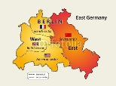 | CASE STUDY 1 GERMANY & BERLIN 1948-9  What did the USA want to see happen to Germany in the future?  $  What did the USA do in 1947 to  encourage this? | CASE STUDY 1 GERMANY & BERLIN 1948-9  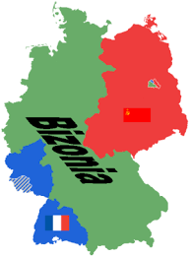  What action did the USA take in 1948 that upset Stalin?  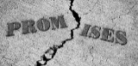  What did he accuse the West of doing? | CASE STUDY 1 GERMANY & BERLIN 1948-9  Stalin Takes Action: What does Stalin do to force the West out of Berlin.  June 194_  When?  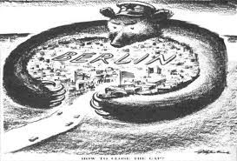
CASE STUDY 1 GERMANY & BERLIN 1948-9  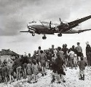  How did the West/Allies respond?  For how long? _____ months | CASE STUDY 1 GERMANY & BERLIN 1948-9  How did the allied airlift make the West / USA look? | CASE STUDY 1 GERMANY & BERLIN 1948-9  How did the blockade make the USSR look? | CASE STUDY 1 GERMANY & BERLIN 1948-9  CONSEQUENCES:  After Stalin called off the blockade, what two countries were formed?  1. West Germany, called the __ __ __  (USA ally)  Which military alliance did it join in 1949?  2. East Germany, called the __ __ __ (USSR ally)
CASE STUDY 2: SOVIET RULE IN HUNGARY  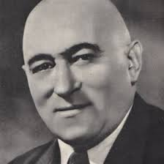  Hungary was a satellite state. Who was the hard-line communist leader?  R________________  What was his nickname?  The B__________ B___________  Why? | CASE STUDY 2: SOVIET RULE IN HUNGARY  What resource was taken away from Hungary by the USSR?  Describe living standards at this time? | CASE STUDY 2: SOVIET RULE IN HUNGARY  After Stalin’s death who led the USSR?  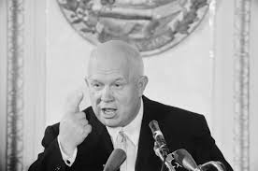  What ‘D’ did he promise in his Secret Speech?  D_______________________ | CASE STUDY 2: SOVIET RULE IN HUNGARY  What did most Hungarians hope would happen as a result of the Secret Speech? | CASE STUDY 2: SOVIET RULE IN HUNGARY  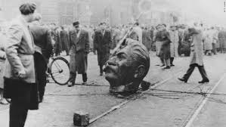  In what year was the anti-communist revolt in Hungary?  195_
CASE STUDY 2: SOVIET RULE IN HUNGARY  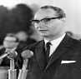  Who did Khrushchev appoint as the new prime minister?  Imre N_________  What reforms did he promise?  1. Hungary should leave the W_________  P______  2. Hungary should hold f_______ eletions (which could allow a non c____________ govterment to be elected).  3. Hungary should have __ __ protection from the __ __ __ __ | 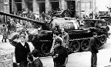  CASE STUDY 2: SOVIET RULE IN HUNGARY  How did the USSR react?  THE SOVIET INVASION:  October 1956 Hungarians revolt following f________ shortages, attack s___________ police & pulled down s_________ of Stalin.  4th November – Nagy says Hungary will leave the W________ P_______  8th November - The USSR invaded Hungary | CASE STUDY 2: SOVIET RULE IN HUNGARY  CONSEQUENCES: On Hungarians:  a) _______ Hungarians are killed  b) The USA accepts __,000 refugees but does not offer military help because it did not want to risk n___________ war.  c) Nagy is a___________ and ex____________  d) He is replaced by K__________ (a liberal leader who improves living standards). | CASE STUDY 2: SOVIET RULE IN HUNGARY  CONSEQUENCES: On the USSR:  a) Many European countries and the USA b_____________ the Moscow Olympics but do not invade.  b) The USA’s refusal to help showed the s____________ states that they were on their own. The USSR tightened its grip on Eastern Europe.  c) The invasion sent a clear message that satellite states could not leave the W________ P__________.

