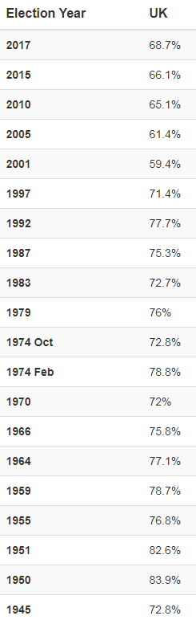
EXAMPLES
1, 2, 3, 4 Turnout figures
UK General Election turnout figures:

1, 2, 3, 4 General elections:
Year | Conservative | Labour | Lib Dem | Other | Key Info
1979  318 for a majority  Turnout – 76.0% (+3.2%) | 339/635  53.3% seats  Net +62  43.9% vote (+8.1%) | 269/635  42.4% seats  Net -50  36.9% vote  (-2.3%) | 11/635  1.7% seats  Net -2  13.8% vote  (-4.5%) |  | - Thatcher, Callaghan  - First of 4 consecutive victories for Cons, 18 years of Cons gov  - Previous election – Wilson with narrow maj of only 3 seats  - Lab had already lost their slim majority before the election  - Callaghan had made deals with UUP, SNP and PC to remain in power  - Thatcher motion of no confidence in Callaghan gov after Scottish devolution ref. Passed by just one vote (311 – 310)  - Labour campaign – Winter of Discontent  - Cons employment of advertising Saatchi & Saatchi; curbing Tus  - Libs damaged by allegations of ex-leader Jeremy Thorpe’s homosexual affair  - Callaghan replaced as leader by Michael Foot n 1980.  - Cons Parliamentary majority of 43 seats. 5.2% swing from Lab to Cons, largest since 1945.
1997  330 for a majority  Turnout – 71.4% (-6.4%) | 165/659  25.0% seats  Net -178  30.7% vote  (-11.2%) | 418/659  63.4% seats  Net +145  43.2% vote  (+8.8%) | 46/659  6.9% seats  Net +28  16.8% vote  (-1%) |  | - Blair, Major  - Landslide for Labour  - Labour – centrist policy – “New Labour”; promised devolution  - Major – promised to rebuild trust following Black Wednesday (1992), division over EU membership  - Opinion polls – support for Lab – popularity of Blair; The Sun endorsement  - Ended 18 years of Cons gov; worst defeat since 1906  - Cons – no MPs outside England  - Led to resignation of Major  - Lab – largest victory ever and by any party since 1945; led to 3 terms in power, 13 years of Lab gov  - Lib Dem – anti-Cons vote; highest seats of any third party since 1929  - Cons lost high profile MPs e.g. Michael Portillo, Neil Hamilton; new MPs – Theresa May, Phillip Hammond, John Bercow and Lindsay Hoyle.
2010  326 for a majority  Turnout -  65.1% (+3.7%) | 306/650  47.1% seats  Net +96  36.1% vote  (+ 3.7%) | 258/650  39.7% seats  Net -97  29.0% vote  (-6.2%) | 57/650  8.7% seats  Net -5  23.0% vote  (+1%) | Green Party won their first ever seat. | - David Cameron, Gordon Brown, Nick Clegg  - No parties achieved a majority – hung parliament  - Only the 2nd since WW2 to lead to a hung parliament  - First coalition ever in British history directly from election outcome  - Conservatives had a higher vote total and higher vote share than Lab in 2005, when Lab had secured a comfortable majority in 2005 (Lab had received 35.2% vote in 2005 but 55% of seats)  - Election result led to Brown’s resignation before coalition decision was made.  - Televised debates – success of Nick Clegg  - Despite this, Lib Dem’s still only had 1% increase in votes and lost 5 seats.  - Share of votes for parties other than Lab and Cons was 35% - largest since 1918.  - 5.1% swing from Lab to Cons, third largest since 1945.
2015  326 for a majority  Turnout – 66.4% (+1.3%) | 330/650  50.8% seats  Net +24  36.9% vote  (+0.8%) | 232/650  36.7% seats  Net -26  30.4% vote  (+1.4%) | 8/650  1.2% seats  Net -49  7.9% vote  (-15.1%) | SNP:  56/59 in Scotland  Net +50  8.6% seats in Westminster but 95% of possible seats  4.7% UK-wide vote (+3% swing)  UKIP:  Third highest party in terms of votes – 12.6% of the vote but only got 1 seat.  Green:  Highest ever vote share – 3.8% but only 1 seat still. | - David Cameron, Ed Miliband, Nicola Sturgeon, Nick Clegg  - Opinion polls predicted a second hung Parliament  - Conservatives won an outright majority similar to the 1992 election  - Small majority of 12 seats; first outright win for 23 years.  - Small increase in vote share for Labour, but net loss of seats – lowest seats since 1987.  - Loss of Senior Lab MPs e.g. Ed Balls, Douglas Alexander, Jim Murphy (Scottish Labour leader)  - SNP surge following 2014 Indyref – Swing of over 30% from Labour.  - Lib Dems worst result since their formation. Loss of Cabinet ministers Vince Cable, Ed Davey and Danny Alexander.  - UKIP Party Leader Nigel Farage failed to win the seat of South Thanet.  - Led to resignation of Ed Miliband and Jim Murphy.  - UUP returned to Commons with two seats.  - Election was the first following the First Term Parliaments Act 2011.
2017  326 for a majority  Turnout – 68.8% (+2.4%) | 317/650  48.8% seats  Net -13  42.4% vote  (+5.5%) | 262/650  40.3% seats  Net +30  40.0% vote  (+9.6%) | 12/650  1.8% seats  Net +4  7.4% vote  (-0.5%) | SNP:  35/59 in Scotland  Net -21  3.0% seats in Westminster but 59% of possible seats  3% of UK-wide vote (-1.7% swing)  DUP:  10 seats (+2)  0.9% vote (+0.3%)  Sinn Fein:  7 seats (+3)  0.7% vote (+0.1%) | - Theresa May, Jeremy Corbyn, Nicola Sturgeon, Tim Farron, Arlene Foster, Gerry Adams  - Conservatives remained the largest single party in HoC but lost its small overall majority.  - Resulted in a minority government with a confidence and supply agreement with the DUP.  - Cons were defending a working majority of 17 seats against the Labour Party.  - Theresa May had called a snap election (one was not due)  - Opinion polls had shown Cons with a 21-point lead in the lead up, but this began to diminish in the final weeks before the election.  - Cons net loss of 13 seats despite getting their highest share of the votes since 1983.  - Labour made net gains of 30 seats with its highest vote share since 2001 and the first gain of seats since 1997.  - Closest result since Feb 1974 and highest combined vote share since 1970.  - SNP and Lib Dems both lost vote share  - The return of two-party politics?  - UKIP lost their only seat, and vote share reduced from 12.6% to 1.8%  - Green Party retained one seat but vote share reduced.  - Brexit was expected to dominate campaigning, but it did not as the campaign was interrupted by two major terrorist incidents: Manchester and London Bridge, so national security became a prominent issue in the final weeks.
2019  326 for a majority  Turnout – 67.3% (-1.5%) | 365/650  56.2% seats  Net +48  43.6% vote  (+1.2%) | 202/650  31.1% seats  Net -60  32.1% vote  (-7.9%) | 11/650  1.7% seats  Net -1  11.6% vote  (+4.2%) | SNP:  48/59 in Scotland Net +13  3.9% vote (+0.8%) | - Boris Johnson, Jeremy Corbyn, Nicola Sturgeon, Jo Swinson  - This election followed prolonged Parliamentary deadlock over Brexit and the forced resignation of Theresa May.  - Boris Johnson called for the early election in December.  - Opinion polls showed a firm lead for the Conservatives against Labour throughout the campaign.  - Landslide majority of 80 seats, the parties largest since 1987.  - Highest seat percentage for Cons of any party since 1979 and highest vote percentage since 1970.  - Fall of the “red wall”.  - Many of these seats had a strong “Leave” vote in the 2016 EU referendum.  - Labour’s was the worst result since 1935.  - For the third election in a row, it was 4 different parties who won in each of the four countries of the UK (Cons in England, SNP in Scotland, Labour in Wales and DUP in NI)  - Led to the Conservatives strengthening their position on Brexit and securing a mandate to withdraw from the EU on 31st Jan 2020.  - Labour’s defeat led to the resignation of Jeremy Corbyn, triggering a leadership election (replaced by Kier Starmer)  - Jo Swinson lost her own constituency seat and resigned, triggering a leadership election (no leader chosen yet)  - SNP success led to renewed calls for a second Independence referendum  - In NI, Nationalist MPs outnumbered unionists for the first time.
*Net +/- is based on the previous election and not what they had leading up to that election.

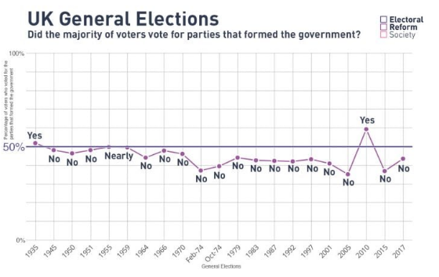
If other systems had been used…
*Remember to take all of these with a pinch of salt; it is impossible to know how people would have voted, list orders etc.
If a PR system had been used for 2019: If AMS had been used in 2019:
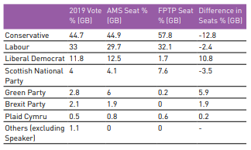
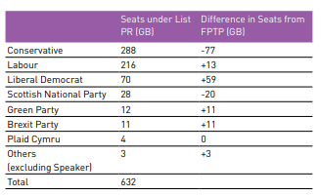

If STV had been used in 2019: Overall:
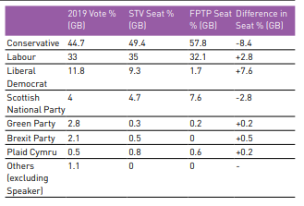
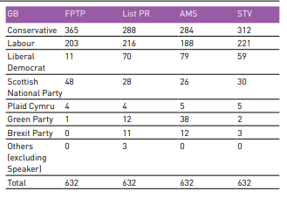
1, 2, 3, 4 Turnout by Various Factors

2017 Election 2019 General Election
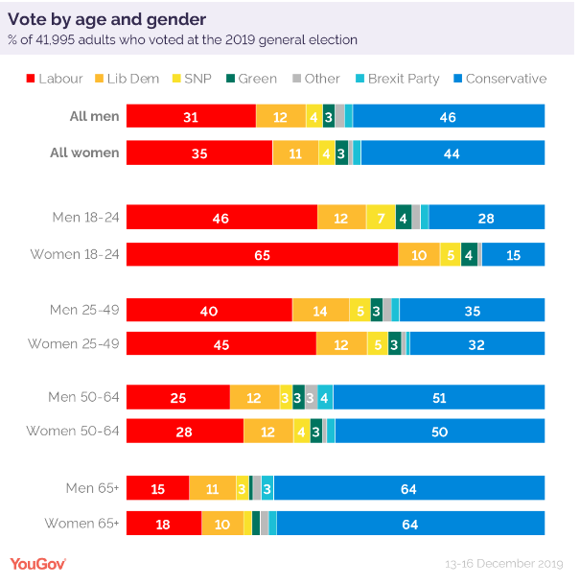
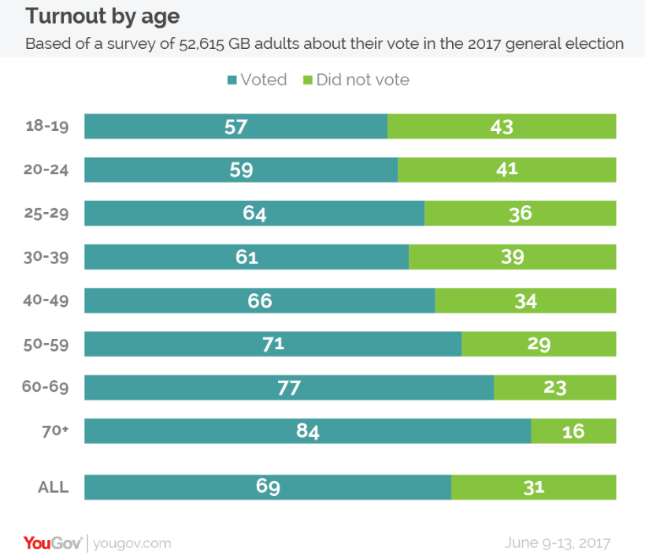
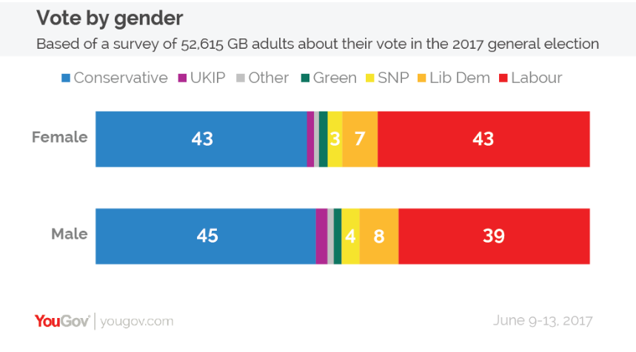

1, 2, 3, 4 Voting Intention by Various Factors
2017 General Election 2019 General Election
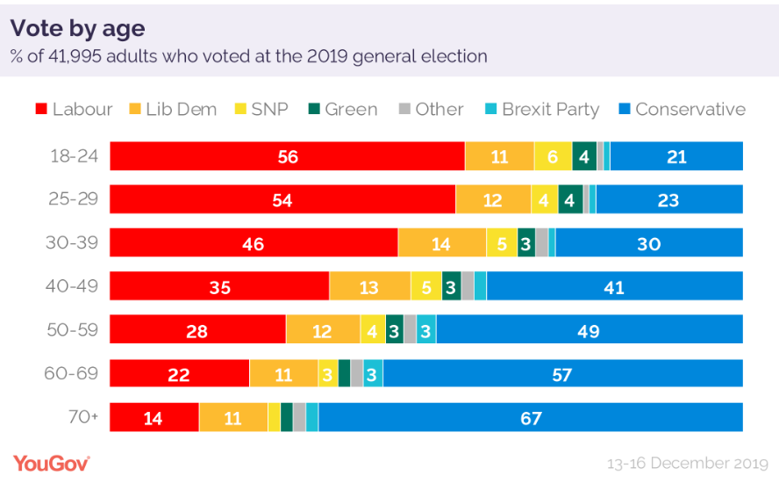
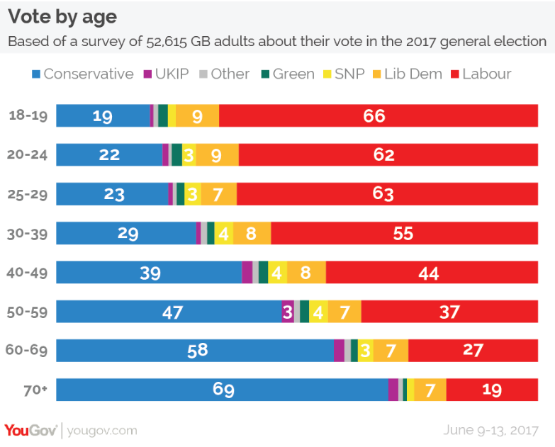
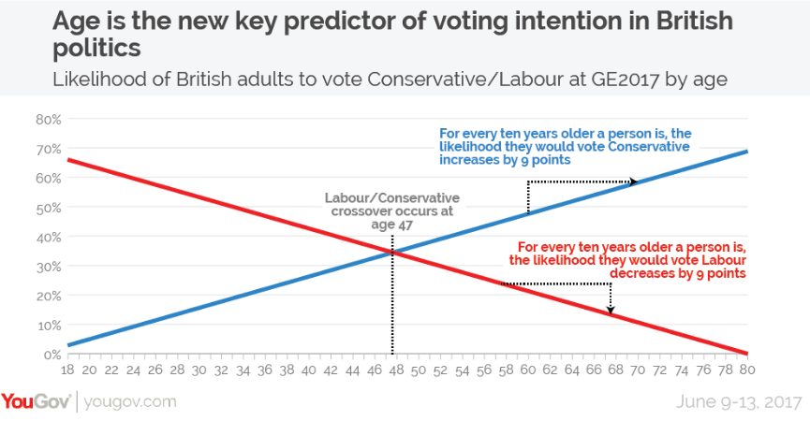
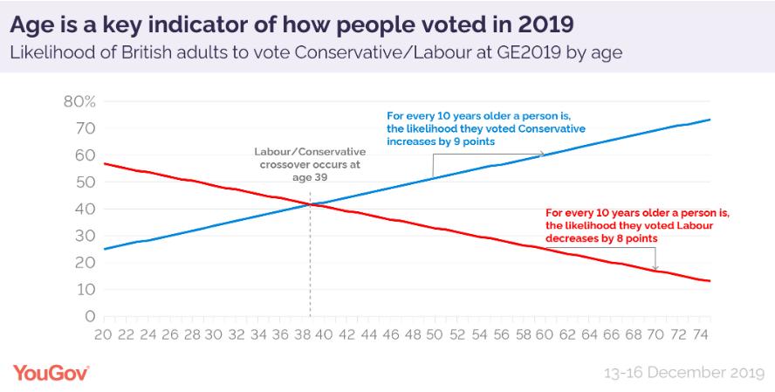
2017 General Election 2019 General Election
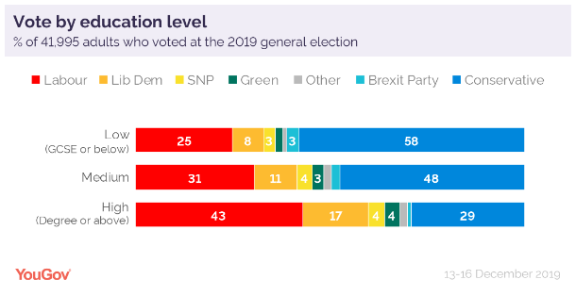
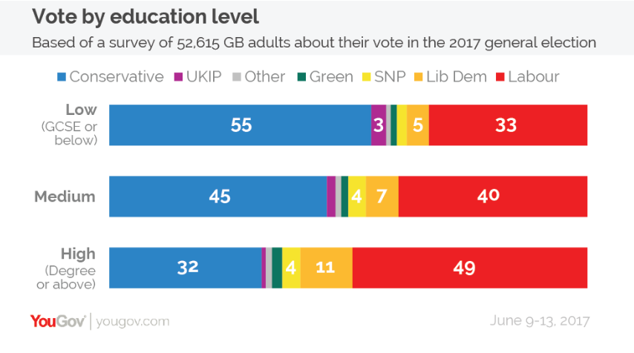
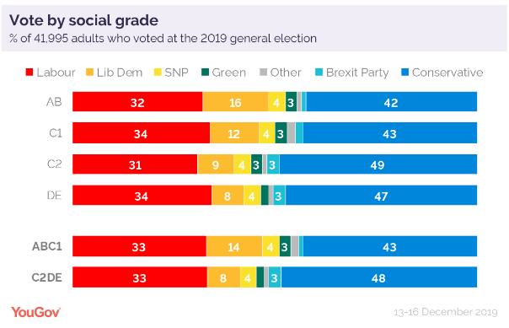
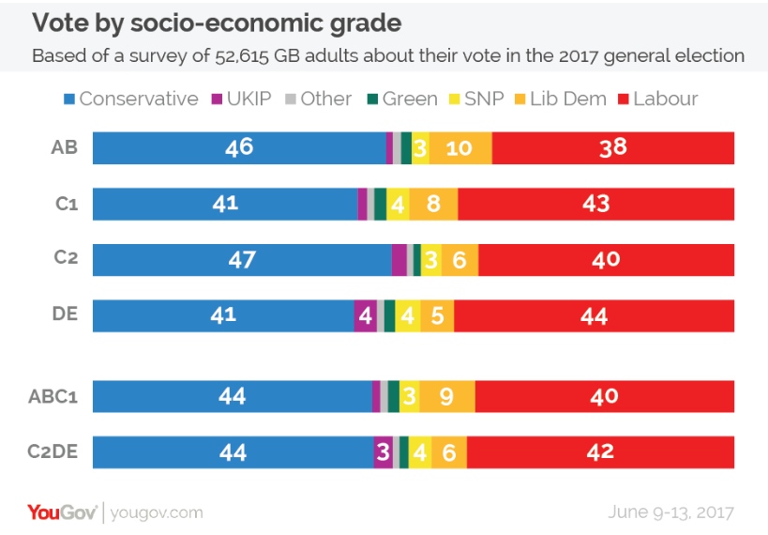
2017 General Election 2019 General Election
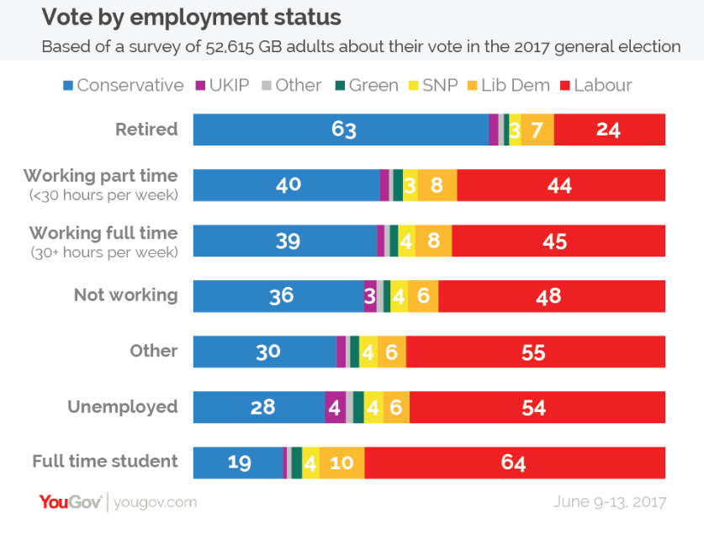
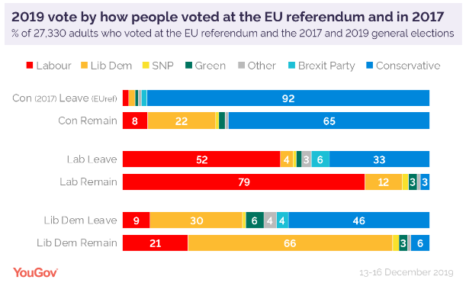
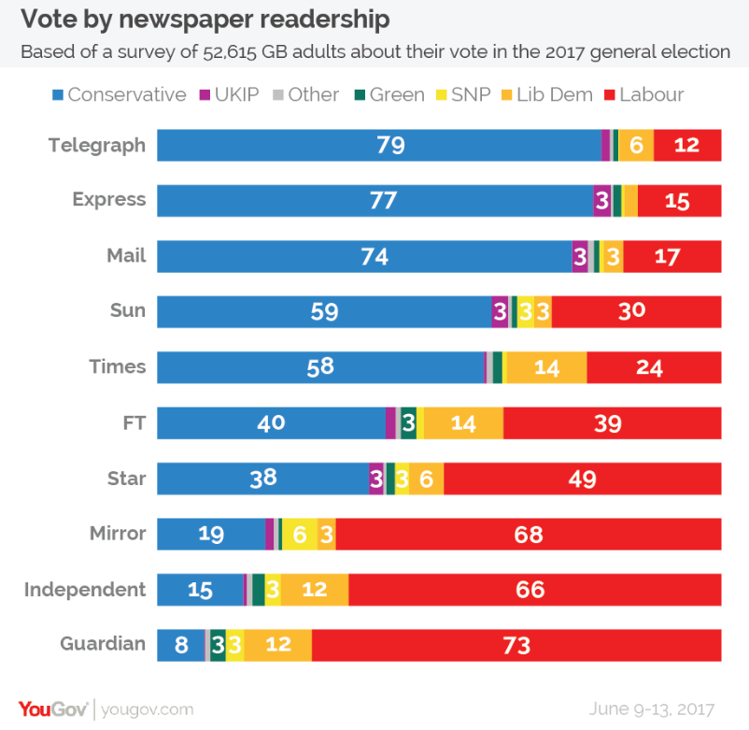

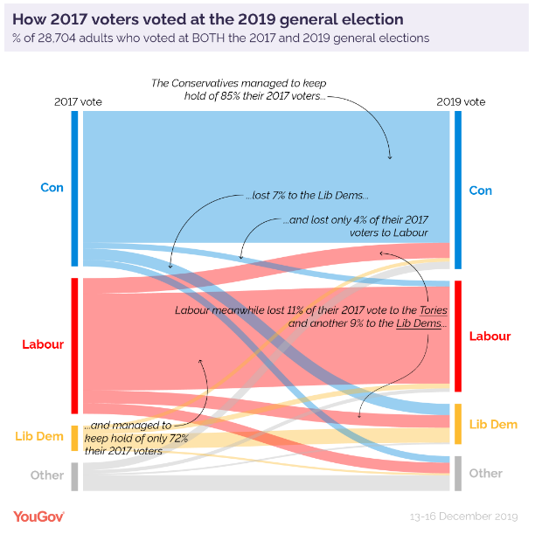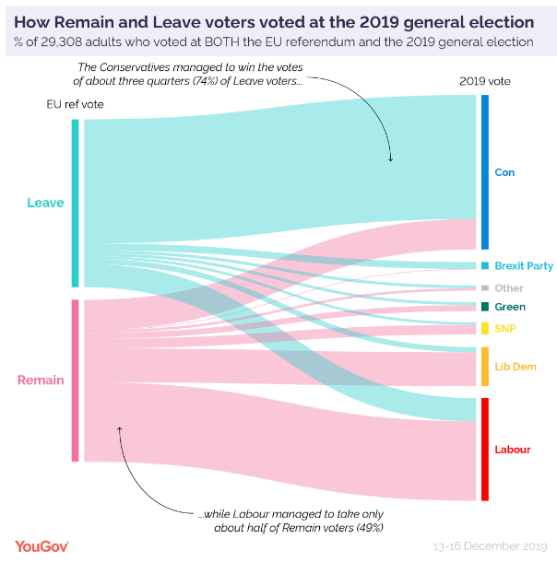

3 Votes to Seats Comparison FPTP
Stark examples
Year | Party | Votes % | Seats %
2005 | Labour | 36.1% | 56.5%
2017 | Lib Dem | 7.9% | 1.2% (8 seats)
2017 | UKIP | 12.6% vote | 1 seat
2019 compared to 2017 | Conservatives | 43.6%  1% increase in vote share from 2017 | 56.2%  8% increase in seat share from 2017  2017 – minority government  2019 – landslide
2019 | Conservatives and SNP compared to Greens | Cons – 13.9 million votes = approximately 380,000 votes per seat  Greens – 900,000 votes, 1 MP elected  SNP – 1.2 million votes = approximately 25,000 votes per seat
2019 | Around 14.5 million voters (30% of voters) didn’t pick the winner in their constituency. This does not include those who did not vote. Including this would increase it to around 68%.
2019 | Nearly 1/3 people apparently voted tactically

1, 2, 3 Safe Seats vs Marginal Seats
Safe seats:
- In 2010, the Electoral Reform Society (ERS) estimated that in the 2010 general election, 59% of constituencies were safe seats.
- Examples of Labour safe seats: North West areas such as Liverpool and Manchester; North East (Newcastle, Sunderland), South and West Yorkshire, South Wales, Inner London.
- Examples of Conservative safe seats: Home Counties (Surrey, Buckinghamshire), the Shires (North Yorkshire, Cheshire), affluent areas of London.
- Some seats have been held by the Conservatives since the 19th century e.g. Haltemprice and Howden, Wokingham, Devon East, Fylde, Arundel and South Down, Hampshire North East, Rutland and Melton, Bognor Regis and Littlehmpton, East Worthing and Shoreham and Shropshire North (this is the safest seat of all – has been held by the Conservatives since before Queen Victoria became Queen).
- The safest seat in 2017 was Liverpool Walton, where Labour received 86% of the vote, giving them a 77% majority over second-placed Conservatives (9%).
- The safest seat for Conservatives in 2017 was Christchurch – 69.6% Conservative, a near-50% majority over Labour.
- Some safe seats can be interrupted e.g.
  - George Galloway won the Bethnal Green and Bow seat in 2005 for the Respect Party (a long-standing Labour safe seat) after being expelled from the Labour Party
  - The “Portillo moment” is used to describe huge voting swings that can usher in a new government following the huge defeat of Michael Portillo (had been a Cabinet minister and seen as a likely contender for Party leadership following/as a challenge to Major) to a Labour candidate.
  - Labour lost many former safe seats in Scotland in 2015, e.g. Kirkcaldy and Cowdenbeath, previous seat of Gordon Brown and Paisley and Renfrewshire South, seat of shadow Foreign Secretary Douglas Alexander. In both cases swings of over 25% to the SNP were recorded.
  - In 2019 Labour lost many formerly safe seats that were part of the “Red Wall” in northern England e.g. Bassetlaw; Bishop Auckland; Bolsover (Dennis Skinner’s seat); Don Valley; and Leigh. About 20% of Labour’s overall loss of support compared to 2017 was in these red wall seats.

Marginal seats:
- Traditionally marginal seats include: Broxtowe, Watford, Bolton West, Thurrock.
- In the 2017 election, 97/650 were won by a margin of 5% of the vote or less (this was a sharp increase on only 56 seats in 2015)
- North East Fife won by SNP by 2 votes in 2017 (SNP hold) but this was taken back by the Liberal Democrats in 2019 by a 3% lead.
- Other marginal seats in 2017: Perth and North Perthshire, Kensington, Dudley North, Southampton Itchen, Richmond Park.
- 2019 marginals: Kensington continued to be marginal (Cons gain from Lab); Carshalton and Wallington (Con gain from LD); Wimbledon (Con hold)

1, 4 Referendums Turnout and Results

1 E-Petitions
- The most signatures = 6.1 million (March 2019) – Revoke Article 50; Debated but not successful
- Second most signed = 4.2 million (March 2019) – Second referendum on Article 50; Debated but not successful
- December 2015 – Ban Donald Trump from entering the UK – caused the website to crash; gained 550,000 signatures; again in Jan 2017 to ban Trump from a state visit received over 1.8 million signatures; Debated but not successful
- March 2016 – Meningitis B vaccine to be given to children – debated in Parliament
- 2007 Petition against introduction of charges for using roads – 1.8 million signatures; Government dropped the plans
- 2019 1.7 million signatures for Johnson not to prorogue Parliament. This was approved by the Queen but later ruled unlawful by the Supreme Court.

2 Party Membership

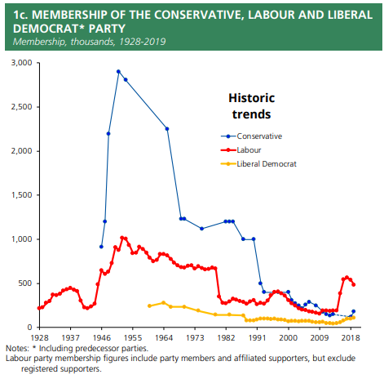
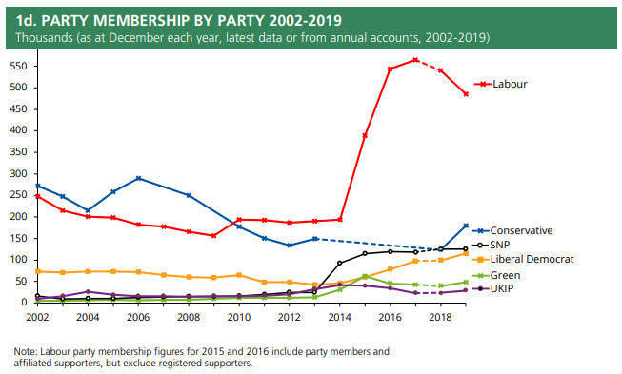
Analysis
- Membership is steadily in decline
- Huge spike in Labour membership from 2014 onwards
- Smaller parties are gaining members
2 Party Donations
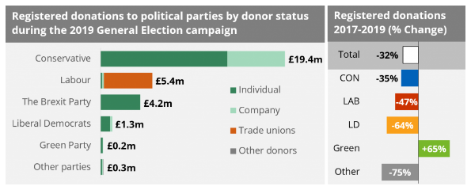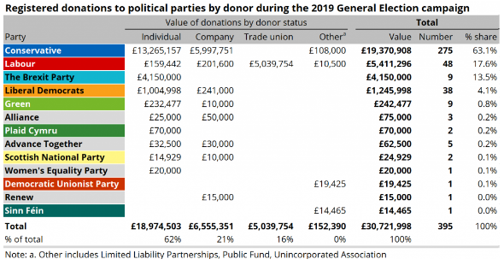
The total number of donations from individuals was almost four times lower during the 2019 General Election than 2017. But the average donation increased almost three-fold from around £24,000 in 2017 to just over £71,000 in 2019.
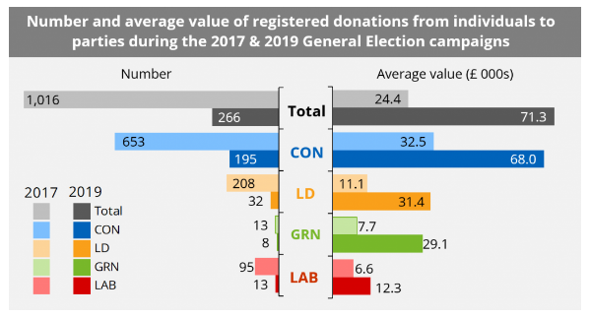
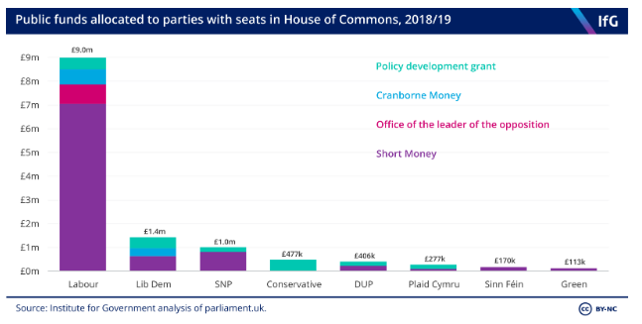

Donations accepted by parties in 2019:
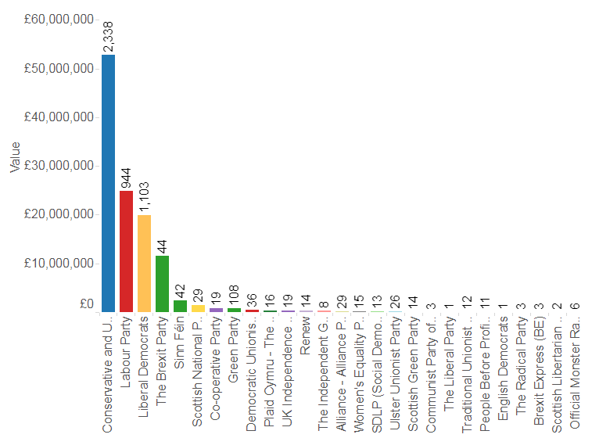
2 Electing Party Leaders
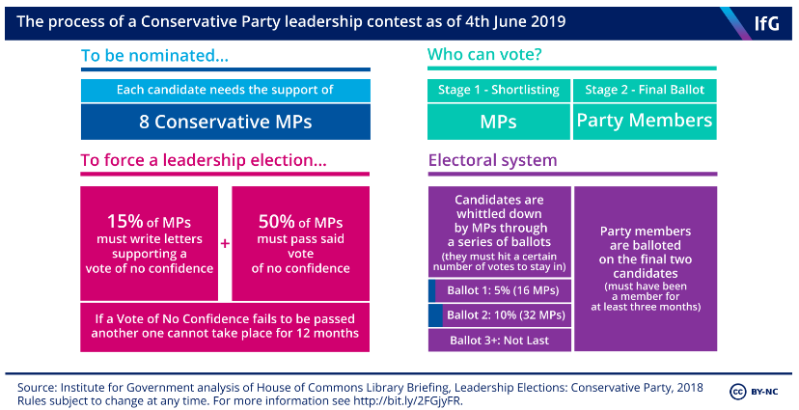
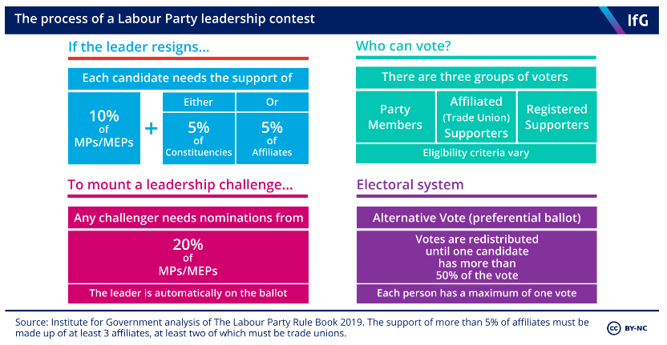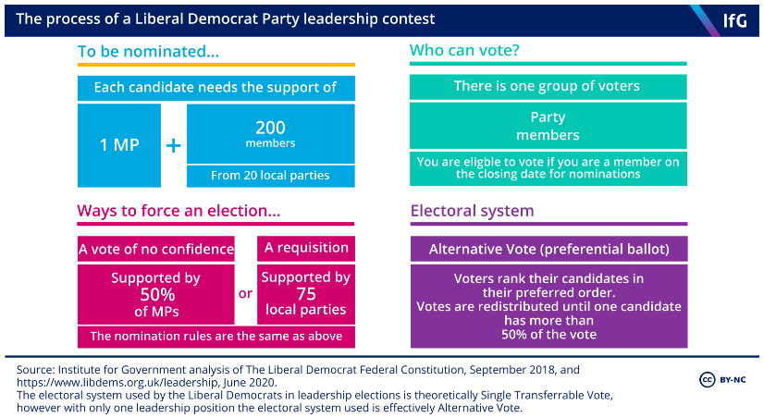

1 Pressure Group Examples
 |  | Examples | Success | Failure
Size (large) | Promotional | Greenpeace – 2.9million member;  National Trust, Stop the War Coalition; RSPCA | RSPCA can afford full page adverts in national newspapers to raise awareness. | Despite their size the Stop the War coalition did not stop the Iraq War; CND had estimated 110,000 members in the mid-1980s but the Thatcher government ignored its demonstrations and relied on the tacit consent of the population
 | Sectional | CBI; Age UK | CBI favoured by Conservatives; Age UK have been successful as they represent a large proportion of society who politicians want to support as they vote | CBI wanted Remain but not able to convince Conservatives
Size (small) | Promotional | KOSSH (Keep our St Helier Hospital); Howard League for Penal Reform (3000 members) | Howard League – success – books into prisons; | Student fees protests in 2010 did not change decision over increasing fees
 | Sectional | NFU; BMA (although 81% of doctors, nurses etc.) | NFU success due to expertise | BMA strikes have not always led to change; junior doctor contracts row
Funding (large) | Promotional | Greenpeace (£23.6million in 2018); Friends of the Earth; WWF | Can fund large national and international campaigns | Some environmental group have seen funding drop due to recession
 | Sectional | CBI; Trade unions | CBI – large funding – able to employ lobbyists | TUs give large funding to Labour but has not led to much legislation and not listened to by Conservatives
Funding (small) | Promotional | League Against Cruel Sports | League Against Cruel Sports and IFAW teamed up with higher-funded RSPCA to secure ban on hunting with dogs in 2004 | KOSHH has not achieved all aims due to not having as much funding
 | Sectional
Insider status | Promotional | Council for the Protection of Rural England; Howard League; Dog’s Trust | HLPR – Small but insider – behind the scenes contact rather than public | Charter 88 (advocated for electoral reform ; now Unlock Democracy) - insider under Lab but outsider under Cons – no meaningful success  Dogs’ Trust rarely needed by the government
 | Sectional | CBI, BMA, NFU; Age UK | NFU links to DEFRA led to 2013 badger cull; Age UK has close links with decision makers  CBI – lobbying and use of media  Countryside Alliance has been an insider under Cons government since 2010 | Insiders can use “outsider” tactics e.g. strikes – BMA and NEU/NUT  BMA has less success with Conservative gov and has therefore moved to more outsider methods e.g. striking
Outsider status | Promotional | CND, PETA; ALF | PETA – major fashion labels banning fur | CND - Have not managed to successfully cancel Trident  ALF – Considered so extreme that no mainstream party would bring them into the political process
 | Sectional | Occupy Movement | Occupy – choose to stay out of government affairs – worldwide attention to protests in 2011-12. | Trade unions ignored by Conservative governments;  Despite Occupy’ s attempts they did not achieve any practical goals
Peaceful methods | Promotional | ASH | ASH - Lobbying led to anti-tobacco legislation | Countervailing groups therefore don’t do so well e.g. Forest (pro-smoking campaign group)
 | Sectional | Stonewall; CPAG | Success due to changing public attitudes; CPAG reduced tax burden on low-income families (influence of LibDems in gov during coalition) | Countryside Alliance took case to ban fox hunting to the High Court in 2004 but lost.
Lobbying | Promotional | RSPCA | RSPCA pressure led to legislation against hunting | NSPCC has consulted with the government but has not always been able to influence government policy
 | Sectional | Liberty; BMA | Liberty hire lawyers to lobby MPs to put views across e.g. on counterterrorism  BMA offers expertise and is therefore listened to | BMA have not been listened to on all occasions e.g. junior doctors contracts
Celebrity Endorse-ment | Promotional | Fare Share UK campaign for free school meals, Marcus Rashford | Government U-turn on FSM after Rashford campaign; Healthy school meals Jamie Oliver | Russell Brand’s campaigns for electoral reform have not led to substantial change
 | Sectional | Joanna Lumley Gurkha campaign | Successfully fought for the right for Nepalese Gurkhas to settle in the UK | Gay rights campaigning with celebrity endorsement still took a very long time to have impact e.g. marriage (Elton John)
Direct action | Promotional | Greenpeace; Fathers 4 Justice | Greenpeace – Heathrow 3rd runway campaign – legal action, ruled unlawful by Court of Appeal; Save the Arctic campaign | Greenpeace – prior attempts to stop 3rd runway were unsuccessful; Plane Stupid seen as too violent  Fathers 4 Justice disbanded after division in group
 | Sectional | BMA; NEU; Black Lives Matters | BMA strikes; Worldwide attention to BLM protests 2016 and 2020. | BMA not successful in changes to junior doctors’ contracts; Student demonstrators against tuition fees were prosecuted for disorderly conduct.
Public support | Promotional | Fuel Tax Protestors | Fuel Tax Protestors forced the Chancellor to lower level of petrol duty because of public support | CND had estimated 110,000 members in the mid-1980s but the Thatcher government ignored its demonstrations and relied on the tacit consent of the population
 | Sectional | TUs; NUS | Snowdrop Campaign gained enormous public support and government legislation banned hand-guns | Have the support of their members but this doesn’t necessarily lead to change e.g. NUS demonstrations against tuition fees 2010-11 gained little and 35 were arrested

