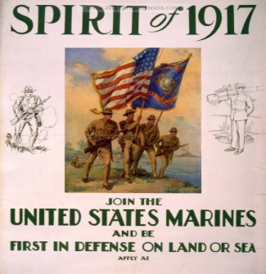

**What impact did World War I have on the US economy?**

You will not get questions about America before 1917 or specifically about the entry into the First

World War, however, you may be asked questions about the impact of the war on the economy.

**Task:** Code the statements below into the **three** categories to show the impact of WWI on the US economy:

**Political impact Social impact Economic impact**

|  |  |  |  |
| --- | --- | --- | --- |
| Federal Government spending increased to 24.1% of GNP. | By April 1917, the US had loaned $2.3 billion to Britain and France. | Living standards increased. | The war strengthened the anti-immigrant movement and the Red Scares of the 1920s |
| The US government increased the size of its army as a result of the Selective Service Act. | Industrial production increased by 39% between 1916-18. | As a result of the war, the USA increasingly replaced Great Britain as the most important creditor nation. | In 1917 the War Industries Board was set up to organize supplies for the army. The government was taking a direct role. |
| As a result of the war the national debt increased, so tax levels remained high. | Isolationist tariffs caused other countries to do the same, so US exports fell. | There was a brief recession after the war in 1920-21. Laissez-faire politicians did not try to stop this. | Patriotism strengthened the appeal of Prohibition as it was argued workforce efficiency would increase. |
| The railways were placed under federal control with the Railroad Administration. | Although wheat farmers had made a profit during the war, they produced too much wheat after the war and prices fell. | The Espionage Act of 1917 made it illegal to attempt to encourage disloyalty or obstruct military recruitment. | The 1918 Prohibition Act stopped the sale and manufacture of alcoholic drinks for the duration of the war. Volstead was passed in 1919. |
| World War One damaged trade between Europe and the rest of the world. The USA penetrated some British markets. | The Sedition Act of May 1918 made it illegal to discourage people from buying war bonds or criticize the constitution. | The Fuel Administration set limits on prices of oil and coal. The National War Labor Board worked with the unions. | By late 1916, Great Britain was spending $10 million a day, on loan from the US. |
| The war gave a push to the enfranchisement of women. The 19th Amendment was passed in 1920. | Mechanisation at this time caused many farmers and labourers to lose their jobs. | Taxation was increased to pay for the war. The 1917 and 1918 War Revenue Act increased income taxes. | Prohibition was helped by many breweries being owned by Americans of German descent. |
| Many older industries such as coal were in decline as demand fell, whilst the demand for electricity rose. | Real wages increased. | The boll weevil caused a 34% drop in cotton production by 1921. | Intolerance of foreigners was also strengthened. |