**SUMARRY NOTES 1917-1933**

**Woodrow Wilson (1913-1921) – Democrat**

Democrats believe in government intervention and centralised power. They prefer federal legislation to local ones. They recognise that the economy is too complex for individuals to navigate on their own; therefore government should guide business decisions. They also implement taxes to enable government intervention.  
**Decision to remain neutral-** 12 million Europeans living in the US- some of whom were German  
US trade would benefit from selling to all belligerent nations

Wilson remained neutral during election to win support; however there were signs America would become involved because of the *preparedness policy, 1915.* This suggested that America should prepare for war and establish an army of 25000 in case of a crisis. The Council of Defence was established in 1916 to advise the president how to prepare for potential war. 5 months after the election, the US entered the war, fighting for the allies.

**Why the US joined the war on the side of the allies?**

1. More support for the allies because of traditional ties, many rich and influential Americans were pro British, and they shared a common language
2. The US traded more with allies than Germany, particularly since the allies blocked German ports. In 1914 US exported $40 million munitions to Britain; by 1916 they exported $1290 million. If they joined Germany- they would lose this trade and profit
3. US invested more in the allies- they loaned Britain $2.3 bn and only $27 mn to Germany, therefore they had more to lose if the allies lost.
4. Germany winning would threaten the US policy of liberal democracy, Wilson wanted peace after war, but Germany would start more wars to invade and take over land, therefore the allies needed to win to establish peace. In 1917, Russia withdrew and this was looking unlikely.
5. German submarines operating in the Atlantic practice unrestricted submarine warfare, and sank the Lusitania in 1915 killing 128 American civilians. After promising not to sink any more US boats, Germany broke their promise and resumed their policy of unrestricted submarine warfare, causing Wilson to break off diplomatic ties with Germany in 1917.
6. The Zimmerman telegram was intercepted, proving that Germany disliked the US as they encouraged Mexico to overthrow US, and offered them support in doing so if they became allies. This caused the US to declare war on Germany.

**Effects of the war on the economy:**

* Brought the US out of their mild depression in 1916
* During war period the value of American trade increased from $2bn to $10bn
* US gave $4bn worth of loans each day- and the war meant countries like Britain were spending $10 million a day on US goods- this caused their companies to boom and turned the country from a debtor to creditor nation, however they did accumulate their own debts as a result of the war
* New York replaced London as the world’s financial capital
* The US government taxed its people to fund the war through the 1916 and 1918 Revenue Acts – at their highest the lowest earners were taxed 6% and the highest were taxed 77% compared to being only taxed 7% in 1913. Overall, 33% of the war was funded through taxation
* Liberty Bonds sold to public allowed them to support the war and redeem their purchase at a later date with added interest. This helped to raise $21bn.
* Industrial production increased by 39%, and farmers profiteered massively as the exported 300% more to allied countries and prices doubled. Overall, unemployment dropped and 1.3 million found work as a result of war.

**Effects of the war on society:**

* Selective service saw 3 million men called to o fight, overall 112500 soldiers were killed
* In 1918 Wilson was granted almost dictatorial powers to control the nation
* Government intervention increased, for example the War industries board- this was the first time that government actively intervened in economics and businesses
* Government intervention is shown as their spending increased by 10%
* Railroad Administration even brought rail lines under federal control
* The 1918 Sedition Act made protesting against the US illegal- sentenced 1500
* The 1917 Espionage Act limited freedom of speech by making it illegal to show or encourage disloyalty or obstruct military recruitment. Eugene Debs given 10 year jail sentence for ‘anti war’ speech
* Closed shop- forced workers to be a union member to improve wage/working conditions, otherwise they could not work. People believed this violated freedom of choice

**Immigration:** Patriotism became prejudice and Germans or those with German sounding names faced abuse. Even ‘Sauerkraut’ was renamed liberty cabbage. America became very intolerant, and this is said to have led to the developed of the 1920’s red scare and anti immigration policies. Harding brought in the emergency quota act in 1921, restricting emigration from each nationality to 3% of national census (only 357000 immigrants) Coolidge brought in the 1924 Quota act, reducing the number to 2% of the 1890 census (only allowing 164000 immigrants)   
  
**Prohibition:** There had previously been a very powerful temperance movement known as the anti saloon league which was heavily supported by Protestants and women. It claimed that alcohol lead to violence, and saloon bars encouraged men not to spend time with their family and spend all the money. They grew in power during war as they claimed banning alcohol would help the war effort and improve worker efficiency and reliability. The grain used for alcohol could be more effectively used to increase food supply. Also, the movement was helped by the fact many breweries were owned by German Americans who were disliked, and therefore Americans wanted to avoid them and put them out of business. In 1918, the Prohibition act banned the sale and manufacture of alcoholic drinks for the duration of the war. Congress also passed the 18th amendment in 1917 to make the ban permanent. The 1919 Volstead act made the sale, transportation and commercial manufacturing of any alcoholic beverage over 0.5% illegal from 1920.

**Women’s rights:** In 1920, the 20th amendment gave women the right to vote in federal elections as people now appreciated their contribution to the war effort. However, 15 states had already allowed women to vote since the 1860s. Alice Paul led suffragette movement- hunger strikes, protests, traffic disruption.

After the war Americans wanted tax cuts, minimal government intervention and for the US to cease involvement in European affairs. The democrat’s proposal of the league of nations involved more relations with Europe, they had also been the ones who increased intervention and taxes, therefore Harding’s ‘return to normalcy’ was a popular choice, winning the election by 7 million votes.

**Warren Harding (1921-1923) – Republican**

**Strengths-**

Appointed very strong people such as Andrew Mellon- Treasury Secretary and Herbert Hoover as Secretary of Commerce. In Wilson’s term government spending increased from $500 mn in 1913 to $5000 mn in 1920. Harding passed the Budgeting and accounting act to increase federal aid and expenditure fell to £3373mn – allowing tax reduction.

**Weaknesses-**Appointed people who were later arrested for corruption like Albert Fall whose $12000 salary was scarcely comparable to his spending. He was bribed by companies to allow them to drill for oil in n area reserved for the Navy; this became known as the Teapot Dome scandal. Charles Forbes was jailed for 2 years for defrauding the government- embezzled $250 million. Harding’s corrupt friends in cabinet became known as the Ohio gang. He also made very few changes, and was seen as doing very little. However, he was elected because the public wanted a president who would not intervene.

Did attempt to make some changes though, he realised the agricultural slump post war and recognised this needed to be rectified. He organised the-

Grain Futures trading Act, 1921to prevent manipulation of the grain market which was artificially keeping prices low

The Capper Volstead Act, 1922 enabled farmers to work in co-operatives to facilitate production and marketing (however could create monopolies keeping farmers poorer)   
Intermediate credit Act 1923 provided easier loans to farmers (could get them in more debt)

Emergency Tariff Act, 1921 and the Fordney-McCumber act, 1922 were flawed as contributed to depression- didn’t have the foresight to see impact on foreign trade- however good intentions wanted to help agriculture to share prosperity by reducing competition- saw it needed addressing and worth intervening- therefore an important issue- however this was ignored by Coolidge who made no new policies or reforms.

**Calvin Coolidge (1923-1929) – Republican**

After the sudden death of Harding, his vice president Coolidge took over- he was a strong believer in that people should work hard and not expect the government to bail them out. As it was the boom period, people didn’t want intervention and so Coolidge didn’t- industry was prosperous and the Democrat party split and couldn’t decide on a candidate. Many believed he was a great president. His popularity explains why he was re-elected.

Intervention was needed as the industry was more complex than in the 19th century, and so was society- a lot of tensions and issues that Coolidge failed to understand. Renowned for his low work rate and reluctance to get involved with issues. He was nick named ‘Silent Cal’.

He vetoed the McNary-Haugen bill in 1927 and 1928, which would have involved the Federal government selling surplus crops abroad. This would have limited over production problems, earned money from abroad and increased domestic prices- resolving the agricultural poverty, however he refused because it would contradict his laissez faire ideals. Acknowledged issues such as lynching, rural poverty and women’s inequality in the workplace as they needed a minimum wage- but never acted to improve conditions. Just tactical way of ensuring voters in the elections.

**BOOM**

**KEY TERM**

**Boom** - an economic state of growth with rising profits and full employment

The 20’s were also known as the Jazz age because it was an era of indulgence, change and new attitudes. - A post war social revolution. There were changes in fashion as many young women were now referred to as ‘flappers’. They wore shorter skirts and low cut tops, they wore their boot flaps undone and cut their hair into a short bob- like Louise Brookes. Young men stopped wearing 3 piece suits; some wore leather jackets and jeans. The music styles changed and Jazz was a growing influence. Divide vs young and old in society. Architecture developed to reflect the extravagant life style and growth of society- skyscrapers starter to develop like Rockefeller, Empire state and the Chrysler building.

Leisure activities became increasingly common such as going to the cinema, by 1920 there were 20000 cinemas, producing 800 films a year. By 1930, 100 million cinema tickets were being sold every week. This helped to endorse a common set of values- others argue cinema helped to isolate certain members of society i.e. Birth of Britain 1915- said to have glorified the KKK.

Consumer goods- 30% owned a vacuum and 27 million owned cars by 1930, many other appliances available- as 85% now had access to electricity.

Causes of the Boom - ACCESS

**A**utomobiles (1919 = 9m, 1929 = 26m)

**C**ycle of prosperity (more sales = more production = more wages = more spending)

**C**onsumer goods/Credit (fridges, radios, telephones etc)

**E**ntertainment (Hollywood, cinemas, jazz clubs, speakeasies)

**S**tock market (Wall Street)

**S**ky scrapers

Plus

**WWI** – During WWI the USA had made a lot of money through loans to Europe and by selling weapons and exporting food to European countries.

**Republican economic policies**

**Laissez-faire** – literally meaning ‘leave alone’. The Republicans believed that businessmen should be left alone by the government to get on with making money and so they made as few restrictive laws as possible.

**Tariffs** – in order to encourage consumers to buy American goods the government put a tax on foreign goods that entered the USA so that they would be more expensive than domestic products.

**Low taxation** – The Republicans believed that if people were able to keep more money then they would spend it on American goods and wealthy people would reinvest their money in industries.

**Trusts** – These were super-corporations which dominated certain industries (Carnegie – steel, Rockefeller – oil). The Republicans allowed the trusts to do what they wanted as they believed that the ‘captains of industry’ knew better than politicians what was good for America.

Henry Ford and the car

Henry Ford had a dream of producing a cheap car which could be afforded by ordinary Americans. He pioneered the development of the **assembly line**. This reduced the time it took to make a car from **13 hours to 1 hour and 33 minutes**. The assembly line meant that the cost of the car decreased. **1908 = $850 by 1925 = $290**. To make up for the boredom of the work **Ford doubled workers wages to $5 a day**. That meant they could buy more consumer goods.



Advertising

The 1920s saw a massive increase in advertising, including a massive growth in advertising on the **radio** and in the **cinema**.

Adverts were aimed at men and women and showed people what new **consumer goods** were available for them.

Credit

Many people did not have the money needed to buy the many new consumer goods that they saw advertised. They got around this problem by spending on **credit** and by buying things from **catalogues** on credit. This meant they **paid for consumer goods bit by bit** but would eventually pay for the whole amount and some more in **interest**. It was also known as **instalment plan buying**.

This led to many Americans being in **debt**. It wasn’t seen as a problem by many people, however, because the economy was **booming** and people had **jobs** and so could make the **repayments.**

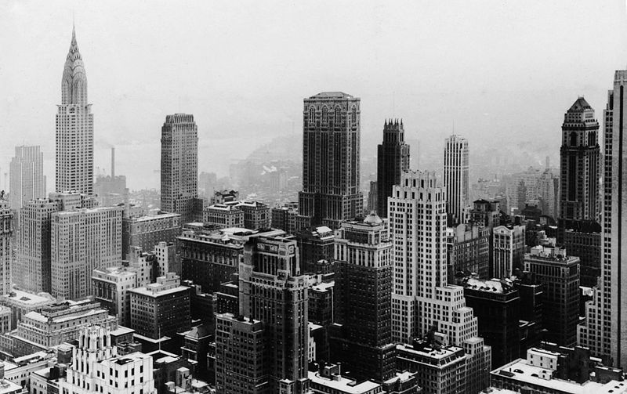

The Building Boom

The 1920s was also a decade of **building** and **construction**. By 1929 the amount of **roads had doubled**. There was a demand for **new factories, offices and shops**. As towns grew in size then they needed **public buildings** such as **schools and hospitals**. The 1920s were the decade of the **skyscraper** and companies competed with each other to have the grandest and largest.

Hollywood and the rise of cinema

Cinema was the main form of entertainment in America by the end of the 1920s. Many Americans went to the cinema a few times every week. Until **1927** all of the movies were silent and the sound came from a **piano accompaniment**. The movies were made in **Hollywood.** Comedies, romance, westerns and slapstick comedies were all popular. **Mass market advertising** built up the reputations of movie stars. They came to symbolize the **“roaring twenties.”**

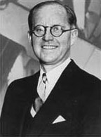**Why was the cinema so popular?**

“The motion picture industry is already the fourth largest in the country”

* **Advertising** made heroes of actors and actresses like Gloria Swanson, Rudolph Valentino and Charlie Chaplin.
* Advertising was used by the emerging companies like **MGM and Warner**.
* America was quite **prosperous** and going to the cinema was **cheap**.
* People had more **leisure time** because of the new **consumer goods**.
* **Talkies** were invented in **1929** and this made cinema even more for people.

**Joseph Kennedy writing in 1927**

**Did everyone approve?**  
A **celebrity culture** developed in the 1920s and stars had their whole lives under **scrutiny**. Some people were shocked by the films and thought they **lowered moral standards**. The public expected very high standards from their movie stars and **scandals** had to be covered up and the real lives of the stars **censored** as well as the movies.

One of the rules about kisses on screen was they could not last for more than 10 feet of film. This meant quite a short kiss…

**Case Study**

Charlie Chaplin became one of the greatest comedians in cinema history and one of its most famous stars. He was a living example of the “American Dream”. The idea that anyone can make it in America if they have talent and work hard enough. He was born in London to a very poor family but moved to the USA to make his fortune.

His famous films include “The kid”, “The Great Dictator” and “The Vagabond”. His films and characters were influenced by other cultural developments in America, including the economic boom and the impact it had on the lives of ordinary people.

The Jazz Age

Louis Armstrong was the first important soloist in jazz, and he became the most influential musician in the music's history. He was a talented trumpet player and was famous for his distinctive voice and fun personality.

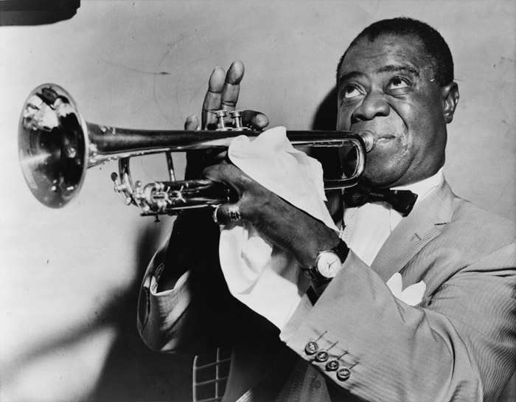

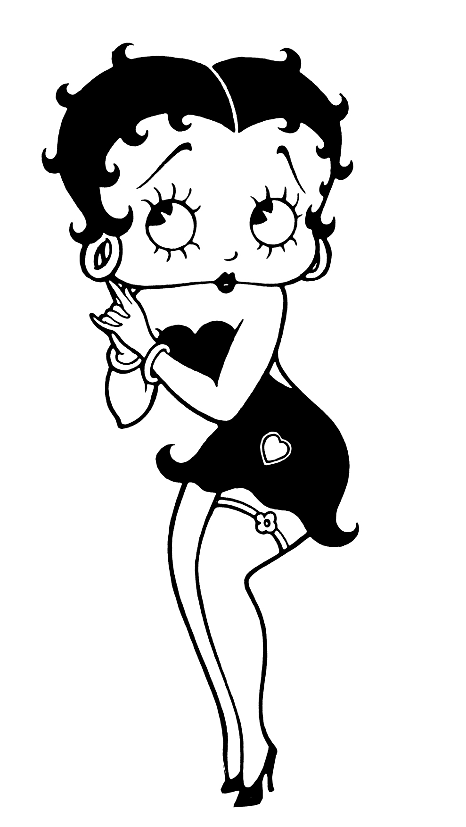Women in the 1920s

**Flappers** – these were fashionable women. They usually came from the cities or from the suburbs. Flappers usually cut their hair short, wore heavy make-up and shorter dresses. They shocked many older Americans and people that were religious or lived in rural areas. This was because they were far more independent than had traditionally been the case. Flappers usually had jobs which gave them more freedom because they had more money. They then used their money and free time to socialise by going to the cinema and jazz clubs where they would drink and apply their make-up in public! Flappers could also play sports in public.

In addition to the social changes, women were also given the vote for the first time in 1920, so this also helped them to gain more power in society.

**HOWEVER** not all women benefitted from these changes. Life only really changed for white, middle or upper class women. Poor people could not afford to live the lifestyle or a flapper and neither could women from ethnic minorities.

Prohibition

**What does prohibition mean?**

Prohibition was introduced to the USA in January 1920 – it banned the sale and production of alcohol.

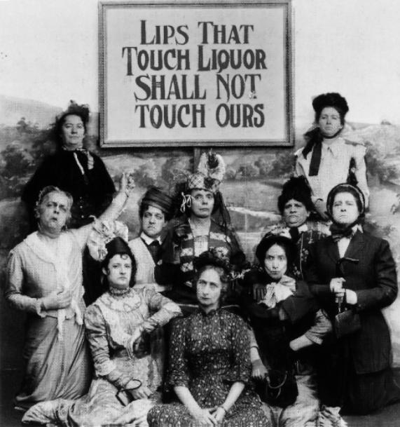**What were the names of the two main movements that wanted prohibition?**

The Anti-Saloon League and the Women’s Christian Temperance Union.

**What were the illegal bars and illegal drinks called?**

Speakeasies and moonshine.

**In what areas were the temperance (anti-alcohol) movements strongest?**

In rural areas. The movement also had a great deal of support among women.

**What were supporters of prohibition known as?**

Dries.

**What arguments did prohibition supporters use against alcohol?**

* 3000 infants a year were smothered in bed by drunk parents.
* 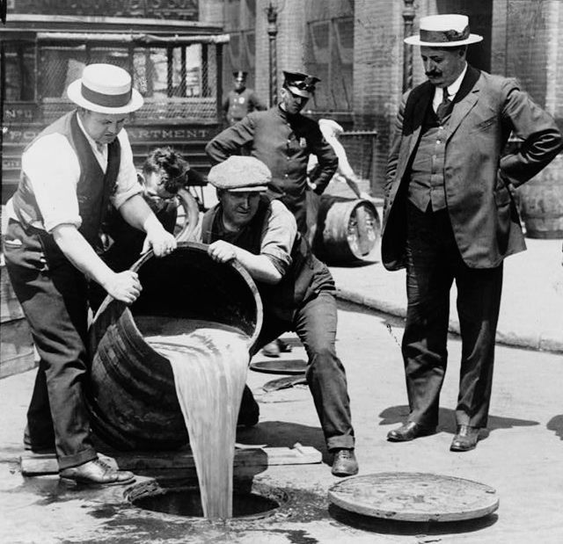WWI – drinkers were accused of being unpatriotic cowards. Most big breweries were run by German immigrants who were portrayed as the enemy.
* Dries claimed that drink caused lawlessness.
* Drinking was said to encourage the spread of communism after the Russian revolution.
* Saloons were seen as dens of vice that destroyed family life.

**Success argument – ALE**

**Alcohol destroyed**: in 1929, 50 million litres of illegal alcohol were discovered and destroyed.

**Legacy**: the actual consumption of alcohol fell, not just during prohibition, but for many years after - did not reach pre-1914 levels until 1971.

**Einstein and Smith** (Izzy and Moe): became famous as examples of the high standards police SHOULD achieve.

Supported in 1920s by women who saw alcohol as a way of men oppressing them. Big businesses such as the Rockefeller Corporation and Heinz who saw drunkenness as a threat to workplace efficiency. Religious groups also supported the movement as they believed alcohol was the work of the devil- causing sin and wrongdoing in society. Small town and rural areas showed significant support wanted to preserve moral righteousness and traditional American ways of life. Prohibition was implemented because of WW1 and disorganisation of any opposition. There were a few minor protests, such as a rally in NY and a parade in Baltimore, but other than this there was little opposition. Significant decline in road accidents across the country. Money not spent on alcohol fuelled prosperity- more money to spend on consumer goods. Even led to a decline in alcohol consumption in Britain and other areas. Able to see the diversity in society from prohibition because small town rural America saw a decline in consumption- even after prohibition ended only half the bars reopened.

**Failure Argument - DAMAGE**

* **Drinking continued**: impossible to enforce (not enough police - only 4000 agents, many of whom were sacked for taking bribes). Prohibition did not end drinking- over 18000 miles of coastline- alcohol smuggled into USA
* **Available**: the liquor trade just 'went underground'. S**peakeasies** (illegal bars), **moonshine** (illegally-made alcohol), **bootlegging** (smuggling alcohol to sell). Bootlegging between Canada and Detroit worth $215m a year.  
  Before prohibition- only 300 bars, in mid twenties there were 700 speakeasies (illegal bars) banning alcohol increased the ‘excitement’ and demand. Congress unwilling to fund enforcement agents- only 3000 to cover whole country. However, Speakeasies promoted gender and racial equality- women entered speakeasies, when they never would have attended saloons. Speakeasies were also famous for their black jazz musicians.
* **Made criminals of ordinary people -** Drinking didn’t stop- simply handed businesses and profits to criminals- decreasing US employment, and possible government earning whilst increasing crime rates.
* **Adverse effects**: moonshine was poor quality and sometimes killed people. 'Jackass brandy' caused internal bleeding, 'Soda Pop Moon' contained poisonous alcohol. Illegal manufacturing without regulation- methyl alcohol produced accidently- could lead to blindness and in New York alone- 30 people a year died as a result.
* **Gangsterism** flourished running the illegal trade: It became hugely profitable, and led to a growth of violence, protection rackets etc. associated with the illegal trade. The general flouting brought the rule of law in general into disrepute as police 'turned a blind eye. Corruption grew due to famous gangsters like Al Capone. rivals ‘turf wars’ – over control and supply of alcohol in certain areas; 1929- St Valentine’s day massacre- 6 killed by Al Capone’s gang- violence in society. High demand- charge high prices- cost of highball increased from 15 cents in 1915- $3 in 1920. Al Capone- earned $60million by 1927 (allowing gangland dominance over society as bribery of government officials and police offers took place)- rise in organised crime- money invested into ‘new industries’- increase in drugs, prostitution and gambling (however was this because of change in attitudes) In Chicago alone 227 gangland murders each year.
* **End**: in 1933 the **21st Amendment** abolished Prohibition (= 'proved' that it failed).

**Who shared the boom?**

**Urbanisation-** 1920 census showed for first time more people living in towns than villages. People living in rural areas saw this as a threat to American way of life- people in towns ‘wild and sinful’. One of many divides within society. Old vs New- rural (traditional) v urban

Prosperity was unequal- 8% of families owned 42% of national wealth- not everyone benefitted

Despite receiving the vote, did **women’s rights** change?

* Although they now had the vote, many women voted alongside their husband’s choice, more men voted than women and even though they could vote, they had very limited involvement in politics. By 1928- only 148 women across 38 state representatives.
* An Equal rights amendment repeatedly failed to be passed through congress
* Facade of becoming liberated- massive social changes. However- the changes in promiscuity, clothes, music, and hair these are all small, superficial things. Cosmetic and beauty industries grew- supporting gender stereotypes if anything.
* Actual changes not made they were still restricted
* If anything gender roles were reinforce as they only able to change appearance and ‘trivial’ things.
* The Sheppard Towner act, 1921 provided funds for women’s healthcare during pregnancy, however these funds were withdrawn in 1929. Anyway, many saw it as reaffirming women’s role as a mother and housewife.
* Limited career prospects- women paid significantly less than men. 3.5 million women in domestic service. Only 150 dentists and 100 accountants. Out of 435 delegates in the House of Representatives- only 2 women.

**Ethnic minorities-** did not share the prosperity. Made up 10% of pop and yet 85% lived in the South- in poorest regions. 14% of farmers were African American. Even when migrating to the north, African-Americans faced discrimination in housing and employment. Lived in ‘ghettos’ poor housing- overcrowding- poor living conditions.

**Farmers:** During the war prices rose 25%. However, in ‘years of prosperity’ wheat prices fell from $2.5 to $1 a bushel. This is because prohibition limited demand for grain, and better standard of living meant high meat consumption than cereal. Technological advances meant farmers produced more and over production pushed prices down. 66% of farmers operated at a loss. Farmers blamed the government- Harding policies made things worse and Coolidge wouldn’t intervene.

Poor banking system (no security or regulation)- small banks- giving loans when they do not have money- go bust and cannot be bailed out. In 1920s- over 30000 banks in the USA. Federal Reserve Board- sold government securities to the market (hoped people would invest in these, not as high payouts as businesses, but less risk). However, bought these from banks allowing them more money to loan to people to gamble on the stock market. Also, kept interest rates low- encouraging people to take out loans and speculate on the market. They raised interest rates from 3.5% to 5% in 1928 (too late to make a difference)

International debt- Britain and France owed money to the US- weakening their purchasing power and restricting their ability to buy consumer goods. Germany also had to pay reparations an loan money of the US. Hoover blamed this rather than himself. However the Fordney McCumber tariff 1922- restricted international trade and even Britain who believed in free trade had to implement tariffs in response. In 1929 trade was worth $36bn and by 1932 it well to $12bn. (the Hawley Smoot tariff further increased trade restrictions in 1930

Market unstable, had been dips in March, June, December 1928 and March 1929. Rodger Babson predicted crash but was ignored. Experts had poor understanding of the economic system- knowledge outdated

**Problems with the economy (making the depression more likely)**

Products brought on credit- e.g. 60% of furniture, 70% of radios = over $7bn worth of goods- economy not based on real money- people couldn’t pay loans back. Banks and people go bust.

Over production- lack of demand. By 1927 everyone who wanted consumer products had bought one- did not need more and wages were  
not rising fast enough for greater consumption. Industries decline- 60% of families living below the line considered ‘necessary’ to live.

Depressed agriculture- due to overproduction, limited international trade and debts- value of farmland dropped 30% from 20-29. Led to under consumption as farmers could did not have money to spend. Also led to overproduction- as farmers try to produce more to earn more. Many old staple industries also fell into decline.

Wall Street market also known as ‘bullish’. - people went ‘wall street crazy’ rumours of people earning a lot from shares e.g. nurse who won $25000 on the market after receiving tips from a grateful patient. In 1927 $3.5bn people invested on Wall Street with loans- by 1929 this reached $6bn. This was because of a desire to ‘get rich quick’ and because of the low interest rates, media encouragement and confidence in the market. 50000 people brought shares on the margin- only paying a small portion themselves and borrowing the rest of banks. Many investors were inexperienced and followed the crowd- this led to panic selling and the Wall Street crash when people lost confidence in the market.

Who didn’t benefit from the boom?

**African Americans** faced racism and discrimination. These problems were particularly bad in the south and thousands of black

Americans were murdered by lynching in this period. As a result many African Americans moved to the north where the situation was slightly better – the black population of both Chicago and New York doubled during the 1920s.

**The Ku Klux Klan (KKK)**

* believed in white supremacy, they began in the Southern states in ‘small town’ America. They were formed in response to losing the American Civil War. Formed
* Used parades, beatings, lynchings and other violent methods to intimidate black people. They planned terrorism attacks against the black community- over 3000 lynching’s before 1877.
* Also attacked Jews, Catholics and immigrants.
* Strongest in the mid-west and rural south.
* The KKK re-emerged after ww1 partly because of nationalist feelings and stricter immigration policies, the Red Scare also provided the perfect breeding ground for the party. By 1921- 100000 members and the Klan had developed a structure- funded by a subscription charge. By 1924 had 4.5 million members. By 1925 they claimed to have 5 million members.
* In the 1920s the KKK managed to get some of their members elected into positions of political power. Spread to some northern states, and even dominated the police and judges in some states.
* Hiram Wesley Evans (dentist) became the KKK’s imperial wizard
* However by 1925 the KKK started to go into decline. David Stephenson- Grand Dragon of Indiana Klan (responsible for KKK expansion in North) accused of rape. Other scandals, usually financial. By 1930 membership fell to 200000.
* **Were they significant?** To black victims very significant- because of terror  
  In peak year, 1925, 40% of members were in 3 states Indiana, Ohio, Illinois.   
  Some senator/congressmen were senators- however achieved little politically or on a national scale.

In the north there was a better chance of receiving a better education and better paid jobs. There were also internationally famous black Americans thanks to the new entertainment industries such as Louis Armstrong. Black Americans also became increasingly involved in politics with new organisations being founded that sought to improve black rights and create more opportunities for black businessmen – W.E.B. DuBois founded the NAACP and Marcus Garvey founded the UNIA.

Despite these improvements life expectancy remained far lower for African Americans than for white Americans and discrimination continued. Many black Americans in the north lived in extreme poverty and were often forced to live in ghettos.

The Monkey Trial, 1925- In Tennessee the clash between ‘old traditional religious views’ and new freer ideas came to a head. There was an argument over whether Darwin should be taught at school. John Scopes wanted to teach national selection in Biology rather than the bible and was prosecuted and fined $500. Teaching Darwin became a criminal offense.

**Poor women** could not afford to lead flapper lifestyles. Many of them had been working for a long time already because they had to support their families. This meant that they did not share in the new freedoms that middle class women enjoyed at this time.

**Native Americans** were discriminated against. Numbers had decline from 1.5million to 250,000 in 1920. Those that survived were forced to leave their traditional way of life and live on reservations in the mid-west. Most were forced to live in extreme poverty with lower life expectancy than white Americans. They had poor health, poor education and low paid jobs. Their children were also sent to boarding school in an attempt to assimilate them into American culture. This was done in an attempt to destroy Native American’s traditions, dances and languages.

However, in some ways the 1920s was a turning point for the Native Americans as in 1924 they were granted US citizenship and given the vote. Life then improved for them even further in the 1930s as a result of Roosevelt’s New Deal.

**Old industries** like cotton suffered due to competition from new synthetic materials like nylon. Flapper fashions also meant that less fabric was required for clothing. Coal suffered because of competition from the oil and electricity industries. New machinery also meant that old industries needed fewer workers and so unemployment became a problem in areas where these were the main source of work.

**Farmers** suffered from overproduction following the end of WWI- European countries were no longer exporting American food. There was also fierce competition from Canadian wheat farmers. This caused prices to fall and so wages were cut too, then unskilled labourers started to leave rural areas to go to cities in search of better paid work.

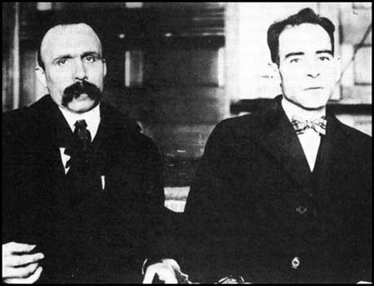**The Red Scare**

Following the Russian Revolution in 1917 Communism terrified Americans; a number of bombs were planted in 1919-21, one by an immigrant Italian.   Immigrants were suspected of being communists and anarchists. Workers involved in strikes and trade unions were also accused of being communists. Americans believed that communism went against the ideas of the American Dream, which celebrated and encouraged capitalism and the pursuit of wealth.

The courts clamped down harshly on political crimes by immigrants at this time.

The case you MUST know about is the trial of **Sacco and Vanzetti** - Sacco and Vanzetti trial, 1921 – Violent robberies occurred in the early 1920s and security guards were killed. Suspicion fell on the migrant community, and Sacco and Vanzetti were reported by a garage owner who was told to report all Italian car owners. As they never admitted to possessing firearms or reveal their anarchist connections, they were presumed guilty. At the trial, the key witness was a 14 year old who never saw either of their faces ‘but could tell the perpetrator was foreign by the way they run. 22/35 eye witnesses said S&V were not there. Both provided alibis which were disregarded by the jury. Despite all this Judge Thayer sentenced them both to death. Many international writers and intellectuals e.g. H.G wells expressed their disgust.  
Despite appeals, the judge persisted with his decision, even though another prisoner confessed to the crimes- both were executed in 1927.

### Immigrants

ALL Americans were immigrant families, of course, but until 1890 most immigrants were 'WASPs' (white Anglo-Saxon Protestants) from the wealthier countries of Europe such as Britain, Germany and Sweden.   After 1890, more immigrants started arriving from Eastern Europe and Asia.

Demand was growing, however, to slow down immigration and there followed a number of laws and quotas to restrict immigration:

a.  **1917:   Immigration Law**

This required all immigrants to prove they could read English, banned all immigration from Asia, and charged an immigration fee of $8.

b.  **1921:   Emergency Quota Act**

This stated that the number of immigrants from 'the eastern hemisphere' could not be more than 3% of the number already in America in 1910.  It set the maximum number of immigrants in any year at 357,000.

c.  **1924: Reed-Johnson Act**

Maximum number of immigrants in any year at 154,000.   Quota from eastern hemisphere reduced to 2% of

those already in America in 1890; the South and the East of Europe were thus only allowed to send 20,000 immigrants per year, and non-Europeans only 4,000.

**Herbert Hoover (1929-1933) – Republican**

Very determined to stick to his principles of ‘rugged individualism’ and ‘voluntarism’. He would never shift from his fundamental beliefs. Ignored warnings about the economy- tried to make few interventions during the depression- some argue this was too little too late whereas his right wing critics believed he intervened too much and should have left the market to correct itself. He was blamed by many for the depression- although it was Coolidge who allowed the inbuilt weaknesses of the economy to thrive. Lack of intervention gave impression he did not care- actual fact he cut his officials salaries by 20% to help provide for recovery measures.

Weaknesses in the economy- throughout the 1920s. Always unstable- on shaky foundations- collapse was inevitable- just needed a trigger.

**Lost confidence**- British financial giant Clarence Hatry collapsed- this shows the enterprises financed by debt were vulnerable. US investors began to worry about the businesses they have brought stock from. Rumours began to spread the successful rich stock market investors like Joseph Kennedy had began to sell their stock- other inexperienced people followed- fearing the price would drop- so the price dropped further- and this began a vicious cycle of panic selling. Banks began to demand the money they had leant out back- people speculating/buying with credit cannot repay debt- banks cannot reclaim money and collapse.

The Wall Street crash wouldn’t have caused the depression alone; it was already coming because of the underlying issues with the economy. The Crash was an effect- not cause of the coming depression. However, the crash was important in worsening the depression.

**Problems caused**- 13 million shares changed hands – normally around 3 million. 14 billion dollars were wiped off share values- the market shrunk 50% in six weeks. Share prices fell- e.g. Woolworths share price went from 100.37 to 52.25 in the two months after the crash- panic selling. Thousands of people became bankrupt, individuals and businesses lost millions. The president of Union Cigar jumped off a hotel roof to his death after shares in his company fell from $113 to $4 in a single day. World trade fell by 70% and unemployment increased from 1.5 million in 1929 to 12 million in 1932 as companies were forced to make cutbacks- this led to a further decline in consumers which inexplicably made the depression worse. 1/3 of the workforce was unemployed; in 1932 the national wage was only 40% of the 1929 figure.   
African Americans and women were main victims of unemployment, more likely to be laid off from unskilled jobs- to allow white men jobs. In 1931 the number of African Americans out of work was 4 to 6 X higher than whites. Major impact in northern states- in southern states the commentator of Georgia reported that ‘most blacks didn’t know the depression had come, they had always been poor’.  
Growth rate went from 6.7% in 1929 to -14.7% in 1932.  
GNP decline $60bn in this period.  
Credit vanished- 10000 bank closures- farmers couldn’t pay back loans so banks took over their land- which was often bankrupt and unsellable. Banks closed- and farmers had no land. People lost confidence in banks and rushed to withdraw all their money.

In society- marriages decreased, suicide rates increased.  
Unemployment relief varied greatly- no federal level help (too much belief that the individual should find work and money themselves) only 11 states offered $200000 help, aiding only 1000 people.  
Ten states- removed right to vote to dissuade people from applying. Only 25% of those who were entitled to aid received it- had to sell all possessions- become destitute and single/childless people were unlikely to receive anything. Relief bodies were running out of money, state governments received less tax because employment was increasing. Charities could only provide 6% of necessarily relief, state couldn’t help and federal didn’t. (In 1932 Hoover set aside funds)

As a result by, 1932 2 million Hoboes lived in shanty towns which were nicknamed Hooverville’s. 28% receiving no income not including 11 million farmers in acute poverty- many of population starving.   
People going hungry- when wheat was rotting in fields of Montana and in Oregon sheep were slaughtered and left for buzzards to eat (lack of intervention)   
  
Agriculture Marketing act, 1929- Established a federal farm board with funds of $500 million to create a farmers marketing co-operative. These would be given the task of buying, storing and disposing of surplus. Not able to restrict production though. Huge surpluses in 1931-1932 saw prices fall and corporations were paying above market value for produce (some saw this as a waste of tax payer money) e.g. in 1931 they paid 82cents a bushel when it cost 40. However, it was aimed to help farmers, in actual fact it encouraged them to produce more rather than less.   
This policy failed because it paid farmers artificially high prices, which could not be sustained.  
Treated agriculture as a domestic situation and didn’t take into account foreign influences  
Also refused to subsidies farmers as it contradict ‘voluntarism’ and ‘rugged individualism’

Hawley Smoot tariff 1930- Highest in American history, charging 40% on agricultural and industrial products. Europeans raised their tariffs in response- made exports and farmers situation worse.  
  
As international trade declined and America withdrew its money from Germany- this led to them repudiating their war debts. Hoover feared this would cause war between France and Germany and issued a Moratorium, 1931- postponing debt repayments for 18months. This was too late to stop the collapse of the European countries; it was passed during his lame duck presidency- Hoover encouraged Roosevelt to continue the policy- but he signed the Johnson Act,1932- refusal to sell securities to any countries who refused to pay debts. Trade was already damaged, but it did make other countries resent the US more. Finland was the only country to pay their debt repayments.

Encouraged voluntarism – businesses maintain wages and employment rates but as the depression worsened they physically couldn’t do this. An example would be when bankers set up the National Credit Corporation, 1931 and financial institutions donated $500 million to its fund. However, only ever spend $10 million- bankers too ingrained in their ways to invest in failing banks- individuals financial concerns always put before others= voluntarism failed.   
  
In 1932- Hoover established $500 million for unemployment relief. However, wouldn’t give directly to people- contradicted his ideals and made people dependent on handouts- distributed to agencies- under control of Presidents Emergency Committee for Employment. – Uneven distribution and not enough to deal with scale of issue. So rigid in his beliefs- even during 1930-31 drought in southern states he would bit give direct relief, eventually gave $47million but it was offered as loans that needed to be repaid.

Federal Home Loan Bank Act, 1932- help loan associations provide mortgages to people- however maximum loan was only 50% of properties value- (largely ineffective)   
  
Reconstruction financed Corporation- lend $2bn to rescue banks, insurance companies, railroads and construction companies in distress. 90% of these loans went to small and medium sized banks. However critics argue not number of loans, but size of loans- biggest banks given most. Government argued they were biggest employers so it made sense to help them and tackle employment. Hoover also allowed the RFC to give $1.5billion to bankrupt states to fiancé public work schemes (where Roosevelt got new deal ideas from)

Hoover was seen as aloof but he did care and tried to implement policies. He rigidly stuck to his beliefs, but gave up his own money to help (maybe not being cruel- he genuinely believed it was for the best). He seemed distant when people were starving and said they didn’t work hard enough alienating people. The ‘us’ and ‘them’ divide was worsened by the treatment of bonus army.

Did set up veteran’s administration, providing $675million on veterans disabilities- still only remembered for Bonus Army. Veterans to be paid in 1945- because of depression- wanted pay early- by 1932 20000 camped out in protest. Feeling sorry for them, Hoover insisted he could not help them get their pay early but offered to pay $100000 for their transport home. When they refused to leave, tanks and tear gas set on veterans. Hoover was blamed, despite it being General McAuthurs idea.

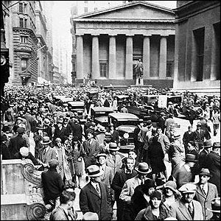The Wall Street Crash

Causes:

1. **over-production** – companies were making more consumer goods than they could sell which then caused prices to fall and unemployment to rise.
2. **unequal distribution of wealth** – even though there had been lots of money in the 1920s it had not been shared out fairly, they rich had got richer and the poor often got poorer.
3. **high import tariffs** **on American goods** - meant that countries outside of the US made their own tariffs that made American goods too expensive to buy in the rest of the world. So when the domestic market became saturated there was nowhere else for the American companies to sell to.
4. **speculation on the stock market** – inexperienced people had invested heavily in the shares during the 1920s hoping to make some fast money. Once companies started to fall in value panic selling began and this then finally triggered the crash.

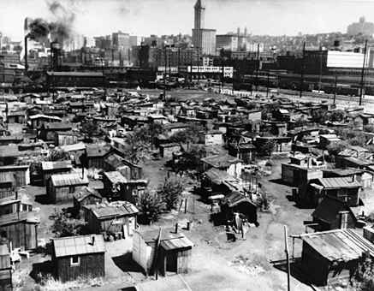The Consequences of the Depression

* Shareholders and businesses lost millions of dollars, industrial production dropped by 45% and 5,000 banks went out of business.
* By 1932 America was in the greatest **economic depression** in its history. Over 13 million people were unemployed.
* Farmers lost their land and more workers were forced to leave the land to find work. They became known as **hobos.** This situation was made even worse by the fact that overproduction in the 1920s had caused the **dustbowl** so that many areas of farmland were no longer suitable for growing crops or keeping animals.
* In cities many people also lost their houses and had to live in shanty towns called **Hoovervilles.**
* There were no welfare systems (benefits etc) in place to help people so the situation continued to get worse.
* People became so poor that they could not afford to feed themselves and had to join **breadlines** where they could queue up to get food supplied by charities.
* People started to **hate President Hoover** because he refused to recognise the probl ems.
* When some ex-army soldiers went to the White House to ask to be paid their pensions early Hoover turned the army on them and even let them use tear gas. The protesters became known as the **Bonus Army** and people all around American were shocked and outraged at the treatment ex-servicemen received on Hoover’s orders.
* All across America people began protesting against the government and violence often broke out.
* America then recalled its loans to European countries from WWI. This had a devastating impact, causing **the depression to become global.**

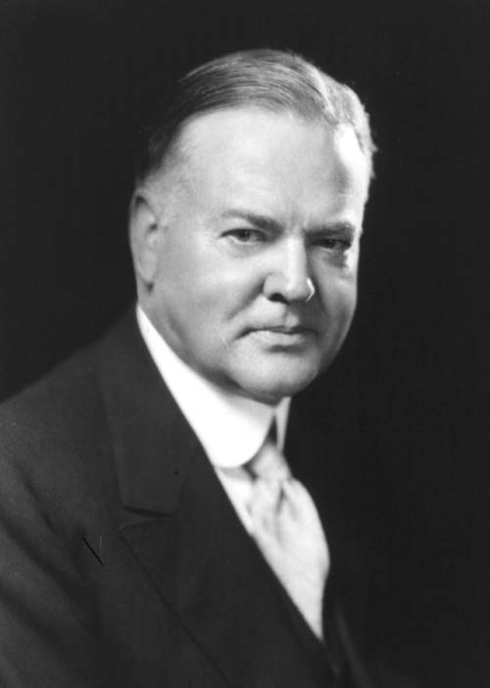The 1932 Election

Despite the huge economic problems after 1929 President Hoover insisted that ‘prosperity is just around the corner’. This made people hate Hoover, they were angry that he was doing nothing to help them. A popular slogan at the time was ‘In Hoover we trusted and now we are busted!’

Hoover was called a ‘do nothing’ President. This was no entirely fair, he had tried to help the banks and to persuade business leaders to improve wages, he passed a Bill in 1932 that allowed Congress to spend $2.1 billion on creating new jobs. However his heavy import duties on strangled international trade and made the economic problems worse. Ultimately the Republicans believed in laissez faire and blamed the Depression on European countries.

As a result of his refusal to help the poor Hoover lost the 1932 election to the Democrat candidate, Franklin D. Roosevelt. Unlike Hoover, Roosevelt believed in strong ‘active government’ to improve the lives of ordinary people. He planned to spend public money to create jobs and solve social problems. Roosevelt was also keen to seek advice on important issues from a range of experts including factory owners and union leaders.

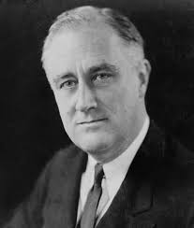

During the election campaign Roosevelt’s aims were deliberately vague but he realised that people wanted change. He travelled the country by train, covering 20,800 km and making important speeches in which he promised the people a ‘New Deal’. This was the 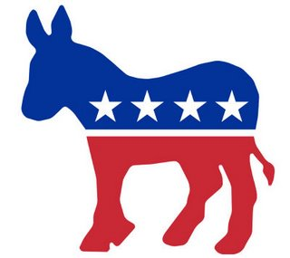first time that a presidential candidate had travelled the country to personally address so many people and impressed the public.

The election was a landslide victory for the Democrats and Roosevelt. He won by 7 million votes. It was the worst defeat that the Republicans had ever suffered.

**Foreign policy 1917-33**USA pursued policy of isolationism between wars- stayed clear of foreign entanglement. E.g. **rejecting League of Nations**. However, the US was far too powerful and influential to remain isolated.They were largest exporter of goods and owned $12bn of war debts after WW1. Also, in order to allow isolated the US often had to intervene.

**1920s:** On the surface the 1920 foreign policy appeared isolationist- however this could not always be maintained. Sometimes have to get involved to protect their own interests not because they had any desire to intervene. 1917- Wilson 14 points went to Paris Peace Conference to try and get them adopted as the basis for peace. Nationwide campaign for League of Nations- however his health deteriorated and opposition grew. Peace treaties accepted but US refused to join League of Nations.  
  
**Open Door Policy**- stimulates trade and export technologies. However, due to the First World War destruction and debts- many countries too poor.  
  
**Repayment of war loans- conferences** and discussions must be held- intervention   
Conferences- **discuss disarmament treaties** and discussions/policies to prevent future wars– intervention.   
  
**1921 Washington disarmament conference-** President Harding left foreign affairs to Secretary of State Charles Hughes. US really pushed for disarmament. Delegates from the US, UK, France, Japan and Italy met in Washington to discuss the balance of power in East Asia. Concerned Japan was becoming too powerful and China too weak. US had colonies in the Philippines that needed to be protected (had to intervene despite wanting to isolate themselves)  
UK, USA, France, Japan- signed **Four Power Treaty** agreeing torespect each other’s interests in the Pacific   
 Agreements were signed on naval disarmament- reduce amount of battleships.  
However- no penalty for defaulters – no alliance or moral obligation

**1924**- American troops withdrawn from **Dominican Republic and Nicaragua.**   
Also withdrew from **Latin America**- (volume of trade between Latin/North America reached $3.2 billion by 1929)

**China**: Japan learned that the USA would not intervene in Chinas civil war (isolationist) Japan saw this as American weakness.  
  
**Kellogg- Briand Pact**: USA wanted to maintain peace- many conferences held and competitions for peace plans throughout the decade e.g. Roosevelt offered $100 000 prize. 1928- Signed this pact which renounced war as a way of settling international grievances.  
(Wanting to isolate- have to intervene to do this)